Modifying Maternal Health Forms – Guide

General Information
Maternal health form fields use tables for all sections. Prior to modifying, it is recommended that you click on one of the tables/fields, go to the “Layout” ribbon at the top (your curser must be in a table for this to show up), and “View Gridlines”
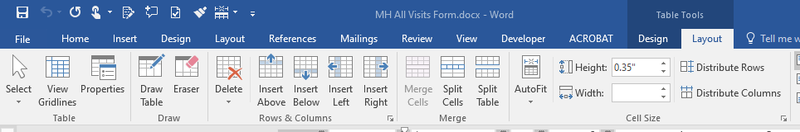

Adjusting spacing, borders, etc.
To adjust the spacing of two cells within a table, highlight both cells and then drag the border – otherwise you will adjust the entire column which will throw off all of the formatting for the table:
These two cells are highlighted so I can just drag the border between them without affecting the border of the cells above or below
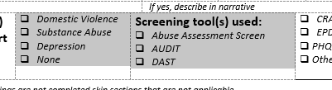
To modify the lines for written text, use the “Border Painter” option in the Design ribbon. Using borders instead of typed underscores allows you to use the forms electronically and type into the cells. Make sure all the settings in the “Border” section are correct and then click “Border Painter” and click on the border you want to modify.
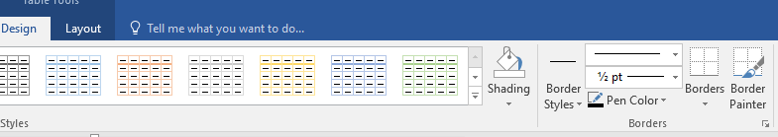
You can change the weight to “No Border” to remove any unwanted lines.
NOTE – sometimes the borders just won’t do what you need them to or line up correctly, it’s usually easiest to add a new row below to make it work. Make the font size in spacer rows small (6) so the row can be smaller
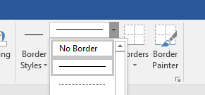

Adding rows, fields, bullets,

Rows
To add a new row for spacing or new cells, you can either hover outside of the table where you want to add it or right click to insert rows above or below.
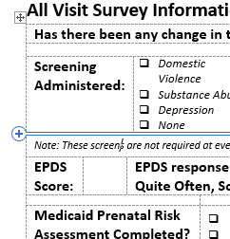 OR 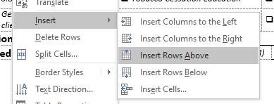

Cells
To get the correct number of cells for the row, either split them (to create more), or merge them (to create fewer cells). Right click on the row or cell to split, the number of columns will be the number of cells. If you want stacked cells on top of each other, select 1 column and 2 rows instead. To reduce the number of cells, select multiple before right clicking and select “Merge Cells”.
Split: 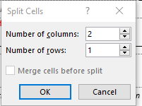 Merge: 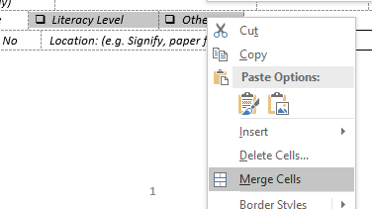

Bullets
When you add bullets to a new cell, the formatting will be off. You need to use the ruler at the top of the document to adjust the alignment. Highlight all of the bullets to adjust (you can do this across multiple adjacent cells in rows and/or columns).
Drag the left indent to the left so it is closer to the edge of the cell: 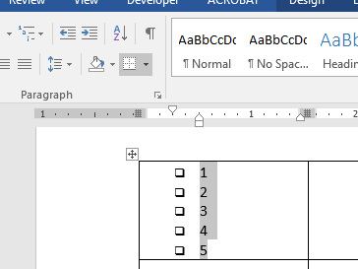
Drag the first line indent to the right so the bullets are closer to the text: 