# SFH Social Memes

[*POST*]

You don’t have to live with secondhand smoke. Check out our smoke

free rental property registry at smokefreehomes.iowa.gov.

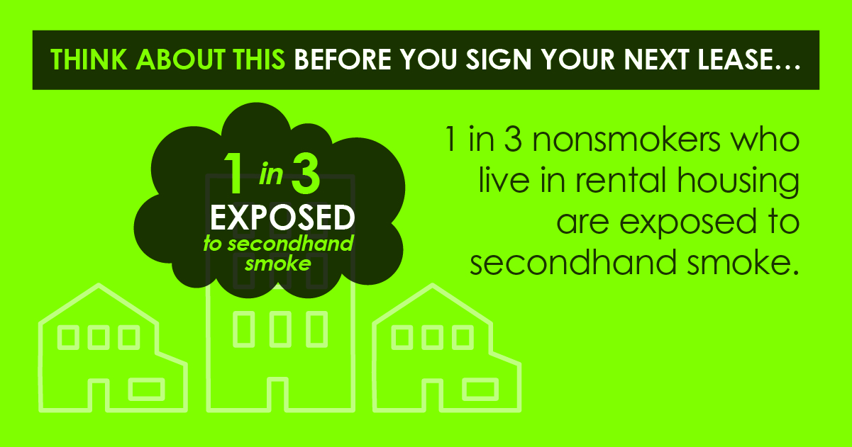

[*POST*]

Breathe freely in your rental property. Find a smoke free

rental property at smokefreehomes.iowa.gov.

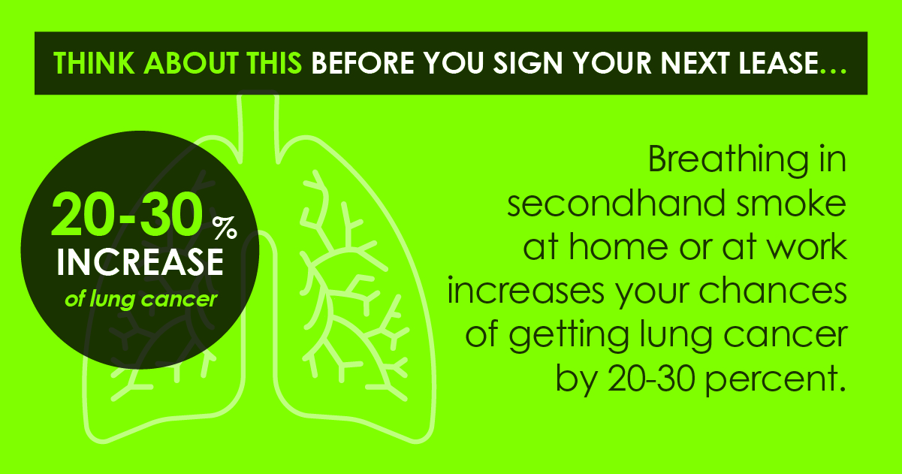

[*POST*]

You deserve a breath of fresh air in your own living room. Check out our

smoke free rental property registry at smokefreehomes.iowa.gov.

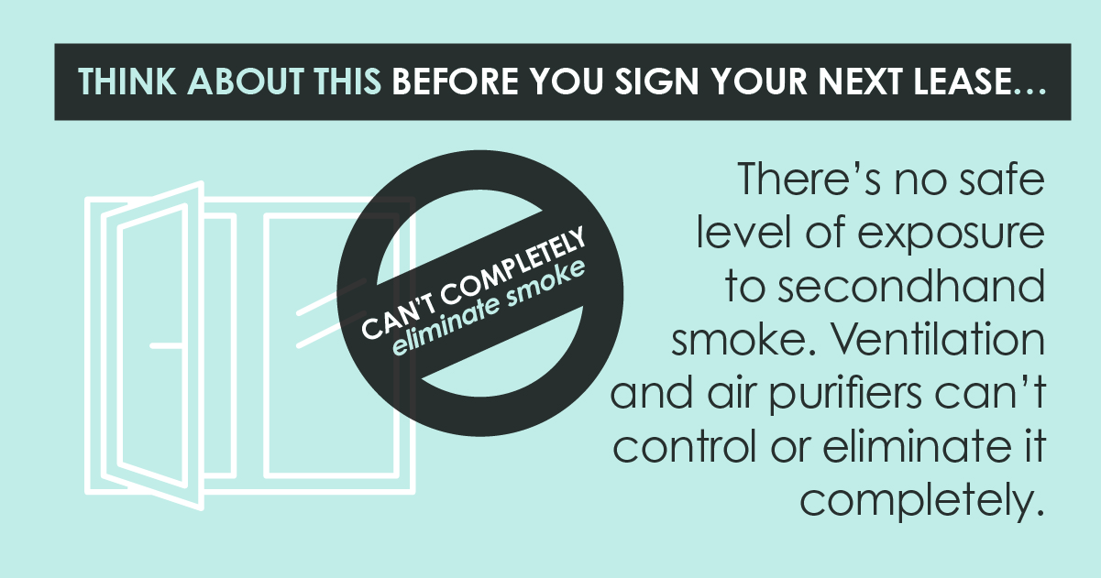

[*POST*]

Your children deserve to live in a smoke free home. Check out our smoke free rental property registry now at [smokefreehomes.iowa.gov](http://smokefreehomes.iowa.gov/).

