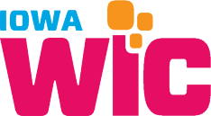
UPC/Brand Request Form

Your Information

Your Name: |  |  |  | Your E-Mail:
Your Company: |  |  |  | City your Company is Located in:

UPC Information

Please provide the following information for each product:
- Submissions do not require images, but you may be asked to provide them before final approval.
- For new brand submissions images of the nutrition panel and ingredient lists are required.
UPC or PLU  (must include ALL digits found on barcode) |  | Product Description  (Brand, Type, Flavor, etc. OR image of front of package) |  | Selling Unit Size  (Ounce, pound, jar, package, gallon, etc.) | Selling Unit Retail  (your retail cost per item) | Images  (Nutrition panel & ingredient list)
9-87564-32100-9 |  | Johns 1% milk |  | 1 gallon | $1.75

Please submit the form by faxing it to 515-281-4913 or e-mailing it to wicvendor@idph.iowa.gov.
June 2017

