### **Email outlineSetting up an Email Account**

**Choosing an email address:**

When choosing an email address for your job search:

* Your email address should ***not*** be suggestive, flirtatious, generic, silly, or funny.
* It should be professional and easy to remember.
* It should include your name, preferably your first and last name; make it easy for prospective employers to find “you” in their inboxes.
  + If you cannot obtain your first and last name as an email address at a popular email service such as Gmail, try it with another email service.
* It should be a personal email address, not one shared with a spouse or family.
* Try not to use numbers or underscores.
  + In particular, avoid including the year of your birth. It’s *very* *easy* to guess the probable age of [Mary.Jane.Smith79@whatever.com](mailto:Mary.Jane.Smith79@whatever.com)

**To create an email account:**

1. Go to [www.gmail.com](http://www.gmail.com)
2. Click “**Create account**”

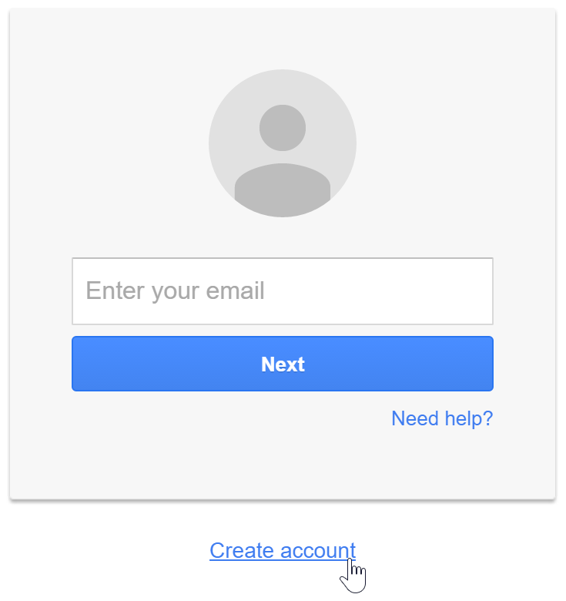

(Continue to the next page)

1. A screenshot of a login form

   Description automatically generatedThe signupform will appear. Follow the directions and enter the required information. Just like with any online service, it’s important to choose a **strong password**—in other words, one that is difficult for someone else to guess. For more information about generating a strong password, check out our [Creating Strong Passwords](http://www.gcflearnfree.org/internetsafety/creating-strong-passwords/1/) lesson.
2. 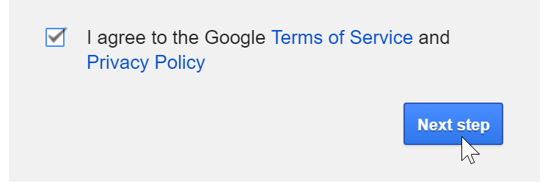Review Google’s [Terms of Service](http://www.google.com/intl/en/policies/terms/) and [Privacy Policy](http://www.google.com/intl/en/policies/privacy/), click the check box, then click “**Next step**”.

(Continue to the next page)

1. 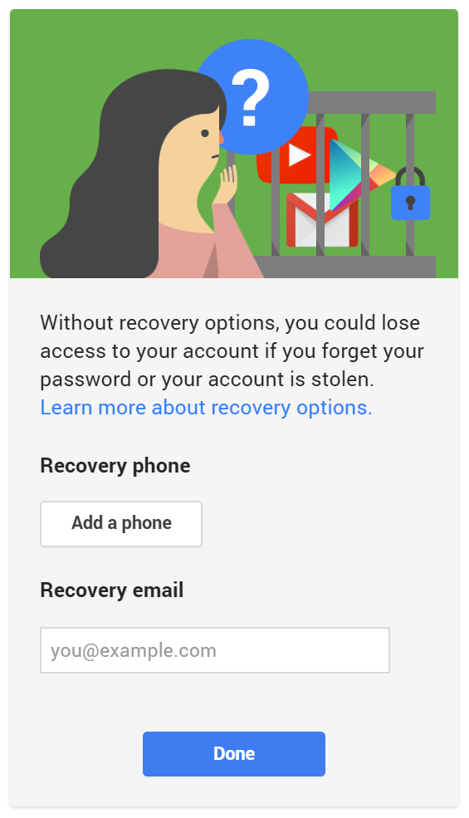Here, you’ll have an opportunity to set up **recovery options**. Recovery options are helpful if you forget your password or if someone tries to access your account. If you don’t want to set up recovery options at this time, just select “**Done**”.
2. 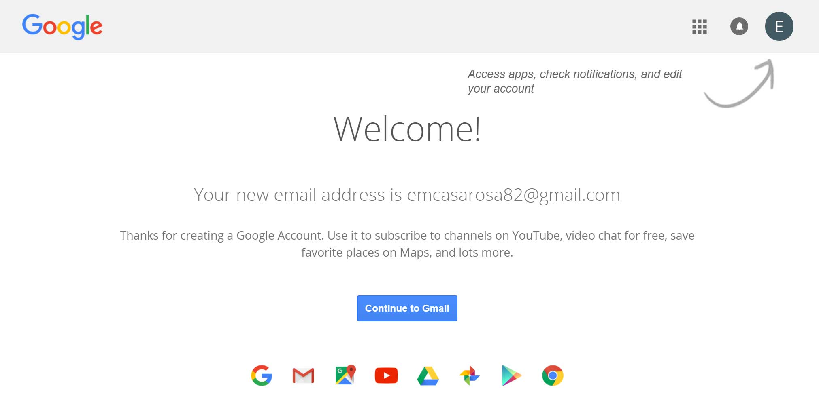Your account will be created and the Google welcome page will appear.

**Signing into and out of your account:**

When you first create your account, you will be automatically signed in. Most of the time, however, you will need to **sign in** to your account and **sign out** when you’re done with it. Signing out is especially important if you’re using a shared computer (for example, at a **library** or an **office**) because it prevents others from viewing your emails.

To sign in:

1. Go to [www.gmail.com](http://www.gmail.com)
2. 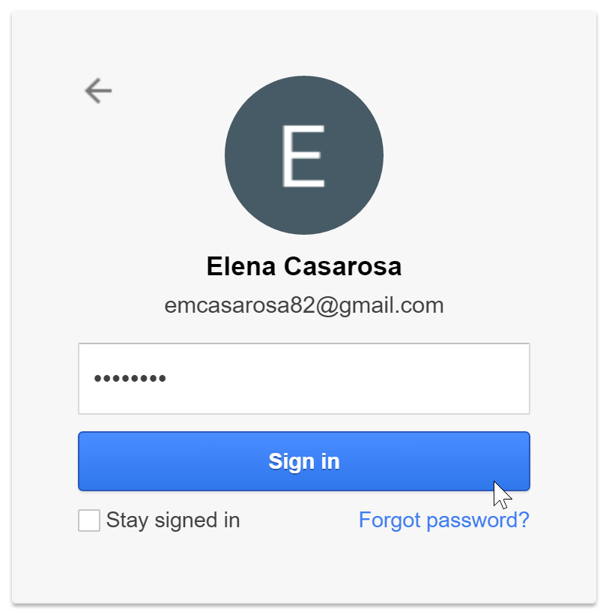Type your **user name** (your email address) and **password**, then click “**sign in**”.

To sign out:

1. In the top-right corner of the page, locate the circle that has your first initial (if you’ve already selected an avatar image, it will show the image instead.)
2. 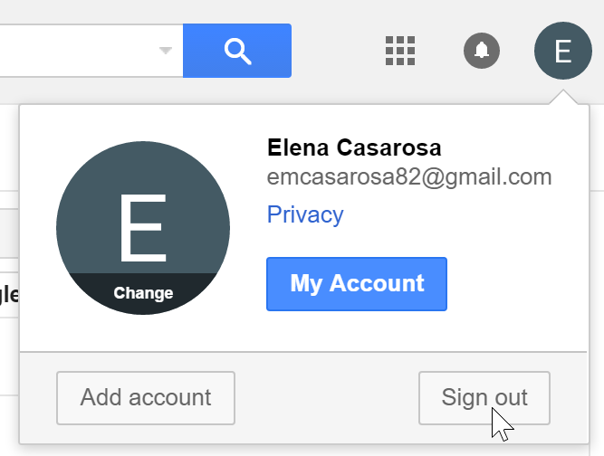Click the circle and select “**sign out**”.

**Making changes to your mail settings:**

Occasionally, you may want to make adjustments to Gmail’s appearance or behavior. For example, you could create a signature or vacation reply, edit your labels, or change the theme. These adjustments can be made from your mail settings.

To access your mail settings:

1. Click the **gear icon** in the top-right corner of the page, then select “**Settings**”.

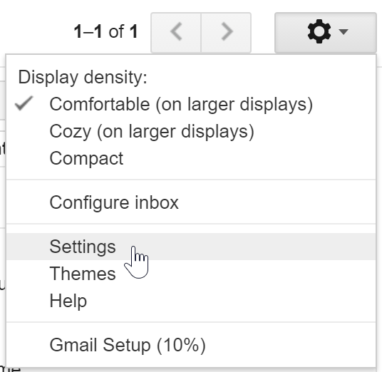

1. From here, you can click any of the categories at the top to edit the desired settings.  
     
   