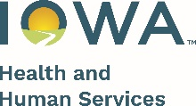 

Date

Family Name  
Address  
City, State, ZIP

Dear HOH Name,

I am reaching out because I have not been able to get in touch with you. Please call me at Number at your earliest convenience, so that we can schedule a home visit.

I look forward to hearing from you,

Staff Signature

Phone Number

Email Address

Office Address

**Appeal Notice:**

You have the right to appeal decision(s) made in the FaDSS program. Appeals may be made by telephone or in writing to the FaDSS State Program Manager:   
**Phone:** (515) 343-6459  
**Mail**: FaDSS State Program Manager  
 Lucas State Office Building, 3rd Floor  
 321 E 12th St  
 Des Moines, Iowa 50319  
**Email**: [FaDSS@hhs.iowa.gov](mailto:FaDSS@hhs.iowa.gov)