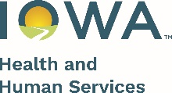 

Date

Family Name  
Address  
City, State, ZIP

Dear HOH Name,

This letter is to inform you of your exit from the FaDSS program. You will be receiving an invitation to complete an optional anonymous satisfaction survey. The survey responses will be used to help us continue to improve our services.

I have appreciated working with you throughout this program and wish you all the best.

Sincerely,

Staff Signature

Phone Number

Email Address

Office Address

**Appeal Notice:**

You have the right to appeal decision(s) made in the FaDSS program. Appeals may be made by telephone or in writing to the FaDSS State Program Manager:   
**Phone:** (515) 343-6459  
**Mail**: FaDSS State Program Manager  
 Lucas State Office Building, 3rd Floor  
 321 E 12th St  
 Des Moines, Iowa 50319  
**Email**: [FaDSS@hhs.iowa.gov](mailto:FaDSS@hhs.iowa.gov)