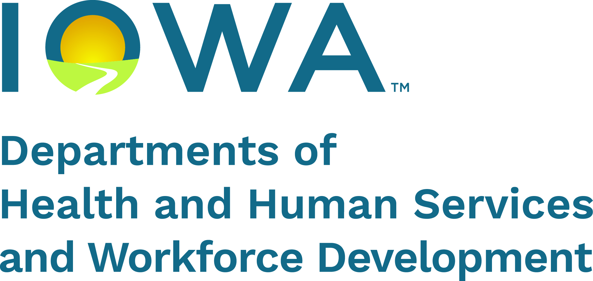 Job Search Plan Agreement
Participant Name
State ID (SID)
As I agreed to on my Family Investment Agreement (FIA), I will participate in job search activities. I will list my job search contacts and activities on the Job Search Activity Log and return the completed form(s) to PROMISE JOBS by the date listed below.
My job search activity log(s) with total hours are due to PROMISE JOBS on .
Job Search Schedule
Week Beginning Date (Saturday) | Week Ending Date (Friday) | Hours per Week
My plan for my job search contacts and activities includes:
Looking for job openings and/or completing online and in-person applications
Research, Career Exploration, Resume Development
Attending Workshops, Interview Preparation, Mock Interviews
Networking with employers (follow up from applications, job fairs, interviews, personal contacts)
Other:
I am interested in these types of jobs or these employers:
Child care I need help with child care. Expected number of days per week:
Expected number of hours per day:
I don’t need help with child care expenses at this time.
Transportation I need help with transportation costs as discussed with my PJ worker. I understand payments are issued each month before the activity begins. Any hours not completed may mean my transportation costs are reduced for future months.
I don’t need help with transportation at this time.
Questions? Please contact:
PROMISE JOBS Worker Name | Phone Number | Email
Address |  | Fax Number
Participant Signature |  | Date
PROMISE JOBS Worker Signature |  | Date
Participant Agreement
I agree to:
- Count the actual hours spent on job search activities to the best of my ability and write the hours on my Job Search Activity Log (form 470-3099). I will not count travel time from home to my first contact or travel time from my last contact to home. If I travel from one job contact to another, I will only count my travel time between the job contacts on my Job Search Activity Log.
- Follow this Job Search Plan Agreement and participate in job search activities for the total number of hours per week as stated in my Job Search Plan Agreement.
- Provide a completed Job Search Activity Log and any other required documentation by the due date on my Job Search Plan Agreement.
- Tell my PROMISE JOBS worker right away if I find a job. If I am already working, I will tell my PROMISE JOBS worker if my hours change or I lose my job.
- Tell my PROMISE JOBS worker right away if I am unable to complete my agreed upon job search activities for any reason.
- Tell my PROMISE JOBS worker if my need for child care or transportation changes.
- Register for work with IowaWORKS and follow up on job leads.
- For online job applications, I will send a copy of the confirmation that I applied to my PROMISE JOBS worker.
I understand that:
- My PROMISE JOBS worker may verify any of my job contacts.
- My PROMISE JOBS worker may monitor my work registration status with IowaWORKS.
- If I fail to follow this Job Search Plan Agreement, I may be choosing the Limited Benefit Plan (LBP) and lose FIP benefits for my family and me. See below for more information about an LBP.
Limited Benefit Plan (LBP)
If you choose an LBP for the first time:
- Your FIP benefits will stop right away.
- You can change your mind at any time. If you want to get back on FIP, you must tell your HHS or PROMISE JOBS worker and you must:
  - Reapply for FIP, and
  - Sign your Family Investment Agreement (FIA).
  - The earliest your FIP benefits can begin is the date you sign your FIA.
If you or the other parent in the home have been on an LBP before, and choose another LBP:
- Your FIP benefits will stop right away. You can’t get FIP for at least six months.
- After the six-month period ends, if you want to get back on FIP, you must tell your HHS or PROMISE JOBS worker and you must:
  - Reapply for FIP
  - Sign your FIA and
  - Complete 20 hours of work or other approved PROMISE JOBS activity.
- The earliest your FIP benefits can begin is the date you sign your FIA. However, your FIP benefits will not be issued until you complete the 20 hours of work or other approved PROMISE JOBS activity and meet all other FIP eligibility requirements.
If you’re age 16 or older and don’t have a child of your own and are not in school, or you’re 17 or younger and have a child of your own, you must either set up and follow the steps of an FIA or enter an LBP. If you choose an LBP and your parent doesn’t have other children in the home who get FIP or SSI benefits, your parent will no longer get FIP benefits.

