Shingles Organic Social Posts
Did you know 1 in 3 adults will get shingles? If you’re 50 or older, talk to your healthcare provider about the shingles vaccine — your best protection against the virus and its serious health risks.  Learn more: https://hhs.iowa.gov/immunization/ask-me  Source: CDC | 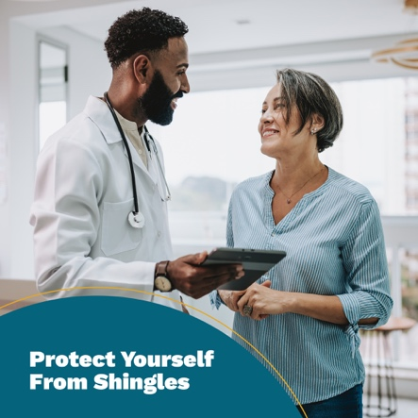
Shingles can cause a painful, itchy rash — and may lead to long-term nerve pain, vision loss and other serious health problems. If you’re 50 or older or 19 or older with a weakened immune system, protect yourself by asking your healthcare provider about the shingles vaccine.  Learn more: https://hhs.iowa.gov/immunization/ask-me  Source: CDC | 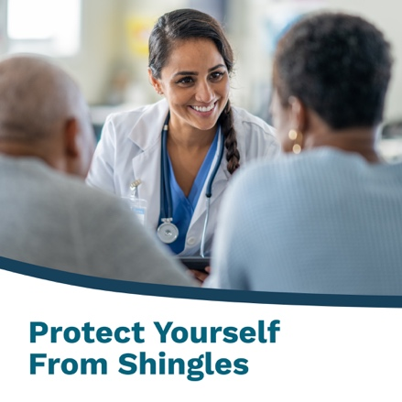
Shingles doesn’t have to be part of getting older. The shingles vaccine is over 90% effective at preventing the virus in adults 50 and older with healthy immune systems. Protect yourself — ask your healthcare provider about the shingles vaccine.  Learn more: https://hhs.iowa.gov/immunization/ask-me  Source: CDC | 