RSV Social Posts
Did you know RSV is the leading cause of infant hospitalization in the United States? Ask your child’s healthcare provider about the RSV antibody.  Learn more: https://hhs.iowa.gov/immunization/ask-me | 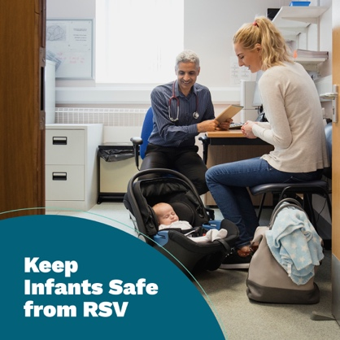
According to the CDC, over 150,000 adults ages 60+ in the United States are admitted to the hospital due to RSV every year. Ask your healthcare provider about the RSV vaccine.  Learn more: https://hhs.iowa.gov/immunization/ask-me | 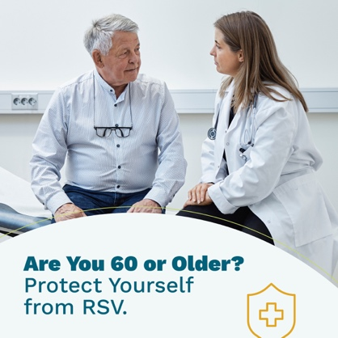
RSV can be serious for infants and older adults. Symptoms in infants include irritability, decreased activity and drinking less. Symptoms in older adults include cold-like symptoms that can turn into pneumonia.  Ask your family’s healthcare providers about the RSV vaccine.  Learn more: https://hhs.iowa.gov/immunization/ask-me | 