Whooping Cough Organic Social Posts
Whooping cough (pertussis) is more than just a little cough. It’s a serious disease that can be deadly. The CDC recommends babies, children, pregnant women and adults get vaccinated.  Learn more: https://hhs.iowa.gov/immunization/ask-me | 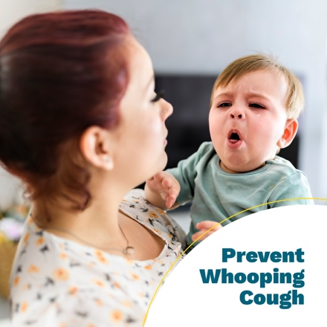
At your child’s next appointment, ask their healthcare provider about the whooping cough (pertussis) vaccine. According to the CDC, when children receive all five doses of the DTaP vaccine on schedule, they’re 98% protected within the year after their last dose.  Learn more: https://hhs.iowa.gov/immunization/ask-me | 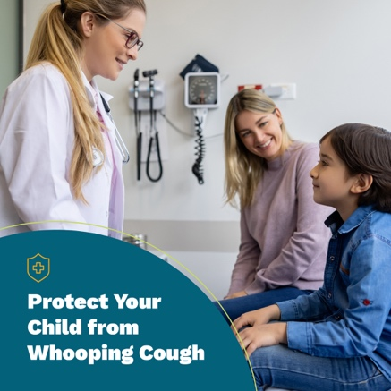
If you’re pregnant, it’s important to ask your healthcare provider about the whooping cough (pertussis) vaccine. According to the CDC, when a mother receives the Tdap vaccine during the third trimester, her infant is less likely to develop whooping cough early in life.  Learn more about pregnancy and whooping cough: https://hhs.iowa.gov/immunization/ask-me | 