Tobacco Prevention Materials Order Form

Please complete the form below and email it to bhassistance@hhs.iowa.gov with the subject line: MATERIALS ORDER FORM.

- Contact Name:
- Agency:
- Mailing Address:
- City: ___________ State: ______ Zip: __________
- County:
- Phone:
- Email:
- Date items needed:

Please allow 2 weeks for delivery. All orders will be shipped via UPS.

Select |  | Name of Item | Number Requested
 | 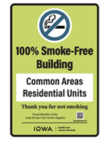 | Metal Smoke Free Building Signs:  Metal 12"x18" sign for smoke-free multi-unit housing complexes on the Iowa Smoke Free Homes Registry (contact 515-393-1340 if you're not sure). This sign does not cover outdoor areas. This sign does NOT meet the signage requirements of the Iowa Smokefree Air Act.  (item 504) | Units of 1
 | 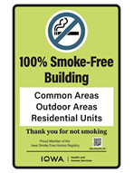 | Metal Smoke Free Property Signs:  Metal 12"x18" sign for smoke-free multi-unit housing complexes on the Iowa Smoke Free Homes Registry (contact 515-393-1340). This sign does NOT meet the signage requirements of the Iowa Smoke-Free Air Act.  (item 506) | Units of 1
 | 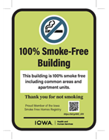 | Tobacco: Smoke Free Homes Window Cling  A 4.5"x6.5" window sticker for smoke-free multi-unit housing complexes on the Iowa Smoke Free Homes Registry (contact 515-393-1340 if you're not sure). This sign does NOT meet the signage requirements of the Iowa Smokefree Air Act.  (item 5086) | Units of 1
 | 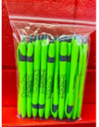 | Smokefree Housing Pens  (item 535) | Units of  20
 |  | Smokefree Homes Rack Cards  (item 5085) | Units of 20
 | 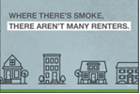 | Smokefree Homes Mailers  (item 5093) | Units of 10
 | 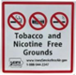 | TF/NF Metal Grounds sign  Metal 12"x12" sign for areas (grounds) that are tobacco and nicotine free. This sign DOES meet the signage requirements of the Iowa Smoke-free Air Act. (item 514) | Units of 1
 | 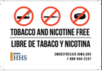 | Bilingual Tobacco Free/Nicotine Free 6” x 4” cling (sticky on front) for areas that are tobacco and nicotine free. This sign DOES meet the signage requirements of the Iowa Smoke-free Air Act (mailed from Iowa HHS) | Units of 1
 |  | Bilingual Tobacco Free/Nicotine Free Window sticker  6” x 4” sticker (sticky on back) for areas that are tobacco and nicotine free. This sign DOES meet the signage requirements of the Iowa Smoke-free Air Act (mailed from Iowa HHS) | Units of 1
 | 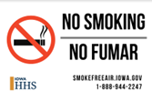 | Bilingual No Smoking Sticker  6” x 4” sticker (sticky on back) for areas that are smoke free. This sign DOES meet the signage requirements of the Iowa Smoke-free Air Act  (mailed from Iowa HHS) | Units of 1
 |  | Bilingual No Smoking Cling  6” x 4” cling (sticky on front) for areas that are smoke free. This sign DOES meet the signage requirements of the Iowa Smoke-free Air Act  (mailed from Iowa HHS) | Units of 1
 | 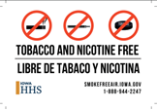 | TF/NF vehicle sticker  3” x 3” sticker (sticky on back) for vehicles that are tobacco and nicotine free. This sign DOES meet the signage requirements of the Iowa Smoke-free Air Act (mailed from Iowa HHS) | Units of 1
 |  | TF/NF vehicle cling  3” x 3” cling (sticky on front) for vehicles that are tobacco and nicotine free. This sign DOES meet the signage requirements of the Iowa Smoke-free Air Act (mailed from Iowa HHS) | Units of 1
 | 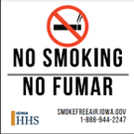 | No Smoking vehicle cling  3” x 3” cling (sticky on front) for vehicles that are smoke free. This sign DOES meet the signage requirements of the Iowa Smoke-free Air Act  (mailed from Iowa HHS) | Units of 1
 |  | No Smoking vehicle sticker  3” x 3” sticker (sticky on back) for vehicles that are smoke free. This sign DOES meet the signage requirements of the Iowa Smoke-free Air Act (mailed from Iowa HHS) | Units of 1
 |  | Quitline Iowa “Quit Card”  A wallet size, plastic card with Quitline Iowa information on it.  (item 513) | Units of  20
 |  | SPANISH: Quitline Iowa Rack Card (brochure) Standard Quitline Iowa rack card  (item 515S) | Units of  25
 | 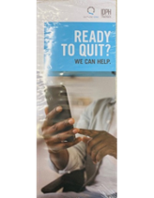 | Quitline Rack Card (brochure) for low health literacy  (item 529) | Units of  20
 | 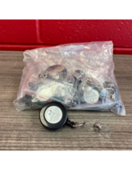 | Quitline Badge Reel  (Item 589) | Units of  10
 | 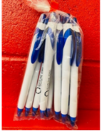 | Quitline Pen  Max of 2 units per county  (Item 5023) | Units of  10
 | 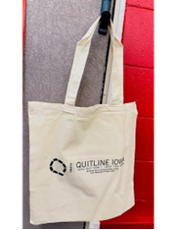 | Quitline Canvas Tote Bag  (Item 5024) | Units of 5
 | 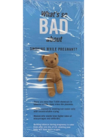 | Smoking While Pregnant-English  (Item 5027) | Units of  25
 | 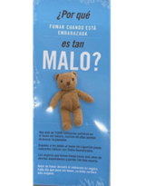 | Smoking While Pregnant-Spanish  (Item 5027s) | Units of  25
 | 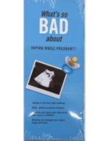 | Vaping While Pregnant-English  (Item 5028) | Units of  25
 | 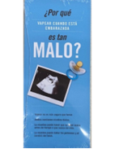 | Vaping While Pregnant-Spanish  (Item 5028s) | Units of  25
 | 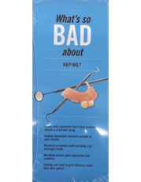 | Vaping Oral Health-English  (Item 5029) | Units of  25
 | 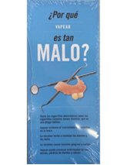 | Vaping Oral Health-Spanish  (Item 5029s) | Units of  25
 |  | Quitline LGBTQ Posters  (item 5055) | Units of  20
 |  | Quitline Latin X Posters  (item 5056) | Units of  20
 |  | Quitline Behavioral Health Posters  (item 5057) | Units of  20
 |  | Quitline Behavioral Health Posters-Spanish  (item 5057s) | Units of  20
 |  | Vaping vs Reality Brochure  (item 586) | Units of  25
 | 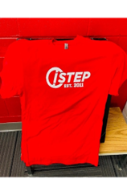 | ISTEP T-Shirt  Red with white logo  (item 5030) | 2XL  3XL
 | 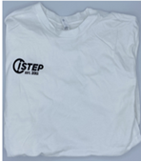 | ISTEP T-Shirt  White with black logo  (item 5030) | Large  XL  2XL  3XL
 | 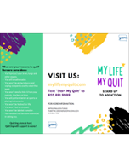 | My Life My Quit Brochure  (item 578) | Units of  20
 | 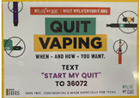 | My Life My Quit Cling  (item 579) | Units of  25
 | 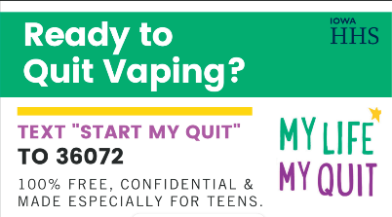 | My Life My Quit tip card  (item 584) | Units of  20
 |  | My Life My Quit School Poster  (item 598) | Units of  10
 | 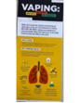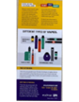 | MLMQ Vaping Rack Card  (item 5060) | Units of  20

