ISTEP Advisor Materials Order Form

Please complete the form below and email it to jill.wright@hhs.iowa.gov with the subject line: ISTEP Materials Order Form

- Advisor Name:
- ISTEP Chapter Name:
- Agency/School:
- Mailing Address:
- City: ____________________ State: ____________ Zip: ____________
- County:
- Phone:
- Email:
- Date items needed:

Please allow 2 weeks for delivery. All orders will be shipped via UPS.

Select | Image of Item | Name of Item | Number Requested
 |  | Vaping vs Reality Brochure  (item 586) | Units of  25
 | 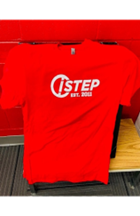 | ISTEP T-Shirt  Red with white logo  (item 5030) | 2XL  3XL
 | 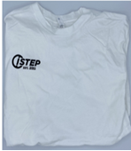 | ISTEP T-Shirt  White with black logo  (item 5030) | Large  XL  2XL  3XL
 |  | ISTEP Stylus Pen  (item 5118) | Units of 1
 |  | ISTEP Lapel Pin  (item 5116) | Units of 25
*Include preferred color(s) |  | ISTEP Notepad  Color options: orange, teal, purple  (item 5117) | Units of 1
 |  | ISTEP Hacky Sacks  (item 5119) | Units of 25
*Include preferred color(s) |  | ISTEP Ice Cube Fidget  Color options: green or blue  (item 5120) | Units of 1
 | 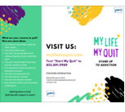 | My Life My Quit Brochure  (item 578) | Units of  20
 |  | My Life My Quit Cling  (item 579) | Units of 25
 | 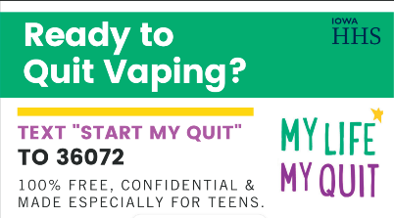 | My Life My Quit tip card  (item 584) | Units of  20
 | 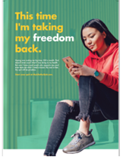 | My Life My Quit School Poster  (item 598) | Units of  10
 |  | MLMQ Vaping Rack Card  (item 5060) | Units of  20

