MASTER FY26 ISTEP Social Schedule
Purpose: Below are ISTEP graphics and caption ideas for your social media accounts. These are only ideas, with the goal to make social posts easier on you. The dates listed are when the ISTEP Facebook/Instagram will be posting these specific items, however you can post them whenever you like.

Instructions: Tag @IowaSTEP in all of your posts. Download the graphics from the monthly folders, then copy and paste the caption from this document.

Recommended hashtags: @IowaSTEP #ISTEP #IowaSTEP #NoTobacco #TobaccoFreeGeneration #StudentLeaders #TobaccoFree #VapeFree #StopVaping #HealthyLungs #KnowTheFacts #YouthToday #StudentSupport #TeensSupportTeens
Date | Graphic | Caption
July 2025
July 1 | 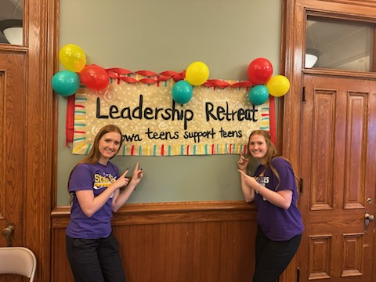 | Grace and Kate attended our very first ever #YouthLeadership Retreat in June! This day was much more than learning about how young Iowans are affected by nicotine use – it was about finding your people! We laughed, we learned, we got real. Learn more about #ISTEP at hhs.iowa.gov/istep.  @IowaSTEP #IowaSTEP #NoTobacco #TobaccoFreeGeneration #StudentLeaders #TobaccoFree #VapeFree #StopVaping #HealthyLungs #KnowTheFacts #YouthToday #StudentSupport #TeensSupportTeens
July 2
July 3 | 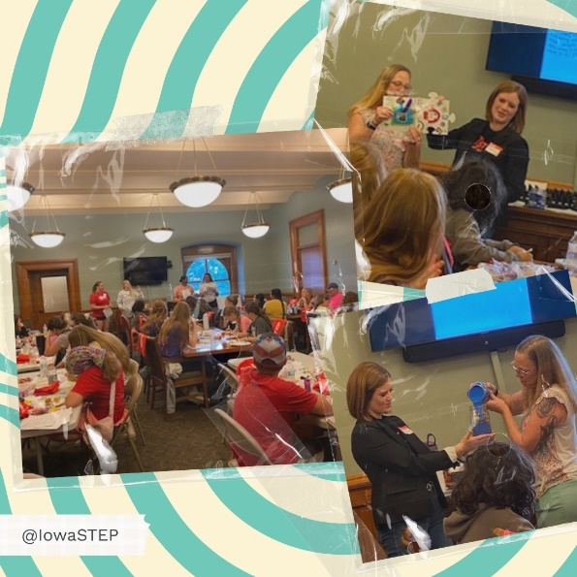 | This #YouthLeadership Retreat hit different. It wasn’t just about skills – it was about belonging. We found friends who listen, who get it and who genuinely care. Because real leadership starts with real connection.  You aren’t alone. You belong here. Always!  @IowaSTEP #ISTEP #IowaSTEP #NoTobacco #TobaccoFreeGeneration #StudentLeaders #TobaccoFree #VapeFree #StopVaping #HealthyLungs #KnowTheFacts #YouthToday #StudentSupport #TeensSupportTeens
July 4
July 5 | Saturday
July 6 | Sunday
July 7 | 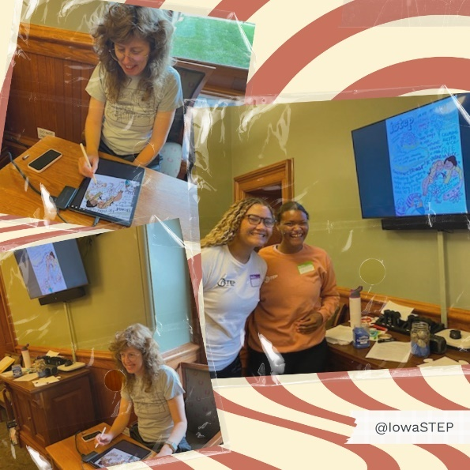 | Big shoutout to Ramona Muse Lambert for turning #YouthLeadership Retreat moments into masterpieces! As we talked about belonging and leading friends and peers at the local level, Ramona captured it all!  @IowaSTEP #ISTEP #IowaSTEP #NoTobacco #TobaccoFreeGeneration #StudentLeaders #TobaccoFree #VapeFree #StopVaping #HealthyLungs #KnowTheFacts #YouthToday #StudentSupport #TeensSupportTeens
July 8 | 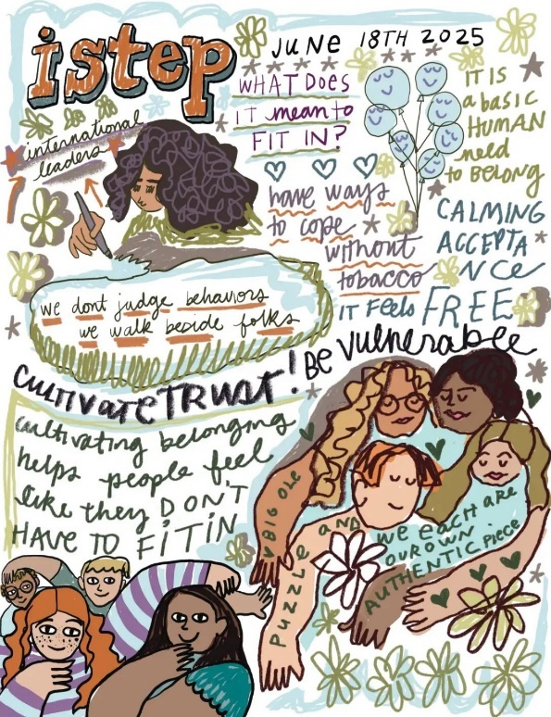 | Ramona Muse Lambert, local Des Moines artist, captured our #YouthLeadership Retreat perfectly! These visual notes remind us that our words, our stories and our connections matter.  @IowaSTEP #ISTEP #IowaSTEP #NoTobacco #TobaccoFreeGeneration #StudentLeaders #TobaccoFree #VapeFree #StopVaping #HealthyLungs #KnowTheFacts #YouthToday #StudentSupport #TeensSupportTeens
July 9 | 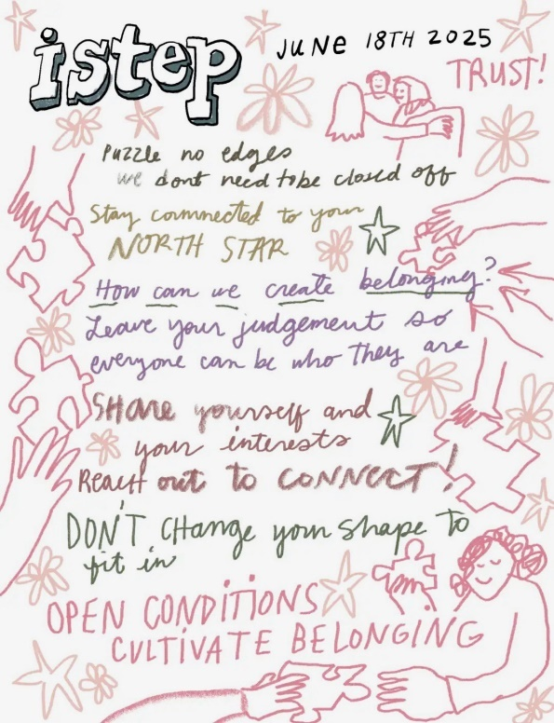 | Ramona Muse Lambert created these visual notes that truly feel like we’re back at the #YouthLeadership Retreat. Here at @IowaSTEP we don’t want you to change who you are to “fit in”, we want you to truly belong simply by being you. Learn more at hhs.iowa.gov/istep.  #ISTEP #IowaSTEP #NoTobacco #TobaccoFreeGeneration #StudentLeaders #TobaccoFree #VapeFree #StopVaping #HealthyLungs #KnowTheFacts #YouthToday #StudentSupport #TeensSupportTeens
July 10 | 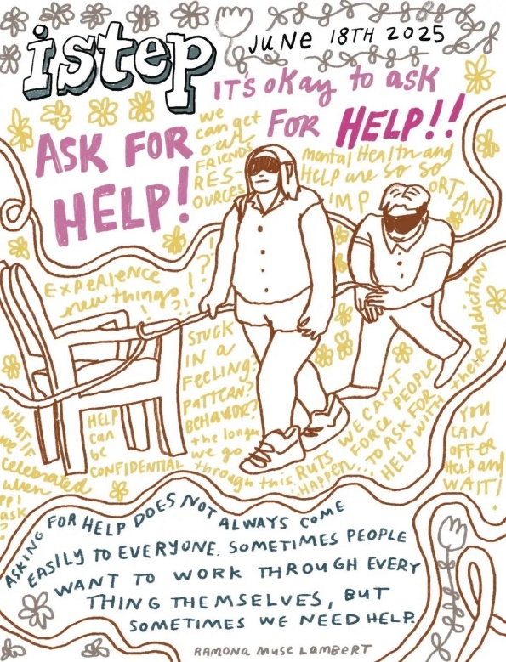 | 🤝 Leadership isn’t about having all the answers—it's knowing when to ask for help and when to offer it.  At our #YouthLeadership Retreat, we dug deep into what it means to support each other—because real strength is shared. We discussed ways to speak up, reach out, and have each other’s backs. No one leads alone. And no one should have to. Learn more at hhs.iowa.gov/istep.  @IowaSTEP #ISTEP #IowaSTEP #NoTobacco #TobaccoFreeGeneration #StudentLeaders #TobaccoFree #VapeFree #StopVaping #HealthyLungs #KnowTheFacts #YouthToday #StudentSupport #TeensSupportTeens
July 11
July 12 | Saturday
July 13 | Sunday
July 14
July 15 | 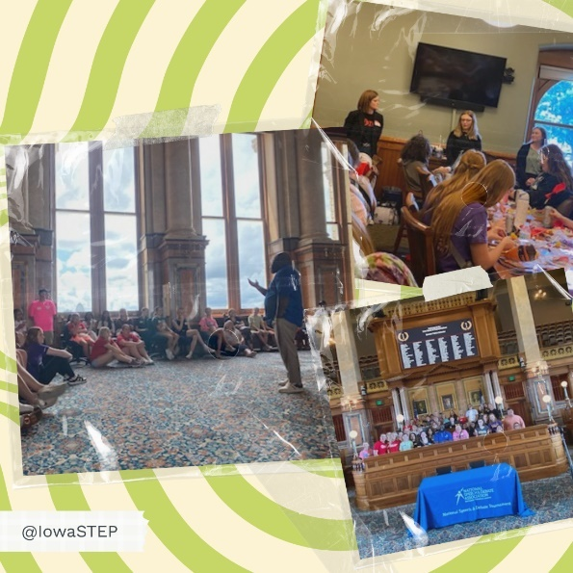 | 🏛️ Big thanks to Representative Johnson for giving young Iowans a behind-the-scenes tour of the Iowa State Capitol! He reminded us that your voice as a young person matters—and that young people have the power to shape the future of our state.  @IowaSTEP #ISTEP #IowaSTEP #NoTobacco #TobaccoFreeGeneration #StudentLeaders #TobaccoFree #VapeFree #StopVaping #HealthyLungs #KnowTheFacts #YouthToday #StudentSupport #TeensSupportTeens
July 16 | 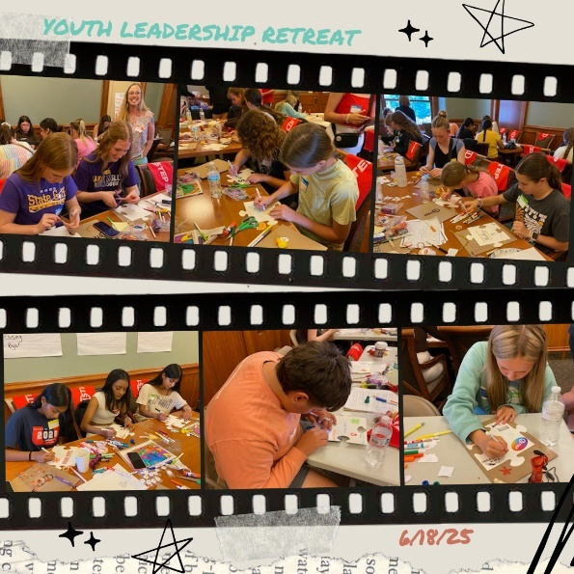 | At our #YouthLeadership Retreat, we each decorated a puzzle piece to represent who we are—our quirks, strengths, stories, and style. Then we brought them all together to create one big puzzle. Because here’s the truth: you don’t have to change your shape to fit in. We all belong. Just as we are. And every piece matters.  @IowaSTEP #ISTEP #IowaSTEP #NoTobacco #TobaccoFreeGeneration #StudentLeaders #TobaccoFree #VapeFree #StopVaping #HealthyLungs #KnowTheFacts #YouthToday #StudentSupport #TeensSupportTeens
July 17
July 18 | 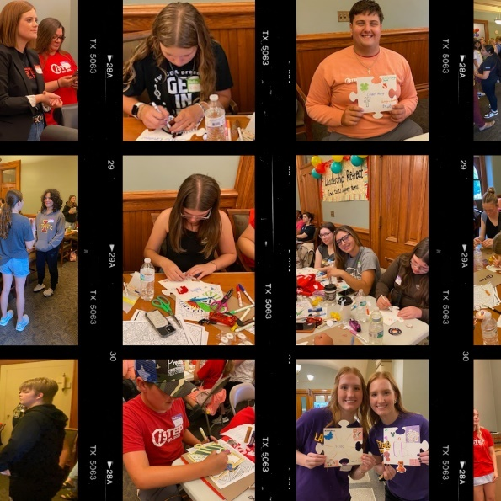 | You don’t have to change your shape to fit in. At our #YouthLeadership Retreat, we reminded each other that we’re not meant to be identical pieces. We’re meant to be ourselves. This puzzle pieces didn’t have edges—because our @IowaSTEP community isn’t closed off. There’s always room for more, for difference, for you.  #ISTEP #IowaSTEP #NoTobacco #TobaccoFreeGeneration #StudentLeaders #TobaccoFree #VapeFree #StopVaping #HealthyLungs #KnowTheFacts #YouthToday #StudentSupport #TeensSupportTeens
July 19 | Saturday
July 20 | Sunday
July 21 | 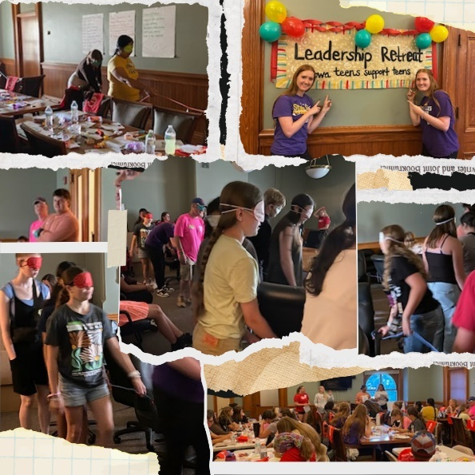 | Sometimes life feels like a maze — confusing, tricky, and full of twists. At our #YouthLeadership Retreat, we learned it’s okay to ask for help when you’re stuck or confused. Because reaching out doesn’t mean you’re weak — it means you’re smart and brave. 💡🤝 No one has to navigate life alone. We’ve got each other’s backs.  @IowaSTEP #ISTEP #IowaSTEP #NoTobacco #TobaccoFreeGeneration #StudentLeaders #TobaccoFree #VapeFree #StopVaping #HealthyLungs #KnowTheFacts #YouthToday #StudentSupport #TeensSupportTeens
July 22
July 23 | 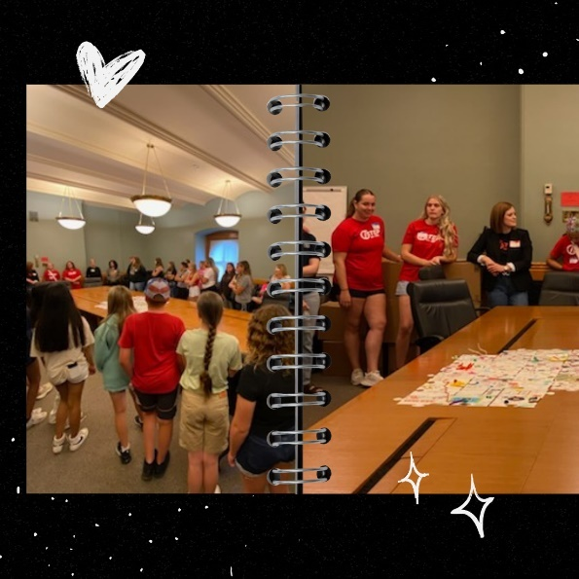 | Belonging starts with us — right here, in our own communities. At our #YouthLeadership Retreat, we didn’t just talk about belonging; we learned how to create it locally. Because when we lift each other up, listen deeply, and celebrate every voice, we build places where everyone feels seen, heard, and valued. 💛🌍  Let’s take that energy back home and make belonging real—for everyone.  @IowaSTEP #ISTEP #IowaSTEP #NoTobacco #TobaccoFreeGeneration #StudentLeaders #TobaccoFree #VapeFree #StopVaping #HealthyLungs #KnowTheFacts #YouthToday #StudentSupport #TeensSupportTeens
July 24 | 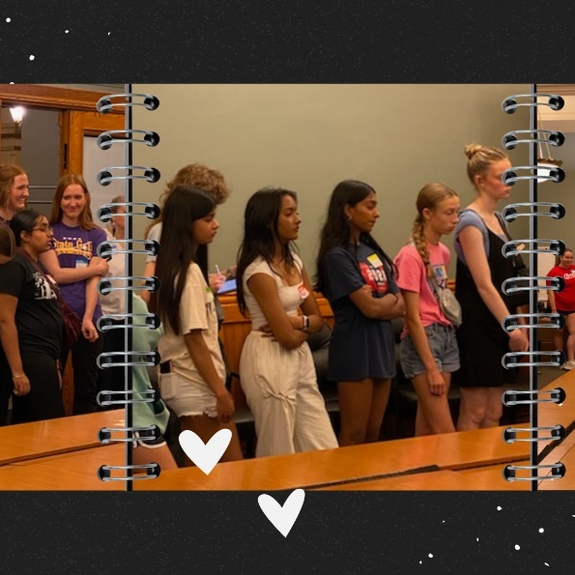 | 🌍 Coming together from all corners of the state, young leaders gathered to listen, share, and learn from one another. Hearing different perspectives and opinions opened our minds and helped us grow—not just as leaders, but as a community.🤝 Because real leadership means showing up for each other and growing together.  @IowaSTEP #ISTEP #IowaSTEP #NoTobacco #TobaccoFreeGeneration #StudentLeaders #TobaccoFree #VapeFree #StopVaping #HealthyLungs #KnowTheFacts #YouthToday #StudentSupport #TeensSupportTeens
July 25 | 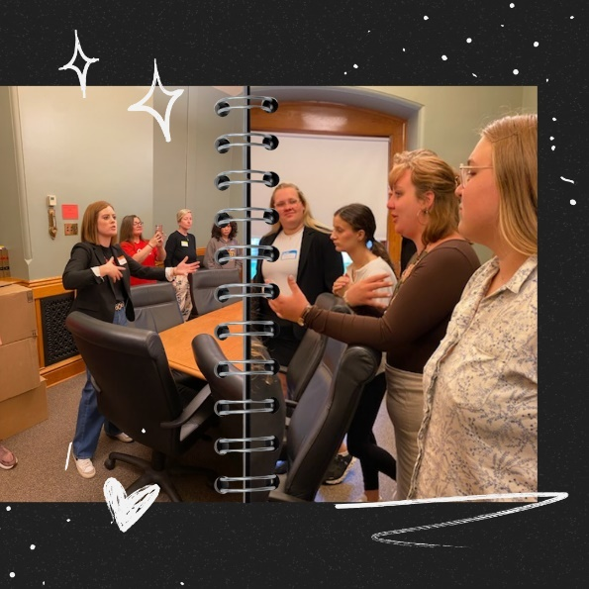 | Our #YouthLeadership Retreat included powerful conversations led by our former #ISTEP President and current Tobacco-Free Kids Youth Ambassador, Courtney Sweet! 🙌  Courtney inspired us to reflect, share, and keep the momentum going for positive change. Leadership is more than a moment—it’s a movement. And with voices like Courtney’s, we’re ready to make an impact!  @IowaSTEP #IowaSTEP #NoTobacco #TobaccoFreeGeneration #StudentLeaders #TobaccoFree #VapeFree #StopVaping #HealthyLungs #KnowTheFacts #YouthToday #StudentSupport #TeensSupportTeens
July 26 | Saturday
July 27 | Sunday
July 28
July 29 | 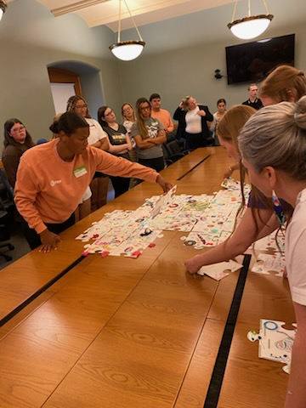  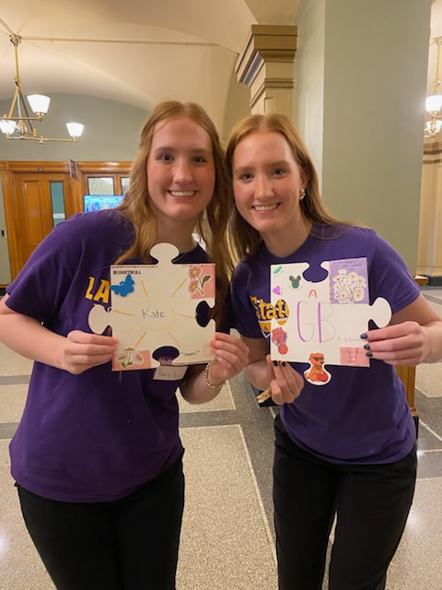  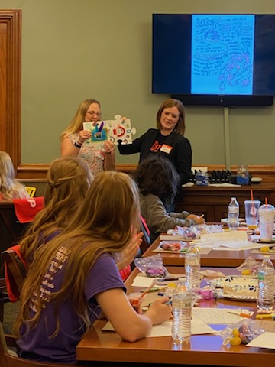  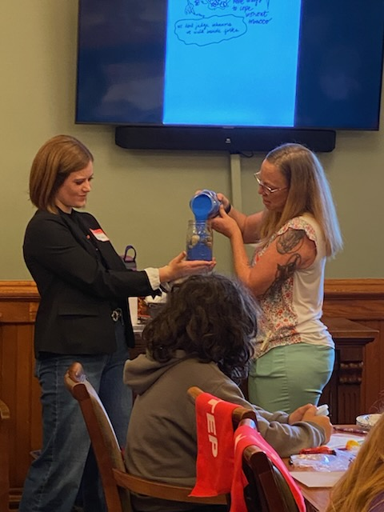  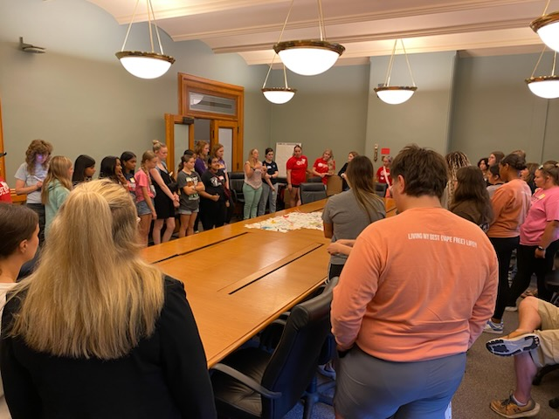 | #ISTEP Council member Sellah stepped up and took the lead in putting together the big puzzle at our #YouthLeadership Retreat! Each piece is unique and special, just like every one of us. But when we come together, those differences build a strong, unbreakable team. 💪 Here’s to celebrating what makes us each one of a kind—and the power we have together.  @IowaSTEP #ISTEP #IowaSTEP #NoTobacco #TobaccoFreeGeneration #StudentLeaders #TobaccoFree #VapeFree #StopVaping #HealthyLungs #KnowTheFacts #YouthToday #StudentSupport #TeensSupportTeens
July 30
July 31 | 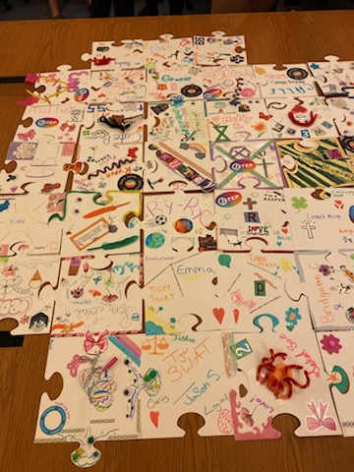  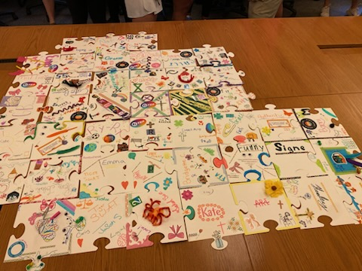    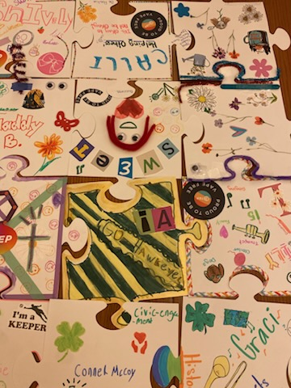  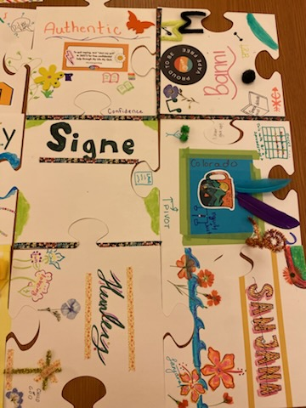  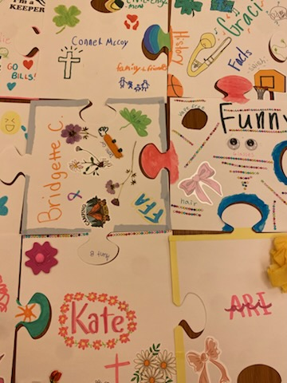  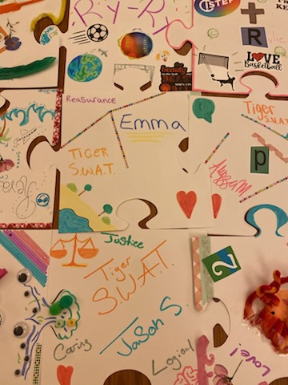 | At our #YouthLeadership Retreat, we each decorated a puzzle piece that shows who we truly are – quirks, strengths and all. Because the world needs your unique shape, story and voice. You don’t have to fit in – you belong just as you are!  Can you find your puzzle piece? Take a screenshot and post it in the comments.  @IowaSTEP #ISTEP #IowaSTEP #NoTobacco #TobaccoFreeGeneration #StudentLeaders #TobaccoFree #VapeFree #StopVaping #HealthyLungs #KnowTheFacts #YouthToday #StudentSupport #TeensSupportTeens

