MASTER FY26 ISTEP Social Schedule
Purpose: Below are ISTEP graphics and caption ideas for your social media accounts. These are only ideas, with the goal to make social posts easier on you. The dates listed are when the ISTEP Facebook/Instagram will be posting these specific items, however you can post them whenever you like.

Instructions: Tag @IowaSTEP in all of your posts. Download the graphics from the monthly folders, then copy and paste the caption from this document.

Recommended hashtags: @IowaSTEP #ISTEP #IowaSTEP #NoTobacco #TobaccoFreeGeneration #StudentLeaders #TobaccoFree #VapeFree #StopVaping #HealthyLungs #KnowTheFacts #YouthToday #StudentSupport #TeensSupportTeens
Date | Graphic | Caption
August 2025
August 1 | 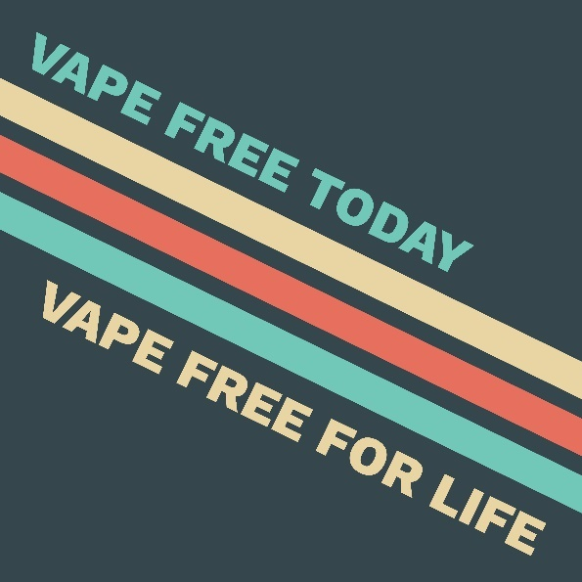 | Use today. Use for life. Adolescents become addicted easier than adults. That’s why almost 90% of adults who use nicotine today started as teens. Don’t risk it. Don’t start. Learn more at: hhs.iowa.gov/istep  @IowaSTEP #ISTEP #IowaSTEP #NoTobacco #TobaccoFreeGeneration #StudentLeaders #TobaccoFree #VapeFree #StopVaping #HealthyLungs #KnowTheFacts #YouthToday #StudentSupport #TeensSupportTeens
August 2 | Saturday
August 3 | Sunday
August 4 | 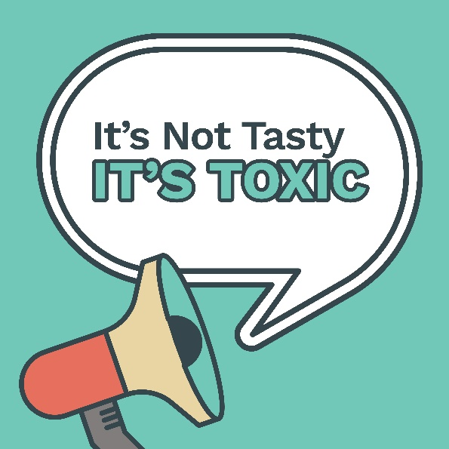 | Cherry, grape, bubblegum - whatever the flavor, vape e-liquid is made of harmful chemicals, including nicotine. Learn the toxic truth at hhs.iowa.gov/istep. @IowaSTEP #ISTEP #IowaSTEP #NoTobacco #TobaccoFreeGeneration #StudentLeaders #TobaccoFree #VapeFree #StopVaping #HealthyLungs #KnowTheFacts #YouthToday #StudentSupport #TeensSupportTeens
August 5
August 6 | 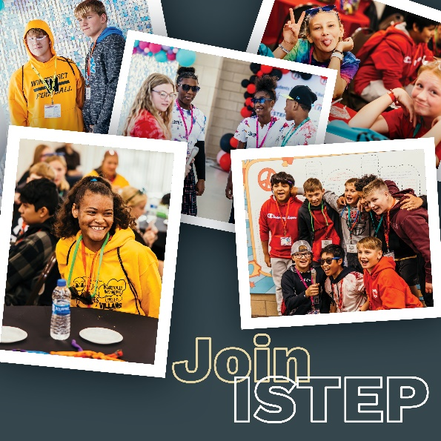 | #ISTEP gives you the power to use your voice with purpose. @IowaSTEP equips you with the tools and skills for you to make a difference in your local communities, state and entire 🌎. Join us at: hhs.iowa.gov/istep  #IowaSTEP #NoTobacco #TobaccoFreeGeneration #StudentLeaders #TobaccoFree #VapeFree #StopVaping #HealthyLungs #KnowTheFacts #YouthToday #StudentSupport #TeensSupportTeens
August 7
August 8
August 9 | Saturday
August 10 | Sunday
August 11
August 12 | 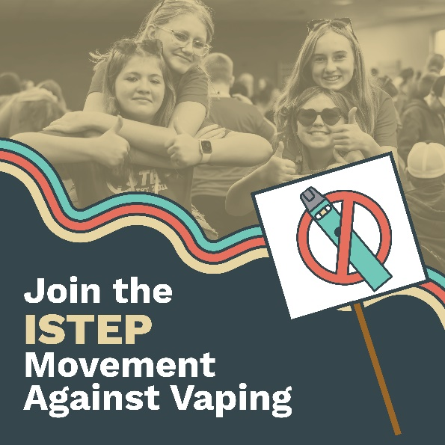 | Feeling our best means being vape free! And, we wouldn’t want it any other way! That’s why we stand up against vaping. Join #ISTEP today at hhs.iowa.gov/istep @IowaSTEP #IowaSTEP #NoTobacco #TobaccoFreeGeneration #StudentLeaders #TobaccoFree #VapeFree #StopVaping #HealthyLungs #KnowTheFacts #YouthToday #StudentSupport #TeensSupportTeens
August 13
August 14
August 15 |  | Clearing your lungs help clear your mind. Breathe free, think free! Learn more at: hhs.iowa.gov/istep  @IowaSTEP #ISTEP #IowaSTEP #NoTobacco #TobaccoFreeGeneration #StudentLeaders #TobaccoFree #VapeFree #StopVaping #HealthyLungs #KnowTheFacts #YouthToday #StudentSupport #TeensSupportTeens
August 16 | Saturday
August 17 | Sunday
August 18
August 19 | 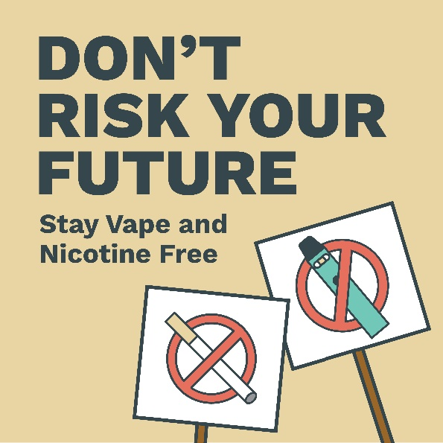 | Using tobacco “every now and then” means more than you might think — 3 out of every 4 teen users stay users as adults. Know the risks! Follow us to learn more. @IowaSTEP #ISTEP #IowaSTEP #NoTobacco #TobaccoFreeGeneration #StudentLeaders #TobaccoFree #VapeFree #StopVaping #HealthyLungs #KnowTheFacts #YouthToday #StudentSupport #TeensSupportTeens
August 20
August 21
August 22 | 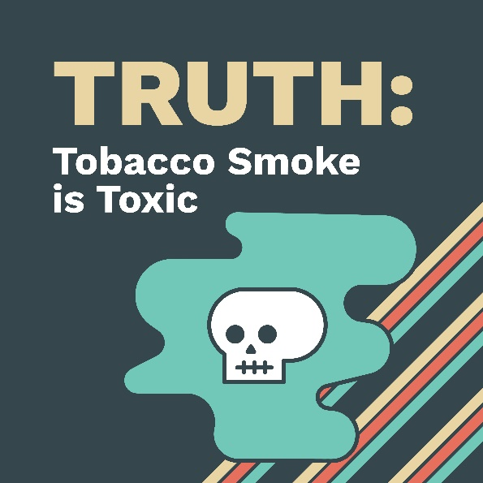 | Tobacco smoke isn’t tasty, it’s toxic! Learn more at: hhs.iowa.gov/istep @IowaSTEP #ISTEP #IowaSTEP #NoTobacco #TobaccoFreeGeneration #StudentLeaders #TobaccoFree #VapeFree #StopVaping #HealthyLungs #KnowTheFacts #YouthToday #StudentSupport #TeensSupportTeens
August 23 | Saturday
August 24 | Sunday
August 25
August 26 | 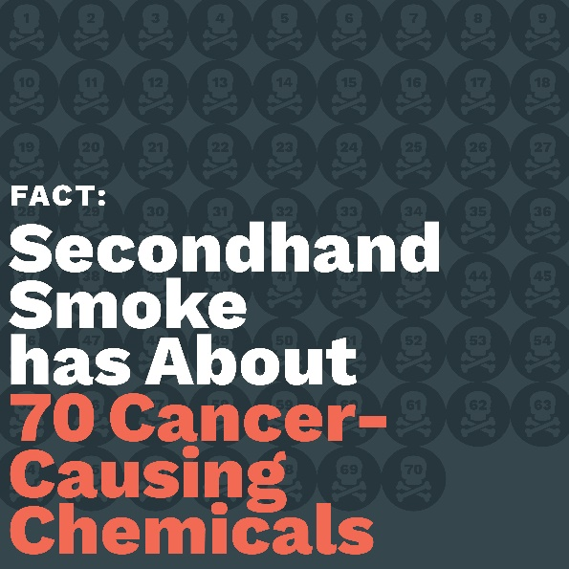 | Secondhand smoke isn’t just gross – it’s dangerous! Protect yourself and friends by being tobacco free. @IowaSTEP #ISTEP #IowaSTEP #NoTobacco #TobaccoFreeGeneration #StudentLeaders #TobaccoFree #VapeFree #StopVaping #HealthyLungs #KnowTheFacts #YouthToday #StudentSupport #TeensSupportTeens
August 27
August 28 | 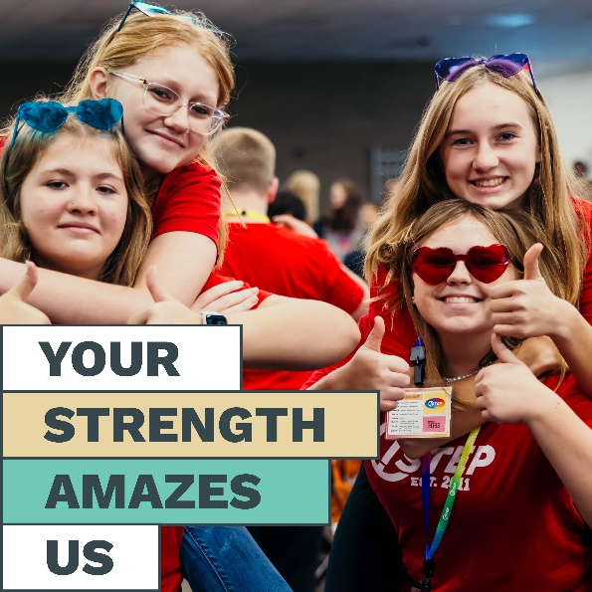 | Peer pressure is a big reason why students try vaping in the first place. If someone pressures you, remember that you’re strong and tell them no thanks. Follow us for vape free inspo! @IowaSTEP #ISTEP #IowaSTEP #NoTobacco #TobaccoFreeGeneration #StudentLeaders #TobaccoFree #VapeFree #StopVaping #HealthyLungs #KnowTheFacts #YouthToday #StudentSupport #TeensSupportTeens
August 29
August 30 | Saturday
August 31 | Sunday

