MASTER FY26 ISTEP Social Schedule
Purpose: Below are ISTEP graphics and caption ideas for your social media accounts. These are only ideas, with the goal to make social posts easier on you. The dates listed are when the ISTEP Facebook/Instagram will be posting these specific items, however you can post them whenever you like.

Instructions: Tag @IowaSTEP in all of your posts. Download the graphics from the monthly folders, then copy and paste the caption from this document.

Recommended hashtags: @IowaSTEP #ISTEP #IowaSTEP #NoTobacco #TobaccoFreeGeneration #StudentLeaders #TobaccoFree #VapeFree #StopVaping #HealthyLungs #KnowTheFacts #YouthToday #StudentSupport #TeensSupportTeens
Date | Graphic | Caption
October 2025
October 1 | 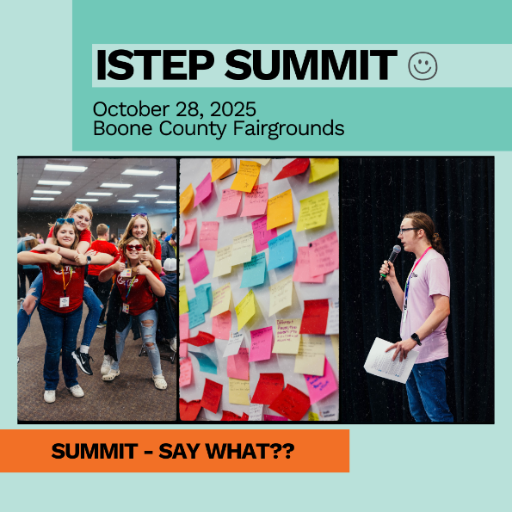 | Each year young Iowans in grades 7-12 come together to expand leadership skills and discover new ways to positively impact peers. The entire Summit is created and led by the youth ISTEP Council, a leadership group of high schoolers across Iowa. Register today at: hhs.iowa.gov/istep  @IowaSTEP #ISTEP #IowaSTEP #NoTobacco #TobaccoFreeGeneration #StudentLeaders #TobaccoFree #VapeFree #StopVaping #HealthyLungs #KnowTheFacts #YouthToday #StudentSupport
October 2 | Video: ISTEP Promo 2022 | We want to see YOU at the Summit this year! Register today at: hhs.iowa.gov/istep  @IowaSTEP #ISTEP #IowaSTEP #NoTobacco #TobaccoFreeGeneration #StudentLeaders #TobaccoFree #VapeFree #StopVaping #HealthyLungs #KnowTheFacts #YouthToday #StudentSupport
October 3
October 4 | Saturday
October 5 | Sunday
October 6 | 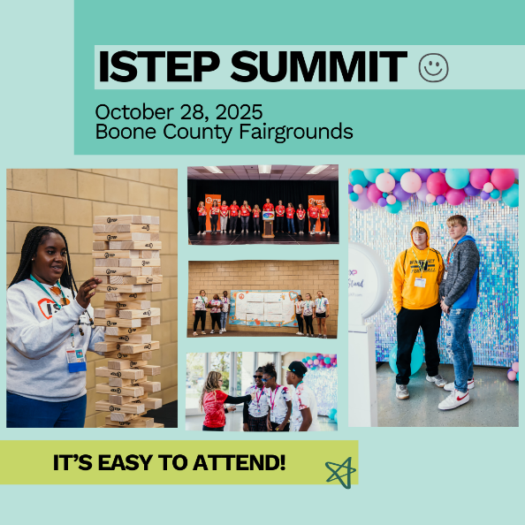 | It’s easy to attend the Summit!  - Gather a group of friends who want to come or come by yourself and make new friends! Be sure to get permission from school and parents.  - Complete the required youth paperwork.  - Register online and upload your paperwork.  Register today at: hhs.iowa.gov/istep  @IowaSTEP #ISTEP #IowaSTEP #NoTobacco #TobaccoFreeGeneration #StudentLeaders #TobaccoFree #VapeFree #StopVaping #HealthyLungs #KnowTheFacts #YouthToday #StudentSupport
October 7
October 8 | 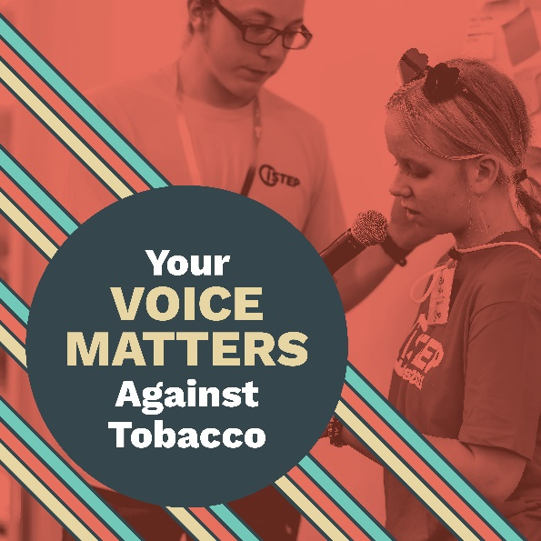 | You may feel small when it comes to standing up against tobacco alone but when you’re a part of @IowaSTEP you’re one of many. Together our voices are strong! Join us today at hhs.iowa.gov/istep.  #ISTEP #IowaSTEP #NoTobacco #TobaccoFreeGeneration #StudentLeaders #TobaccoFree #VapeFree #StopVaping #HealthyLungs #KnowTheFacts #YouthToday #StudentSupport
October 9 | 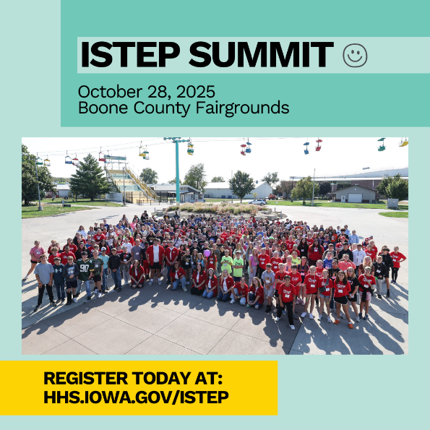 | What makes the Summit so special? It’s planned by teens for teens. Register today at: hhs.iowa.gov/istep  @IowaSTEP #ISTEP #IowaSTEP #NoTobacco #TobaccoFreeGeneration #StudentLeaders #TobaccoFree #VapeFree #StopVaping #HealthyLungs #KnowTheFacts #YouthToday #StudentSupport
October 10
October 11 | Saturday
October 12 | Sunday
October 13 | 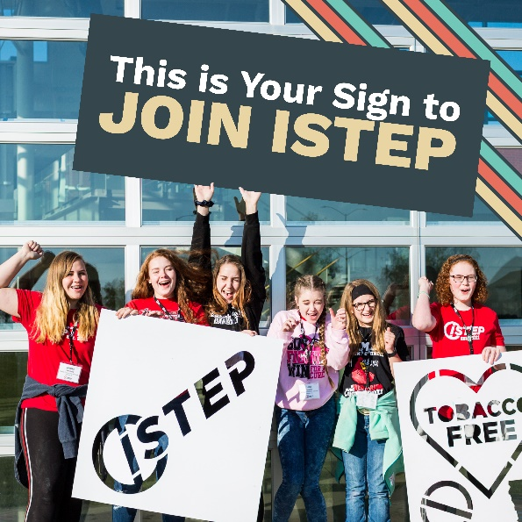 | Here’s your sign, friends! Join us today at hhs.iowa.gov/istep.  @IowaSTEP #ISTEP #IowaSTEP #NoTobacco #TobaccoFreeGeneration #StudentLeaders #TobaccoFree #VapeFree #StopVaping #HealthyLungs #KnowTheFacts #YouthToday #StudentSupport
October 14 | 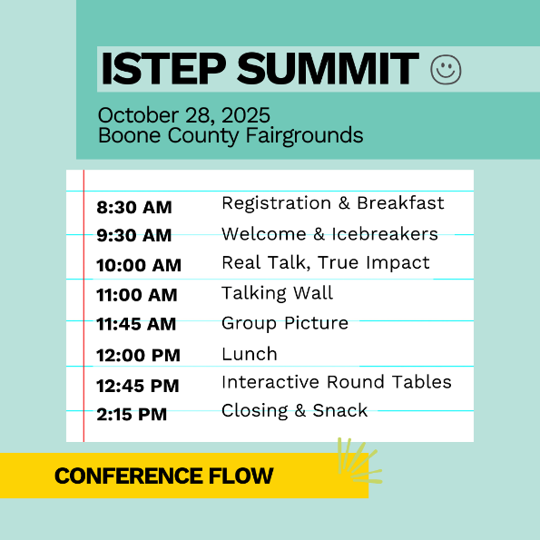 | This year’s Summit will be held at the Boone County Fairgrounds on Tuesday, October 28th from 9:30am-2:30pm with registration beginning at 8:30am. Keynote speakers will be National Youth Ambassador and ISTEP Council Alumni Courtney Sweet and ISTEP Coordinator Jill Wright. Register today at: hhs.iowa.gov/istep  @IowaSTEP #ISTEP #IowaSTEP #NoTobacco #TobaccoFreeGeneration #StudentLeaders #TobaccoFree #VapeFree #StopVaping #HealthyLungs #KnowTheFacts #YouthToday #StudentSupport
October 15
October 16

October 17 |  | Come see us in person at the Summit on October 28th in Boone – you’re guaranteed to make friends and make a difference! Learn more at hhs.iowa.gov/istep.  @IowaSTEP #ISTEP #IowaSTEP #NoTobacco #TobaccoFreeGeneration #StudentLeaders #TobaccoFree #VapeFree #StopVaping #HealthyLungs #KnowTheFacts #YouthToday #StudentSupport
October 18 | Saturday
October 19 | Sunday
October 20
October 21 | 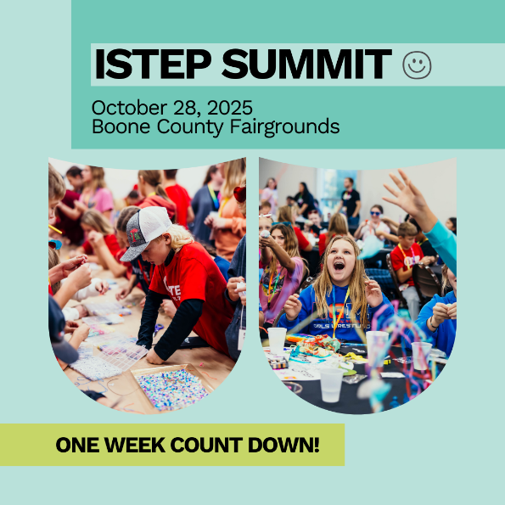 | The one-week countdown is on! We can’t wait to see you next Tuesday at the Summit in Boone. Learn more at hhs.iowa.gov/istep.  @IowaSTEP #ISTEP #IowaSTEP #NoTobacco #TobaccoFreeGeneration #StudentLeaders #TobaccoFree #VapeFree #StopVaping #HealthyLungs #KnowTheFacts #YouthToday #StudentSupport
October 22
October 23 | 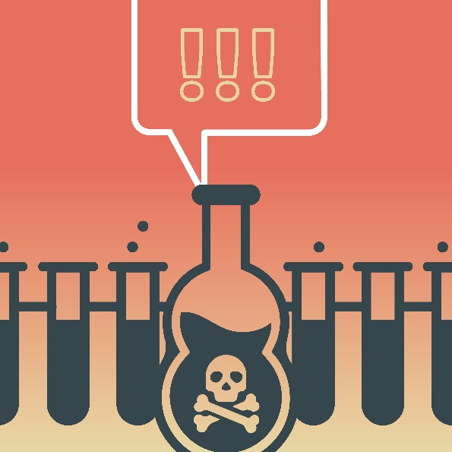 | Cherry, grape, bubblegum - whatever the flavor, vape e-liquid is made of harmful chemicals, including nicotine. Learn the toxic truth at hhs.iowa.gov/istep.  @IowaSTEP #ISTEP #IowaSTEP #NoTobacco #TobaccoFreeGeneration #StudentLeaders #TobaccoFree #VapeFree #StopVaping #HealthyLungs #KnowTheFacts #YouthToday #StudentSupport
October 24
October 25 | Saturday
October 26 | Sunday
October 27 | 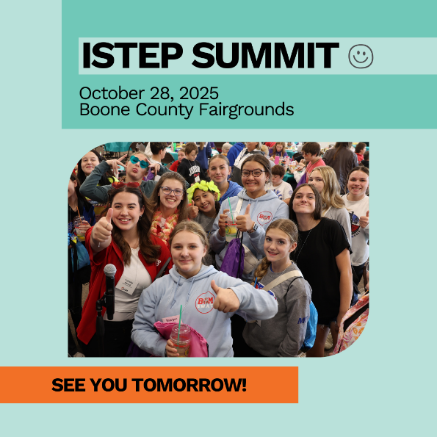 | Tomorrow is Summit Day! Be prepared to have fun, learn new skills and make friends from across the state. @IowaSTEP #ISTEP #IowaSTEP #NoTobacco #TobaccoFreeGeneration #StudentLeaders #TobaccoFree #VapeFree #StopVaping #HealthyLungs #KnowTheFacts #YouthToday #StudentSupport
October 28
October 29
October 30 | 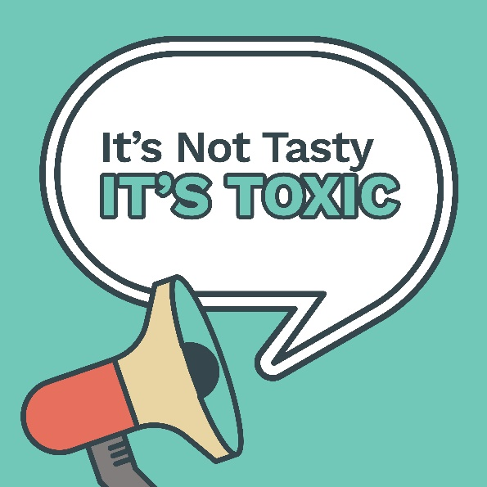 | The truth can be hard to find when there are so many lies told by vape companies, but here’s the hard cold facts...vaping isn’t tasty! It’s toxic! Learn more at hhs.iowa.gov/istep.  @IowaSTEP #ISTEP #IowaSTEP #NoTobacco #TobaccoFreeGeneration #StudentLeaders #TobaccoFree #VapeFree #StopVaping #HealthyLungs #KnowTheFacts #YouthToday #StudentSupport
October 31

