MASTER FY26 ISTEP Social Schedule
Purpose: Below are ISTEP graphics and caption ideas for your social media accounts. These are only ideas, with the goal to make social posts easier on you. The dates listed are when the ISTEP Facebook/Instagram will be posting these specific items, however you can post them whenever you like.

Instructions: Tag @IowaSTEP in all of your posts. Download the graphics from the monthly folders, then copy and paste the caption from this document.

Recommended hashtags: @IowaSTEP #ISTEP #IowaSTEP #NoTobacco #TobaccoFreeGeneration #StudentLeaders #TobaccoFree #VapeFree #StopVaping #HealthyLungs #KnowTheFacts #YouthToday #StudentSupport #TeensSupportTeens
Date | Graphic | Caption
November 2025
November 1 | Saturday
November 2 | Sunday
November 3 |  | We step up for ourselves, friends and family to have a healthy future. Join us today in making a difference! Learn more at hhs.iowa.gov/istep. @IowaSTEP #ISTEP #IowaSTEP #NoTobacco #TobaccoFreeGeneration #StudentLeaders #TobaccoFree #VapeFree #StopVaping #HealthyLungs #KnowTheFacts #YouthToday #StudentSupport #TeensSupportTeens
November 4 | 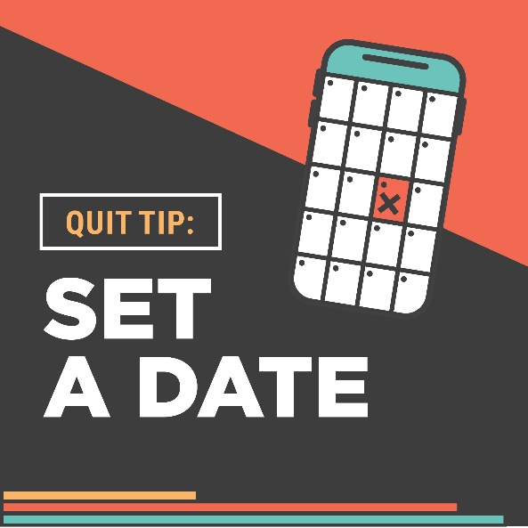 | It’s #QuitTip Tuesday! Pick a date to stop vaping, chewing or using other tobacco products — tell a friend and mark your calendar. For support on your journey to being nicotine-free, text “Start My Quit” to 36072. @IowaSTEP #ISTEP #IowaSTEP #NoTobacco #TobaccoFreeGeneration #StudentLeaders #TobaccoFree #VapeFree #StopVaping #HealthyLungs #KnowTheFacts #YouthToday #StudentSupport #TeensSupportTeens
November 5 | 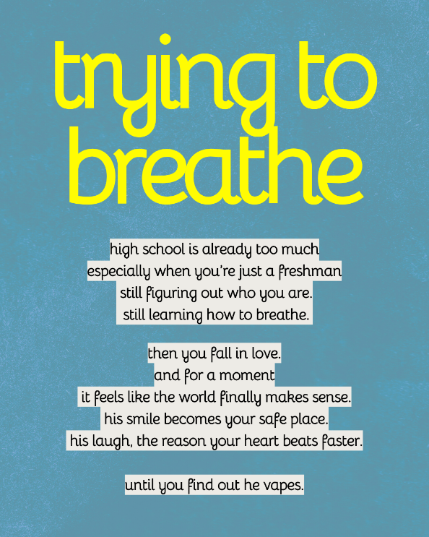  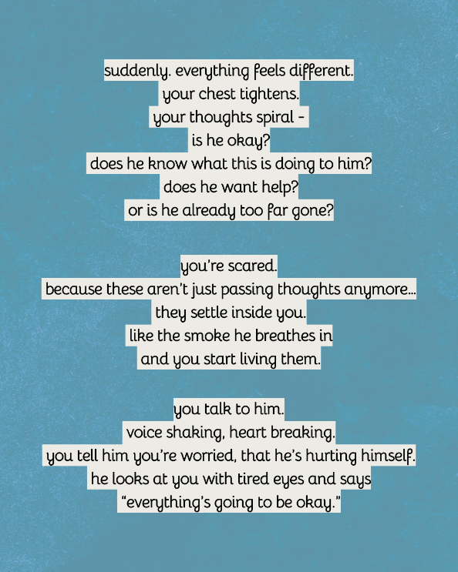  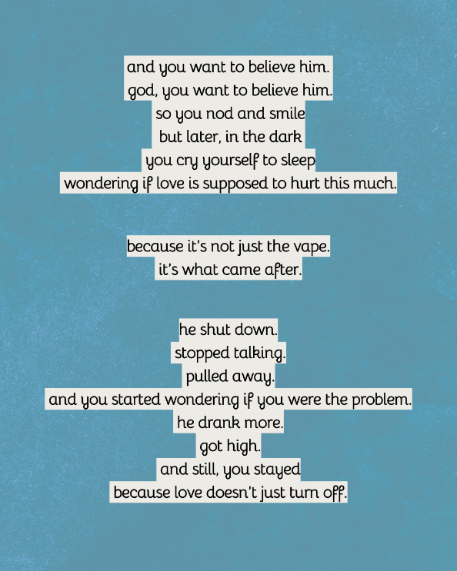  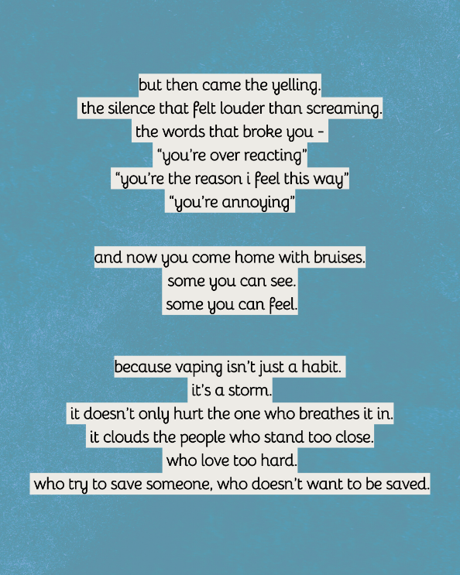  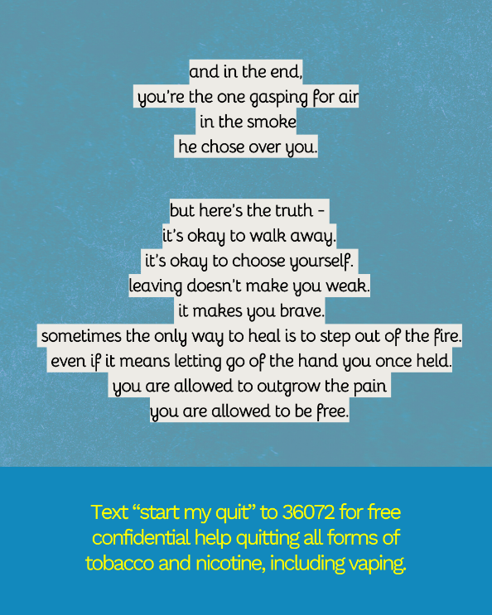 | When you don’t know who to turn to, Your Life Iowa is here for you 24/7. Whether its alcohol, drugs, gambling, mental health, suicidal thoughts, or something else. No judgement. Just help. Call (855)581-8111, text (855)895-8398 or live chat (yourlifeiowa.org). @IowaSTEP #ISTEP #IowaSTEP #NoTobacco #TobaccoFreeGeneration #StudentLeaders #TobaccoFree #VapeFree #StopVaping #HealthyLungs #KnowTheFacts #YouthToday #StudentSupport #TeensSupportTeens
November 6 | 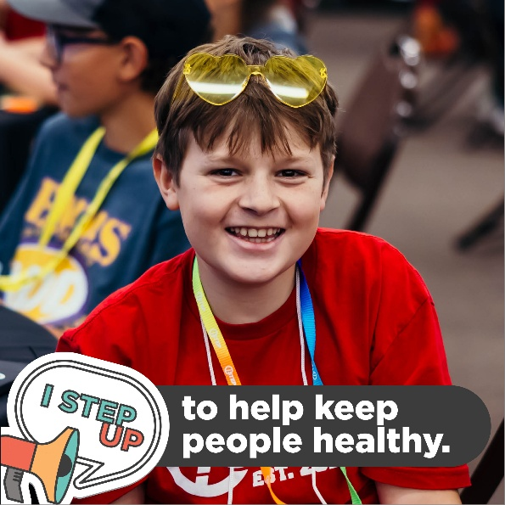 | We all know vaping, chewing and using other tobacco products are bad for our health. So if we can stop just one person from using, then we’re a success.  (Spoiler alert: We’re actually helping thousands!) @IowaSTEP #ISTEP #IowaSTEP #NoTobacco #TobaccoFreeGeneration #StudentLeaders #TobaccoFree #VapeFree #StopVaping #HealthyLungs #KnowTheFacts #YouthToday #StudentSupport #TeensSupportTeens
November 7
November 8 | Saturday
November 9 | Sunday
November 10
November 11 | 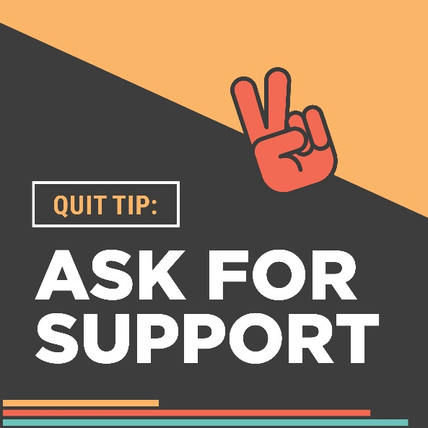 | It’s #QuitTip Tuesday! When you’re ready to quit, remember you’re not alone. Ask your friends and family to support your journey by staying vape and tobacco free with you. Text “Start My Quit” to 36072 for even more help staying on track. @IowaSTEP #ISTEP #IowaSTEP #NoTobacco #TobaccoFreeGeneration #StudentLeaders #TobaccoFree #VapeFree #StopVaping #HealthyLungs #KnowTheFacts #YouthToday #StudentSupport #TeensSupportTeens
November 12 |  | ISTEP members have seen the devastating effects vaping and other tobacco products have had on their friends and family. That’s just one reason why they’re stepping up. Will you join us? @IowaSTEP #ISTEP #IowaSTEP #NoTobacco #TobaccoFreeGeneration #StudentLeaders #TobaccoFree #VapeFree #StopVaping #HealthyLungs #KnowTheFacts #YouthToday #StudentSupport #TeensSupportTeens
November 13 |  | #ISTEP students tend to have a few things in common — including the drive to make our world better. If this sounds like you, join us in positively influencing our peers! Find a chapter at hhs.iowa.gov/istep. @IowaSTEP #ISTEP #IowaSTEP #NoTobacco #TobaccoFreeGeneration #StudentLeaders #TobaccoFree #VapeFree #StopVaping #HealthyLungs #KnowTheFacts #YouthToday #StudentSupport #TeensSupportTeens
November 14
November 15 | Saturday
November 16 | Sunday
November 17
November 18 | 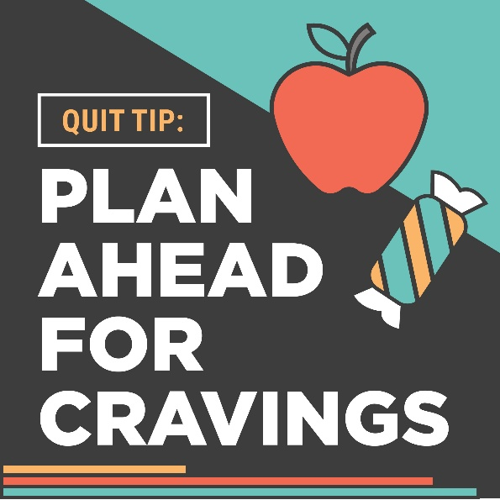 | It’s #QuitTip Tuesday! Make it through the cravings that can come with quitting. Have gum, hard candy and crunchy (healthy) food on hand. For free, confidential help, text “Start My Quit” to 36072. @IowaSTEP #ISTEP #IowaSTEP #NoTobacco #TobaccoFreeGeneration #StudentLeaders #TobaccoFree #VapeFree #StopVaping #HealthyLungs #KnowTheFacts #YouthToday #StudentSupport #TeensSupportTeens
November 19
November 20 | 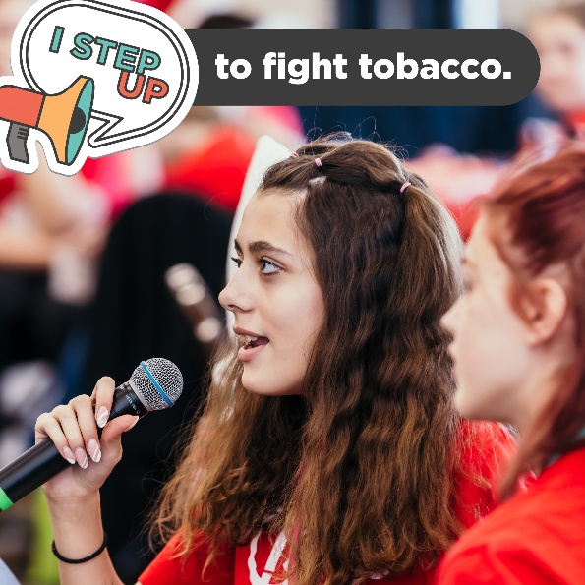 | Big tobacco still targets youth. That’s why we need you to step up with us — because our work is far from done. Join the movement at hhs.iowa.gov/istep. @IowaSTEP #ISTEP #IowaSTEP #NoTobacco #TobaccoFreeGeneration #StudentLeaders #TobaccoFree #VapeFree #StopVaping #HealthyLungs #KnowTheFacts #YouthToday #StudentSupport #TeensSupportTeens
November 21
November 22 | Saturday
November 23 | Sunday
November 24
November 25 | 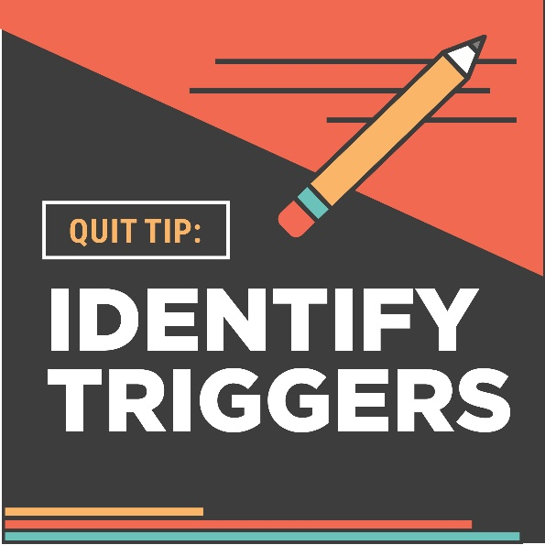 | It’s #QuitTip Tuesday! Start a craving journal to learn triggers to avoid. When you have a craving, write:  The time.  What you were doing.  How you were feeling.  The intensity of your craving (1-10).  For more help, text “Start My Quit” to 36072.  @IowaSTEP #ISTEP #IowaSTEP #NoTobacco #TobaccoFreeGeneration #StudentLeaders #TobaccoFree #VapeFree #StopVaping #HealthyLungs #KnowTheFacts #YouthToday #StudentSupport #TeensSupportTeens
November 26
November 27 |  | Why do Iowa students step up against tobacco? To make a difference in their school, community and world! Join the movement at hhs.iowa.gov/istep. @IowaSTEP #ISTEP #IowaSTEP #NoTobacco #TobaccoFreeGeneration #StudentLeaders #TobaccoFree #VapeFree #StopVaping #HealthyLungs #KnowTheFacts #YouthToday #StudentSupport #TeensSupportTeens
November 28 | 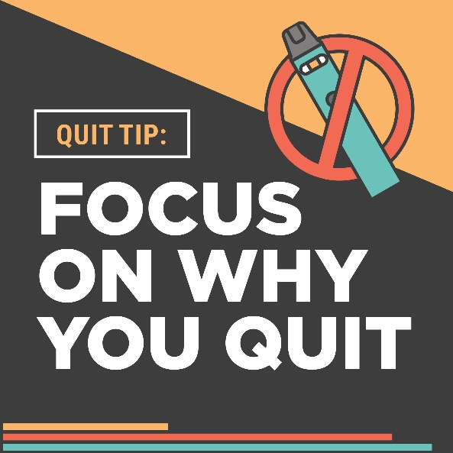 | It’s #QuitTip Tuesday! Before you stop vaping or using other tobacco products – or if you feel tempted to start again – remember your reasons for quitting, like better health, self-esteem and relationships. For free, confidential help, text “Start My Quit” to 36072. @IowaSTEP #ISTEP #IowaSTEP #NoTobacco #TobaccoFreeGeneration #StudentLeaders #TobaccoFree #VapeFree #StopVaping #HealthyLungs #KnowTheFacts #YouthToday #StudentSupport #TeensSupportTeens
November 29 | Saturday
November 30 | Sunday

