MASTER FY26 ISTEP Social Schedule
Purpose: Below are ISTEP graphics and caption ideas for your social media accounts. These are only ideas, with the goal to make social posts easier on you. The dates listed are when the ISTEP Facebook/Instagram will be posting these specific items, however you can post them whenever you like.

Instructions: Tag @IowaSTEP in all of your posts. Download the graphics from the monthly folders, then copy and paste the caption from this document.

Recommended hashtags: @IowaSTEP #ISTEP #IowaSTEP #NoTobacco #TobaccoFreeGeneration #StudentLeaders #TobaccoFree #VapeFree #StopVaping #HealthyLungs #KnowTheFacts #YouthToday #StudentSupport #TeensSupportTeens
Date | Graphic | Caption
September 2025
September 1
September 2 | 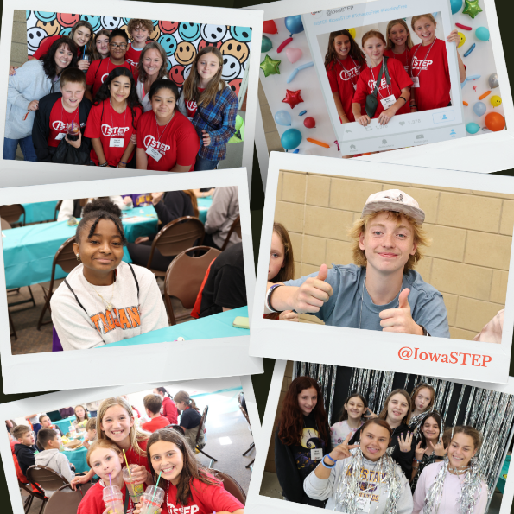 | #ISTEP gives you the power to use your voice with purpose. Iowa Students for Tobacco Education and Prevention equips you with the tools and skills for you to make a difference in your local communities, state and entire 🌎. Join us at: hhs.iowa.gov/istep  @IowaSTEP #IowaSTEP #NoTobacco #TobaccoFreeGeneration #StudentLeaders #TobaccoFree #VapeFree #StopVaping #HealthyLungs #KnowTheFacts #YouthToday #StudentSupport #TeensSupportTeens
September 3
September 4 |  | Have fun, make new friends and step up to make a difference where you live. Learn more about #ISTEP in your community at IowaSTEP.org. @IowaSTEP #IowaSTEP #NoTobacco #TobaccoFreeGeneration #StudentLeaders #TobaccoFree #VapeFree #StopVaping #HealthyLungs #KnowTheFacts #YouthToday #StudentSupport #TeensSupportTeens
September 5
September 6 | Saturday
September 7 | Sunday
September 8 | 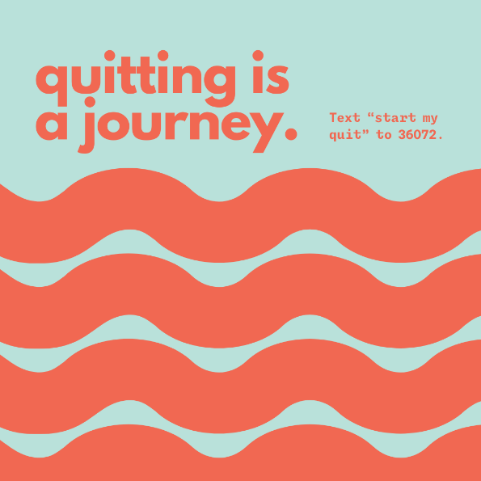 | Quitting vaping is a journey. Don’t do it alone – text “start my quit” to 36072 for free confidential help.  @IowaSTEP #ISTEP #IowaSTEP #NoTobacco #TobaccoFreeGeneration #StudentLeaders #TobaccoFree #VapeFree #StopVaping #HealthyLungs #KnowTheFacts #YouthToday #StudentSupport #TeensSupportTeens
September 9
September 10 | 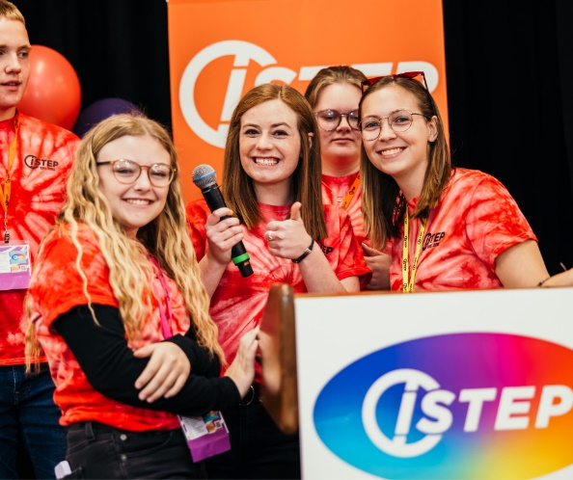 | It’s plain and simple. Youth are the ones who bring about change but are still the ones being targeted when it comes to tobacco. #ISTEP won’t stand by while our friends, peers and family are targeted. We’re doing something about it. We’re getting involved for the overall good of our communities and state. Join the movement at hhs.iowa.gov/istep. @IowaSTEP #IowaSTEP #NoTobacco #TobaccoFreeGeneration #StudentLeaders #TobaccoFree #VapeFree #StopVaping #HealthyLungs #KnowTheFacts #YouthToday #StudentSupport #TeensSupportTeens
September 11
September 12
September 13 | Saturday
September 14 | Sunday
September 15 | 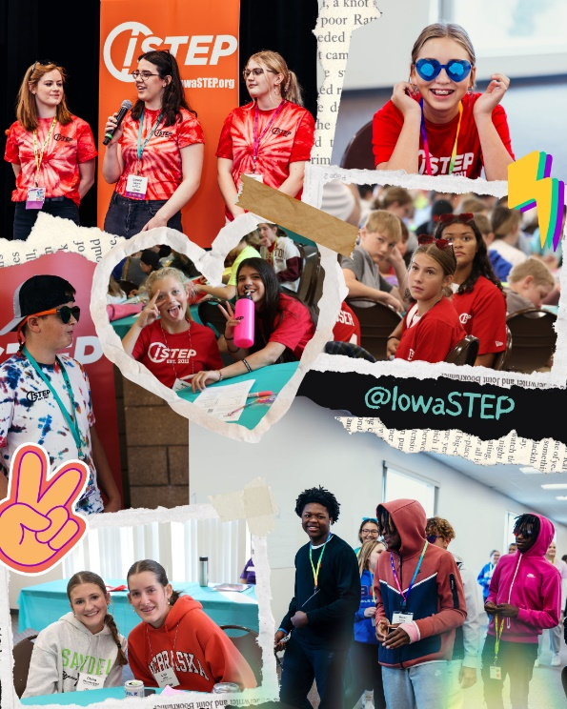 | What we love most about being in #ISTEP is the people who we get to make a difference with. Join @IowaSTEP today and you might just find your new bestie!  #IowaSTEP #NoTobacco #TobaccoFreeGeneration #StudentLeaders #TobaccoFree #VapeFree #StopVaping #HealthyLungs #KnowTheFacts #YouthToday #StudentSupport #TeensSupportTeens
September 16

September 17
September 18 |  | Did you know #ISTEP has a youth Council that leads the program statewide? This is what truly keeps the #IowaSTEP program youth-led. To learn more, visit hhs.iowa.gov/istep.  @IowaSTEP #NoTobacco #TobaccoFreeGeneration #StudentLeaders #TobaccoFree #VapeFree #StopVaping #HealthyLungs #KnowTheFacts #YouthToday #StudentSupport #TeensSupportTeens
September 19 | Video: Summit Experience | #ISTEP is way more than standing up for making healthy choices. It’s about making friends and finding a place where you truly belong. To learn more, visit hhs.iowa.gov/istep. @IowaSTEP #IowaSTEP #NoTobacco #TobaccoFreeGeneration #StudentLeaders #TobaccoFree #VapeFree #StopVaping #HealthyLungs #KnowTheFacts #YouthToday #StudentSupport #TeensSupportTeens
September 20 | Saturday
September 21 | Sunday
September 22
September 23 | 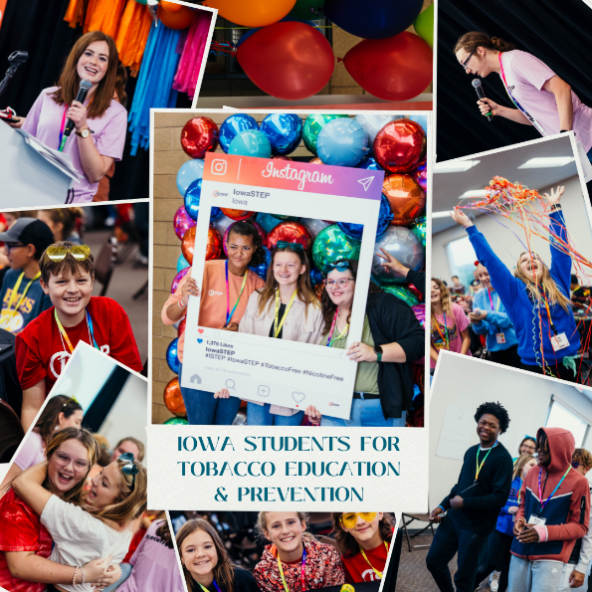 | @IowaSTEP is made up of amazing young Iowans in grades 7-12 who step up to make a difference in their local communities and state. #ISTEP members talk to their peers about living a healthy life and that includes being vape free. To learn more, visit hhs.iowa.gov/istep. #IowaSTEP #NoTobacco #TobaccoFreeGeneration #StudentLeaders #TobaccoFree #VapeFree #StopVaping #HealthyLungs #KnowTheFacts #YouthToday #StudentSupport #TeensSupportTeens
September 24
September 25 |  | #ISTEP supports one another to bloom and grow into the best version of ourselves! We make friends, make a difference and become leaders!  @IowaSTEP #IowaSTEP #NoTobacco #TobaccoFreeGeneration #StudentLeaders #TobaccoFree #VapeFree #StopVaping #HealthyLungs #KnowTheFacts #YouthToday #StudentSupport #TeensSupportTeens
September 26
September 27 | Saturday
September 28 | Sunday
September 29 | 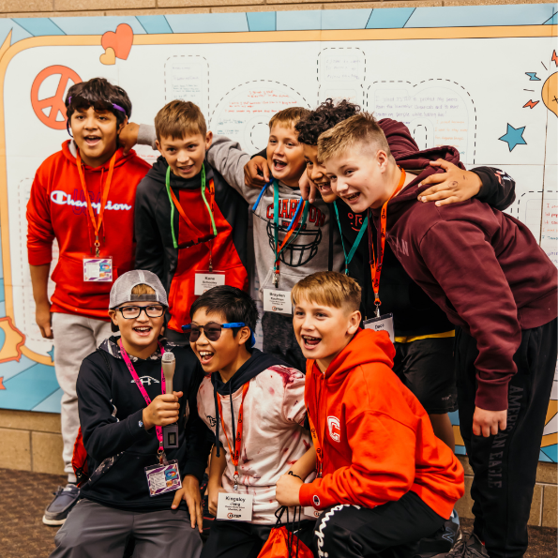 | Why do Iowa students step up against tobacco? To make a difference in their school, community and world! Join the movement at hhs.iowa.gov/istep. @IowaSTEP #ISTEP #IowaSTEP #NoTobacco #TobaccoFreeGeneration #StudentLeaders #TobaccoFree #VapeFree #StopVaping #HealthyLungs #KnowTheFacts #YouthToday #StudentSupport #TeensSupportTeens
September 30

