MASTER FY26 ISTEP Social Schedule
Purpose: Below are ISTEP graphics and caption ideas for your social media accounts. These are only ideas, with the goal to make social posts easier on you. The dates listed are when the ISTEP Facebook/Instagram will be posting these specific items, however you can post them whenever you like.

Instructions: Tag @IowaSTEP in all of your posts. Download the graphics from the monthly folders, then copy and paste the caption from this document.

Recommended hashtags: @IowaSTEP #ISTEP #IowaSTEP #NoTobacco #TobaccoFreeGeneration #StudentLeaders #TobaccoFree #VapeFree #StopVaping #HealthyLungs #KnowTheFacts #YouthToday #StudentSupport #YouthVoice #TeensSupportTeens
Date | Graphic | Caption
December 2025
December 1 | 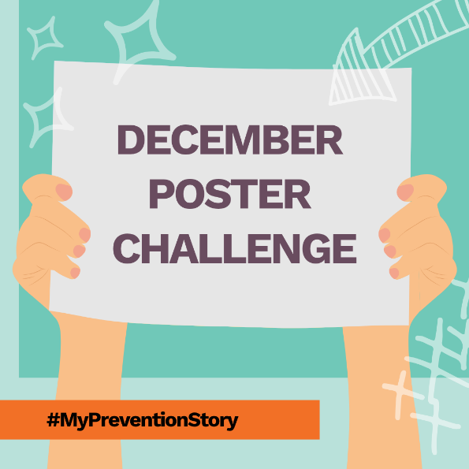 | We’re celebrating all month long! 🎉 We’re sharing our favorite #MyPreventionStory artwork from the #Summit all December long — can you find yours?! 👀  Like your favorite at the end of the month to help turn it into a poster! 🏆  @IowaSTEP #ISTEP #IowaSTEP #NoTobacco #TobaccoFreeGeneration #StudentLeaders #TobaccoFree #VapeFree #StopVaping #HealthyLungs #KnowTheFacts #YouthToday #StudentSupport #TeensSupportTeens #YouthVoice #MentalHealth #MentalHealthMatters #MentalHealthMattersEveryDay #MentalHealthAwareness
December 2 | 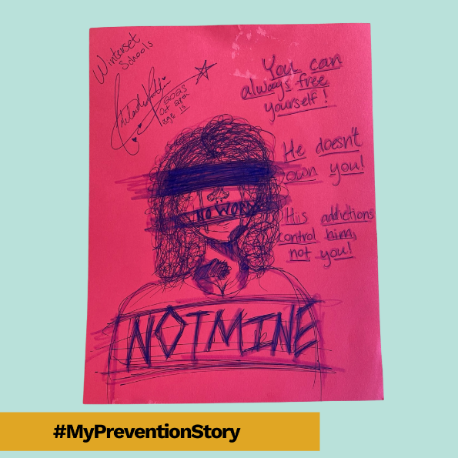 | Vote for your favorite #MyPreventionStory artwork at the end of the month by liking the post — the top one will be turned into a poster! 🏆  @IowaSTEP #ISTEP #IowaSTEP #NoTobacco #TobaccoFreeGeneration #StudentLeaders #TobaccoFree #VapeFree #StopVaping #HealthyLungs #KnowTheFacts #YouthToday #StudentSupport #TeensSupportTeens #YouthVoice #MentalHealth #MentalHealthMatters #MentalHealthMattersEveryDay #MentalHealthAwareness
December 3
December 4 | 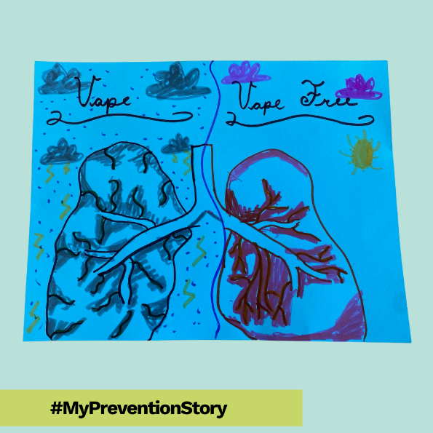 | Vote for your favorite #MyPreventionStory artwork at the end of the month by liking the post — the top one will be turned into a poster! 🏆  @IowaSTEP #ISTEP #IowaSTEP #NoTobacco #TobaccoFreeGeneration #StudentLeaders #TobaccoFree #VapeFree #StopVaping #HealthyLungs #KnowTheFacts #YouthToday #StudentSupport #TeensSupportTeens #YouthVoice #MentalHealth #MentalHealthMatters #MentalHealthMattersEveryDay #MentalHealthAwareness
December 5
December 6 | Saturday
December 7 | Sunday
December 8 | 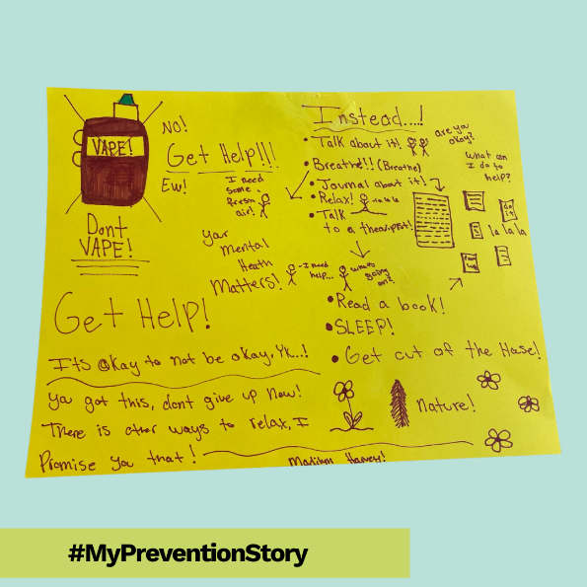 | Vote for your favorite #MyPreventionStory artwork at the end of the month by liking the post — the top one will be turned into a poster! 🏆  @IowaSTEP #ISTEP #IowaSTEP #NoTobacco #TobaccoFreeGeneration #StudentLeaders #TobaccoFree #VapeFree #StopVaping #HealthyLungs #KnowTheFacts #YouthToday #StudentSupport #TeensSupportTeens #YouthVoice #MentalHealth #MentalHealthMatters #MentalHealthMattersEveryDay #MentalHealthAwareness
December 9 | 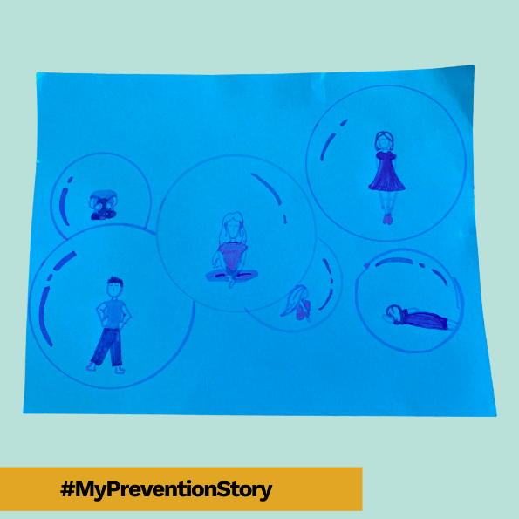 | Vote for your favorite #MyPreventionStory artwork at the end of the month by liking the post — the top one will be turned into a poster! 🏆  @IowaSTEP #ISTEP #IowaSTEP #NoTobacco #TobaccoFreeGeneration #StudentLeaders #TobaccoFree #VapeFree #StopVaping #HealthyLungs #KnowTheFacts #YouthToday #StudentSupport #TeensSupportTeens #YouthVoice #MentalHealth #MentalHealthMatters #MentalHealthMattersEveryDay #MentalHealthAwareness
December 10
December 11
December 12 | 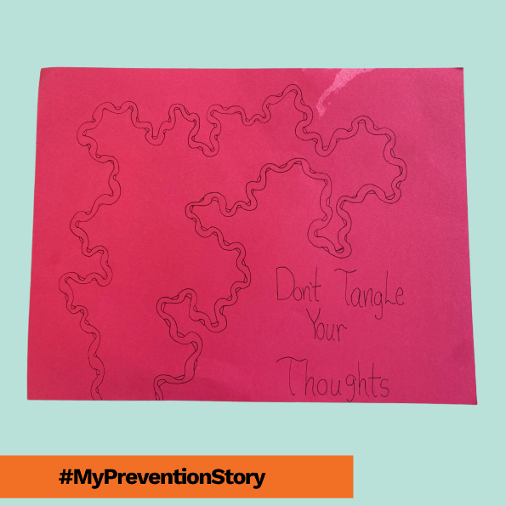 | Vote for your favorite #MyPreventionStory artwork at the end of the month by liking the post — the top one will be turned into a poster! 🏆  @IowaSTEP #ISTEP #IowaSTEP #NoTobacco #TobaccoFreeGeneration #StudentLeaders #TobaccoFree #VapeFree #StopVaping #HealthyLungs #KnowTheFacts #YouthToday #StudentSupport #TeensSupportTeens #YouthVoice #MentalHealth #MentalHealthMatters #MentalHealthMattersEveryDay #MentalHealthAwareness
December 13 | Saturday
December 14 | Sunday
December 15 | 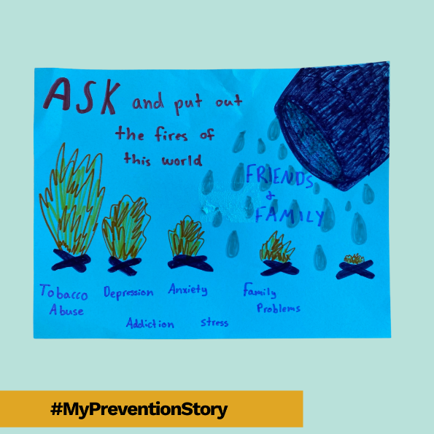 | Vote for your favorite #MyPreventionStory artwork at the end of the month by liking the post — the top one will be turned into a poster! 🏆  @IowaSTEP #ISTEP #IowaSTEP #NoTobacco #TobaccoFreeGeneration #StudentLeaders #TobaccoFree #VapeFree #StopVaping #HealthyLungs #KnowTheFacts #YouthToday #StudentSupport #TeensSupportTeens #YouthVoice #MentalHealth #MentalHealthMatters #MentalHealthMattersEveryDay #MentalHealthAwareness
December 16 | 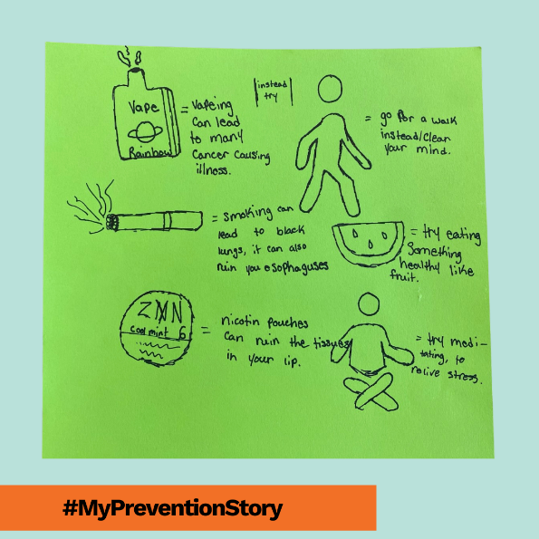 | Vote for your favorite #MyPreventionStory artwork at the end of the month by liking the post — the top one will be turned into a poster! 🏆  @IowaSTEP #ISTEP #IowaSTEP #NoTobacco #TobaccoFreeGeneration #StudentLeaders #TobaccoFree #VapeFree #StopVaping #HealthyLungs #KnowTheFacts #YouthToday #StudentSupport #TeensSupportTeens #YouthVoice #MentalHealth #MentalHealthMatters #MentalHealthMattersEveryDay #MentalHealthAwareness
December 17
December 18 | 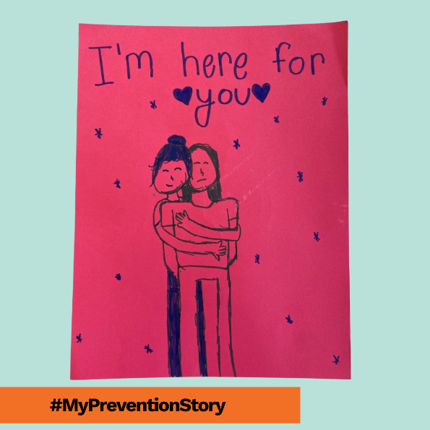 | Vote for your favorite #MyPreventionStory artwork at the end of the month by liking the post — the top one will be turned into a poster! 🏆  @IowaSTEP #ISTEP #IowaSTEP #NoTobacco #TobaccoFreeGeneration #StudentLeaders #TobaccoFree #VapeFree #StopVaping #HealthyLungs #KnowTheFacts #YouthToday #StudentSupport #TeensSupportTeens #YouthVoice #MentalHealth #MentalHealthMatters #MentalHealthMattersEveryDay #MentalHealthAwareness
December 19 | 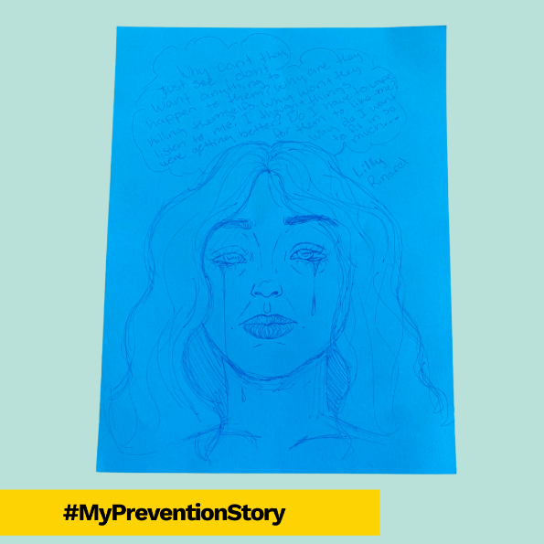 | Vote for your favorite #MyPreventionStory artwork at the end of the month by liking the post — the top one will be turned into a poster! 🏆  @IowaSTEP #ISTEP #IowaSTEP #NoTobacco #TobaccoFreeGeneration #StudentLeaders #TobaccoFree #VapeFree #StopVaping #HealthyLungs #KnowTheFacts #YouthToday #StudentSupport #TeensSupportTeens #YouthVoice #MentalHealth #MentalHealthMatters #MentalHealthMattersEveryDay #MentalHealthAwareness
December 20 | Saturday
December 21 | Sunday
December 22 | 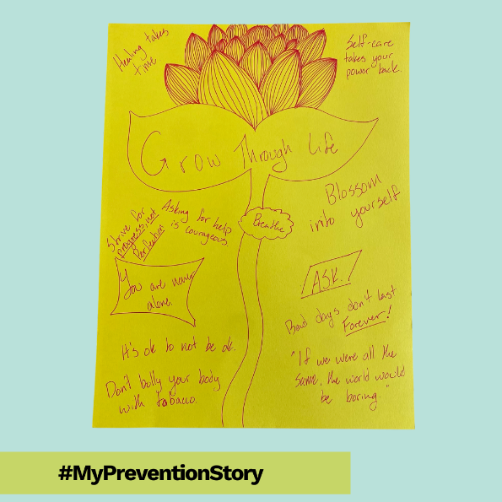 | Vote for your favorite #MyPreventionStory artwork at the end of the month by liking the post — the top one will be turned into a poster! 🏆  @IowaSTEP #ISTEP #IowaSTEP #NoTobacco #TobaccoFreeGeneration #StudentLeaders #TobaccoFree #VapeFree #StopVaping #HealthyLungs #KnowTheFacts #YouthToday #StudentSupport #TeensSupportTeens #YouthVoice #MentalHealth #MentalHealthMatters #MentalHealthMattersEveryDay #MentalHealthAwareness
December 23
December 24 | 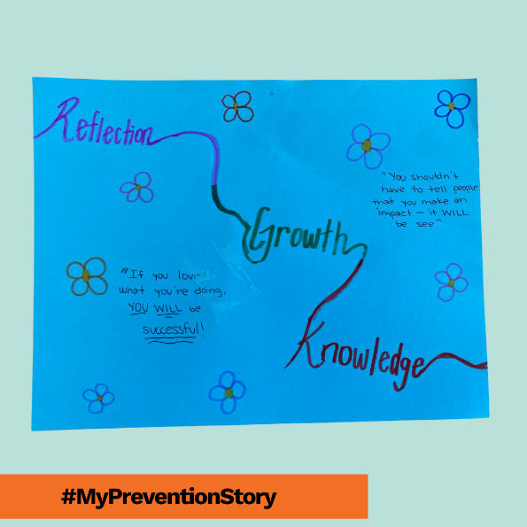 | Vote for your favorite #MyPreventionStory artwork at the end of the month by liking the post — the top one will be turned into a poster! 🏆  @IowaSTEP #ISTEP #IowaSTEP #NoTobacco #TobaccoFreeGeneration #StudentLeaders #TobaccoFree #VapeFree #StopVaping #HealthyLungs #KnowTheFacts #YouthToday #StudentSupport #TeensSupportTeens #YouthVoice #MentalHealth #MentalHealthMatters #MentalHealthMattersEveryDay #MentalHealthAwareness
December 25
December 26
December 27 | Saturday
December 28 | Sunday
December 29 | 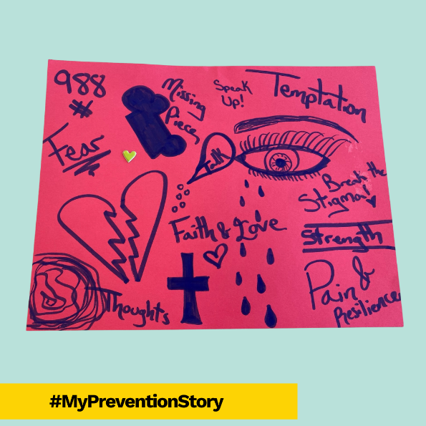 | Vote for your favorite #MyPreventionStory artwork at the end of the month by liking the post — the top one will be turned into a poster! 🏆  @IowaSTEP #ISTEP #IowaSTEP #NoTobacco #TobaccoFreeGeneration #StudentLeaders #TobaccoFree #VapeFree #StopVaping #HealthyLungs #KnowTheFacts #YouthToday #StudentSupport #TeensSupportTeens #YouthVoice #MentalHealth #MentalHealthMatters #MentalHealthMattersEveryDay #MentalHealthAwareness
December 30 | 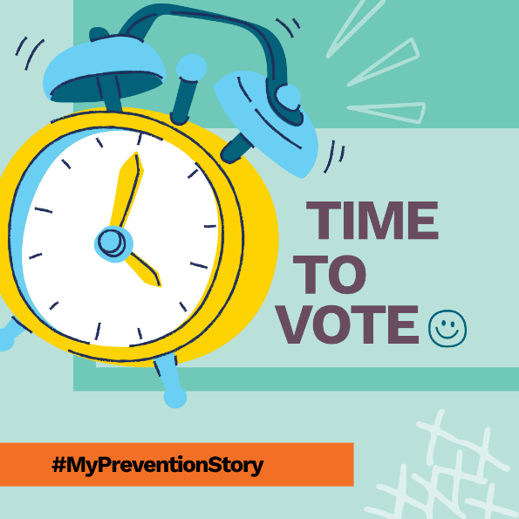 | You’ve seen our favorites — now it’s your turn to decide! 🏆Vote for your favorite #MyPreventionStory artwork from the #Summit by hitting “like.” The top pick becomes our next poster! 💥  @IowaSTEP #ISTEP #IowaSTEP #NoTobacco #TobaccoFreeGeneration #StudentLeaders #TobaccoFree #VapeFree #StopVaping #HealthyLungs #KnowTheFacts #YouthToday #StudentSupport #TeensSupportTeens #YouthVoice #MentalHealth #MentalHealthMatters #MentalHealthMattersEveryDay #MentalHealthAwareness
December 31

