MASTER FY26 ISTEP Social Schedule
Purpose: Below are ISTEP graphics and caption ideas for your social media accounts. These are only ideas, with the goal to make social posts easier on you. The dates listed are when the ISTEP Facebook/Instagram will be posting these specific items, however you can post them whenever you like.

Instructions: Tag @IowaSTEP in all of your posts. Download the graphics from the monthly folders, then copy and paste the caption from this document.

Recommended hashtags: @IowaSTEP #ISTEP #IowaSTEP #NoTobacco #TobaccoFreeGeneration #StudentLeaders #TobaccoFree #VapeFree #StopVaping #HealthyLungs #KnowTheFacts #YouthToday #StudentSupport #YouthVoice #TeensSupportTeens
Date | Graphic | Caption
January 2026
January 1 | 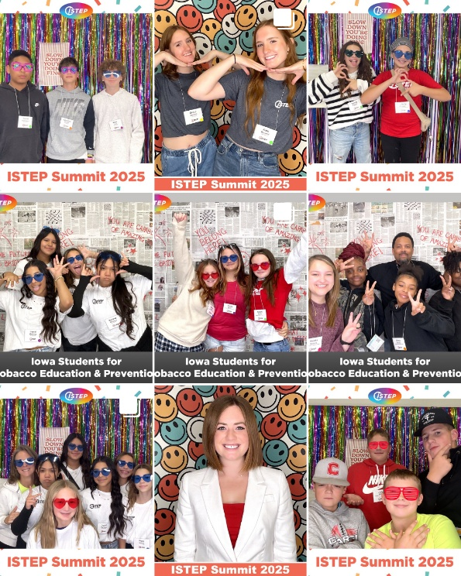 | Be the generation that says NO to vaping & YES to real freedom. @IowaSTEP #ISTEP #IowaSTEP #NoTobacco #TobaccoFreeGeneration #StudentLeaders #TobaccoFree #VapeFree #StopVaping #HealthyLungs #KnowTheFacts #YouthToday #StudentSupport #YouthVoice #TeensSupportTeens
January 2
January 3 | Saturday
January 4 | Sunday
January 5
January 6 |  | When teens unite — big change happens. Join the movement at hhs.iowa.gov/istep.✨@IowaSTEP #ISTEP #IowaSTEP #NoTobacco #TobaccoFreeGeneration #StudentLeaders #TobaccoFree #VapeFree #StopVaping #HealthyLungs #KnowTheFacts #YouthToday #StudentSupport #YouthVoice #TeensSupportTeens
January 7
January 8 | 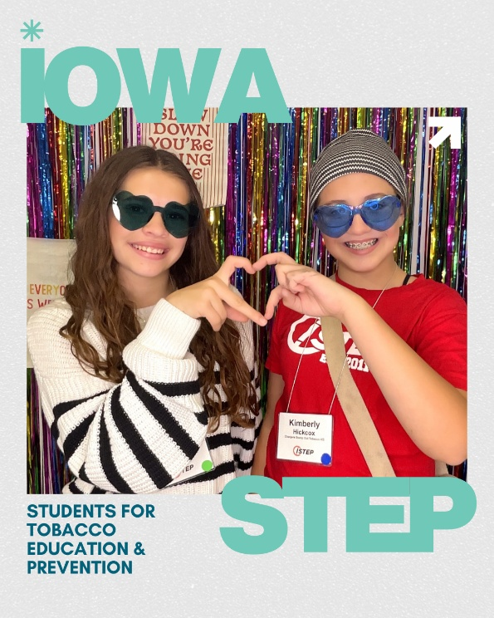 | Friends who care support each other. Say NO to tobacco together. @IowaSTEP #ISTEP #IowaSTEP #NoTobacco #TobaccoFreeGeneration #StudentLeaders #TobaccoFree #VapeFree #StopVaping #HealthyLungs #KnowTheFacts #YouthToday #StudentSupport #YouthVoice #TeensSupportTeens
January 9
January 10 | Saturday
January 11 | Sunday
January 12 | 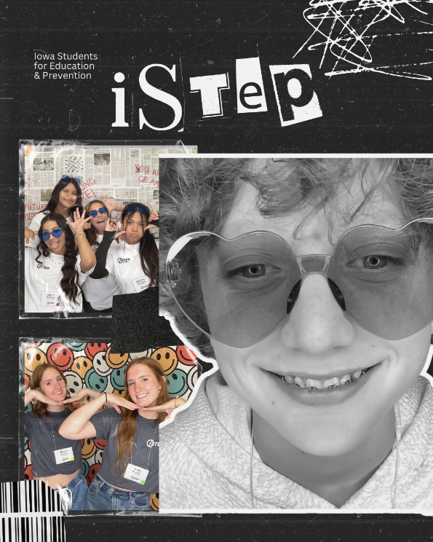 | Want to make a difference? Join an @IowaSTEP chapter near you.🤘Learn more at hhs.iowa.gov/istep. #ISTEP #IowaSTEP #NoTobacco #TobaccoFreeGeneration #StudentLeaders #TobaccoFree #VapeFree #StopVaping #HealthyLungs #KnowTheFacts #YouthToday #StudentSupport #YouthVoice #TeensSupportTeens
January 13 | 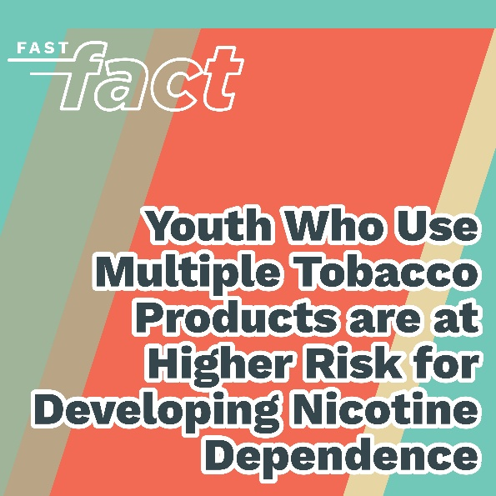 | Your story could save someone else’s future. Speak up about the risks of using tobacco. @IowaSTEP #ISTEP #IowaSTEP #NoTobacco #TobaccoFreeGeneration #StudentLeaders #TobaccoFree #VapeFree #StopVaping #HealthyLungs #KnowTheFacts #YouthToday #StudentSupport #YouthVoice #TeensSupportTeens
January 14
January 15 | 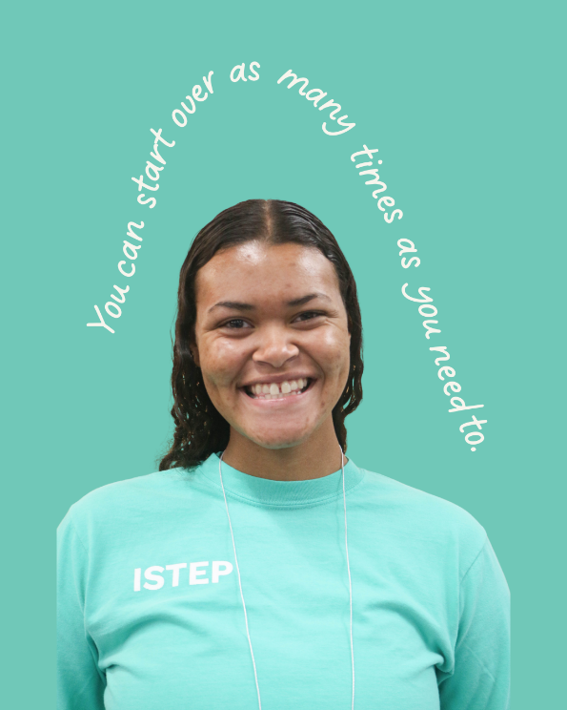 | You don’t have to be perfect to quit — you just have to keep going. Text “start my quit” to 36072 for free confidential help quitting all tobacco products, including vaping. @IowaSTEP #ISTEP #IowaSTEP #NoTobacco #TobaccoFreeGeneration #StudentLeaders #TobaccoFree #VapeFree #StopVaping #HealthyLungs #KnowTheFacts #YouthToday #StudentSupport #YouthVoice #TeensSupportTeens
January 16

January 17 | Saturday
January 18 | Sunday
January 19 | 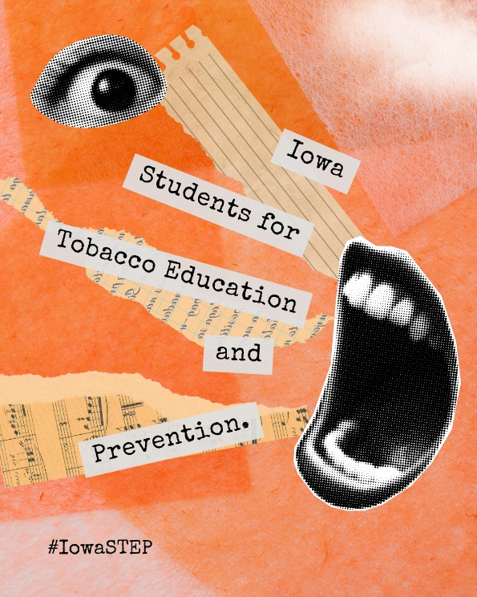 | Your voice = your strength. Use it to shape a healthier Iowa!  @IowaSTEP #ISTEP #IowaSTEP #NoTobacco #TobaccoFreeGeneration #StudentLeaders #TobaccoFree #VapeFree #StopVaping #HealthyLungs #KnowTheFacts #YouthToday #StudentSupport #YouthVoice #TeensSupportTeens
January 20
January 21
January 22 | 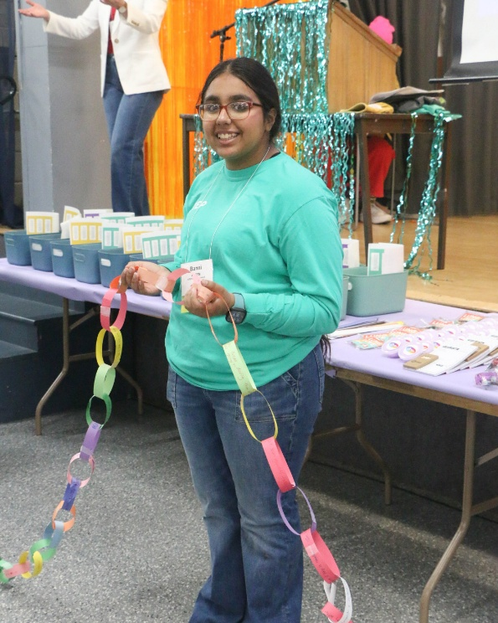 | Be the link that helps someone break free from pressure, stress or nicotine. You matter.💛@IowaSTEP #ISTEP #IowaSTEP #NoTobacco #TobaccoFreeGeneration #StudentLeaders #TobaccoFree #VapeFree #StopVaping #HealthyLungs #KnowTheFacts #YouthToday #StudentSupport #YouthVoice #TeensSupportTeens
January 23 | 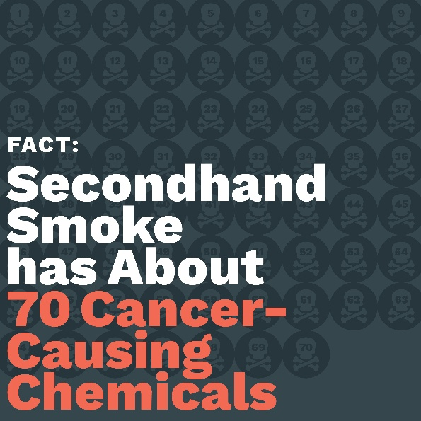 | Yup. Even if you don’t smoke, your lungs still get hit.🚫💨@IowaSTEP #ISTEP #IowaSTEP #NoTobacco #TobaccoFreeGeneration #StudentLeaders #TobaccoFree #VapeFree #StopVaping #HealthyLungs #KnowTheFacts #YouthToday #StudentSupport #YouthVoice #TeensSupportTeens
January 24 | Saturday
January 25 | Sunday
January 26
January 27 |  | From small chapters to statewide impact — together we’ve got this. Let’s make a difference in Iowa and the whole wide world.🌎@IowaSTEP #ISTEP #IowaSTEP #NoTobacco #TobaccoFreeGeneration #StudentLeaders #TobaccoFree #VapeFree #StopVaping #HealthyLungs #KnowTheFacts #YouthToday #StudentSupport #YouthVoice #TeensSupportTeens
January 28
January 29 | 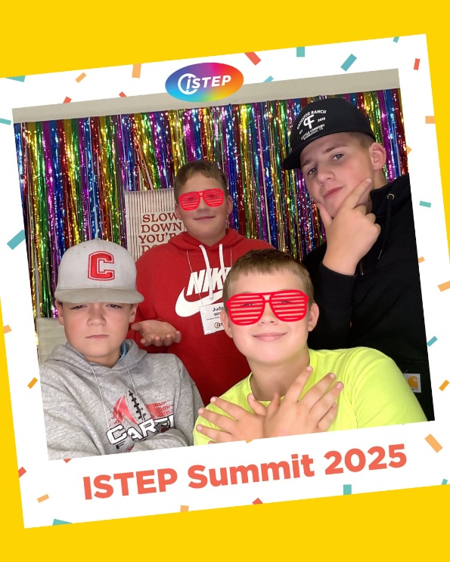 | It takes 3 friends to start a chapter. Grab your crew and change the game. Join today at hhs.iowa.gov/istep. @IowaSTEP #ISTEP #IowaSTEP #NoTobacco #TobaccoFreeGeneration #StudentLeaders #TobaccoFree #VapeFree #StopVaping #HealthyLungs #KnowTheFacts #YouthToday #StudentSupport #YouthVoice #TeensSupportTeens
January 30
January31 | Saturday

