Master FY26 ISTEP Social Schedule
Purpose: Below are ISTEP graphics and caption ideas for your social media accounts. These are only ideas, with the goal to make social posts easier on you. The dates listed are when the ISTEP Facebook/Instagram will be posting these specific items, however you can post them whenever you like.

Instructions: Tag @IowaSTEP in all posts. Download the graphics, then copy and paste the caption from this document.

Recommended hashtags: @IowaSTEP #ISTEP #IowaSTEP #NoTobacco #TobaccoFreeGeneration #StudentLeaders #TobaccoFree #VapeFree #StopVaping #HealthyLungs #KnowTheFacts #YouthToday #StudentSupport #YouthVoice #TeensSupportTeens
Date | Graphic | Caption
March 2026
March 1 | Sunday
March 2
March 3 | 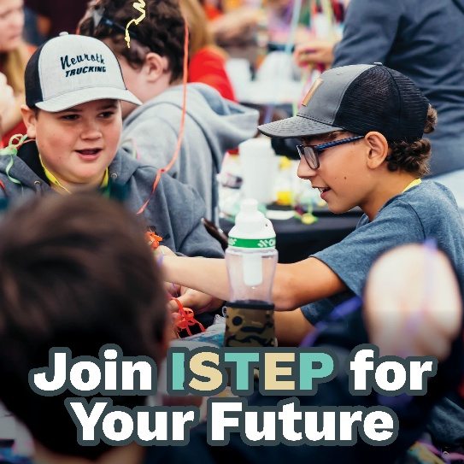 | Joining #ISTEP means standing up for health, for friends, and for your future. Ready to lead? 🌟Join the movement at hhs.iowa.gov/istep. @IowaSTEP #IowaSTEP #NoTobacco #TobaccoFreeGeneration #StudentLeaders #TobaccoFree #VapeFree #StopVaping #HealthyLungs #KnowTheFacts #YouthToday #StudentSupport #YouthVoice #TeensSupportTeens
March 4
March 5 | 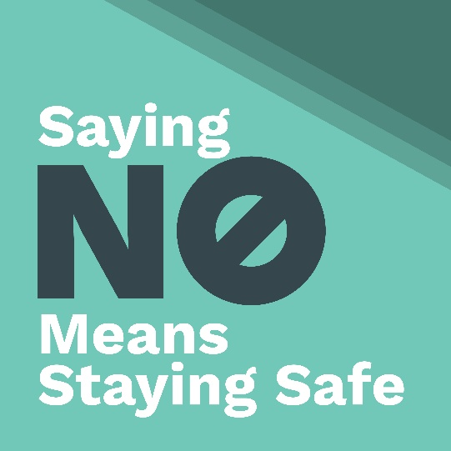 | Saying no to tobacco isn’t just a choice—it’s your safety plan. Protect your lungs, your future, and your vibe. 🚫💨@IowaSTEP #ISTEP #IowaSTEP #NoTobacco #TobaccoFreeGeneration #StudentLeaders #TobaccoFree #VapeFree #StopVaping #HealthyLungs #KnowTheFacts #YouthToday #StudentSupport #YouthVoice #TeensSupportTeens
March 6
March 7 | Saturday
March 8 | Sunday
March 9 | 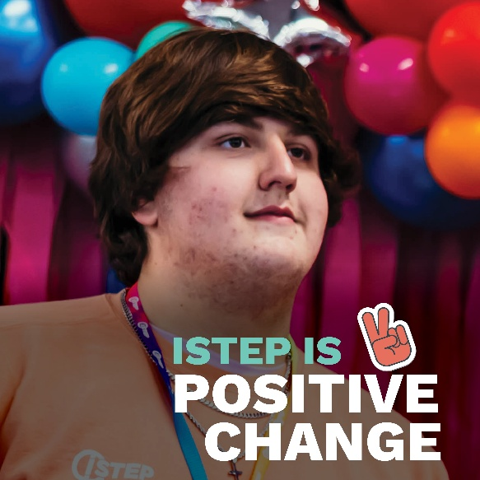 | Want to make a positive difference? #ISTEP gives YOU the power to create a tobacco-free generation. 💪 @IowaSTEP #IowaSTEP #NoTobacco #TobaccoFreeGeneration #StudentLeaders #TobaccoFree #VapeFree #StopVaping #HealthyLungs #KnowTheFacts #YouthToday #StudentSupport #YouthVoice #TeensSupportTeens
March 10
March 11 | 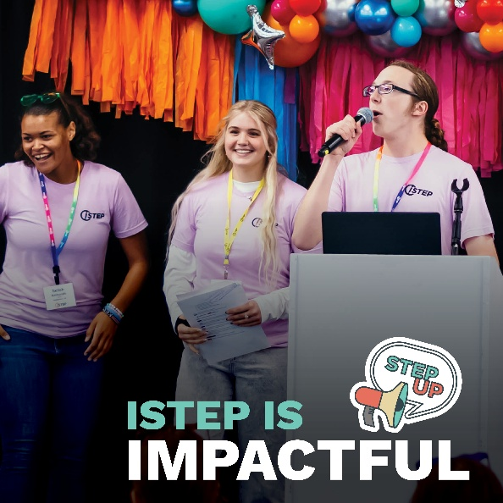 | Your voice matters and is impactful! Decisions about youth should include youth. Join #ISTEP and make sure YOUR voice is heard! 🔊 @IowaSTEP #IowaSTEP #NoTobacco #TobaccoFreeGeneration #StudentLeaders #TobaccoFree #VapeFree #StopVaping #HealthyLungs #KnowTheFacts #YouthToday #StudentSupport #YouthVoice #TeensSupportTeens
March 12
March 13
March 14 | Saturday
March 15 | Sunday
March 16 |  | Did you know vaping can damage your lungs for life? Protect your future—be vape free TODAY. @IowaSTEP #ISTEP #IowaSTEP #NoTobacco #TobaccoFreeGeneration #StudentLeaders #TobaccoFree #VapeFree #StopVaping #HealthyLungs #KnowTheFacts #YouthToday #StudentSupport #YouthVoice #TeensSupportTeens
March 17
March 18 | 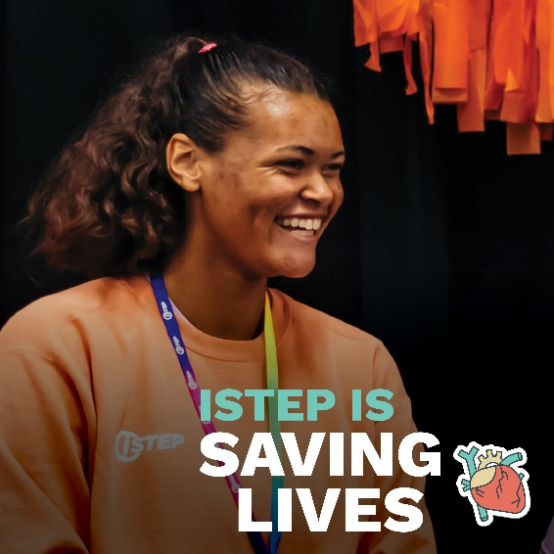 | Your ideas can change your school, your community, and Iowa. Join #ISTEP and lead the way to saving lives! @IowaSTEP #IowaSTEP #NoTobacco #TobaccoFreeGeneration #StudentLeaders #TobaccoFree #VapeFree #StopVaping #HealthyLungs #KnowTheFacts #YouthToday #StudentSupport #YouthVoice #TeensSupportTeens
March 19
March 20
March 21 | Saturday
March 22 | Sunday
March 23 | 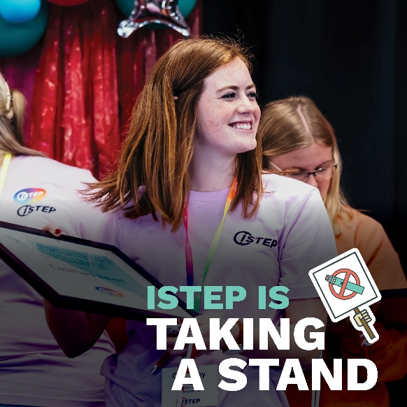 | #ISTEP isn’t just a club—it’s a movement. Build skills, make friends, and lead change! Learn more at hhs.iowa.gov/istep. @IowaSTEP #IowaSTEP #NoTobacco #TobaccoFreeGeneration #StudentLeaders #TobaccoFree #VapeFree #StopVaping #HealthyLungs #KnowTheFacts #YouthToday #StudentSupport #YouthVoice #TeensSupportTeens
March 24
March 25
March 26 | 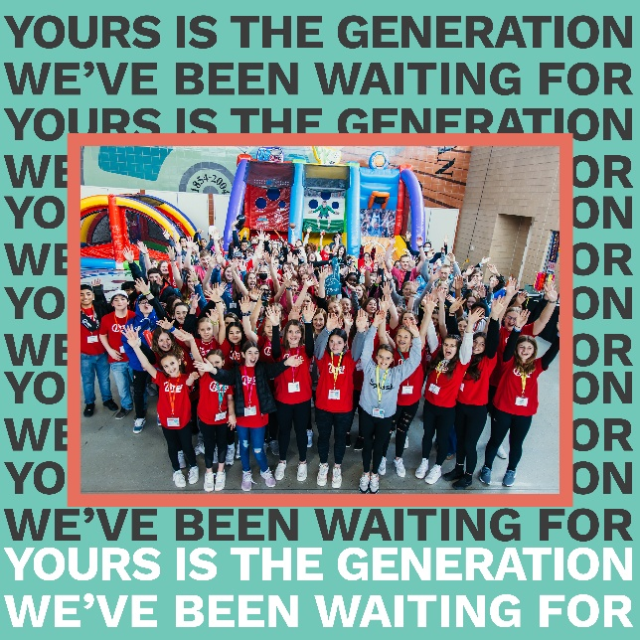 | Yours is the generation we’ve been waiting for—the one that says NO to tobacco and YES to a healthier future. Lead the change! 🌟 @IowaSTEP #ISTEP #IowaSTEP #NoTobacco #TobaccoFreeGeneration #StudentLeaders #TobaccoFree #VapeFree #StopVaping #HealthyLungs #KnowTheFacts #YouthToday #StudentSupport #YouthVoice #TeensSupportTeens
March 27
March 28 | Saturday
March 29 | Sunday
March 30
March 31 |  | #ISTEP is where friendships meet purpose. Make memories while making change! @IowaSTEP #IowaSTEP #NoTobacco #TobaccoFreeGeneration #StudentLeaders #TobaccoFree #VapeFree #StopVaping #HealthyLungs #KnowTheFacts #YouthToday #StudentSupport #YouthVoice #TeensSupportTeens

