Master FY26 ISTEP Social Schedule
Purpose: Below are ISTEP graphics and caption ideas for your social media accounts. These are only ideas, with the goal to make social posts easier on you. The dates listed are when the ISTEP Facebook/Instagram will be posting these specific items, however you can post them whenever you like.

Instructions: Tag @IowaSTEP in all posts. Download the graphics, then copy and paste the caption from this document.

Recommended hashtags: @IowaSTEP #ISTEP #IowaSTEP #NoTobacco #TobaccoFreeGeneration #StudentLeaders #TobaccoFree #VapeFree #StopVaping #HealthyLungs #KnowTheFacts #YouthToday #StudentSupport #YouthVoice #TeensSupportTeens
Date | Graphic | Caption
April 2026
April 1 | 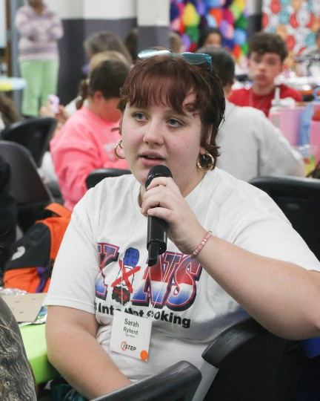 | Your voice isn’t just important—it’s unstoppable. Together, we can break the cycle and build a tobacco-free future.  @IowaSTEP #ISTEP #IowaSTEP #NoTobacco #TobaccoFreeGeneration #StudentLeaders #TobaccoFree #VapeFree #StopVaping #HealthyLungs #KnowTheFacts #YouthToday #StudentSupport #YouthVoice #TeensSupportTeens
April 2 | 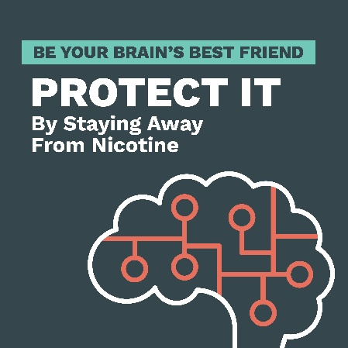 | Tobacco doesn’t just harm your lungs—it harms your mind. Nicotine can increase anxiety, stress, and depression. Protect your mental health: choose tobacco-free. 💙  @IowaSTEP #ISTEP #IowaSTEP #NoTobacco #TobaccoFreeGeneration #StudentLeaders #TobaccoFree #VapeFree #StopVaping #HealthyLungs #KnowTheFacts #YouthToday #StudentSupport #YouthVoice #TeensSupportTeens
April 3
April 4 | Saturday
April 5 | Sunday
April 6 | 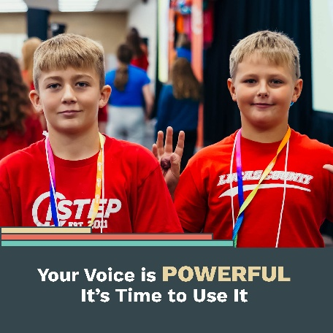 | Your voice matters—and it’s powerful. When youth speak up, communities listen. #ISTEP gives YOU the platform to create change and inspire a healthier Iowa. 💪  @IowaSTEP #IowaSTEP #NoTobacco #TobaccoFreeGeneration #StudentLeaders #TobaccoFree #VapeFree #StopVaping #HealthyLungs #KnowTheFacts #YouthToday #StudentSupport #YouthVoice #TeensSupportTeens
April 7 |  | Iowa youth stepping up for a tobacco-free future! 🚭 #ISTEP empowers students in grades 7–12 to share the unfiltered facts about tobacco and nicotine. Join the movement!  @IowaSTEP #IowaSTEP #NoTobacco #TobaccoFreeGeneration #StudentLeaders #TobaccoFree #VapeFree #StopVaping #HealthyLungs #KnowTheFacts #YouthToday #StudentSupport #YouthVoice #TeensSupportTeens
April 8
April 9 | 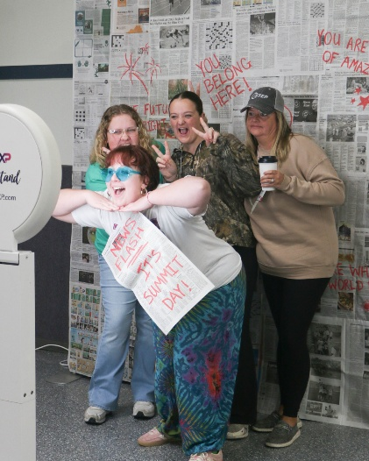 | Making friends, making a difference—and leading the charge for healthy choices. That’s the #ISTEP way. Want to lead too? Register your chapter today at hhs.iowa.gov/istep.  @IowaSTEP #IowaSTEP #NoTobacco #TobaccoFreeGeneration #StudentLeaders #TobaccoFree #VapeFree #StopVaping #HealthyLungs #KnowTheFacts #YouthToday #StudentSupport #YouthVoice #TeensSupportTeens
April 10 | 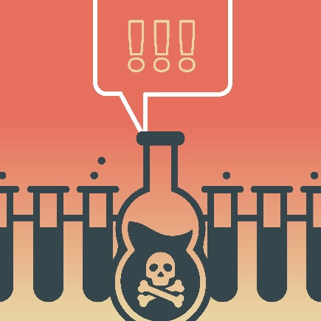 | Vaping isn’t harmless—it’s a chemical cocktail. From nicotine to toxic metals and cancer-causing agents, these substances damage your lungs, heart, and overall health. Don’t be fooled!  @IowaSTEP #ISTEP #IowaSTEP #NoTobacco #TobaccoFreeGeneration #StudentLeaders #TobaccoFree #VapeFree #StopVaping #HealthyLungs #KnowTheFacts #YouthToday #StudentSupport #YouthVoice #TeensSupportTeens
April 11 | Saturday
April 12 | Sunday
April 13 | 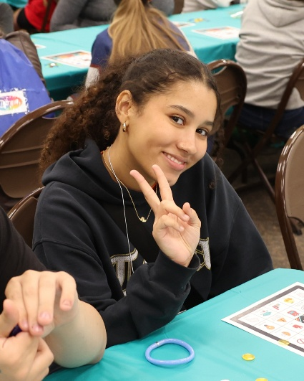 | Your peace of mind is priceless. Tobacco steals it by fueling stress and addiction. Take back control—live tobacco free.  @IowaSTEP #ISTEP #IowaSTEP #NoTobacco #TobaccoFreeGeneration #StudentLeaders #TobaccoFree #VapeFree #StopVaping #HealthyLungs #KnowTheFacts #YouthToday #StudentSupport #YouthVoice #TeensSupportTeens
April 14
April 15 | 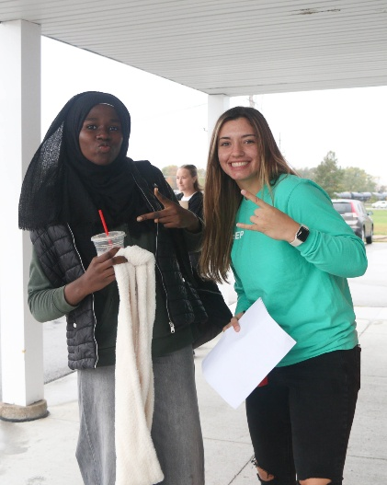 | Speak up. Stand out. Step up. Your voice is the key to change—let’s use it to protect our generation.  @IowaSTEP #ISTEP #IowaSTEP #NoTobacco #TobaccoFreeGeneration #StudentLeaders #TobaccoFree #VapeFree #StopVaping #HealthyLungs #KnowTheFacts #YouthToday #StudentSupport #YouthVoice #TeensSupportTeens
April 16
April 17 | 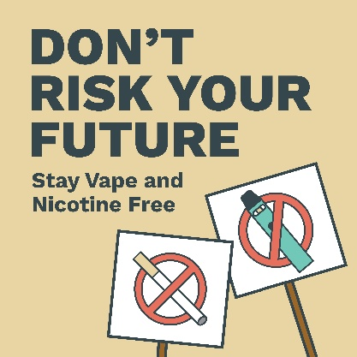 | Vapes? Nicotine pouches? Not worth it. The industry targets us, but #ISTEP equips us with the real facts—so we can say NO!  @IowaSTEP #IowaSTEP #NoTobacco #TobaccoFreeGeneration #StudentLeaders #TobaccoFree #VapeFree #StopVaping #HealthyLungs #KnowTheFacts #YouthToday #StudentSupport #YouthVoice #TeensSupportTeens
April 18 | Saturday
April 19 | Sunday
April 20 | 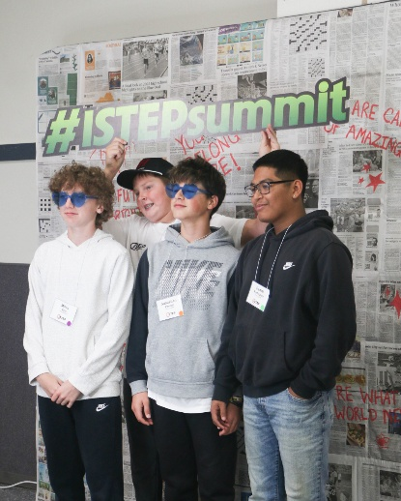 | Strong minds make strong futures. Don’t let tobacco cloud your mental health. You deserve clarity, confidence, and calm. 💪  @IowaSTEP #ISTEP #IowaSTEP #NoTobacco #TobaccoFreeGeneration #StudentLeaders #TobaccoFree #VapeFree #StopVaping #HealthyLungs #KnowTheFacts #YouthToday #StudentSupport #YouthVoice #TeensSupportTeens
April 21 | 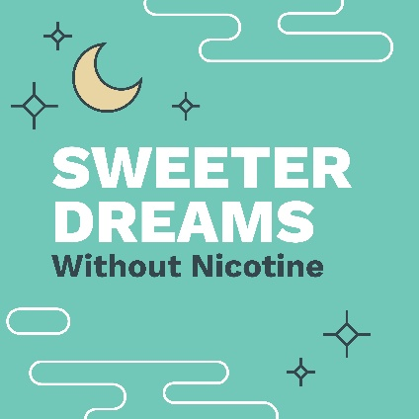 | Sweet dreams start with a clear mind. Nicotine disrupts your sleep cycle, making rest harder and stress worse. Go tobacco-free for better sleep and brighter mornings. 🌙✨  @IowaSTEP #ISTEP #IowaSTEP #NoTobacco #TobaccoFreeGeneration #StudentLeaders #TobaccoFree #VapeFree #StopVaping #HealthyLungs #KnowTheFacts #YouthToday #StudentSupport #YouthVoice #TeensSupportTeens
April 22
April 23
April 24 |  | #ISTEP isn’t just about making change—it’s about making friends, having fun, and creating memories while building a healthier Iowa. 🎉 Ready to join the movement? Learn more at hhs.iowa.gov/istep.  @IowaSTEP #IowaSTEP #NoTobacco #TobaccoFreeGeneration #StudentLeaders #TobaccoFree #VapeFree #StopVaping #HealthyLungs #KnowTheFacts #YouthToday #StudentSupport #YouthVoice #TeensSupportTeens
April 25 | Saturday
April 26 | Sunday
April 27
April 28 | 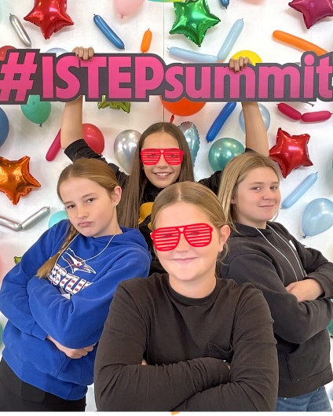 | #ISTEP = friends, fun, and making a difference! Who says leadership can’t be a blast? 🎉  @IowaSTEP #IowaSTEP #NoTobacco #TobaccoFreeGeneration #StudentLeaders #TobaccoFree #VapeFree #StopVaping #HealthyLungs #KnowTheFacts #YouthToday #StudentSupport #YouthVoice #TeensSupportTeens
April 29
April 30 | 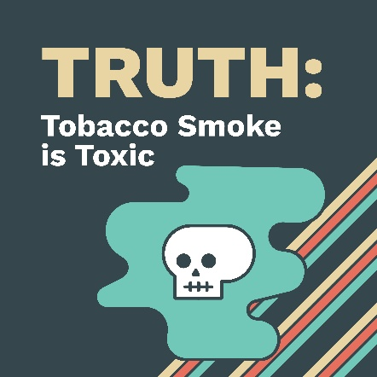 | Tobacco smoke isn’t just unpleasant—it’s toxic. It contains thousands of chemicals, including poisons and carcinogens that harm your lungs, heart, and overall health. Choose clean air, choose life. 🚭  @IowaSTEP #ISTEP #IowaSTEP #NoTobacco #TobaccoFreeGeneration #StudentLeaders #TobaccoFree #VapeFree #StopVaping #HealthyLungs #KnowTheFacts #YouthToday #StudentSupport #YouthVoice #TeensSupportTeens

