Assessment Tool Questionnaire
Current waiver members
Background
There are several interRAI assessment tools, each designed to assess the needs of specific populations. The Assessment Tool Questionnaire is a brief survey designed to identify members' needs and determine the most suitable interRAI assessment tool for them.
The case manager completes the questionnaire for all currently enrolled Child and Youth or Adult and Disability waiver members.
Who conducts the current waiver member questionnaire with members?
- The CSA scheduler completes the current waiver member questionnaire for all currently enrolled fee-for-service members (FFS).
- The case manager completes the current waiver member questionnaire for all currently enrolled MCO members.
Completing the questionnaire
Step 1: Identify if the member must complete a questionnaire and which questionnaire.
Group | Complete questionnaire? | Which questionnaire?
Newly enrolled Children and Youth waiver members aged 0 to 3 | No | These members will use the interRAI Early Years assessment tool.
Newly enrolled Children and Youth waiver members ages 4–20 | Yes | Complete the New Member Youth Assessment Tool Questionnaire.
Newly Enrolled Adult and Disability waiver members aged 21 and older | Yes | Complete the New Member Adult Assessment Tool Questionnaire.
Current and New Elderly waiver members aged 65 and older | No | These members will use the interRAI Home Care assessment tool

Step 2: Work with the member or their family member/caregiver to complete Q1.
- If the member answers “No” to Q1, stop here.
  - Case managers should notify the CSA scheduler to schedule the same interRAI assessment as last year. Do not upload the completed questionnaire to xx.
  - The CSA scheduler should schedule the same interRAI assessment as last year. Do not upload the completed questionnaire to xx.
- If the member answers “Yes” to Q1, proceed to Step 3.
Step 3: Work with the member or their loved one to complete Q2 through Q6 of the questionnaire using the “How to complete” instructions. For more information on interpreting the questions, see section “How to interpret the questions” below.
Step 4: Add up the totals for each column at the bottom of the questionnaire where it says “Total.” For boxes that are blank, count them as zero.
Step 5: Schedule the members assessment.
- Case managers should notify the CSA scheduler to schedule the assessment corresponding with the highest scoring column using the criteria below. If the total for two or more columns is the same, ask the member which column is most critical to them. Upload the completed questionnaire to XX.
- The CSA scheduler should schedule the assessment corresponding with the highest scoring column using the criteria below. If the total for two or more columns is the same, ask the member which column is most critical to them. Upload the completed questionnaire to XX.

Adults Ages 21+ Scoring Criteria
Highest scoring column | Assessment to schedule
Developmental | ID Assessment
Medical | HC Assessment
If scores are tied in both columns, the member will be scheduled for the assessment that corresponds to the column they feel is most critical to them.

Children Ages 4-20 Scoring Criteria
Highest scoring column | Assessment to schedule
Developmental | ChMYH-DD Assessment
Medical | Peds-HC Assessment
Mental Health | ChMYH Assessment
If scores are tied in two or more columns, the member will be scheduled for the assessment that corresponds to the column they feel is most critical to them.

FAQs
Who should complete the current member questionnaire?
- A: The CSA scheduler should conduct the assessment questionnaire with current FFS members during the phone call to schedule the assessment.
- A: The case manager should conduct the assessment questionnaire with current MCO members at least 30 days before the CSA scheduler schedules the member’s assessment.
Q: Why is the assessment questionnaire necessary?
A: The assessment questionnaire is necessary to match each member’s unique needs to the most appropriate interRAI tool for them.
Q: What autonomy do members have in choosing their interRAI assessment tool?
A: The assessment questionnaire is intended to be completed with the member and/or their guardian to capture their most important needs. Their responses directly impact how the assessment tool is scored.

How to interpret Assessment Questionnaire Questions
The purpose of the questionnaire is to determine which interRAI assessment tool best fits the member’s life context. The questionnaire identifies the best fit by pinpointing the source or root cause of the functional limitation or need for help. The table below provides guidance on how to interpret each interRAI assessment tool category.

Category | Adult Questionnaire | Child/Youth Questionnaire | Focus
Developmental | How the member learns, understands, or behaves | How the member learns, understands or behaves | Cognition, skill acquisition, and sustained behavioral patterns that interfere with daily life or learning
Medical | The member’s health, medicine, illness, or injury | The member’s health, medicine, illness, or injury | Physical health conditions that limit mobility or physical function, or require medical management
Mental Health | Not Applicable | The member’s social, emotional, and psychological well-being | Emotional and psychological disorders that cause functional impairment
Question-Specific Interpretation Guidance
Q1: Have your/your child’s needs changed since last year, or do you feel that your/your child’s previous assessment is not appropriate to assess your/your child’s needs?
Guidance: Look for new diagnoses, changes in functioning, or significant life events. If the member/their family express concern that the previous assessment is no longer a good match, select “Yes” and proceed to Q2.
________________________________________________________________________________________
Q2: Help with Everyday Tasks (e.g., Dressing, Bathing, Eating, Shopping)
Guidance:
For children, compare to typical developmental milestones. For adults, children, and youth, consider:
- Developmental: Delays in motor or cognitive skills.
- Medical Health: Physical impairments or chronic illness.
- Mental Health: Anxiety, depression, or behavioral issues affecting daily functioning.
For children and adults: If the answer is “yes”, the reason for the limitation is likely...
- Developmental if the member struggles to follow multi-step directions or cannot remember the steps of an ADL/IADL routine due to a cognitive or intellectual disability.
- Medical if the member cannot perform the ADL/IADL task because they have a medical condition such as a spinal injury, chronic arthritis, or require medical support to perform an ADL such as eating through the use of a feeding tube.
- Mental health if the child/youth refuses to perform an ADL such as bathing or eating due to extreme anxiety, depression or an emotional disorder that causes severe functional regression in self-care.
________________________________________________________________________________________
Q3: Help Managing Physical Limitations (e.g., Wheelchair, Moving from Bed to Chair)
Guidance: Consider use of assistive devices, frequent falls, or fatigue, then:
- Developmental: Neuromuscular delays.
- Medical Health: Conditions like cerebral palsy or muscular dystrophy.
- Mental Health: Psychosomatic symptoms or fear-based immobility.
For children and adults: If the answer is “yes”, the reason for the limitation is likely...
- Developmental if the member has severe gross motor developmental delays and cannot safely ambulate or transfer without hands-on assistance.
- Medical if the member needs help due to paralysis, muscular dystrophy, or a physical injury requiring assistance with transfers and mobility devices.
- Mental health if the child/youth has a conversion disorder or severe functional neurological symptom disorder that physically prevents movement.
________________________________________________________________________________________
Q4: Help Managing Behavioral Concerns (e.g., Self-Injury, Aggression)
Guidance: Look for aggression, self-harm, defiance, or social withdrawal, then:
- Developmental: Autism spectrum behaviors.
- Medical Health: Medication side effects or neurological issues.
- Mental Health: ADHD, trauma, anxiety, or mood disorders.
For children and adults: If the answer is “yes”, the reason for the limitation is likely...
- Developmental if the member has behaviors that stem from an intellectual or autism spectrum disorder, where the behavior is related to communication or coping deficits.
- Medical if the member has behaviors resulting from a side effect of a medication, or directly caused by a medical issue (e.g., severe pain, seizure activity).
- Mental health if the child/youth has behaviors that are primarily symptoms of a mental illness such as Bipolar Disorder, Conduct Disorder, or severe anxiety impacting emotional or psychological well-being.
________________________________________________________________________________________
Q5: Help to Manage Chronic Medical Conditions
Guidance: Include chronic illnesses, frequent hospitalizations, or complex medication regimens.
________________________________________________________________________________________
Q6: Ranking the Reasons for Help
Guidance: Consider which domain most affects the member’s daily life and long-term outcomes, and
- Validate their choice by making statements such as “that makes sense given [refer to specific need mentioned earlier in the conversation]”.
- Explain the outcome by reinforcing that their choice directly determines which instrument/tool and assessor will conduct the assessment (e.g., an assessor who specializes in working with people with developmental disabilities or a nurse who understands medical needs).
- Focus on function by reminding them to think about which issue is causing the greatest functional challenge or the most immediate risk in daily life.
Suggested Script: “We have covered the specific areas where you need help. For the last question, we want to look at overall needs. I need you to think about the challenges we discussed – whether they were related to learning, physical health or behavior – and tell me which area is the most important right now.
For Adults: Please rank the needs between developmental (learning, understanding, or behavior) and Medical (health, medicine, illness, or injury). Use 2 for the most important and 1 for the least important reason.
For Children/Youth: Please rank the needs between developmental (learning, understanding, or behavior), Medical (health, medicine, illness, or injury) or Mental Health (emotional, social, or psychological well-being). Use 3 for the main reason, 2 for the second most important and 1 for the least important reason.”

Current Member Example – Adult

Name: John M.

Age: 45

Diagnosis: Traumatic Brain Injury (TBI), Post-Traumatic Epilepsy, Right Hemiparesis.

Living Situation: Assisted Living Facility (ALF)

Background: John sustained a severe TBI 10 years ago. He is an existing member up for his annual reassessment. He has chronic right-sided weakness (hemiparesis) requiring assistance with physical tasks. The most challenging aspect of his care, however, is his severe short-term memory loss, poor judgment, and impulsive behavior, which require constant supervision for safety. Because John is enrolled with an MCO, his MCO case manager should complete the questionnaire.
- Q1: John completed the ID assessment last year. John’s staff informs his case manager that he has been experiencing more impulsive behavior recently.
- Q2: John needs cueing and sequencing help for dressing and managing his money due to cognitive deficits. He also needs physical assistance with bathing. Put a 2 under Developmental (Cognitive/Behavior) and a 1 under Medical (Physical help).
- Q3: John uses a walker and needs hands-on assistance for transfers (bed/chair) due to his right-sided weakness. Put a 2 under Medical (Physical limitation) and a 1 under Developmental (If he resists using aids/following directions).
- Q4: John exhibits severe impulsivity and poor safety judgment (e.g., leaving the stove on, trying to walk unassisted), which is a direct result of his TBI. Put a 2 under Developmental and a 1 under Medical (Secondary consideration for medication management).
- Q4: John has post-traumatic epilepsy and chronic spasticity requiring regular medication management and monitoring. Put a 2 under Medical.
- Q5: John’s assisted living facility staff reports his cognitive and behavioral needs are the biggest safety concern and the main reason he requires this level of care. John also agrees that safety is his biggest worry. Put a 2 under Developmental and a 1 under Medical.
Total Score:
- Developmental: 7
- Medical: 7

The Developmental and Medical totals are tied (7 each). The case manager asks John/staff which is most critical. Based on the overall concern for safety and impulsivity (Q5), the ID Assessment is still the best fit for John’s needs.

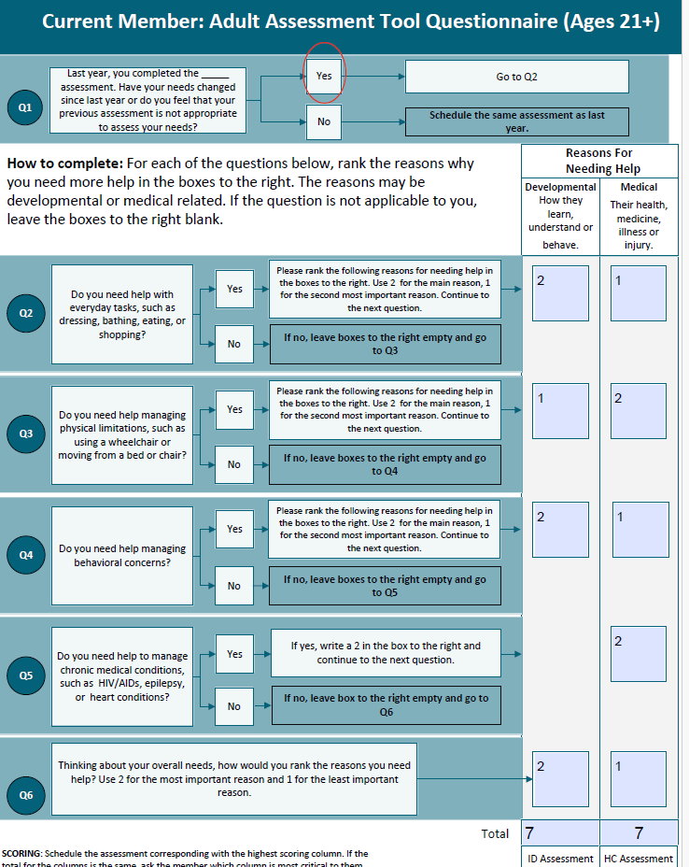

Current Member Example – Child
Name: Chloe
Age: 14
Diagnosis: Type 1 Diabetes (T1D), Major Depressive Disorder, and Severe Anxiety
Living Situation: With a single mother
Background: Chloe has had diabetes since age 8, requiring daily insulin and blood sugar monitoring. Over the last year, her diabetes management has declined due to severe depression and anxiety, resulting in multiple hospitalizations for diabetic ketoacidosis. Her mother is struggling to manage both her physical and mental health needs. She is up for her annual reassessment. Because Chloe is enrolled in an MCO, her MCO case manager should complete the questionnaire.
- Q1: Due to her recent hospitalizations, Chloe and her family answer Yes to Q1, her needs have changed.
- Q2: Chloe struggles to maintain her daily routines, including adequate nutrition, due to her depression. Put a 3 under Mental Health (Emotional refusal/apathy), 2 under Medical (Impact on diabetes management) and 1 under Developmental.
- Q3: Chloe is physically mobile and does not require help with mobility devices. Leave boxes empty.
- Q4: Chloe exhibits severe withdrawal, self-isolation, and refusal to participate in treatment (including diabetes care). Put a 3 under Mental Health (Core symptoms of depression/anxiety), a 2 under Medical (Refusal impacts physical health), and a 1 under Developmental.
- Q5: Chloe has Type 1 Diabetes, a chronic medical condition. Put a 3 under Medical.
- Q6: The mother states that while the diabetes is serious, the Mental Health issues are currently the most critical barrier to all areas of her life. Put a 3 under Mental Health, 2 under Medical and a 1 under Developmental.
Total Score:
- Developmental: 3
- Medical: 9
- Mental Health: 9
Last year, Chloe completed the Peds-HC assessment. The Medical and Mental Health totals are tied (9 each). The case manager asks Chloe and her family which is most critical. Chloe and her family say that managing her depression and anxiety are most important at the moment. Based on the overall concern for her emotional wellbeing, the ChYMH Assessment is the best fit for Chloe's needs.

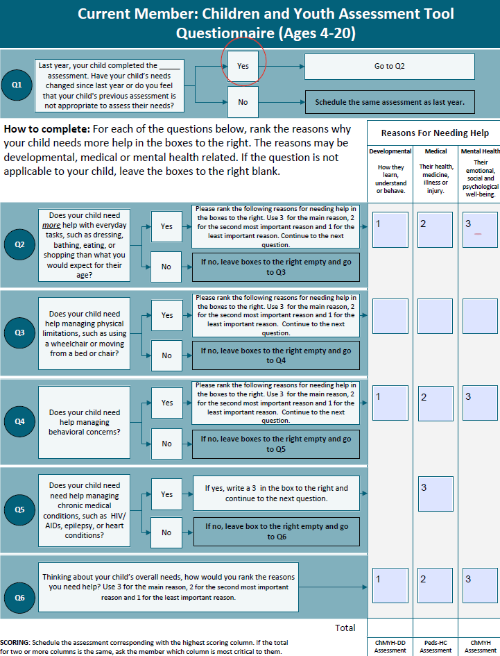
9
3
9

