Master FY26 ISTEP Social Schedule
Purpose: Below are ISTEP graphics and caption ideas for your social media accounts. These are only ideas, with the goal to make social posts easier on you. The dates listed are when the ISTEP Facebook/Instagram will be posting these specific items, however you can post them whenever you like.

Instructions: Tag @IowaSTEP in all posts. Download the graphics, then copy and paste the caption from this document.

Recommended hashtags: @IowaSTEP #ISTEP #IowaSTEP #NoTobacco #TobaccoFreeGeneration #StudentLeaders #TobaccoFree #VapeFree #StopVaping #HealthyLungs #KnowTheFacts #YouthToday #StudentSupport #YouthVoice #TeensSupportTeens
Date | Graphic | Caption
May 2026
May 1
May 2 | Saturday
May 3 | Sunday
May 4 | 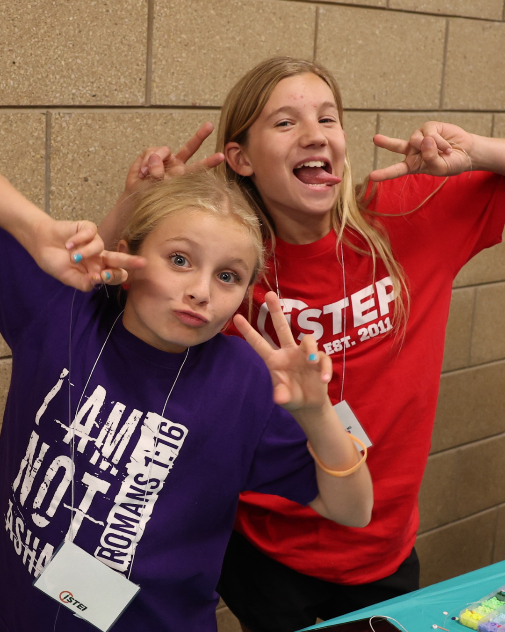 | When we feel connected, we thrive! @IowaSTEP builds communities of like-minded teens where everyone belongs. Join today at hhs.iowa.gov/istep. #ISTEP #IowaSTEP #NoTobacco #TobaccoFreeGeneration #StudentLeaders #TobaccoFree #VapeFree #StopVaping #HealthyLungs #KnowTheFacts #YouthToday #StudentSupport #YouthVoice #TeensSupportTeens
May 5 | 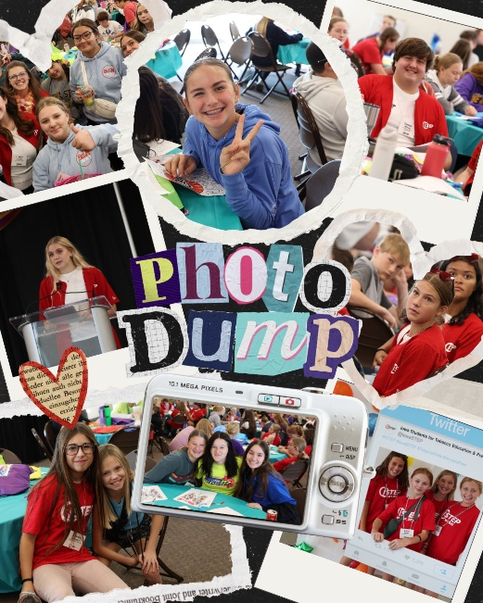 | A supportive peer can change someone’s entire school year. Be that spark – join @IowaSTEP!  #ISTEP #IowaSTEP #NoTobacco #TobaccoFreeGeneration #StudentLeaders #TobaccoFree #VapeFree #StopVaping #HealthyLungs #KnowTheFacts #YouthToday #StudentSupport #YouthVoice #TeensSupportTeens
May 6
May 7 | 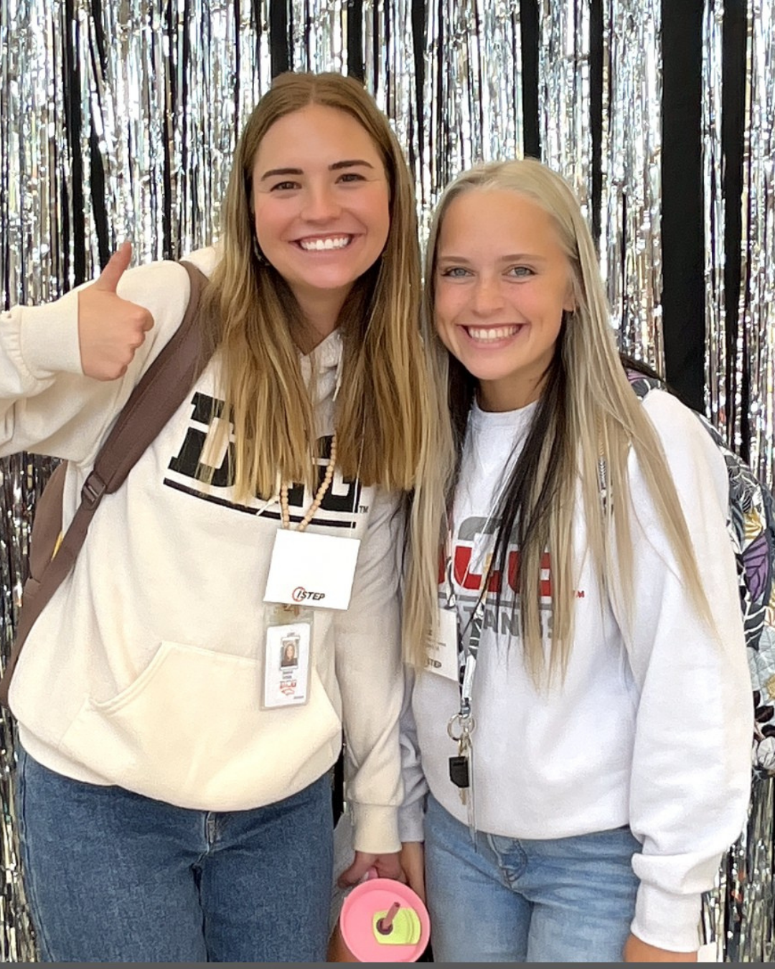 | @IowaSTEP is all about friendship, and friendship is a strength! Empowered teens lift each other up. #ISTEP #IowaSTEP #NoTobacco #TobaccoFreeGeneration #StudentLeaders #TobaccoFree #VapeFree #StopVaping #HealthyLungs #KnowTheFacts #YouthToday #StudentSupport #YouthVoice #TeensSupportTeens
May 8
May 9 | Saturday
May 10 | Sunday
May 11 | 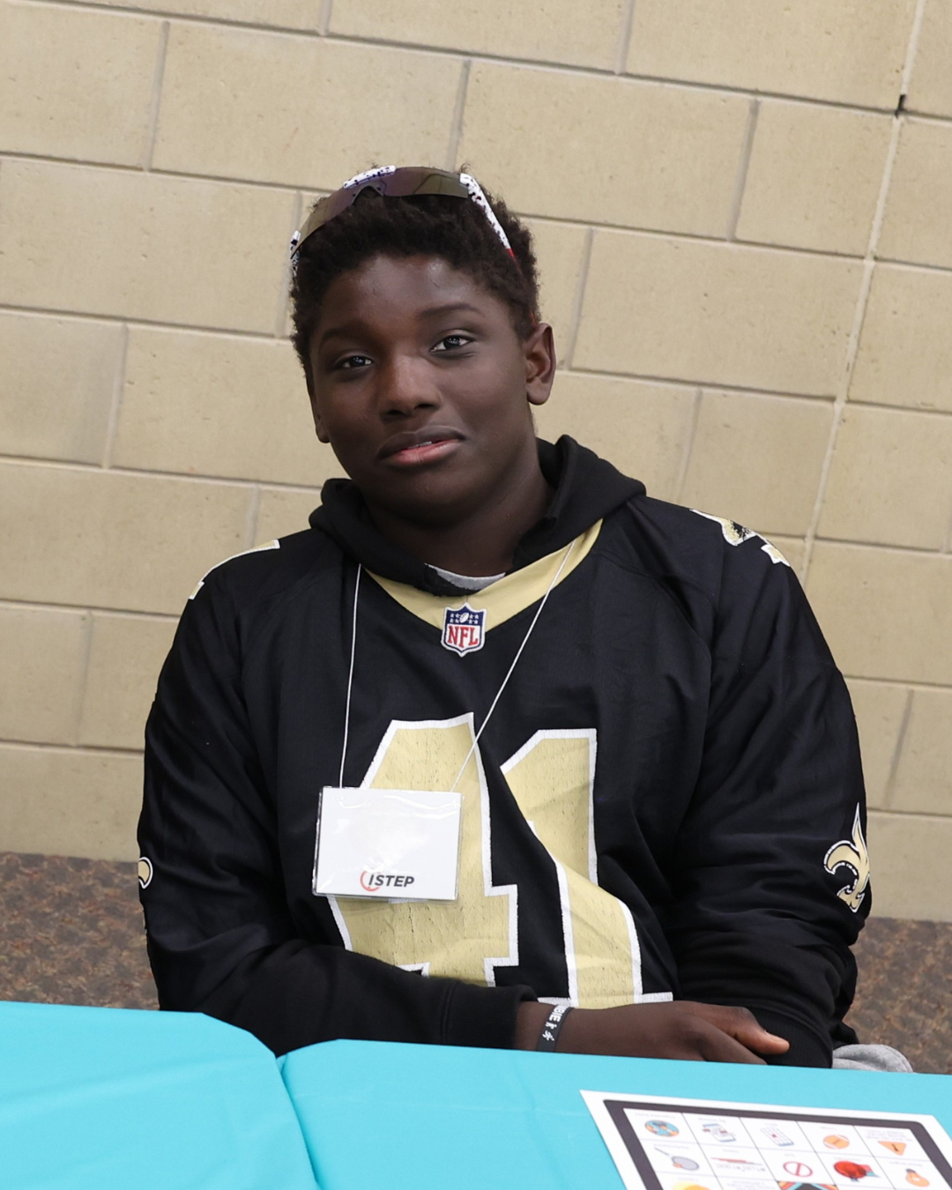 | Confidence grows when teens feel seen, heard and supported by their friends. Join @IowaSTEP to meet like-minded teens at hhs.iowa.gov/istep. #ISTEP #IowaSTEP #NoTobacco #TobaccoFreeGeneration #StudentLeaders #TobaccoFree #VapeFree #StopVaping #HealthyLungs #KnowTheFacts #YouthToday #StudentSupport #YouthVoice #TeensSupportTeens
May 12 | 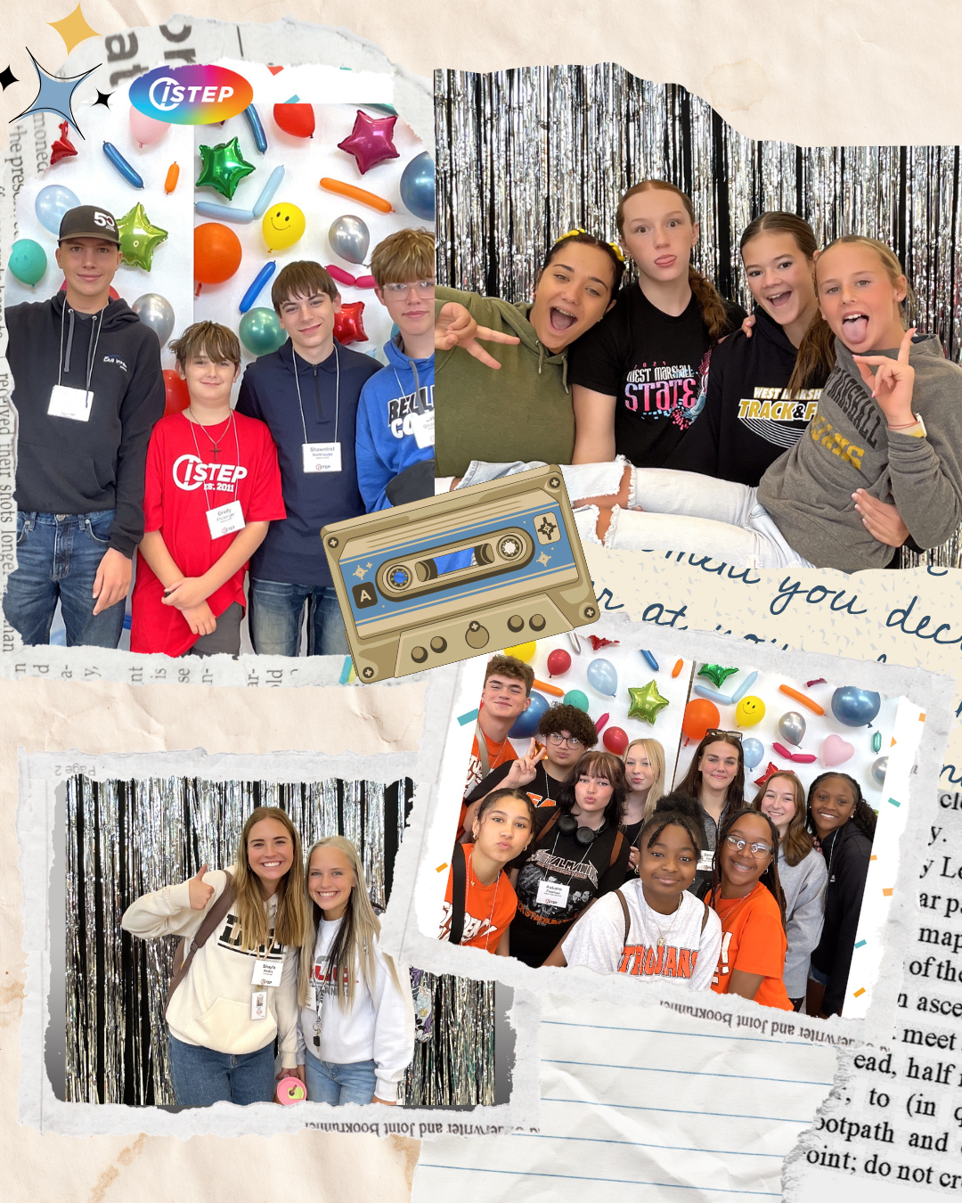 | Teens learn best from teens, and that’s what #ISTEP is all about! Learn more at hhs.iowa.gov/istep. Peer leadership matters! #IowaSTEP #NoTobacco #TobaccoFreeGeneration #StudentLeaders #TobaccoFree #VapeFree #StopVaping #HealthyLungs #KnowTheFacts #YouthToday #StudentSupport #YouthVoice #TeensSupportTeens
May 13
May 14 |  | @IowaSTEP starts with kindness, connection and youth voices. Join #IowaSTEP today at hhs.iowa.gov/istep to make a difference! #ISTEP #NoTobacco #TobaccoFreeGeneration #StudentLeaders #TobaccoFree #VapeFree #StopVaping #HealthyLungs #KnowTheFacts #YouthToday #StudentSupport #YouthVoice #TeensSupportTeens
May 15
May 16 | Saturday
May 17 | Sunday
May 18
May 19 |  | Your voice matters. Your kindness matters. YOU matter. @IowaSTEP #ISTEP #IowaSTEP #NoTobacco #TobaccoFreeGeneration #StudentLeaders #TobaccoFree #VapeFree #StopVaping #HealthyLungs #KnowTheFacts #YouthToday #StudentSupport #YouthVoice #TeensSupportTeens
May 20
May 21 | 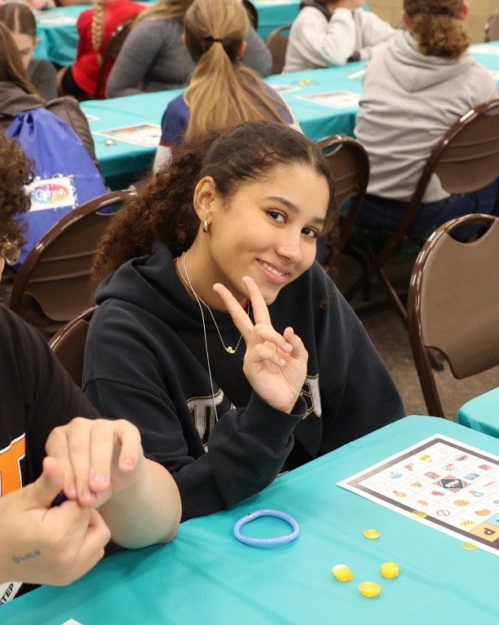 | Be the friend who hypes everyone up. We all need one! @IowaSTEP #ISTEP #IowaSTEP #NoTobacco #TobaccoFreeGeneration #StudentLeaders #TobaccoFree #VapeFree #StopVaping #HealthyLungs #KnowTheFacts #YouthToday #StudentSupport #YouthVoice #TeensSupportTeens
May 22 | 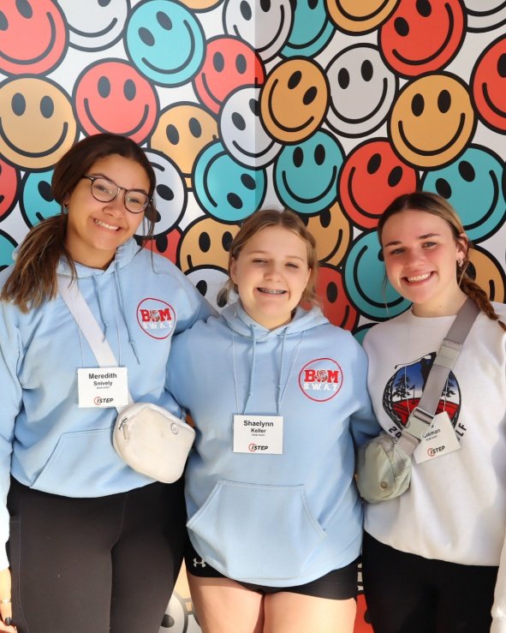 | When we support each other, amazing things happen! Join the movement at hhs.iowa.gov/istep to support other teens across Iowa. @IowaSTEP #ISTEP #IowaSTEP #NoTobacco #TobaccoFreeGeneration #StudentLeaders #TobaccoFree #VapeFree #StopVaping #HealthyLungs #KnowTheFacts #YouthToday #StudentSupport #YouthVoice #TeensSupportTeens
May 23 | Saturday
May 24 | Sunday
May 25
May 26 | 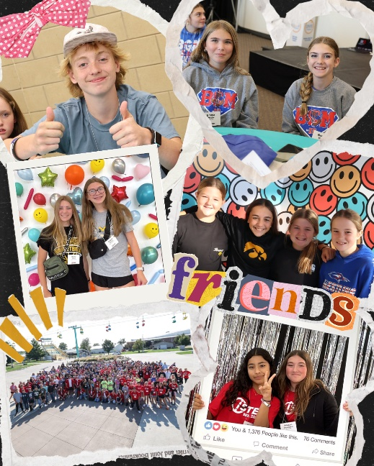 | Empowering others doesn’t dim your light – it brightens the whole room! Get involved in #ISTEP at hhs.iowa.gov/istep. @IowaSTEP #IowaSTEP #NoTobacco #TobaccoFreeGeneration #StudentLeaders #TobaccoFree #VapeFree #StopVaping #HealthyLungs #KnowTheFacts #YouthToday #StudentSupport #YouthVoice #TeensSupportTeens
May 27
May 28 |  | You never know who needs your smile today. Share it freely! Make a difference at hhs.iowa.gov/istep. @IowaSTEP #ISTEP #IowaSTEP #NoTobacco #TobaccoFreeGeneration #StudentLeaders #TobaccoFree #VapeFree #StopVaping #HealthyLungs #KnowTheFacts #YouthToday #StudentSupport #YouthVoice #TeensSupportTeens
May 29
May 30 | Saturday
May 31 | Sunday

