Master FY26 ISTEP Social Schedule
Purpose: Below are ISTEP graphics and caption ideas for your social media accounts. These are only ideas, with the goal to make social posts easier on you. The dates listed are when the ISTEP Facebook/Instagram will be posting these specific items, however you can post them whenever you like.

Instructions: Tag @IowaSTEP in all posts. Download the graphics, then copy and paste the caption from this document.

Recommended hashtags: @IowaSTEP #ISTEP #IowaSTEP #NoTobacco #TobaccoFreeGeneration #StudentLeaders #TobaccoFree #VapeFree #StopVaping #HealthyLungs #KnowTheFacts #YouthToday #StudentSupport #YouthVoice #TeensSupportTeens
Date | Graphic | Caption
June 2026
June 1
June 2 | 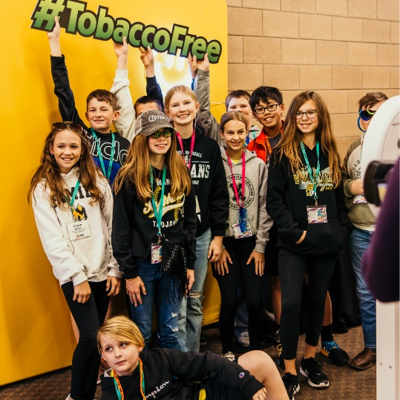 | Healthy habits hit different when your whole squad joins in. Learn more at hhs.iowa.gov/istep. @IowaSTEP #ISTEP #IowaSTEP #NoTobacco #TobaccoFreeGeneration #StudentLeaders #TobaccoFree #VapeFree #StopVaping #HealthyLungs #KnowTheFacts #YouthToday #StudentSupport #YouthVoice #TeensSupportTeens
June 3
June 4
June 5 |  | Iowa students for…  Making healthy choices.  Influencing your peers.  Empowering your friends.  Making a difference!  @IowaSTEP #ISTEP #IowaSTEP #NoTobacco #TobaccoFreeGeneration #StudentLeaders #TobaccoFree #VapeFree #StopVaping #HealthyLungs #KnowTheFacts #YouthToday #StudentSupport #YouthVoice #TeensSupportTeens
June 6 | Saturday
June 7 | Sunday
June 8
June 9 |  | Being positive is contagious. Be the friend who people love being around. @IowaSTEP #ISTEP #IowaSTEP #NoTobacco #TobaccoFreeGeneration #StudentLeaders #TobaccoFree #VapeFree #StopVaping #HealthyLungs #KnowTheFacts #YouthToday #StudentSupport #YouthVoice #TeensSupportTeens
June 10
June 11 |  | Healthy choices today build the Iowa you want tomorrow. Let’s make it a good one. Learn more about ISTEP at hhs.iowa.gov. @IowaSTEP #ISTEP #IowaSTEP #NoTobacco #TobaccoFreeGeneration #StudentLeaders #TobaccoFree #VapeFree #StopVaping #HealthyLungs #KnowTheFacts #YouthToday #StudentSupport #YouthVoice #TeensSupportTeens
June 12
June 13 | Saturday
June 14 | Sunday
June 15 | 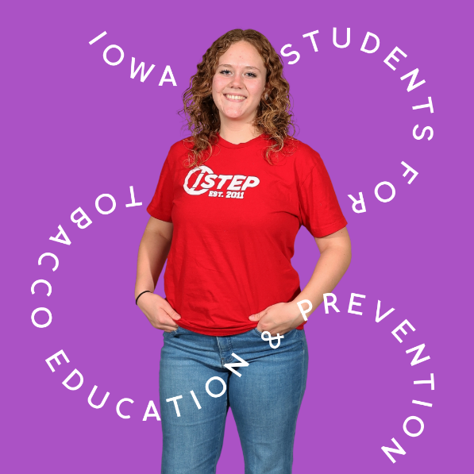 | Choosing healthy habits isn’t boring—it’s a power move. Lead the way, ISTEP! @IowaSTEP #ISTEP #IowaSTEP #NoTobacco #TobaccoFreeGeneration #StudentLeaders #TobaccoFree #VapeFree #StopVaping #HealthyLungs #KnowTheFacts #YouthToday #StudentSupport #YouthVoice #TeensSupportTeens
June 16
June 17 | 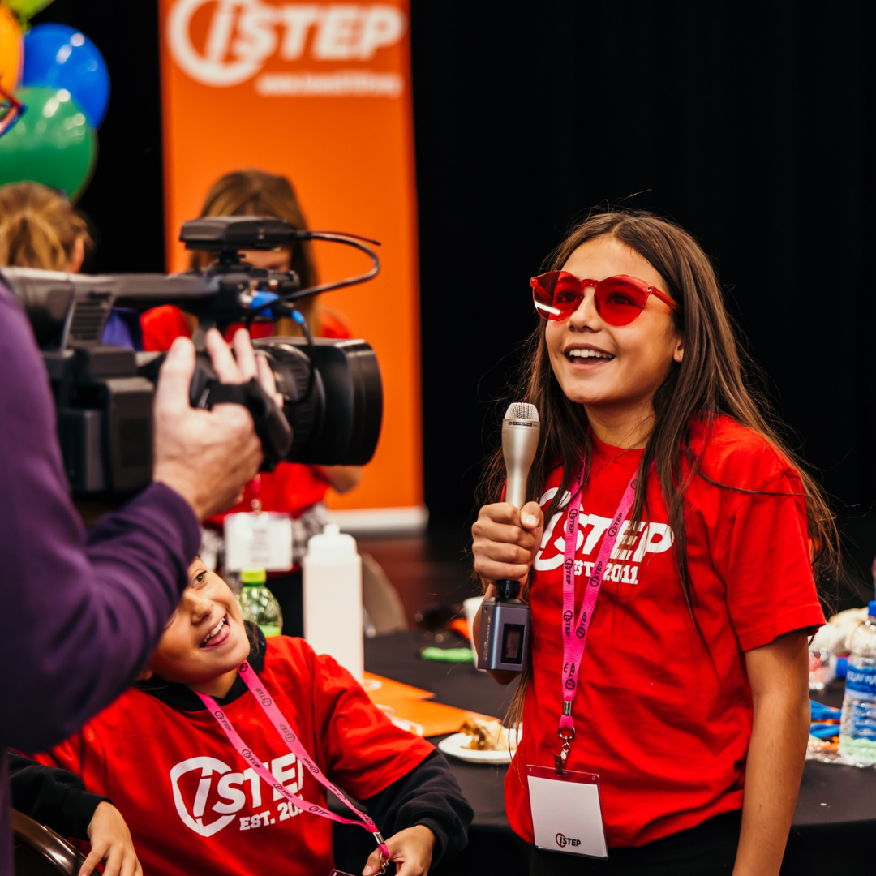 | Your choices influence your crew—make ones worth copying. @IowaSTEP #ISTEP #IowaSTEP #NoTobacco #TobaccoFreeGeneration #StudentLeaders #TobaccoFree #VapeFree #StopVaping #HealthyLungs #KnowTheFacts #YouthToday #StudentSupport #YouthVoice #TeensSupportTeens
June 18
June 19
June 20 | Saturday
June 21 | Sunday
June 22 | 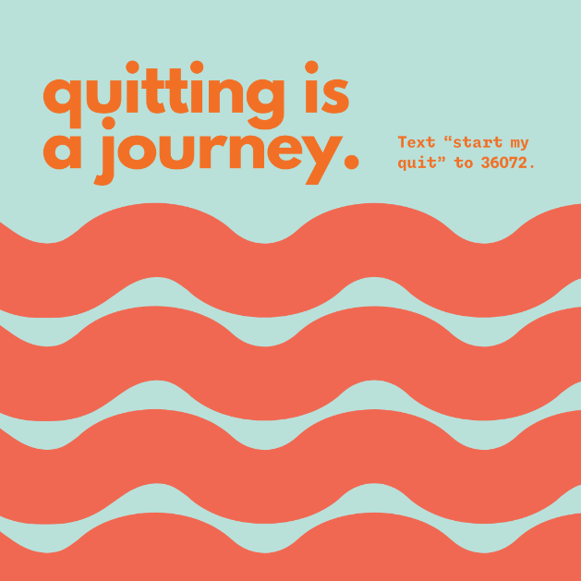 | Your future self is silently fist-bumping every healthy choice you make. Text “Start My Quit” to 36072 for free support quitting vaping.  @IowaSTEP #ISTEP #IowaSTEP #NoTobacco #TobaccoFreeGeneration #StudentLeaders #TobaccoFree #VapeFree #StopVaping #HealthyLungs #KnowTheFacts #YouthToday #StudentSupport #YouthVoice #TeensSupportTeens
June 23
June 24
June 25 |  | Healthy choices aren’t about being perfect—they’re about being good to yourself. Set yourself up for success by joining ISTEP! @IowaSTEP #ISTEP #IowaSTEP #NoTobacco #TobaccoFreeGeneration #StudentLeaders #TobaccoFree #VapeFree #StopVaping #HealthyLungs #KnowTheFacts #YouthToday #StudentSupport #YouthVoice #TeensSupportTeens
June 26 |  | Be the friend who says “Let’s do something good for us.” Join ISTEP to make a difference in Iowa. @IowaSTEP #ISTEP #IowaSTEP #NoTobacco #TobaccoFreeGeneration #StudentLeaders #TobaccoFree #VapeFree #StopVaping #HealthyLungs #KnowTheFacts #YouthToday #StudentSupport #YouthVoice #TeensSupportTeens
June 27 | Saturday
June 28 | Sunday
June 29
June 30 | 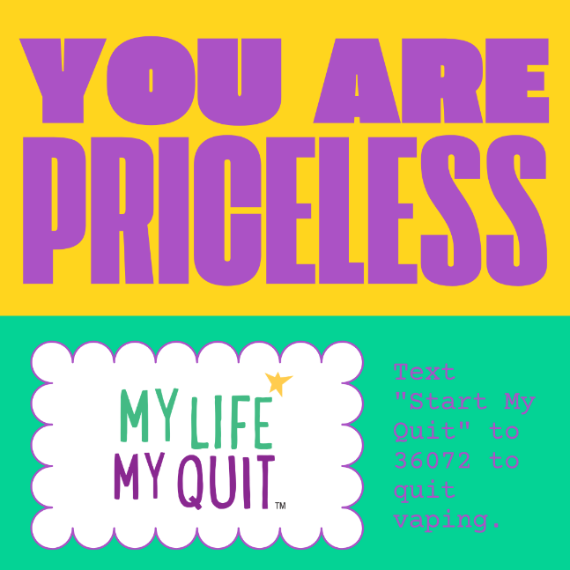 | Take care of yourself—it’s the trend that never dies. Text “Start My Quit” to 36072 to quit vaping. @IowaSTEP #ISTEP #IowaSTEP #NoTobacco #TobaccoFreeGeneration #StudentLeaders #TobaccoFree #VapeFree #StopVaping #HealthyLungs #KnowTheFacts #YouthToday #StudentSupport #YouthVoice #TeensSupportTeens

