Master FY27 ISTEP Social Schedule
Purpose: Below are ISTEP graphics and caption ideas for your social media accounts. These are only ideas, with the goal to make social posts easier on you. The dates listed are when the ISTEP Facebook/Instagram will be posting these specific items, however you can post them whenever you like.

Instructions: Tag @IowaSTEP in all posts. Download the graphics, then copy and paste the caption from this document.

Recommended hashtags: @IowaSTEP #ISTEP #IowaSTEP #YouthToday #StudentSupport #YouthVoice #TeensSupportTeens #StudentLeaders #MentalHealthMatters #SuicidePrevention #StayAnotherDay #TobaccoFreeGeneration #TobaccoFree #VapeFree #DrugFree #AlcoholFree #HealthyChoices #KnowTheFacts
Date | Graphic | Caption
October 2026
October 1 | 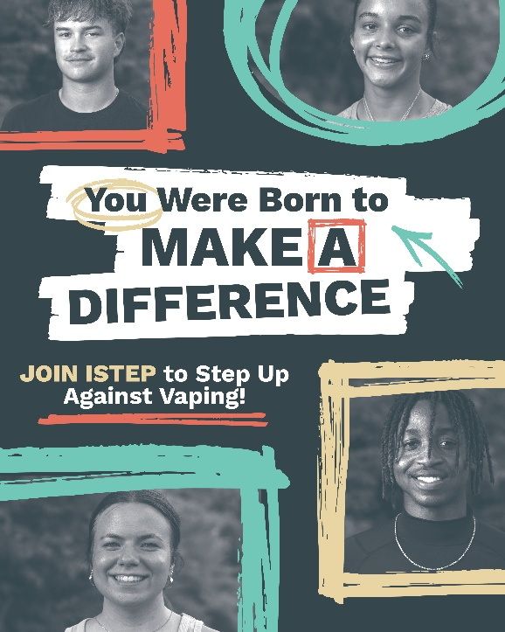 | Help make a difference in your community by letting others know the true harms of vaping. Join Iowa Students Together Empowering Peers, a statewide movement made up of youth in grades 7 through 12.  Find an ISTEP chapter near you: hhs.iowa.gov/istep  @IowaSTEP #ISTEP #IowaSTEP #YouthToday #StudentSupport #YouthVoice #TeensSupportTeens #StudentLeaders #MentalHealthMatters #SuicidePrevention #StayAnotherDay #TobaccoFreeGeneration #TobaccoFree #VapeFree #DrugFree #AlcoholFree #HealthyChoices #KnowTheFacts
October 2
October 3 | Saturday
October 4 | Sunday
October 5 | 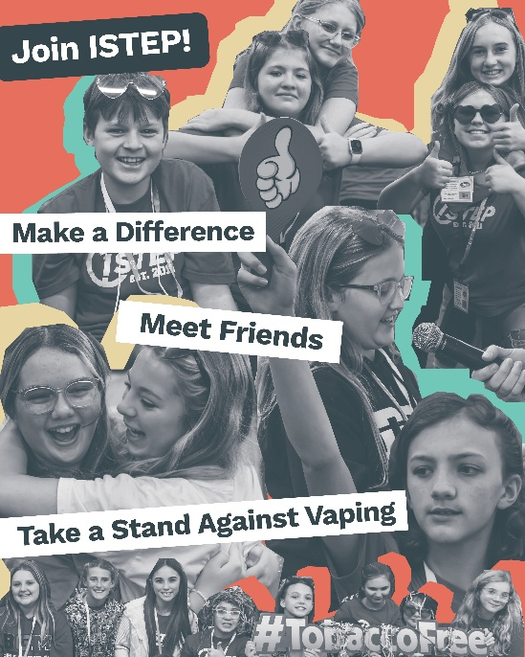 | Looking for an extracurricular where you can meet friends, have fun and make a difference? Then check out Iowa Students Together Empowering Peers!  Learn more at: hhs.iowa.gov/istep  @IowaSTEP #ISTEP #IowaSTEP #YouthToday #StudentSupport #YouthVoice #TeensSupportTeens #StudentLeaders #MentalHealthMatters #SuicidePrevention #StayAnotherDay #TobaccoFreeGeneration #TobaccoFree #VapeFree #DrugFree #AlcoholFree #HealthyChoices #KnowTheFacts
October 6
October 7 | 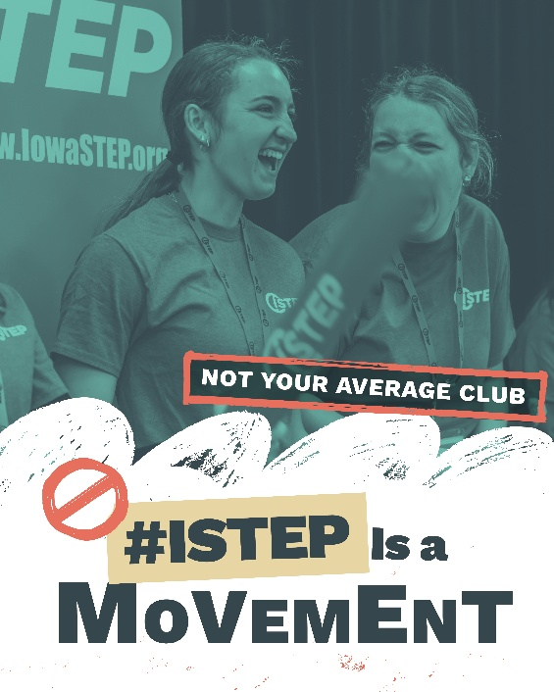 | Teens across Iowa are leading the way in creating healthier communities and promoting positive mental well-being. Want to get involved? Check us out at: hhs.iowa.gov/istep  @IowaSTEP #ISTEP #IowaSTEP #YouthToday #StudentSupport #YouthVoice #TeensSupportTeens #StudentLeaders #MentalHealthMatters #SuicidePrevention #StayAnotherDay #TobaccoFreeGeneration #TobaccoFree #VapeFree #DrugFree #AlcoholFree #HealthyChoices #KnowTheFacts
October 8 |  | Feeling overwhelmed with everything on your plate? Same here. But at #ISTEP, we get what it’s like to be a teen leader—and we know it can be a lot.  Just a quick reminder: You’ve got this. Keep going. Keep leading. Keep empowering.  We’re in this together! 💪✨  @IowaSTEP #IowaSTEP #YouthToday #StudentSupport #YouthVoice #TeensSupportTeens #StudentLeaders #MentalHealthMatters #SuicidePrevention #StayAnotherDay #TobaccoFreeGeneration #TobaccoFree #VapeFree #DrugFree #AlcoholFree #HealthyChoices #KnowTheFacts
October 9
October 10 | Saturday
October 11 | Sunday
October 12
October 13 | 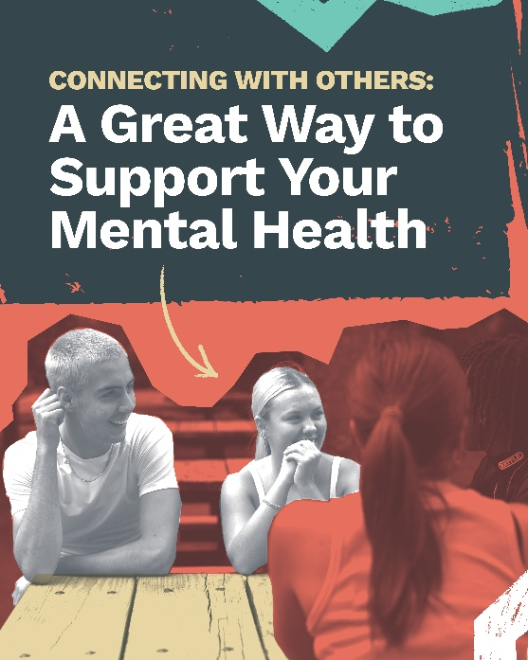 | When you join #ISTEP, you'll make a difference in your community while making all kinds of friends. Talk about a positive impact on your mental health! Check out ISTEP: hhs.iowa.gov/istep  @IowaSTEP #IowaSTEP #YouthToday #StudentSupport #YouthVoice #TeensSupportTeens #StudentLeaders #MentalHealthMatters #SuicidePrevention #StayAnotherDay #TobaccoFreeGeneration #TobaccoFree #VapeFree #DrugFree #AlcoholFree #HealthyChoices #KnowTheFacts
October 14
October 15 | 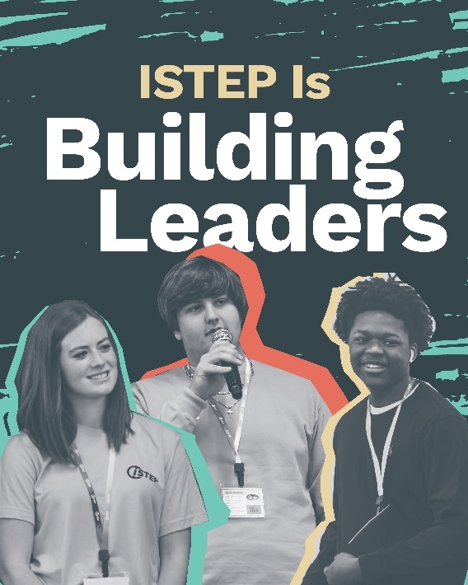 | Join #ISTEP to connect with teens across Iowa, build leadership skills, and learn how to take action in your community. Don’t miss this opportunity to get involved.  Join today! Find a local chapter: https://hhs.iowa.gov/istep  @IowaSTEP #IowaSTEP #YouthToday #StudentSupport #YouthVoice #TeensSupportTeens #StudentLeaders #MentalHealthMatters #SuicidePrevention #StayAnotherDay #TobaccoFreeGeneration #TobaccoFree #VapeFree #DrugFree #AlcoholFree #HealthyChoices #KnowTheFacts
October 16
October 17 | Saturday
October 18 | Sunday
October 19 | 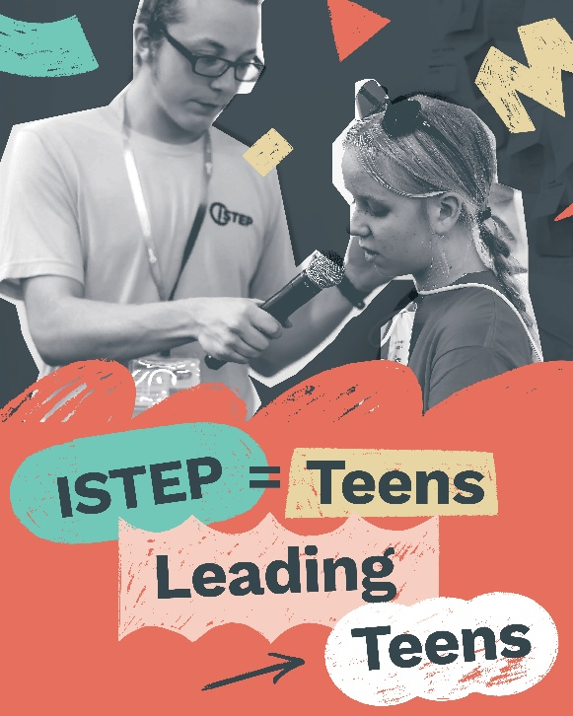 | When young people lead, communities change. #ISTEP is a youth-led program where Iowa teens are taking action.  Join today! Find a local chapter: hhs.iowa.gov/istep  @IowaSTEP #IowaSTEP #YouthToday #StudentSupport #YouthVoice #TeensSupportTeens #StudentLeaders #MentalHealthMatters #SuicidePrevention #StayAnotherDay #TobaccoFreeGeneration #TobaccoFree #VapeFree #DrugFree #AlcoholFree #HealthyChoices #KnowTheFacts
October 20
October 21 | 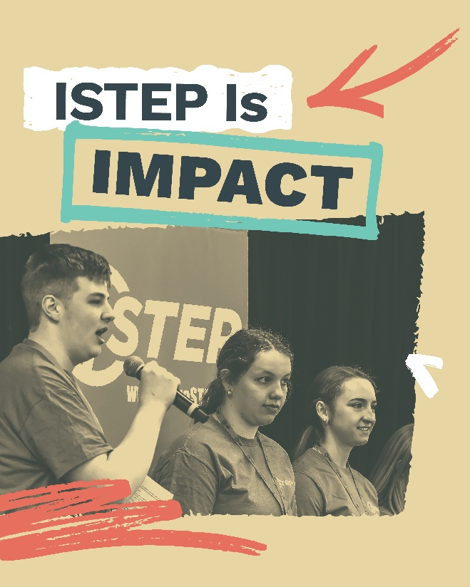 | Learning, connecting and leading define #ISTEP. It’s where teens from across Iowa come together to gain the tools and confidence to help their communities make healthy choices.  @IowaSTEP #IowaSTEP #YouthToday #StudentSupport #YouthVoice #TeensSupportTeens #StudentLeaders #MentalHealthMatters #SuicidePrevention #StayAnotherDay #TobaccoFreeGeneration #TobaccoFree #VapeFree #DrugFree #AlcoholFree #HealthyChoices #KnowTheFacts
October 22
October 23 | 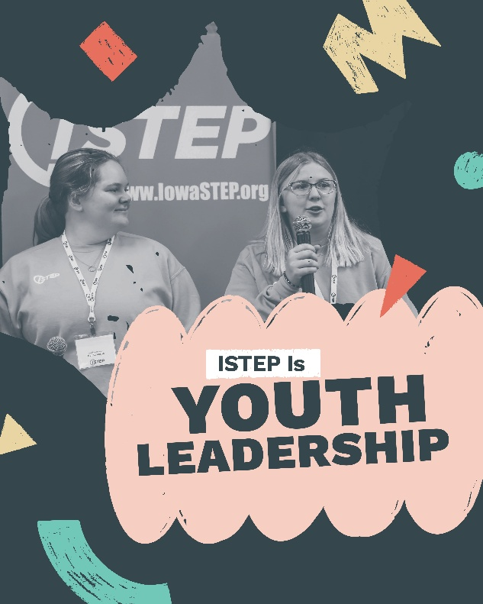 | Youth led.  Statewide.  Making an impact.  #ISTEP teens are creating a healthier future for Iowa by promoting healthy choices and supporting mental well-being.  @IowaSTEP #IowaSTEP #YouthToday #StudentSupport #YouthVoice #TeensSupportTeens #StudentLeaders #MentalHealthMatters #SuicidePrevention #StayAnotherDay #TobaccoFreeGeneration #TobaccoFree #VapeFree #DrugFree #AlcoholFree #HealthyChoices #KnowTheFacts
October 24 | Saturday
October 25 | Sunday
October 26
October 27 | 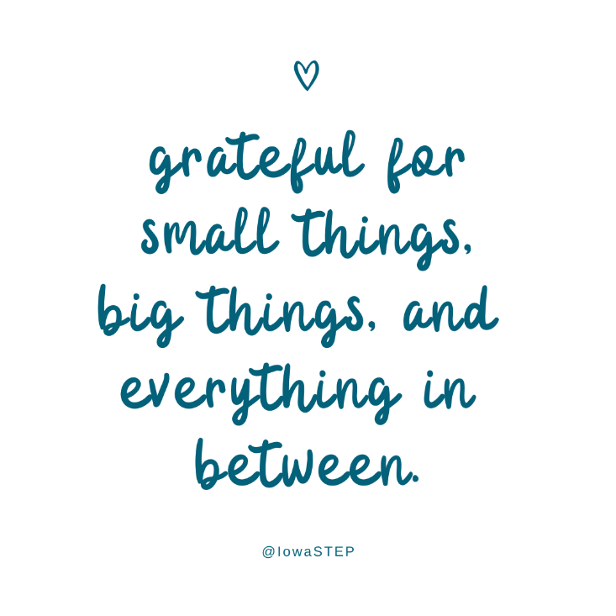 | At #ISTEP, we’re grateful for the little things, the big things, and everything in between. We know life as a teen comes with ups and downs — and that’s totally normal. Just remember: one bad day doesn’t mean a bad life. 💛✨  #Grateful #Thanksful #Blessed  @IowaSTEP #ISTEP #IowaSTEP #YouthToday #StudentSupport #YouthVoice #TeensSupportTeens #StudentLeaders #MentalHealthMatters #SuicidePrevention #StayAnotherDay #TobaccoFreeGeneration #TobaccoFree #VapeFree #DrugFree #AlcoholFree #HealthyChoices #KnowTheFacts
October 28
October 29 | 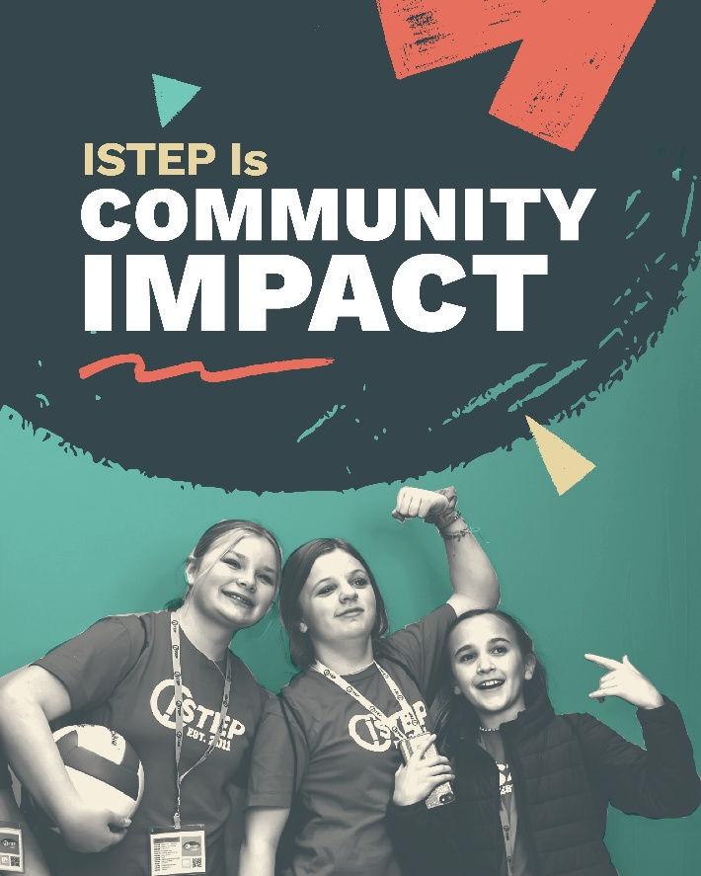 | From small steps to community-wide efforts, #ISTEP teens are helping make healthy living the norm across Iowa. Take local action and create supportive, healthier environments at hhs.iowa.gov/istep.  @IowaSTEP #IowaSTEP #YouthToday #StudentSupport #YouthVoice #TeensSupportTeens #StudentLeaders #MentalHealthMatters #SuicidePrevention #StayAnotherDay #TobaccoFreeGeneration #TobaccoFree #VapeFree #DrugFree #AlcoholFree #HealthyChoices #KnowTheFacts
October 30 | 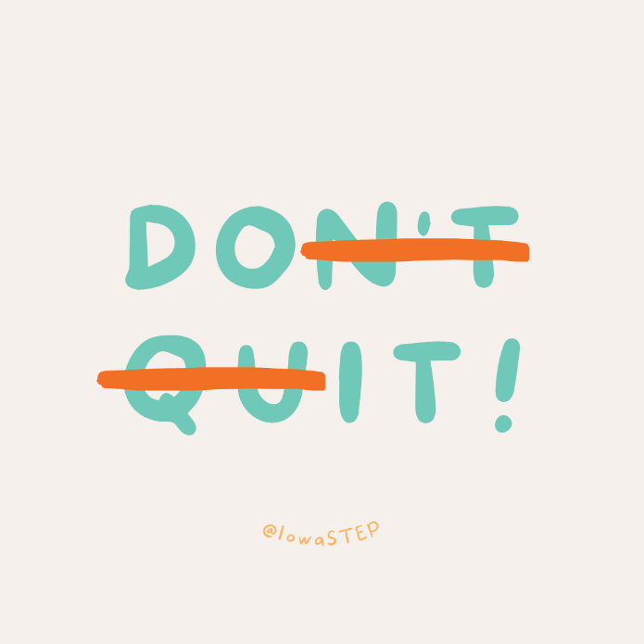 | Thinking about quitting vaping? Do it! You don’t have to wait — you can start today. Text “start my quit” to 36072 for free, confidential support. You don’t have to do it alone.  @IowaSTEP #ISTEP #IowaSTEP #YouthToday #StudentSupport #YouthVoice #TeensSupportTeens #StudentLeaders #MentalHealthMatters #SuicidePrevention #StayAnotherDay #TobaccoFreeGeneration #TobaccoFree #VapeFree #DrugFree #AlcoholFree #HealthyChoices #KnowTheFacts
October 31 | Saturday

