Master FY27 ISTEP Social Schedule
Purpose: Below are ISTEP graphics and caption ideas for your social media accounts. These are only ideas, with the goal to make social posts easier on you. The dates listed are when the ISTEP Facebook/Instagram will be posting these specific items, however you can post them whenever you like.

Instructions: Tag @IowaSTEP in all posts. Download the graphics, then copy and paste the caption from this document.

Recommended hashtags: @IowaSTEP #ISTEP #IowaSTEP #NoTobacco #TobaccoFreeGeneration #StudentLeaders #TobaccoFree #VapeFree #StopVaping #HealthyLungs #KnowTheFacts #YouthToday #StudentSupport #YouthVoice #TeensSupportTeens
Date | Graphic | Caption
September 2026
September 1 | 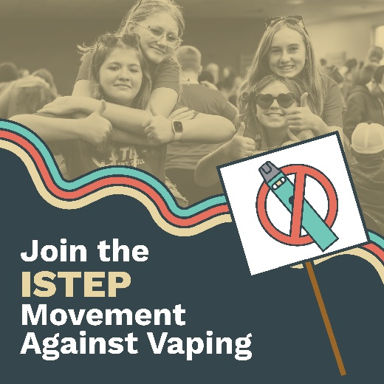 | Feeling our best means being vape free! And, we wouldn’t want it any other way! That’s why we stand up against vaping. Join #ISTEP today at hhs.iowa.gov/istep  @IowaSTEP #ISTEP #IowaSTEP #NoTobacco #TobaccoFreeGeneration #StudentLeaders #TobaccoFree #VapeFree #StopVaping #HealthyLungs #KnowTheFacts #YouthToday #StudentSupport #YouthVoice #TeensSupportTeens
September 2
September 3 | 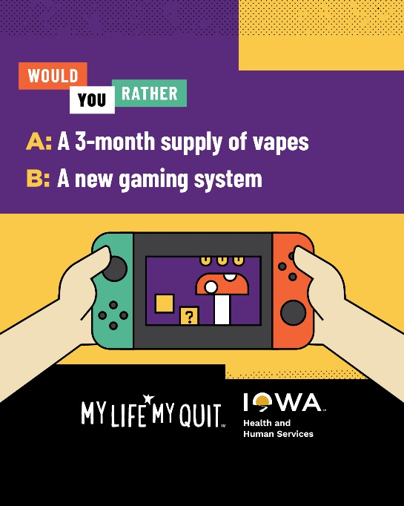 | Vaping costs really add up, with teens spending as much as $500 a month. How many concert tickets, pairs of shoes, video games and <insert whatever you love here> could that money buy. Get free, confidential help quitting: ia.mylifemyquit.org  @IowaSTEP #ISTEP #IowaSTEP #NoTobacco #TobaccoFreeGeneration #StudentLeaders #TobaccoFree #VapeFree #StopVaping #HealthyLungs #KnowTheFacts #YouthToday #StudentSupport #YouthVoice #TeensSupportTeens
September 4
September 5 | Saturday
September 6 | Sunday
September 7
September 8 |  | Have fun, make new friends and step up to make a difference where you live. Learn more about #ISTEP in your community at hhs.iowa.gov/istep.  @IowaSTEP #ISTEP #IowaSTEP #NoTobacco #TobaccoFreeGeneration #StudentLeaders #TobaccoFree #VapeFree #StopVaping #HealthyLungs #KnowTheFacts #YouthToday #StudentSupport #YouthVoice #TeensSupportTeens
September 9
September 10
September 11 | 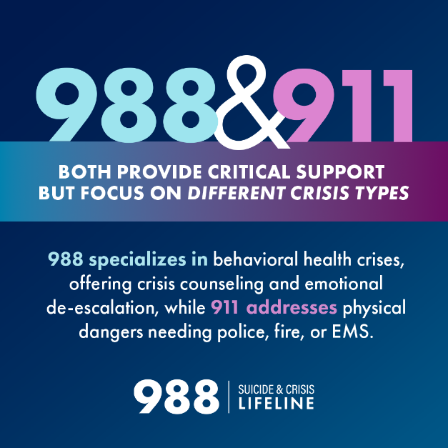 | Need help but not sure who to call?  - Text, call, or chat 988 for help with #mentalhealth, #suicide, and substance use problems.  - Call 911 for emergencies involving immediate physical danger.  Knowing the right number can make all the difference.  @IowaSTEP #ISTEP #IowaSTEP #NoTobacco #TobaccoFreeGeneration #StudentLeaders #TobaccoFree #VapeFree #StopVaping #HealthyLungs #KnowTheFacts #YouthToday #StudentSupport #YouthVoice #TeensSupportTeens
September 12 | Saturday
September 13 | Sunday
September 14
September 15 |  | Letting go of mental clutter opens the door to fresh ideas and new beginnings.  Breathe free, think free! Learn more at: hhs.iowa.gov/istep  @IowaSTEP #ISTEP #IowaSTEP #NoTobacco #TobaccoFreeGeneration #StudentLeaders #TobaccoFree #VapeFree #StopVaping #HealthyLungs #KnowTheFacts #YouthToday #StudentSupport #YouthVoice #TeensSupportTeens
September 16
September 17
September 18 | 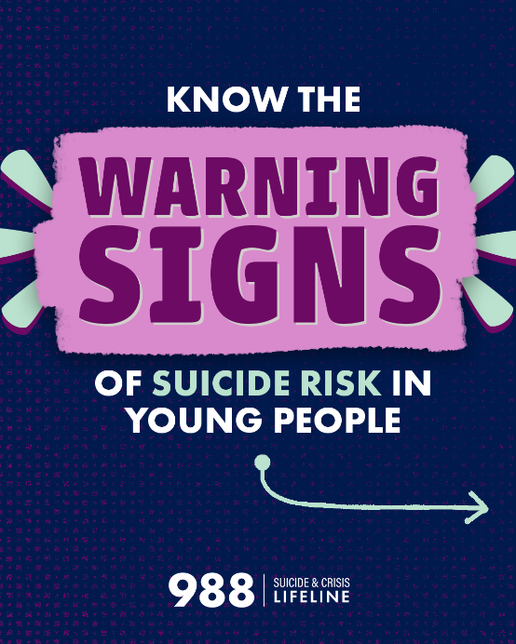  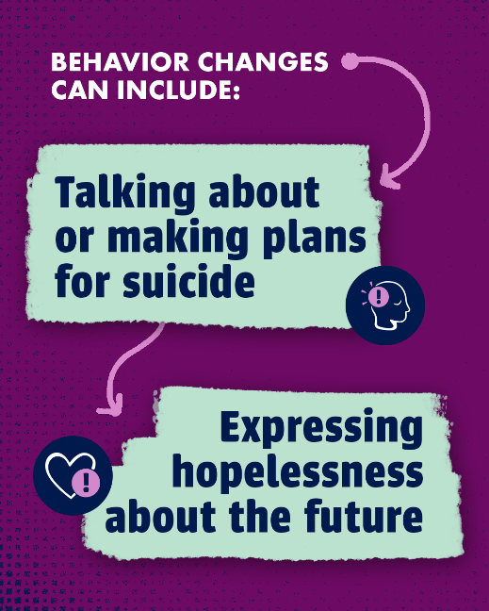  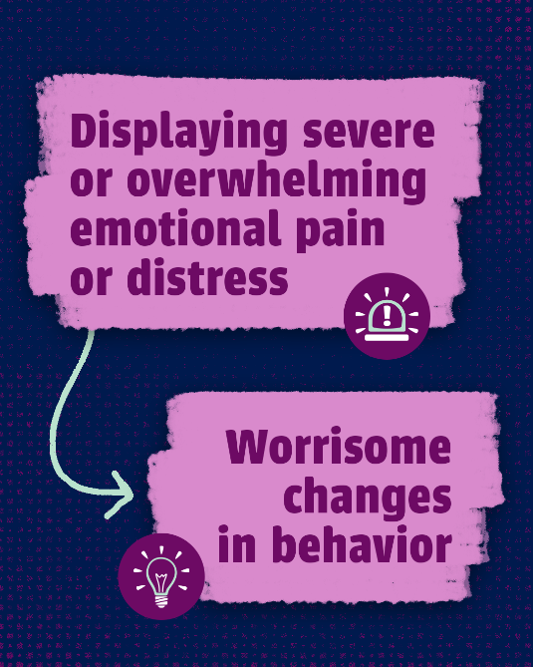  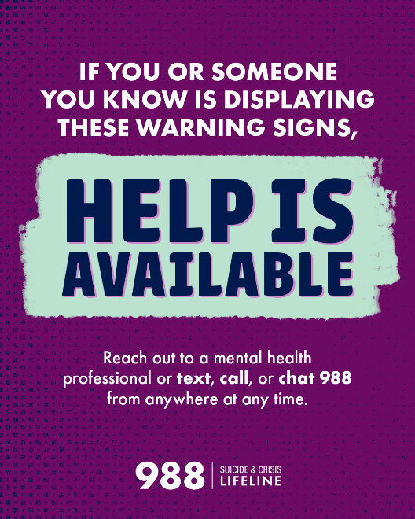 | If you or someone you know is displaying these warning signs, help is available. Reach out to a mental health professional or text, call, or chat 988 from anywhere at any time.  @IowaSTEP #ISTEP #IowaSTEP #NoTobacco #TobaccoFreeGeneration #StudentLeaders #TobaccoFree #VapeFree #StopVaping #HealthyLungs #KnowTheFacts #YouthToday #StudentSupport #YouthVoice #TeensSupportTeens
September 19 | Saturday
September 20 | Sunday
September 21 | 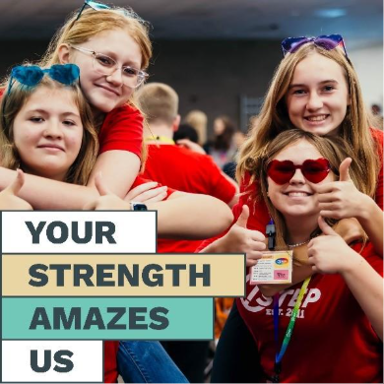 | Choosing what’s healthy isn’t always easy—but that’s what makes your strength stand out. Keep being amazing – join ISTEP today at hhs.iowa.gov/istep.  @IowaSTEP #ISTEP #IowaSTEP #NoTobacco #TobaccoFreeGeneration #StudentLeaders #TobaccoFree #VapeFree #StopVaping #HealthyLungs #KnowTheFacts #YouthToday #StudentSupport #YouthVoice #TeensSupportTeens
September 22
September 23
September 24 | 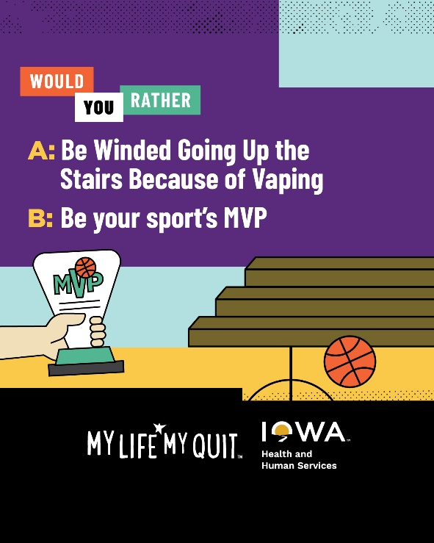 | By quitting vaping and other tobacco products, you can improve your health, self-esteem and more. My Life, My Quit is here with free, confidential support: ia.mylifemyquit.org  @IowaSTEP #ISTEP #IowaSTEP #NoTobacco #TobaccoFreeGeneration #StudentLeaders #TobaccoFree #VapeFree #StopVaping #HealthyLungs #KnowTheFacts #YouthToday #StudentSupport #YouthVoice #TeensSupportTeens
September 25
September 26 | Saturday
September 27 | Sunday
September 28 | 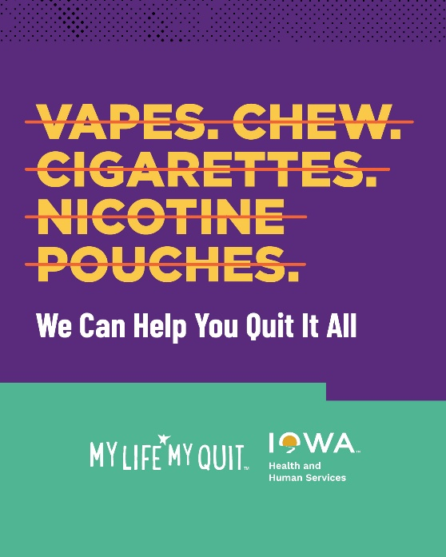 | With My Life, My Quit, you get free, confidential support from people who get you and what you’re going through. It only takes a few minutes to start your quitting journey: ia.mylifemyquit.org  @IowaSTEP #ISTEP #IowaSTEP #NoTobacco #TobaccoFreeGeneration #StudentLeaders #TobaccoFree #VapeFree #StopVaping #HealthyLungs #KnowTheFacts #YouthToday #StudentSupport #YouthVoice #TeensSupportTeens
September 29
September 30 |  | Your choices inspire more people than you realize. Keep being the positive influence your friends look up to.  @IowaSTEP #ISTEP #IowaSTEP #NoTobacco #TobaccoFreeGeneration #StudentLeaders #TobaccoFree #VapeFree #StopVaping #HealthyLungs #KnowTheFacts #YouthToday #StudentSupport #YouthVoice #TeensSupportTeens

