Master FY27 ISTEP Social Schedule
Purpose: Below are ISTEP graphics and caption ideas for your social media accounts. These are only ideas, with the goal to make social posts easier on you. The dates listed are when the ISTEP Facebook/Instagram will be posting these specific items, however you can post them whenever you like.

Instructions: Tag @IowaSTEP in all posts. Download the graphics, then copy and paste the caption from this document.

Recommended hashtags: @IowaSTEP #ISTEP #IowaSTEP #NoTobacco #TobaccoFreeGeneration #StudentLeaders #TobaccoFree #VapeFree #StopVaping #HealthyLungs #KnowTheFacts #YouthToday #StudentSupport #YouthVoice #TeensSupportTeens
Date | Graphic | Caption
July 2026
July 1 | 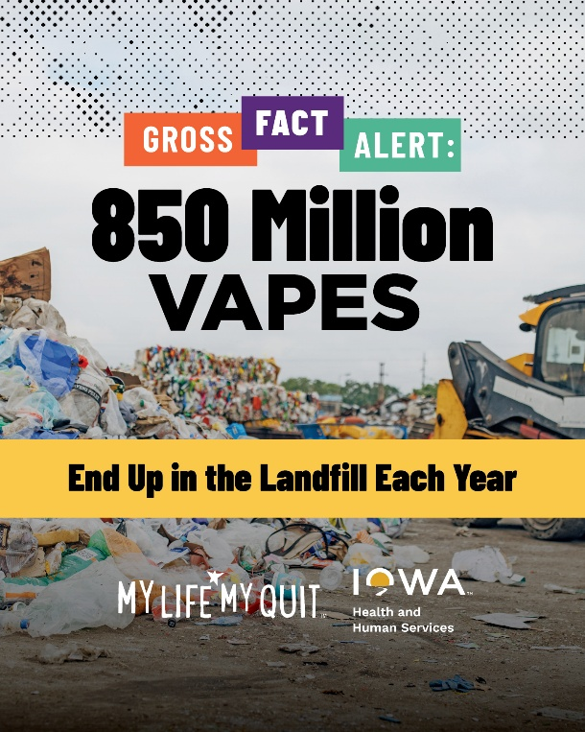 | Quitting vaping is good for your health — and the environment. My Life, My Quit offers free, confidential support to help you quit. Text “Start My Quit” to 36072 or start chatting now: ia.mylifemyquit.org  @IowaSTEP #ISTEP #IowaSTEP #NoTobacco #TobaccoFreeGeneration #StudentLeaders #TobaccoFree #VapeFree #StopVaping #HealthyLungs #KnowTheFacts #YouthToday #StudentSupport #YouthVoice #TeensSupportTeens
July 2
July 3 |   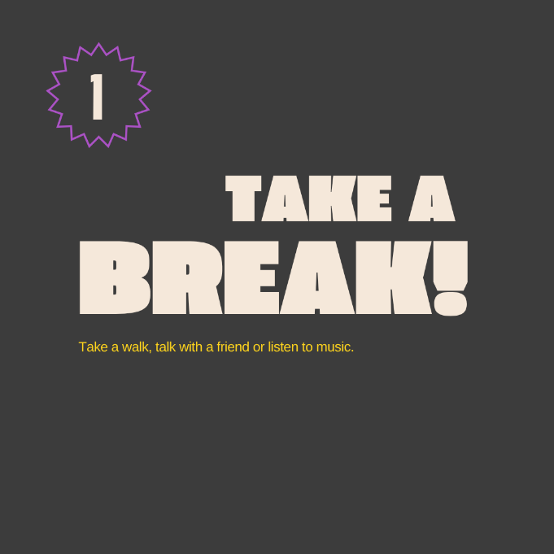    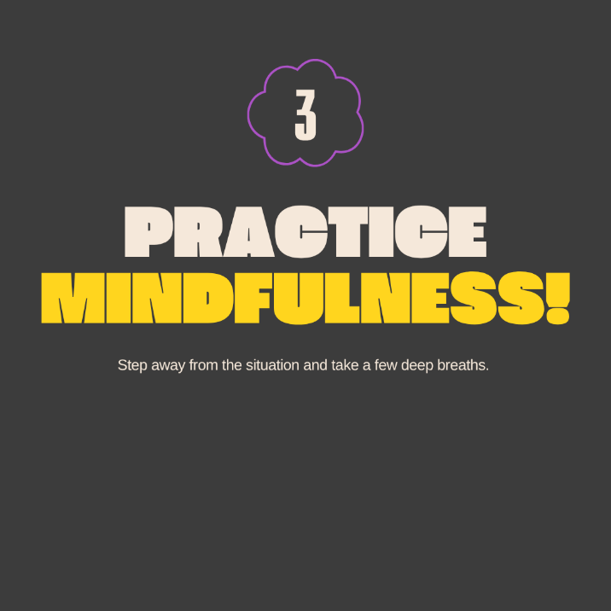    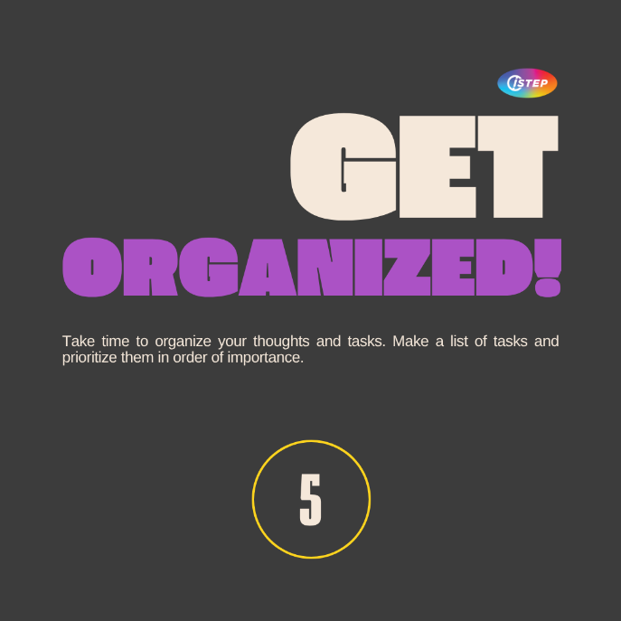 | Even on the busiest days, a quick mental reset can change everything. @IowaSTEP #ISTEP #IowaSTEP #NoTobacco #TobaccoFreeGeneration #StudentLeaders #TobaccoFree #VapeFree #StopVaping #HealthyLungs #KnowTheFacts #YouthToday #StudentSupport #YouthVoice #TeensSupportTeens
July 4 | Saturday
July 5 | Sunday
July 6 |  | @IowaSTEP youth make friends and make a difference, all while learning new leadership skills along the way. Join today at hhs.iowa.gov/istep. #ISTEP #IowaSTEP #NoTobacco #TobaccoFreeGeneration #StudentLeaders #TobaccoFree #VapeFree #StopVaping #HealthyLungs #KnowTheFacts #YouthToday #StudentSupport #YouthVoice #TeensSupportTeens
July 7
July 8 | 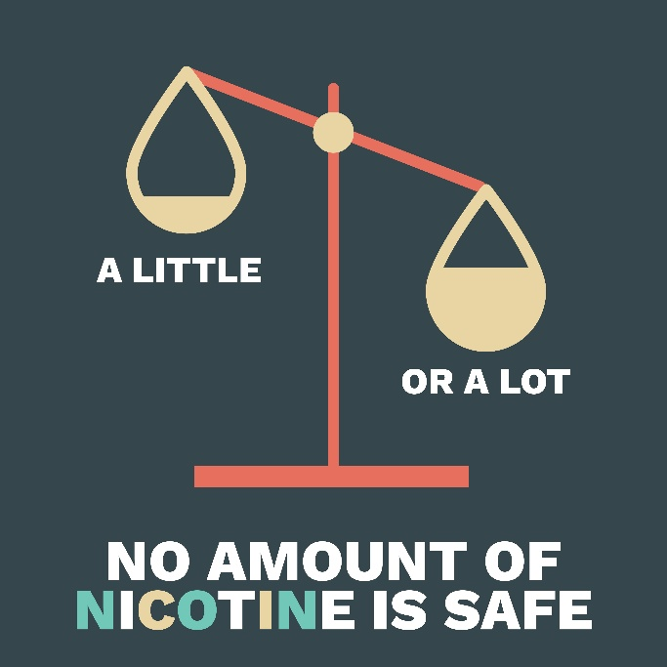 | Not even a tiny bit of nicotine is safe. Protect your health, protect your future. @IowaSTEP #ISTEP #IowaSTEP #NoTobacco #TobaccoFreeGeneration #StudentLeaders #TobaccoFree #VapeFree #StopVaping #HealthyLungs #KnowTheFacts #YouthToday #StudentSupport #YouthVoice #TeensSupportTeens
July 9
July 10 | 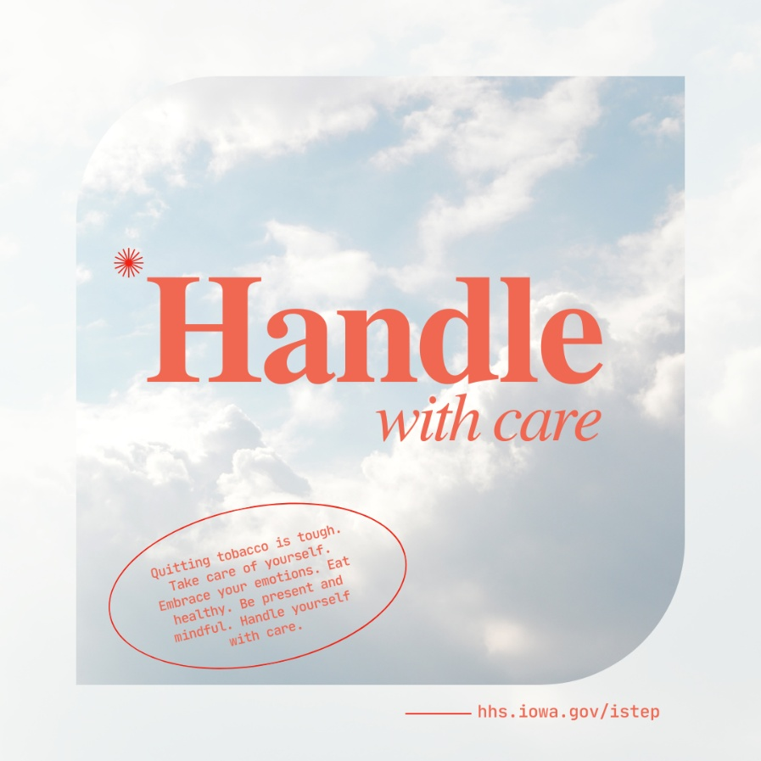 | Handle with care when quitting tobacco - it’s tough! Embrace your emotions. Eat healthy. Be present and mindful. Take it one day at a time. You got this! @IowaSTEP #ISTEP #IowaSTEP #NoTobacco #TobaccoFreeGeneration #StudentLeaders #TobaccoFree #VapeFree #StopVaping #HealthyLungs #KnowTheFacts #YouthToday #StudentSupport #YouthVoice #TeensSupportTeens
July 11 | Saturday
July 12 | Sunday
July 13
July 14 | 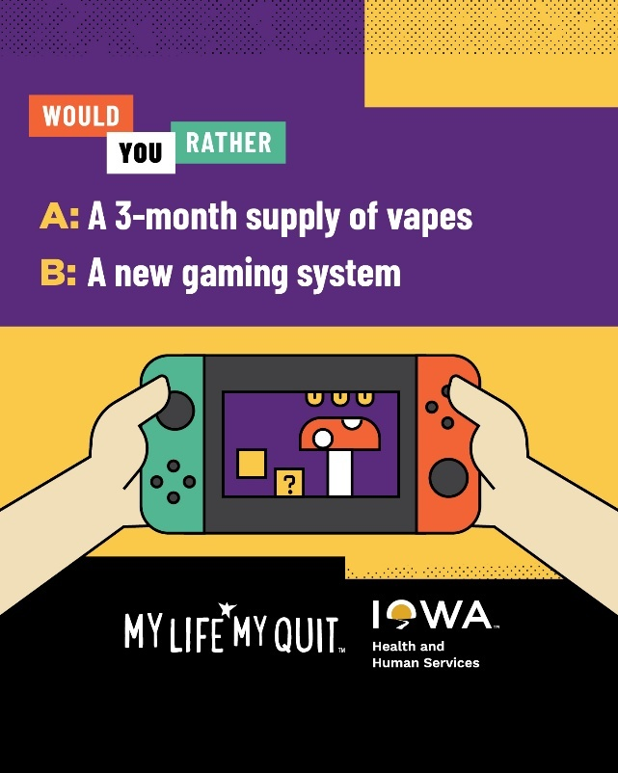 | Vaping costs really add up, with teens spending as much as $500 a month. How many concert tickets, pairs of shoes, video games and <insert whatever you love here> could that money buy. Get free, confidential help quitting: ia.mylifemyquit.org  @IowaSTEP #ISTEP #IowaSTEP #NoTobacco #TobaccoFreeGeneration #StudentLeaders #TobaccoFree #VapeFree #StopVaping #HealthyLungs #KnowTheFacts #YouthToday #StudentSupport #YouthVoice #TeensSupportTeens
July 15
July 16 | 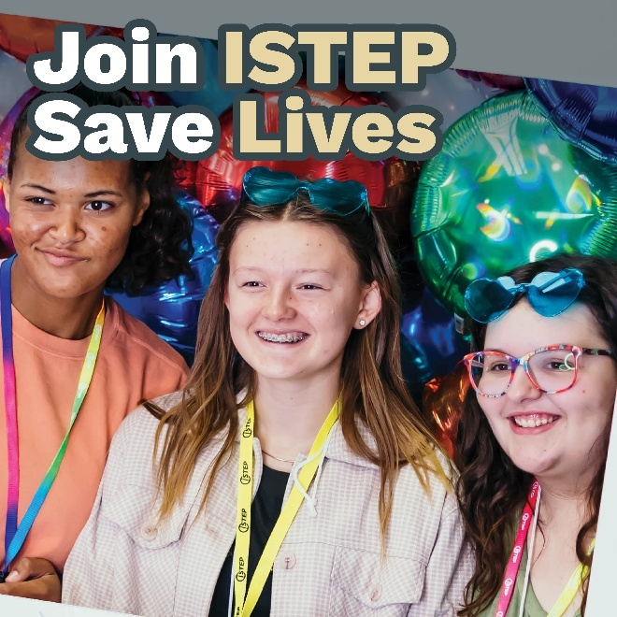 | We step up for ourselves, friends and family to have a healthy future. Join us today in making a difference in the lives of Iowans! Learn more at hhs.iowa.gov/istep. #ISTEP #IowaSTEP #NoTobacco #TobaccoFreeGeneration #StudentLeaders #TobaccoFree #VapeFree #StopVaping #HealthyLungs #KnowTheFacts #YouthToday #StudentSupport #TeensSupportTeens
July 17
July 18 | Saturday
July 19 | Sunday
July 20 |  | #ISTEP students tend to have a few things in common — including the drive to make our world better. If this sounds like you, join us in positively influencing our peers! Find a chapter at hhs.iowa.gov/istep. #ISTEP #IowaSTEP #NoTobacco #TobaccoFreeGeneration #StudentLeaders #TobaccoFree #VapeFree #StopVaping #HealthyLungs #KnowTheFacts #YouthToday #StudentSupport #TeensSupportTeens
July 21
July 22
July 23 | 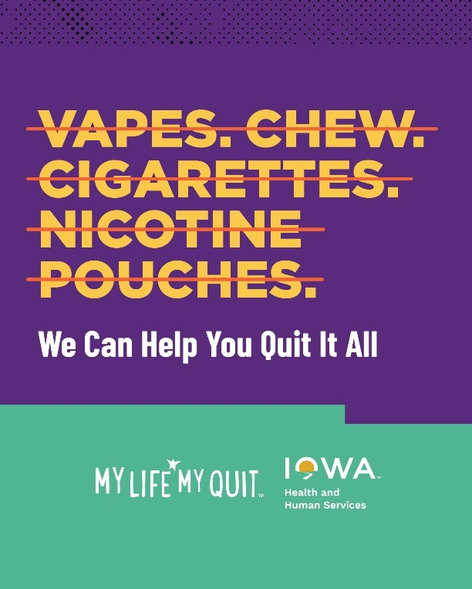 | With My Life, My Quit, you get free, confidential support from people who get you and what you’re going through. It only takes a few minutes to start your quitting journey: ia.mylifemyquit.org  @IowaSTEP #ISTEP #IowaSTEP #NoTobacco #TobaccoFreeGeneration #StudentLeaders #TobaccoFree #VapeFree #StopVaping #HealthyLungs #KnowTheFacts #YouthToday #StudentSupport #YouthVoice #TeensSupportTeens
July 24
July 25 | Saturday
July 26 | Sunday
July 27
July 28 | 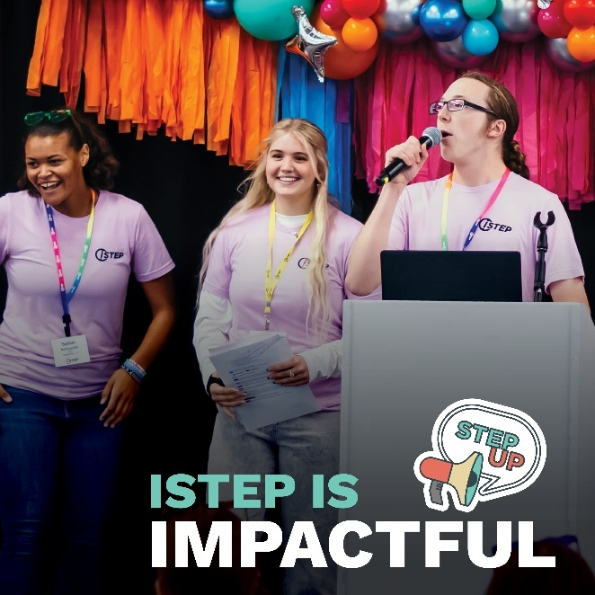 | Your voice matters and is impactful! Decisions about youth should include youth. Join #ISTEP and make sure YOUR voice is heard! 🔊 #IowaSTEP #NoTobacco #TobaccoFreeGeneration #StudentLeaders #TobaccoFree #VapeFree #StopVaping #HealthyLungs #KnowTheFacts #YouthToday #StudentSupport #YouthVoice #TeensSupportTeens
July 29
July 30 | 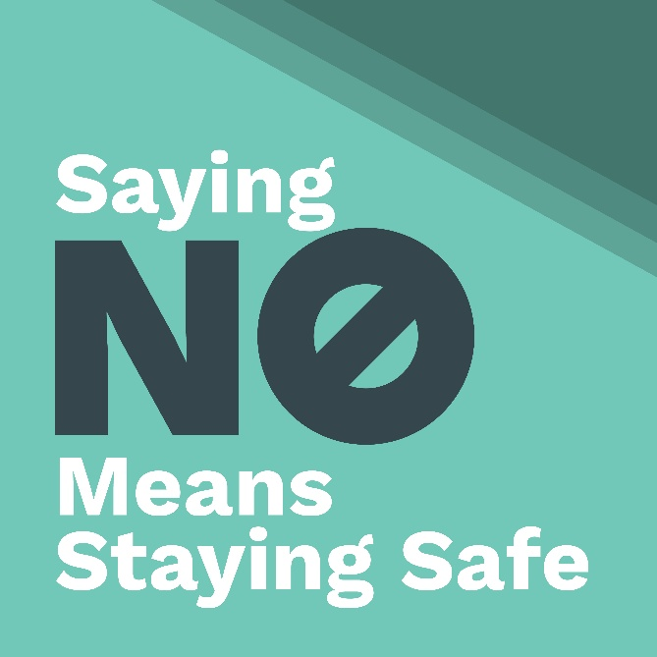 | Saying no to tobacco isn’t just a choice—it’s your safety plan. Protect your lungs, your future, and your vibe. 🚫💨 #ISTEP #IowaSTEP #NoTobacco #TobaccoFreeGeneration #StudentLeaders #TobaccoFree #VapeFree #StopVaping #HealthyLungs #KnowTheFacts #YouthToday #StudentSupport #YouthVoice #TeensSupportTeens

