Master FY27 ISTEP Social Schedule
Purpose: Below are ISTEP graphics and caption ideas for your social media accounts. These are only ideas, with the goal to make social posts easier on you. The dates listed are when the ISTEP Facebook/Instagram will be posting these specific items, however you can post them whenever you like.

Instructions: Tag @IowaSTEP in all posts. Download the graphics, then copy and paste the caption from this document.

Recommended hashtags: @IowaSTEP #ISTEP #IowaSTEP #NoTobacco #TobaccoFreeGeneration #StudentLeaders #TobaccoFree #VapeFree #StopVaping #HealthyLungs #KnowTheFacts #YouthToday #StudentSupport #YouthVoice #TeensSupportTeens
Date | Graphic | Caption
August 2026
August 1 | Saturday
August 2 | Sunday
August 3 | 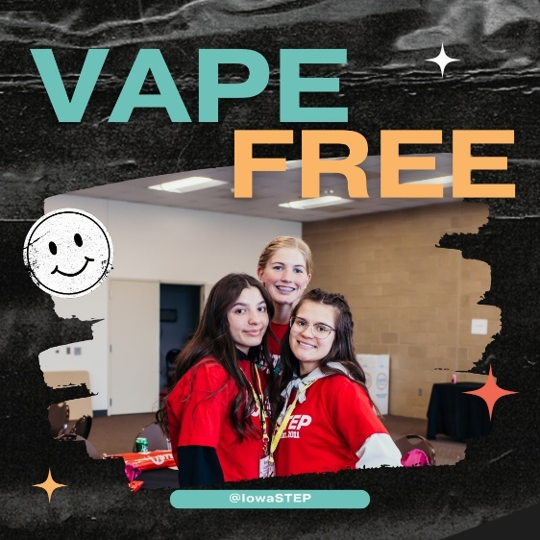 | Why do you choose to be vape free? Comment below! @IowaSTEP #ISTEP #IowaSTEP #NoTobacco #TobaccoFreeGeneration #StudentLeaders #TobaccoFree #VapeFree #StopVaping #HealthyLungs #KnowTheFacts #YouthToday #StudentSupport #YouthVoice #TeensSupportTeens
August 4 | 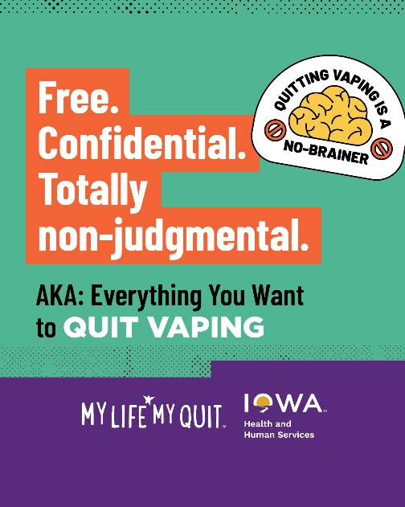 | Think of My Life, My Quit as your understanding friend who just wants to help you be your best self. Our coaches are always standing by to help you quit vaping. Start here: ia.mylifemyquit.org  @IowaSTEP #ISTEP #IowaSTEP #NoTobacco #TobaccoFreeGeneration #StudentLeaders #TobaccoFree #VapeFree #StopVaping #HealthyLungs #KnowTheFacts #YouthToday #StudentSupport #YouthVoice #TeensSupportTeens
August 5
August 6 |   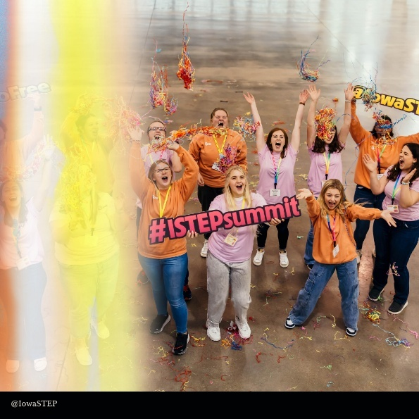  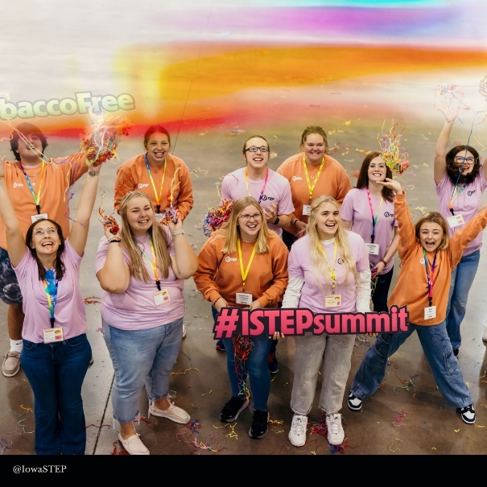 | Led by teens and supported by adults, #ISTEP is a statewide movement made up of young people who want to step up and make a difference in their communities! We make friends, make a difference and become leaders. @IowaSTEP #IowaSTEP #NoTobacco #TobaccoFreeGeneration #StudentLeaders #TobaccoFree #VapeFree #StopVaping #HealthyLungs #KnowTheFacts #YouthToday #StudentSupport #YouthVoice #TeensSupportTeens
August 7
August 8 | Saturday
August 9 | Sunday
August 10 |    | Meet our #ISTEP President! Sellah positively influences her peers by making healthy choices like being vape free. Learn more about #IowaSTEP at hhs.iowa.gov/istep.  @IowaSTEP #NoTobacco #TobaccoFreeGeneration #StudentLeaders #TobaccoFree #VapeFree #StopVaping #HealthyLungs #KnowTheFacts #YouthToday #StudentSupport #YouthVoice #TeensSupportTeens
August 11
August 12 | 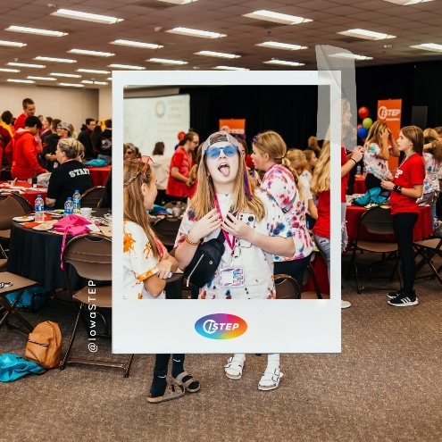 | #ISTEP is made up of passionate teens across Iowa who are stepping up and making a difference in their communities by bringing light to the true unfiltered facts about vaping. Learn how you can get involved at hhs.iowa.gov/istep. @IowaSTEP #IowaSTEP #NoTobacco #TobaccoFreeGeneration #StudentLeaders #TobaccoFree #VapeFree #StopVaping #HealthyLungs #KnowTheFacts #YouthToday #StudentSupport #YouthVoice #TeensSupportTeens
August 13 | 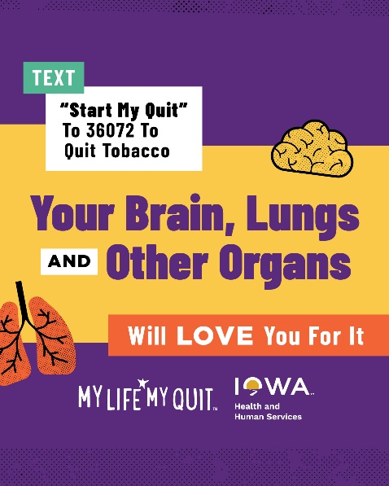 | When you quit vaping, chewing, smoking or nicotine pouches, you help your body be healthier. Isn’t that a great reason to start quitting ASAP? Learn more: ia.mylifemyquit.org  @IowaSTEP #ISTEP #IowaSTEP #NoTobacco #TobaccoFreeGeneration #StudentLeaders #TobaccoFree #VapeFree #StopVaping #HealthyLungs #KnowTheFacts #YouthToday #StudentSupport #YouthVoice #TeensSupportTeens
August 14
August 15 | Saturday
August 16 | Sunday
August 17 | 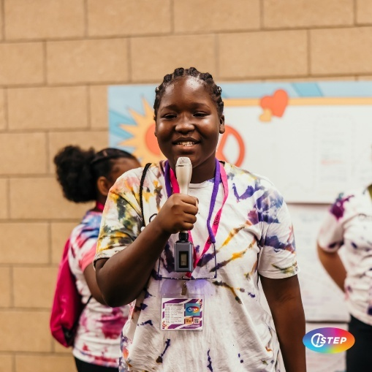 | You have an important voice, and here at @IowaSTEP we want to hear it! Join the movement at hhs.iowa.gov.istep. #ISTEP #IowaSTEP #NoTobacco #TobaccoFreeGeneration #StudentLeaders #TobaccoFree #VapeFree #StopVaping #HealthyLungs #KnowTheFacts #YouthToday #StudentSupport #YouthVoice #TeensSupportTeens
August 18
August 19 | 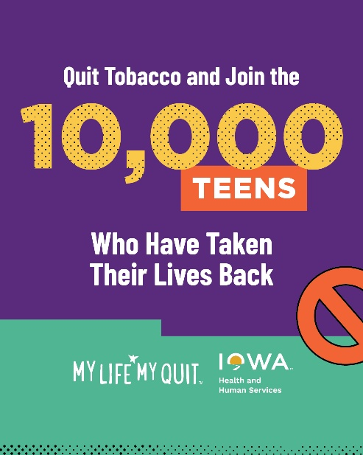 | We can help you get your life back by helping you quit vaping and other tobacco products. It’s free, confidential and only takes a few minutes to join. Start here: ia.mylifemyquit.org  @IowaSTEP #ISTEP #IowaSTEP #NoTobacco #TobaccoFreeGeneration #StudentLeaders #TobaccoFree #VapeFree #StopVaping #HealthyLungs #KnowTheFacts #YouthToday #StudentSupport #YouthVoice #TeensSupportTeens
August 20
August 21 | 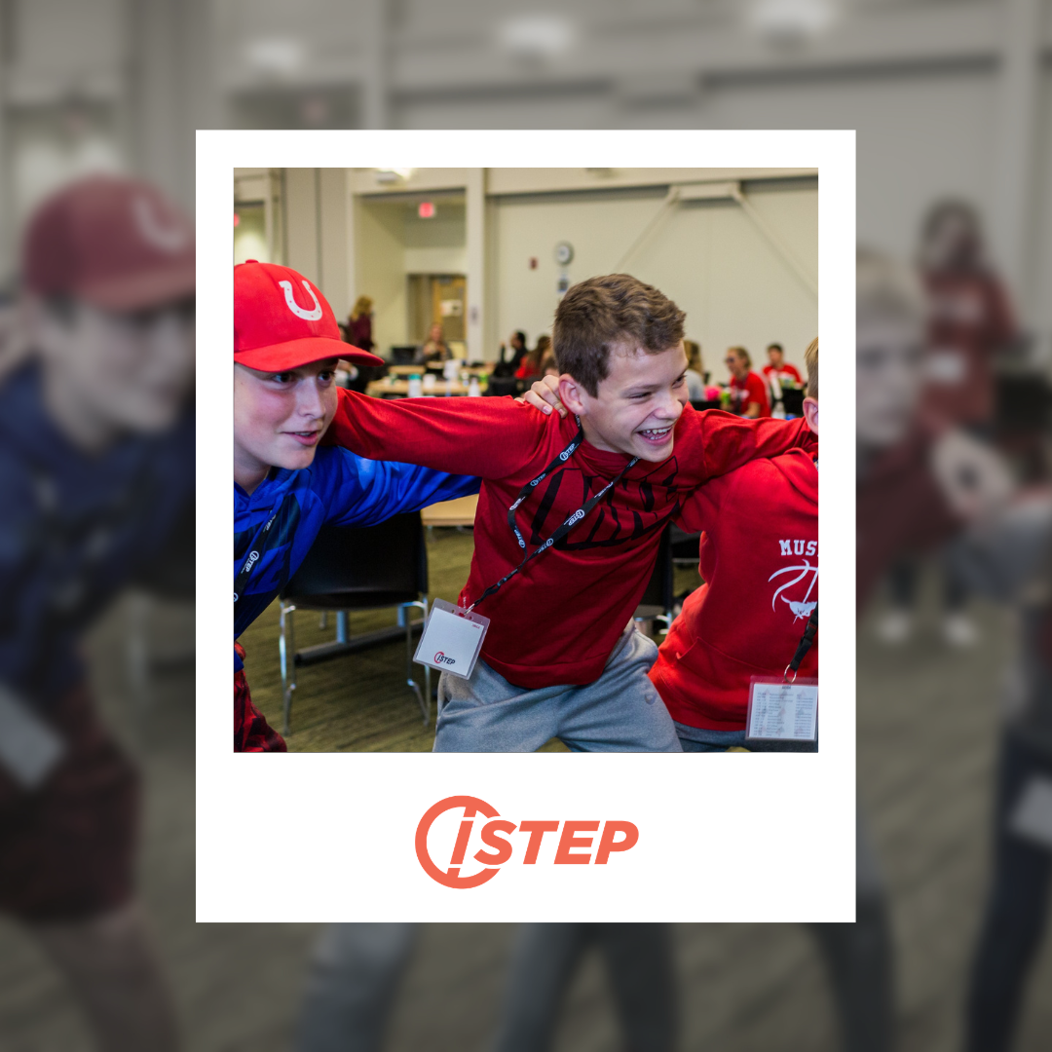 | @IowaSTEP #ISTEP #IowaSTEP #NoTobacco #TobaccoFreeGeneration #StudentLeaders #TobaccoFree #VapeFree #StopVaping #HealthyLungs #KnowTheFacts #YouthToday #StudentSupport #YouthVoice #TeensSupportTeens
August 22 | Saturday
August 23 | Sunday
August 24
August 25 |  | Stella is one of our youth Council members. She speaks to youth across Iowa about making healthy choices, like being vape free. Learn about how you can get involved at hhs.iowa.gov/istep. @IowaSTEP #ISTEP #IowaSTEP #NoTobacco #TobaccoFreeGeneration #StudentLeaders #TobaccoFree #VapeFree #StopVaping #HealthyLungs #KnowTheFacts #YouthToday #StudentSupport #YouthVoice #TeensSupportTeens
August 26
August 27 | 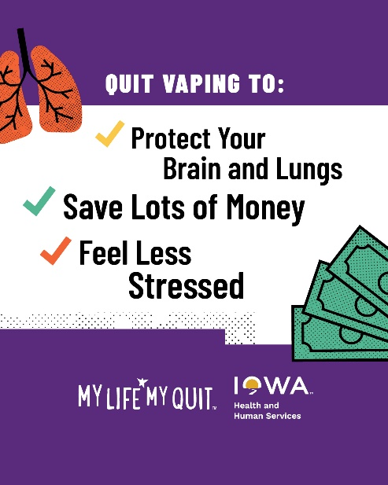 | Why are you ready to quit vaping? Whatever the reason, we’re here to help with free, confidential support. Text “Start My Quit” to 36072 or sign up here: ia.mylifemyquit.org  @IowaSTEP #ISTEP #IowaSTEP #NoTobacco #TobaccoFreeGeneration #StudentLeaders #TobaccoFree #VapeFree #StopVaping #HealthyLungs #KnowTheFacts #YouthToday #StudentSupport #YouthVoice #TeensSupportTeens
August 28
August 29 | Saturday
August 30 | Sunday
August 31 | 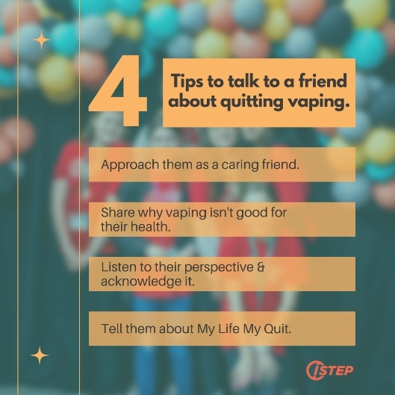 | Quitting tobacco and nicotine is hard, but it’s easier when you have the support of a friend – be that friend! @IowaSTEP #ISTEP #IowaSTEP #NoTobacco #TobaccoFreeGeneration #StudentLeaders #TobaccoFree #VapeFree #StopVaping #HealthyLungs #KnowTheFacts #YouthToday #StudentSupport #YouthVoice #TeensSupportTeens

