Master FY27 ISTEP Social Schedule
Purpose: Below are ISTEP graphics and caption ideas for your social media accounts. These are only ideas, with the goal to make social posts easier on you. The dates listed are when the ISTEP Facebook/Instagram will be posting these specific items, however you can post them whenever you like.

Instructions: Tag @IowaSTEP in all posts. Download the graphics, then copy and paste the caption from this document.

Recommended hashtags: @IowaSTEP #ISTEP #IowaSTEP #YouthToday #StudentSupport #YouthVoice #TeensSupportTeens #StudentLeaders #MentalHealthMatters #SuicidePrevention #StayAnotherDay #TobaccoFreeGeneration #TobaccoFree #VapeFree #DrugFree #AlcoholFree #HealthyChoices #KnowTheFacts
Date | Graphic | Caption
November 2026
November 1 | Sunday
November 2
November 3 | 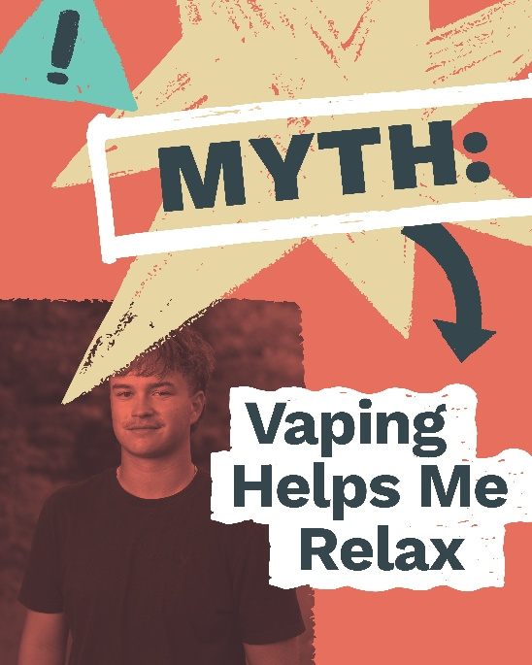 | The reality is nicotine may feel calming at first, but it can increase anxiety over time. That short relief often leads to more stress and cravings later.  @IowaSTEP #ISTEP #IowaSTEP #YouthToday #StudentSupport #YouthVoice #TeensSupportTeens #StudentLeaders #MentalHealthMatters #SuicidePrevention #StayAnotherDay #TobaccoFreeGeneration #TobaccoFree #VapeFree #DrugFree #AlcoholFree #HealthyChoices #KnowTheFacts
November 4
November 5 |  | When you join ISTEP, not only can you learn how to make healthy choices in your life — you can help your friends learn too! Talk about being a great friend.  Ready to get involved? Find a chapter near you: https://hhs.iowa.gov/istep  @IowaSTEP #ISTEP #IowaSTEP #YouthToday #StudentSupport #YouthVoice #TeensSupportTeens #StudentLeaders #MentalHealthMatters #SuicidePrevention #StayAnotherDay #TobaccoFreeGeneration #TobaccoFree #VapeFree #DrugFree #AlcoholFree #HealthyChoices #KnowTheFacts
November 6
November 7 | Saturday
November 8 | Sunday
November 9
November 10 | 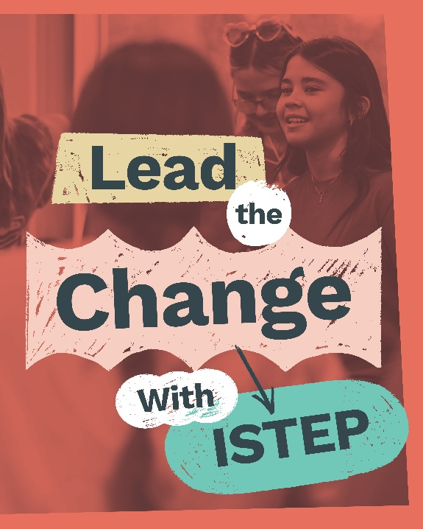 | Across Iowa #ISTEP youth take action by raising awareness about tobacco and vaping while supporting healthier communities. Learn more at hhs.iowa.gov/istep.  @IowaSTEP #IowaSTEP #YouthToday #StudentSupport #YouthVoice #TeensSupportTeens #StudentLeaders #MentalHealthMatters #SuicidePrevention #StayAnotherDay #TobaccoFreeGeneration #TobaccoFree #VapeFree #DrugFree #AlcoholFree #HealthyChoices #KnowTheFacts
November 11
November 12 | 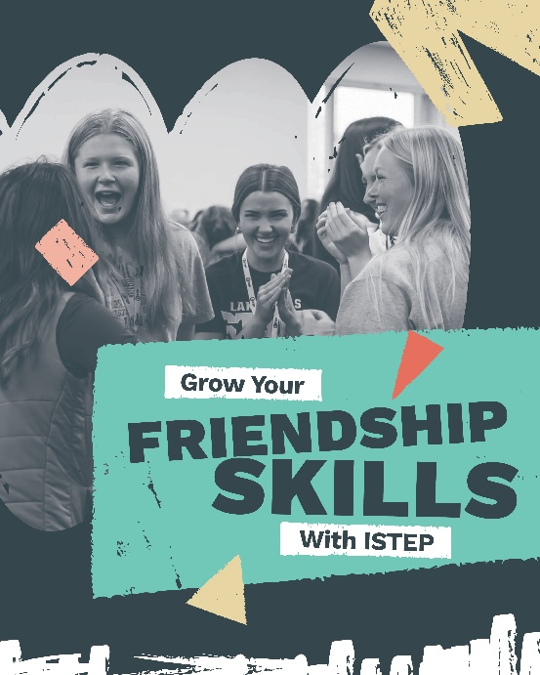 | You’re already a great friend to so many. Join ISTEP to learn even more ways to connect with and support your peers, no matter what they’re going through.  Find an ISTEP chapter near you: hhs.iowa.gov/istep  @IowaSTEP #ISTEP #IowaSTEP #YouthToday #StudentSupport #YouthVoice #TeensSupportTeens #StudentLeaders #MentalHealthMatters #SuicidePrevention #StayAnotherDay #TobaccoFreeGeneration #TobaccoFree #VapeFree #DrugFree #AlcoholFree #HealthyChoices #KnowTheFacts
November 13
November 14 | Saturday
November 15 | Sunday
November 16 | 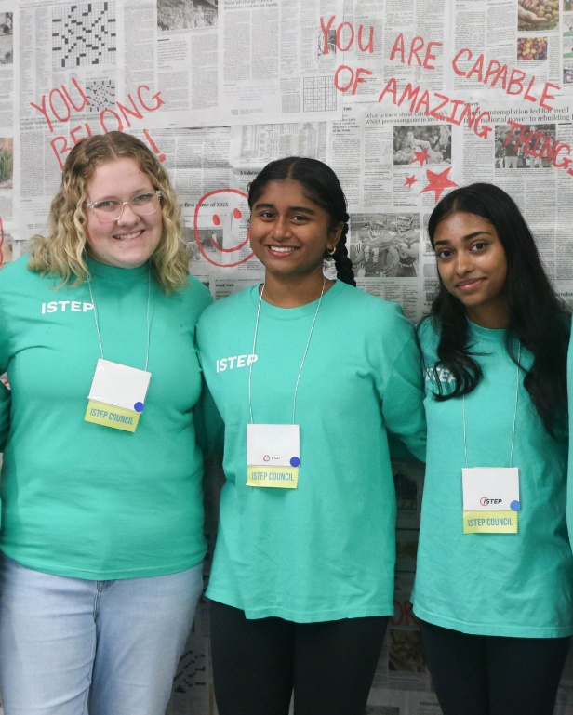 | #ISTEP is more than another teen club – it’s where you belong! Join us today at hhs.iowa.gov/istep.  @IowaSTEP #IowaSTEP #YouthToday #StudentSupport #YouthVoice #TeensSupportTeens #StudentLeaders #MentalHealthMatters #SuicidePrevention #StayAnotherDay #TobaccoFreeGeneration #TobaccoFree #VapeFree #DrugFree #AlcoholFree #HealthyChoices #KnowTheFacts
November 17
November 18 | 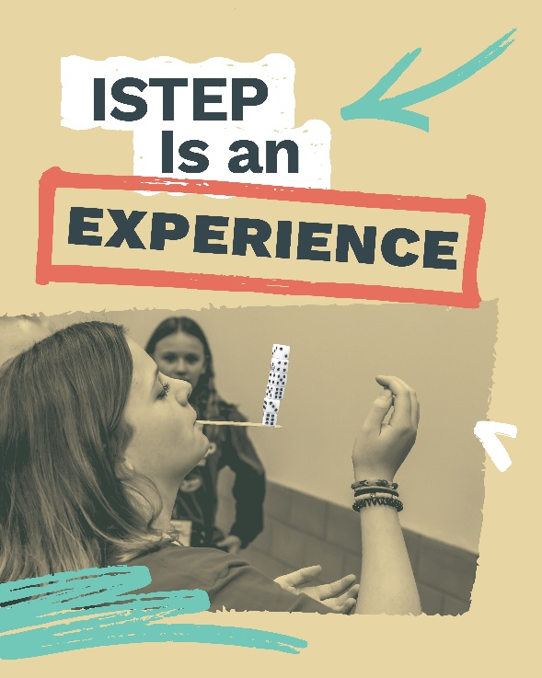 | What’s the ISTEP Summit? Only the best event of the year! Here, Iowa youth come together to build leadership skills, connect, learn the importance of mental health and more. Watch their experience: https://www.youtube.com/watch?si=164NDiNB5osF4qW5&v=mn0CDAKn_vo&feature=youtu.be  @IowaSTEP #ISTEP #IowaSTEP #YouthToday #StudentSupport #YouthVoice #TeensSupportTeens #StudentLeaders #MentalHealthMatters #SuicidePrevention #StayAnotherDay #TobaccoFreeGeneration #TobaccoFree #VapeFree #DrugFree #AlcoholFree #HealthyChoices #KnowTheFacts
November 19
November 20
November 21 | Saturday
November 22 | Sunday
November 23 | 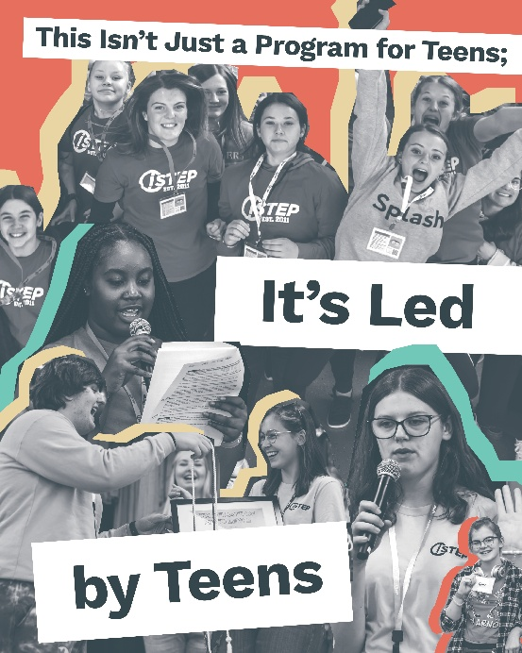 | #ISTEP empowers Iowa students to take leadership and promote healthy choices, including mental health, in their communities. Their voices are driving real, local change.  Join today! Find local chapters near you: hhs.iowa.gov/istep  @IowaSTEP #IowaSTEP #YouthToday #StudentSupport #YouthVoice #TeensSupportTeens #StudentLeaders #MentalHealthMatters #SuicidePrevention #StayAnotherDay #TobaccoFreeGeneration #TobaccoFree #VapeFree #DrugFree #AlcoholFree #HealthyChoices #KnowTheFacts
November 24
November 25 | 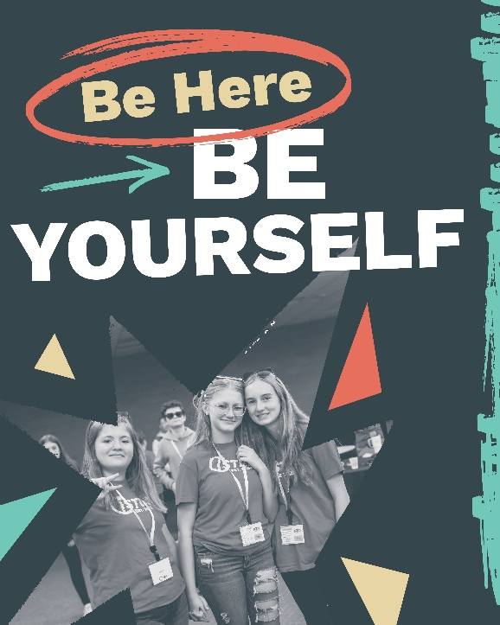 | #ISTEP comes together to learn, connect and feel supported. It’s a space to recharge, be heard and realize you’re not alone in working toward a healthier future.  Join today! Find local chapters near you: hhs.iowa.gov/istep  @IowaSTEP #IowaSTEP #YouthToday #StudentSupport #YouthVoice #TeensSupportTeens #StudentLeaders #MentalHealthMatters #SuicidePrevention #StayAnotherDay #TobaccoFreeGeneration #TobaccoFree #VapeFree #DrugFree #AlcoholFree #HealthyChoices #KnowTheFacts
November 26
November 27 | 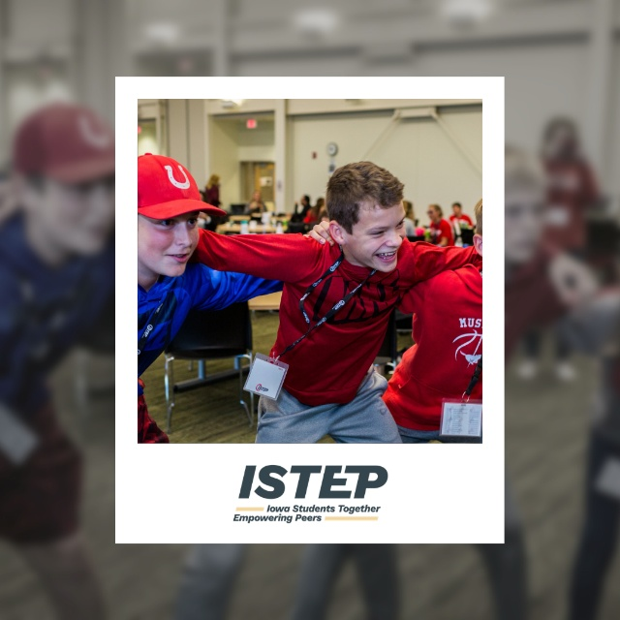 | When you join #ISTEP you join a community of young Iowans to care deeply for making a difference in our state. Learn more at: hhs.iowa.gov/istep  @IowaSTEP #IowaSTEP #YouthToday #StudentSupport #YouthVoice #TeensSupportTeens #StudentLeaders #MentalHealthMatters #SuicidePrevention #StayAnotherDay #TobaccoFreeGeneration #TobaccoFree #VapeFree #DrugFree #AlcoholFree #HealthyChoices #KnowTheFacts
November 28 | Saturday
November 29 | Sunday
November 30

