Master FY27 ISTEP Social Schedule
Purpose: Below are ISTEP graphics and caption ideas for your social media accounts. These are only ideas, with the goal to make social posts easier on you. The dates listed are when the ISTEP Facebook/Instagram will be posting these specific items, however you can post them whenever you like.

Instructions: Tag @IowaSTEP in all posts. Download the graphics, then copy and paste the caption from this document.

Recommended hashtags: @IowaSTEP #ISTEP #IowaSTEP #YouthToday #StudentSupport #YouthVoice #TeensSupportTeens #StudentLeaders #MentalHealthMatters #SuicidePrevention #StayAnotherDay #TobaccoFreeGeneration #TobaccoFree #VapeFree #DrugFree #AlcoholFree #HealthyChoices #KnowTheFacts
Date | Graphic | Caption
December 2026
December 1
December 2 | 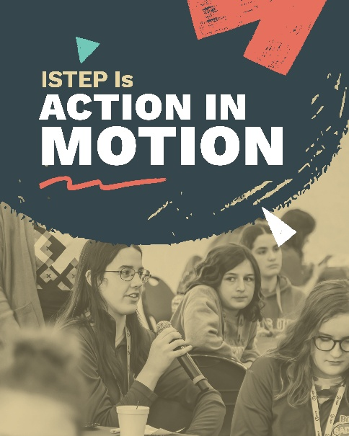 | #ISTEP helps students turn knowledge into action. Building skills, connecting with peers and creating positive change in their communities while promoting healthy choices, including mental health.  Join today! Find a chapter near you: https://hhs.iowa.gov/istep  @IowaSTEP #IowaSTEP #YouthToday #StudentSupport #YouthVoice #TeensSupportTeens #StudentLeaders #MentalHealthMatters #SuicidePrevention #StayAnotherDay #TobaccoFreeGeneration #TobaccoFree #VapeFree #DrugFree #AlcoholFree #HealthyChoices
December 3
December 4
December 5 | Saturday
December 6 | Sunday
December 7 |  | Do you have friends who can’t seem to stop sports betting or making in-game purchases? When you join ISTEP, you can learn ways to help them and others who may have a problem with gambling. #ISTEP is here for you and your friends.  Join today! Find a chapter near you: hhs.iowa.gov/istep  @IowaSTEP #IowaSTEP #YouthToday #StudentSupport #YouthVoice #TeensSupportTeens #StudentLeaders #MentalHealthMatters #SuicidePrevention #StayAnotherDay #TobaccoFreeGeneration #TobaccoFree #VapeFree #DrugFree #AlcoholFree #HealthyChoices
December 8
December 9
December 10 | 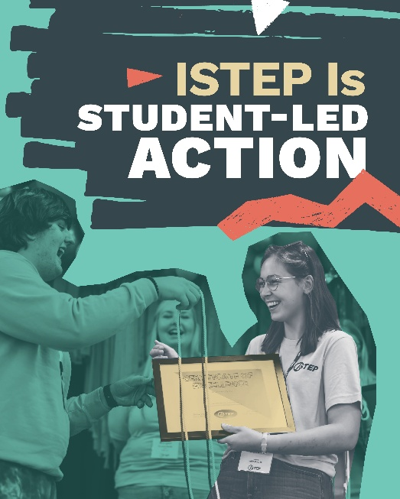 | From small steps to community-wide efforts, students are helping make healthy living the norm across the state. Take local action and create supportive, healthier environments at hhs.iowa.gov/istep.  @IowaSTEP #ISTEP #IowaSTEP #YouthToday #StudentSupport #YouthVoice #TeensSupportTeens #StudentLeaders #MentalHealthMatters #SuicidePrevention #StayAnotherDay #TobaccoFreeGeneration #TobaccoFree #VapeFree #DrugFree #AlcoholFree #HealthyChoices
December 11
December 12 | Saturday
December 13 | Sunday
December 14
December 15 | 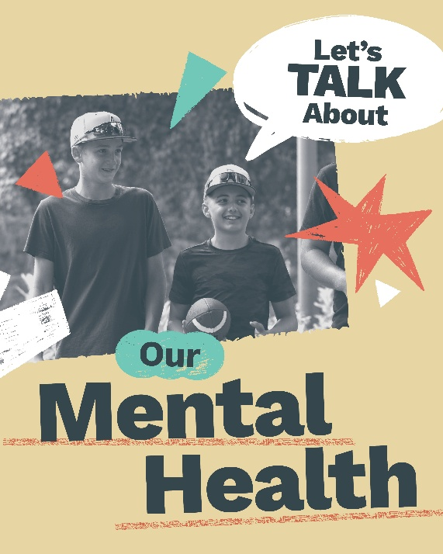 | With ISTEP, we’re prioritizing the health of Iowa youth. It means we’re talking about our mental health and how our daily decisions can make a big impact. We got this.  @IowaSTEP #ISTEP #IowaSTEP #YouthToday #StudentSupport #YouthVoice #TeensSupportTeens #StudentLeaders #MentalHealthMatters #SuicidePrevention #StayAnotherDay #TobaccoFreeGeneration #TobaccoFree #VapeFree #DrugFree #AlcoholFree #HealthyChoices
December 16
December 17
December 18 | 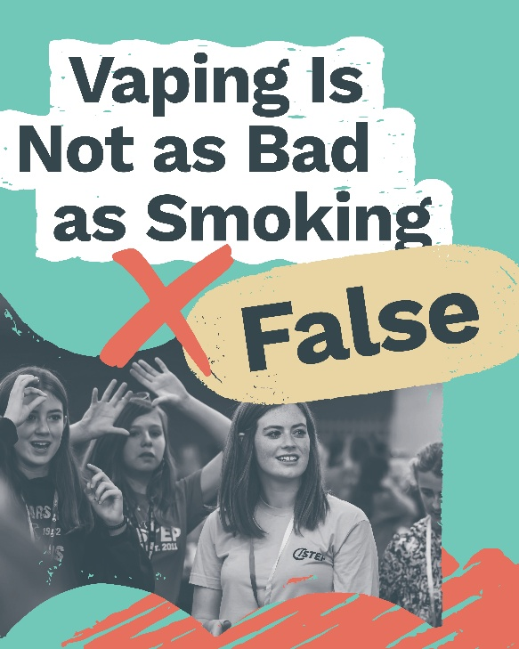 | Although it may look different, vaping still exposes the body to nicotine and other harmful substances. It can affect both lung and brain health, especially for teens.  Help stop nicotine use. Join today: hhs.iowa.gov/istep  @IowaSTEP #ISTEP #IowaSTEP #YouthToday #StudentSupport #YouthVoice #TeensSupportTeens #StudentLeaders #MentalHealthMatters #SuicidePrevention #StayAnotherDay #TobaccoFreeGeneration #TobaccoFree #VapeFree #DrugFree #AlcoholFree #HealthyChoices
December 19 | Saturday
December 20 | Sunday
December 21
December 22 | 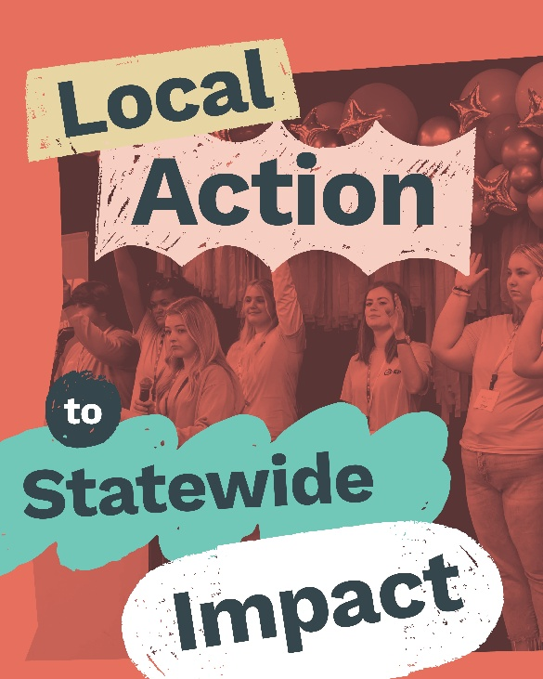 | Different communities. One shared mission. #ISTEP students across Iowa are taking action to build a future that supports healthy choices and mental well-being.  Join today! Find a chapter near you: hhs.iowa.gov/istep  @IowaSTEP #IowaSTEP #YouthToday #StudentSupport #YouthVoice #TeensSupportTeens #StudentLeaders #MentalHealthMatters #SuicidePrevention #StayAnotherDay #TobaccoFreeGeneration #TobaccoFree #VapeFree #DrugFree #AlcoholFree #HealthyChoices
December 23
December 24 | 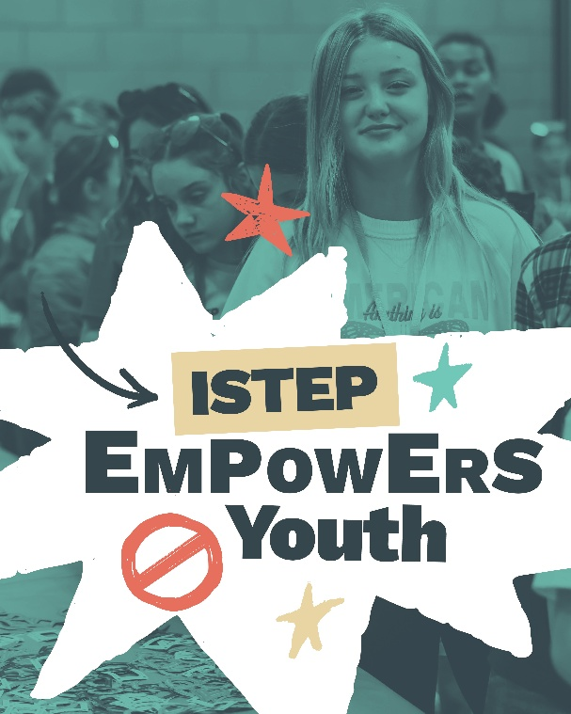 | Through peer connection and real-world experiences, #ISTEP empowers students to lead and create healthier communities. Learn more at hhs.iowa.gov/istep.  @IowaSTEP #IowaSTEP #YouthToday #StudentSupport #YouthVoice #TeensSupportTeens #StudentLeaders #MentalHealthMatters #SuicidePrevention #StayAnotherDay #TobaccoFreeGeneration #TobaccoFree #VapeFree #DrugFree #AlcoholFree #HealthyChoices
December 25
December 26 | Saturday
December 27 | Sunday
December 28 | 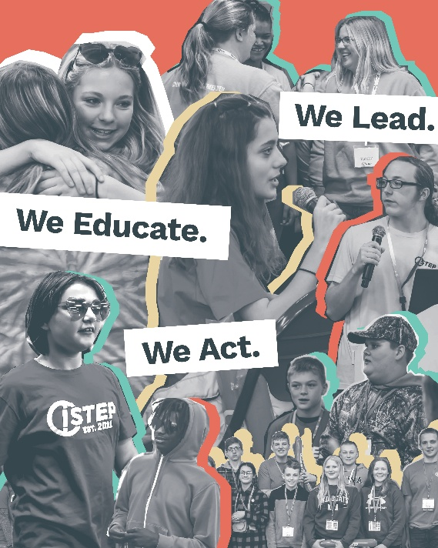 | We’re the generation that sees through the smoke. #ISTEP is Iowa students calling out tobacco and vape culture while promoting healthier choices and supporting mental well-being.  Join us at hhs.iowa.gov/istep.  @IowaSTEP #IowaSTEP #YouthToday #StudentSupport #YouthVoice #TeensSupportTeens #StudentLeaders #MentalHealthMatters #SuicidePrevention #StayAnotherDay #TobaccoFreeGeneration #TobaccoFree #VapeFree #DrugFree #AlcoholFree #HealthyChoices
December 29
December 30 | 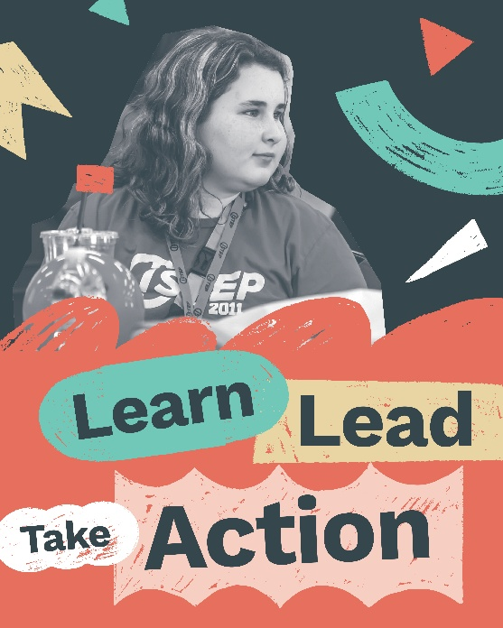 | #ISTEP brings Iowa students together to learn, lead and take action toward a healthier future.  Join Today! Find a chapter near you: https://hhs.iowa.gov/istep  @IowaSTEP #IowaSTEP #YouthToday #StudentSupport #YouthVoice #TeensSupportTeens #StudentLeaders #MentalHealthMatters #SuicidePrevention #StayAnotherDay #TobaccoFreeGeneration #TobaccoFree #VapeFree #DrugFree #AlcoholFree #HealthyChoices
December 31

