Master FY27 ISTEP Social Schedule
Purpose: Below are ISTEP graphics and caption ideas for your social media accounts. These are only ideas, with the goal to make social posts easier on you. The dates listed are when the ISTEP Facebook/Instagram will be posting these specific items, however you can post them whenever you like.

Instructions: Tag @IowaSTEP in all posts. Download the graphics, then copy and paste the caption from this document.

Recommended hashtags: @IowaSTEP #ISTEP #IowaSTEP #YouthToday #StudentSupport #YouthVoice #TeensSupportTeens #StudentLeaders #MentalHealthMatters #SuicidePrevention #StayAnotherDay #TobaccoFreeGeneration #TobaccoFree #VapeFree #DrugFree #AlcoholFree #HealthyChoices #KnowTheFacts
Date | Graphic | Caption
February 2027
February 1 | 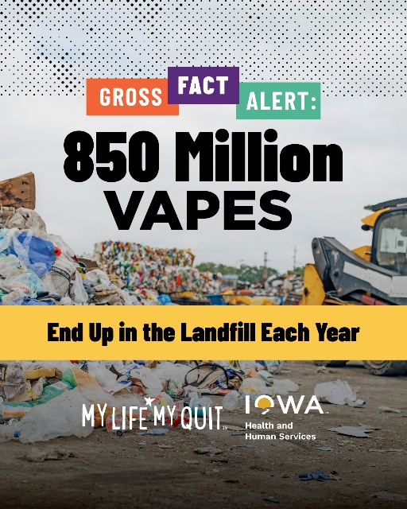 | Quitting vaping is good for your health — and the environment. My Life, My Quit offers free, confidential support to help you quit. Text “Start My Quit” to 36072 or start chatting now: ia.mylifemyquit.org  @IowaSTEP #ISTEP #IowaSTEP #YouthToday #StudentSupport #YouthVoice #TeensSupportTeens #StudentLeaders #MentalHealthMatters #SuicidePrevention #StayAnotherDay #TobaccoFreeGeneration #TobaccoFree #VapeFree #DrugFree #AlcoholFree #HealthyChoices
February 2
February 3
February 4 | 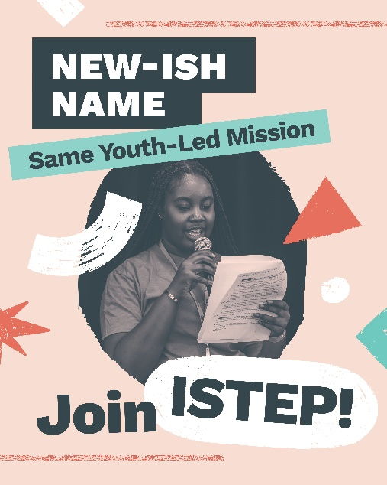 | ISTEP got its start as Iowa Students for Tobacco Education and Prevention. But today’s youth are dealing with so much more, like mental health concerns, substance use and bullying. That’s why we’re now Iowa Students Together Empowering Peers. And we’d love for you to join us.  Learn more: hhs.iowa.gov/istep  @IowaSTEP #ISTEP #IowaSTEP #YouthToday #StudentSupport #YouthVoice #TeensSupportTeens #StudentLeaders #MentalHealthMatters #SuicidePrevention #StayAnotherDay #TobaccoFreeGeneration #TobaccoFree #VapeFree #DrugFree #AlcoholFree #HealthyChoices
February 5
February 6 | Saturday
February 7 | Sunday
February 8 | 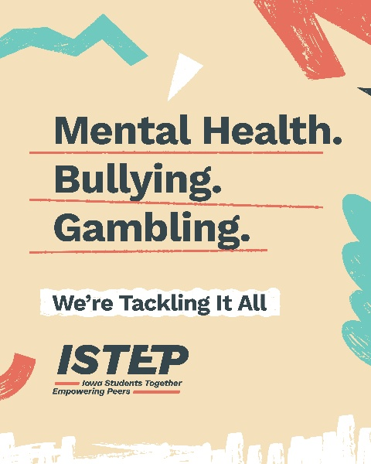 | If our peers are dealing with it, we’re here for it. Our newly expanded ISTEP (Iowa Students Together Empowering Peers) empowers youth to make healthier choices and get help when they need it most.  Join us: hhs.iowa.gov/istep  @IowaSTEP #ISTEP #IowaSTEP #YouthToday #StudentSupport #YouthVoice #TeensSupportTeens #StudentLeaders #MentalHealthMatters #SuicidePrevention #StayAnotherDay #TobaccoFreeGeneration #TobaccoFree #VapeFree #DrugFree #AlcoholFree #HealthyChoices
February 9
February 10
February 11 | 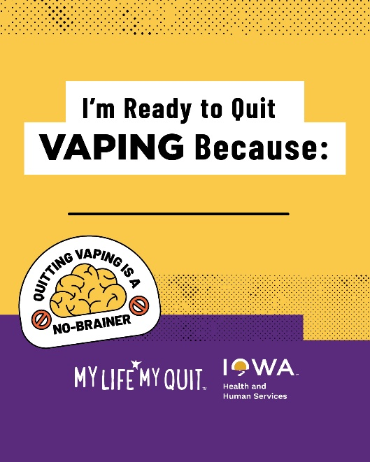 | Whatever your reason, My Life, My Quit will be there for you every step of the way with free, confidential and non-judgmental support. Text “Start My Quit” to 36072 or chat with a quit coach here: ia.mylifemyquit.org  @IowaSTEP #ISTEP #IowaSTEP #YouthToday #StudentSupport #YouthVoice #TeensSupportTeens #StudentLeaders #MentalHealthMatters #SuicidePrevention #StayAnotherDay #TobaccoFreeGeneration #TobaccoFree #VapeFree #DrugFree #AlcoholFree #HealthyChoices
February 12
February 13 | Saturday
February 14 | Sunday
February 15 | 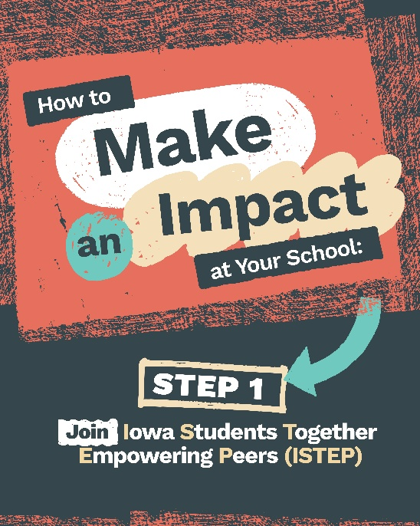 | With just one easy step, you can make a difference in your community while making friends along the way! Learn more about how ISTEP is expanding our mission to help empower youth to take charge of their lives at hhs.iowa.gov/istep.  @IowaSTEP #ISTEP #IowaSTEP #YouthToday #StudentSupport #YouthVoice #TeensSupportTeens #StudentLeaders #MentalHealthMatters #SuicidePrevention #StayAnotherDay #TobaccoFreeGeneration #TobaccoFree #VapeFree #DrugFree #AlcoholFree #HealthyChoices
February 16
February 17 | 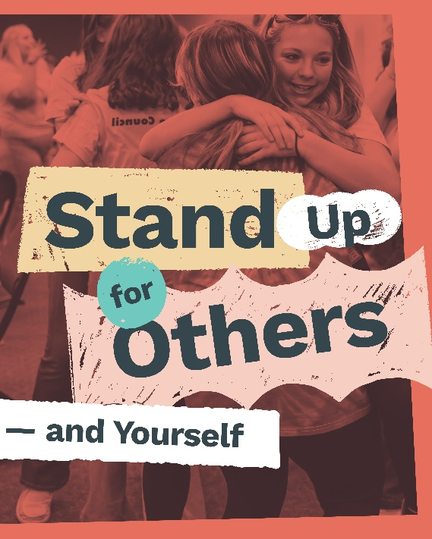 | Bullying is never okay. ISTEP empowers youth to face hard issues head-on, like standing up for others and themselves.  Learn more: hhs.iowa.gov/istep  @IowaSTEP #ISTEP #IowaSTEP #YouthToday #StudentSupport #YouthVoice #TeensSupportTeens #StudentLeaders #MentalHealthMatters #SuicidePrevention #StayAnotherDay #TobaccoFreeGeneration #TobaccoFree #VapeFree #DrugFree #AlcoholFree #HealthyChoices
February 18
February 19 | 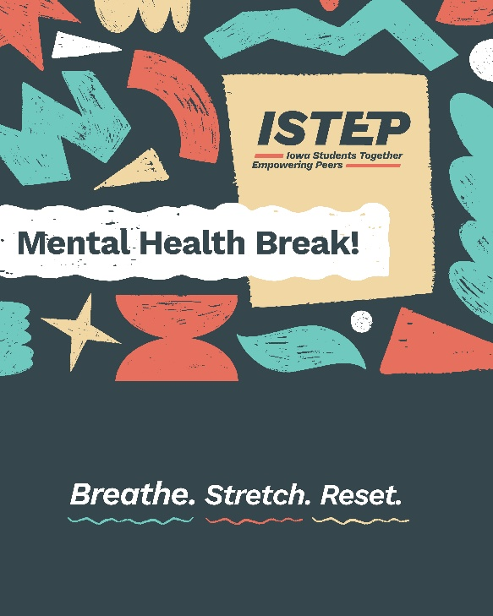 | At Iowa Students Together Empowering Peers (ISTEP), we know mental health is as important as physical health. That’s why we’ve expanded our mission to help teens tackle all kinds of issues, from mental health to substance use.  Join us to help make a difference: hhs.iowa.gov/istep  @IowaSTEP #ISTEP #IowaSTEP #YouthToday #StudentSupport #YouthVoice #TeensSupportTeens #StudentLeaders #MentalHealthMatters #SuicidePrevention #StayAnotherDay #TobaccoFreeGeneration #TobaccoFree #VapeFree #DrugFree #AlcoholFree #HealthyChoices
February 20 | Saturday
February 21 | Sunday
February 22
February 23 | 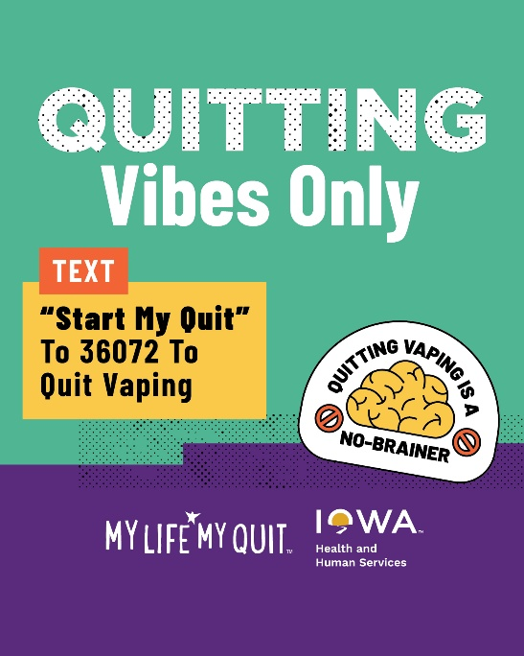 | My Life, My Quit coaches don’t just give you good vibes when you want to quit vaping. They give you real ways to make quitting easier! Learn more and sign up for free: ia.mylifemyquit.org  @IowaSTEP #ISTEP #IowaSTEP #YouthToday #StudentSupport #YouthVoice #TeensSupportTeens #StudentLeaders #MentalHealthMatters #SuicidePrevention #StayAnotherDay #TobaccoFreeGeneration #TobaccoFree #VapeFree #DrugFree #AlcoholFree #HealthyChoices
February 24
February 25
February 26 | 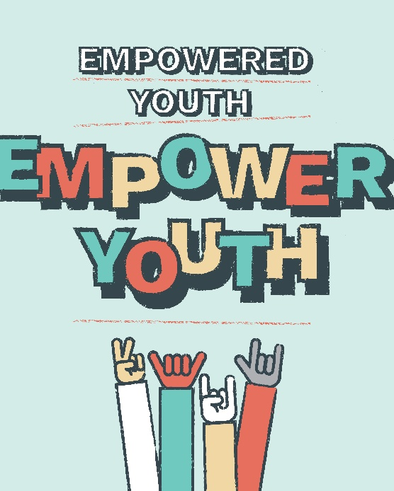 | ISTEP is back with an expanded mission — empowering teens to tackle hard life issues head-on, including mental health, bullying and more. Learn about Iowa Students Together Empowering Peers and join us here: hhs.iowa.gov/istep.  @IowaSTEP #ISTEP #IowaSTEP #YouthToday #StudentSupport #YouthVoice #TeensSupportTeens #StudentLeaders #MentalHealthMatters #SuicidePrevention #StayAnotherDay #TobaccoFreeGeneration #TobaccoFree #VapeFree #DrugFree #AlcoholFree #HealthyChoices
February 27 | Saturday

