Master FY27 ISTEP Social Schedule
Purpose: Below are ISTEP graphics and caption ideas for your social media accounts. These are only ideas, with the goal to make social posts easier on you. The dates listed are when the ISTEP Facebook/Instagram will be posting these specific items, however you can post them whenever you like.

Instructions: Tag @IowaSTEP in all posts. Download the graphics, then copy and paste the caption from this document.

Recommended hashtags: @IowaSTEP #ISTEP #IowaSTEP #YouthToday #StudentSupport #YouthVoice #TeensSupportTeens #StudentLeaders #MentalHealthMatters #SuicidePrevention #StayAnotherDay #TobaccoFreeGeneration #TobaccoFree #VapeFree #DrugFree #AlcoholFree #HealthyChoices #KnowTheFacts
Date | Graphic | Caption
January 2027
January 1 | 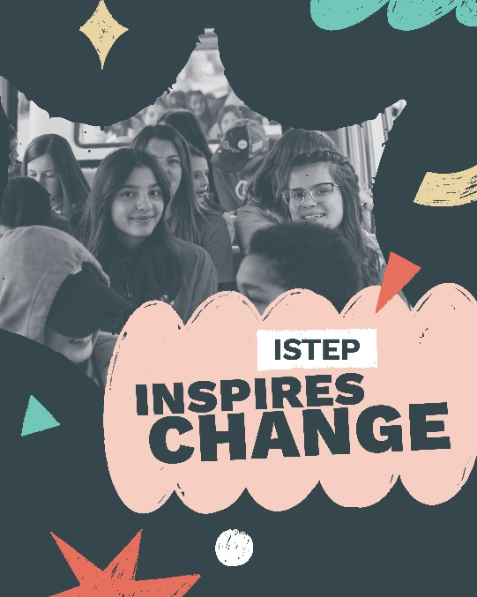 | From hands-on activities to peer connection, #ISTEP gives students the skills and confidence to make a difference in their communities. Ready to get involved? Learn more at hhs.iowa.gov/istep.  @IowaSTEP #IowaSTEP #YouthToday #StudentSupport #YouthVoice #TeensSupportTeens #StudentLeaders #MentalHealthMatters #SuicidePrevention #StayAnotherDay #TobaccoFreeGeneration #TobaccoFree #VapeFree #DrugFree #AlcoholFree #HealthyChoices #KnowTheFacts
January 2 | Saturday
January 3 | Sunday
January 4
January 5 | 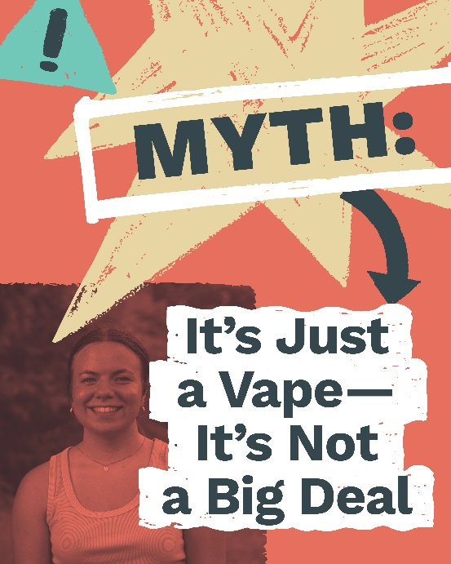 | What may seem small can have long-term effects. Most vapes contain nicotine, which can lead to addiction and affect brain development in teens.  Ready to get involved? Find a chapter near you: https://hhs.iowa.gov/istep  @IowaSTEP #ISTEP #IowaSTEP #YouthToday #StudentSupport #YouthVoice #TeensSupportTeens #StudentLeaders #MentalHealthMatters #SuicidePrevention #StayAnotherDay #TobaccoFreeGeneration #TobaccoFree #VapeFree #DrugFree #AlcoholFree #HealthyChoices #KnowTheFacts
January 6
January 7 | 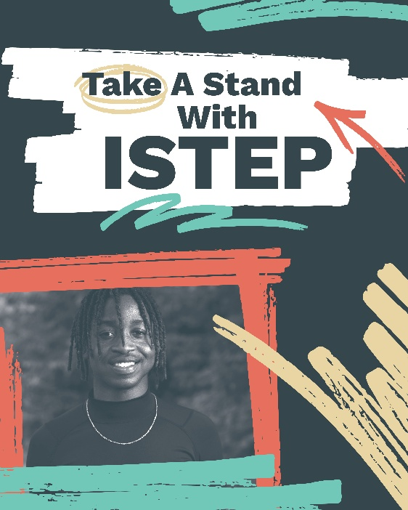 | Change is happening across Iowa. Through events, education and peer support, ISTEP students are encouraging healthy choices, including supporting mental well-being.  @IowaSTEP #ISTEP #IowaSTEP #YouthToday #StudentSupport #YouthVoice #TeensSupportTeens #StudentLeaders #MentalHealthMatters #SuicidePrevention #StayAnotherDay #TobaccoFreeGeneration #TobaccoFree #VapeFree #DrugFree #AlcoholFree #HealthyChoices #KnowTheFacts
January 8
January 9 | Saturday
January 10 | Sunday
January 11 | 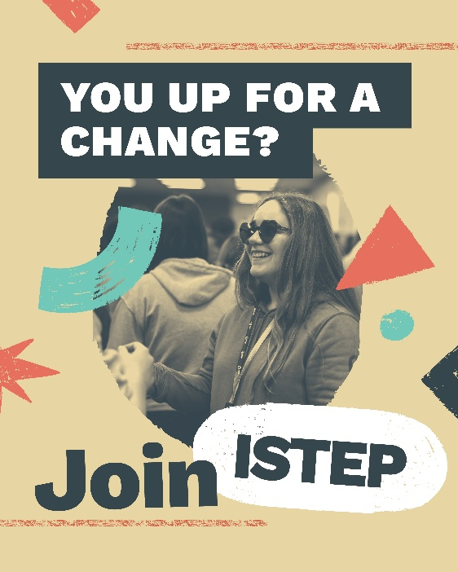 | The time for change is now. Join the ISTEP movement today and help your community learn about healthy choices.  Find a chapter near you: hhs.iowa.gov/istep  @IowaSTEP #ISTEP #IowaSTEP #YouthToday #StudentSupport #YouthVoice #TeensSupportTeens #StudentLeaders #MentalHealthMatters #SuicidePrevention #StayAnotherDay #TobaccoFreeGeneration #TobaccoFree #VapeFree #DrugFree #AlcoholFree #HealthyChoices #KnowTheFacts
January 12
January 13
January 14 | 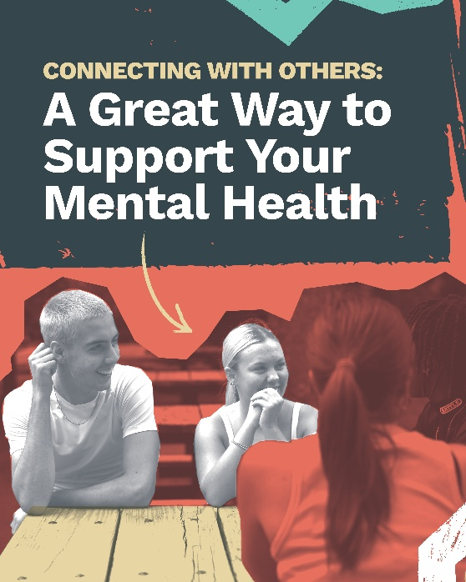 | When you join ISTEP, you'll make a difference in your community while making all kinds of friends. Talk about a positive impact on your mental health. Check out ISTEP: hhs.iowa.gov/istep  @IowaSTEP #ISTEP #IowaSTEP #YouthToday #StudentSupport #YouthVoice #TeensSupportTeens #StudentLeaders #MentalHealthMatters #SuicidePrevention #StayAnotherDay #TobaccoFreeGeneration #TobaccoFree #VapeFree #DrugFree #AlcoholFree #HealthyChoices #KnowTheFacts
January 15
January 16 | Saturday
January 17 | Sunday
January 18
January 19 | 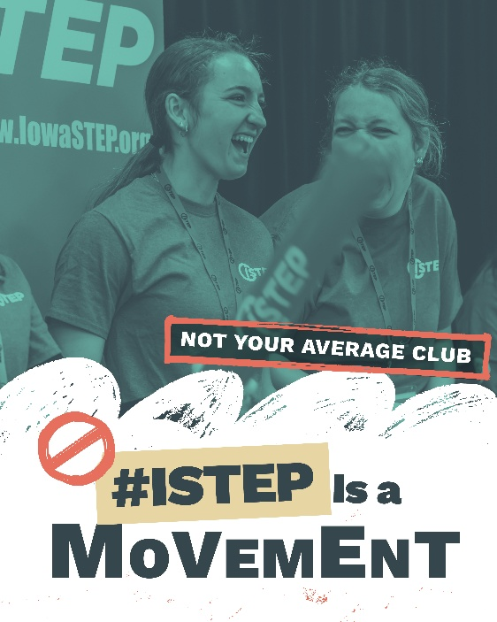 | Students across Iowa are leading the way in creating healthier communities and promoting positive mental well-being. Want to get involved? Learn more at hhs.iowa.gov/istep.  @IowaSTEP #ISTEP #IowaSTEP #YouthToday #StudentSupport #YouthVoice #TeensSupportTeens #StudentLeaders #MentalHealthMatters #SuicidePrevention #StayAnotherDay #TobaccoFreeGeneration #TobaccoFree #VapeFree #DrugFree #AlcoholFree #HealthyChoices #KnowTheFacts
January 20
January 21
January 22 | 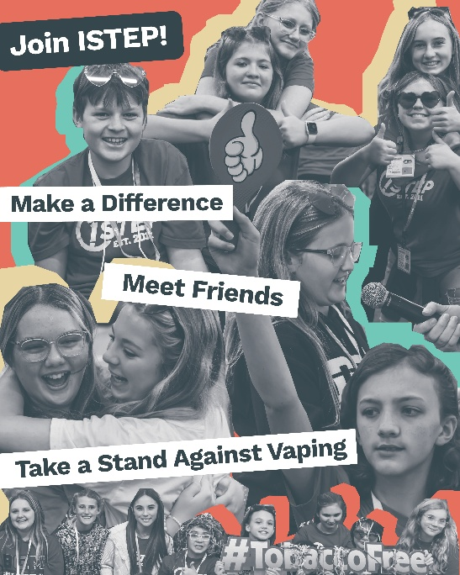 | When you join ISTEP, you'll make a difference in your community while making all kinds of friends. Talk about a positive impact! Check out ISTEP: hhs.iowa.gov/istep  @IowaSTEP #ISTEP #IowaSTEP #YouthToday #StudentSupport #YouthVoice #TeensSupportTeens #StudentLeaders #MentalHealthMatters #SuicidePrevention #StayAnotherDay #TobaccoFreeGeneration #TobaccoFree #VapeFree #DrugFree #AlcoholFree #HealthyChoices #KnowTheFacts
January 23 | Saturday
January 24 | Sunday
January 25
January 26 | 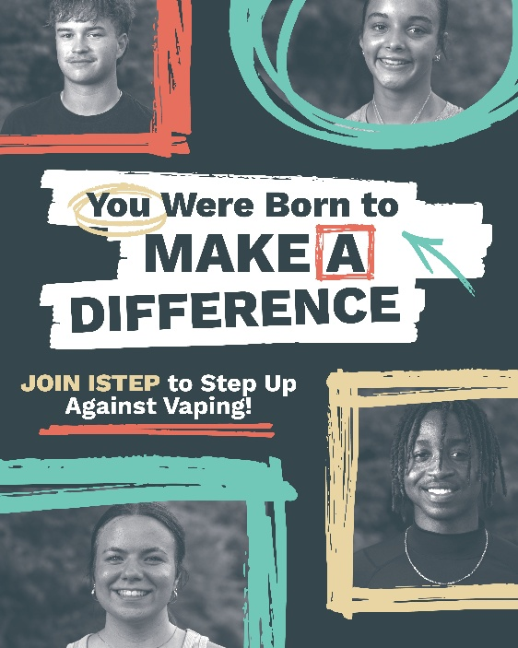 | The time for change is now. Join the ISTEP movement today and help your community learn about healthy choices.  Find a chapter near you: hhs.iowa.gov/istep  @IowaSTEP #ISTEP #IowaSTEP #YouthToday #StudentSupport #YouthVoice #TeensSupportTeens #StudentLeaders #MentalHealthMatters #SuicidePrevention #StayAnotherDay #TobaccoFreeGeneration #TobaccoFree #VapeFree #DrugFree #AlcoholFree #HealthyChoices #KnowTheFacts
January 27
January 28 | 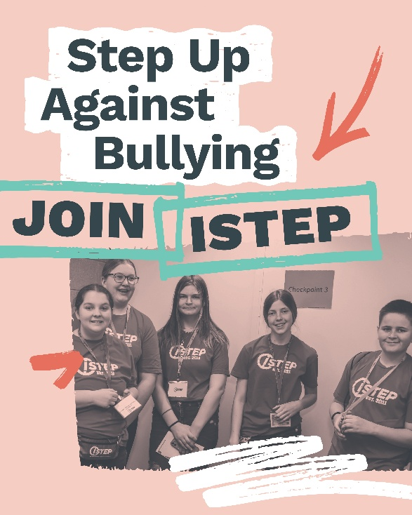 | Across Iowa, students are stepping up to help stop bullying by creating spaces where everyone feels welcome. #ISTEP is here to make a difference.  Join today: hhs.iowa.gov/istep  @IowaSTEP #ISTEP #IowaSTEP #YouthToday #StudentSupport #YouthVoice #TeensSupportTeens #StudentLeaders #MentalHealthMatters #SuicidePrevention #StayAnotherDay #TobaccoFreeGeneration #TobaccoFree #VapeFree #DrugFree #AlcoholFree #HealthyChoices #KnowTheFacts
January 29
January 30 | Saturday
January 31 | Sunday

