Introduction to this example template
Quality Assurance Plan for Performing Radon Measurements in Single-family Residential Buildings.

The content provided in this template is a compilation that includes essential practices commonly associated with quality assurance programs as outlined in the ANSI/AARST MS-QA and Iowa Administrative Code. This template is not the only model that can provide a responsible QAP plan.

Note: No template is a complete Quality Management or Quality Assurance Manual until amended to reflect operations for an individual organization. Each topic item needs to be reviewed and, as applicable, amended to match each organization's structure and operation.

In addition: Completing a QAP template does not, in itself, fulfill requirements for Quality Control. Those occur as an ongoing process by observing requirements you have established in your QAP. If called to task by an audit or in a courtroom, evidence would be sought for verifying the degree that an organization complied with their customized QA plan.

Guide for completing this form:
- This document is provided as template to get you started on developing a QA\QC plan and can be altered, formatted as you see fit for your organization as long as the basic components as outlined in the ANSI/AARST MS-QA and applicable ANSI/AARST (MAH, MAMF & MALB) Testing Standards are included.
- This QA\QC template is designed primarily for those testing residential properties and care will need to be taken to include, where applicable, the specific requirements for testing multi-family buildings and schools & large buildings. See https://standards.aarst.org/public%20review/ and https://nrpp.info/ for user tools and forms and Notices to Occupants that be used when testing is done in these structures.
- Items in brackets < > need replaced with your or your company’s information, some are highlighted.
- Any highlighting, instructions and place holders for information should be removed from final draft.
The ANSI/AARST Standards referenced in this document can be viewed for free here: https://standards.aarst.org/

Disclaimer: The Iowa Department of Public Health (IDPH) nor any person contributing to the preparation of this document makes any warranty, express or implied, with respect to the usefulness or effectiveness of any information, method or process disclosed in this material. Nor does IDPH assume any liability for the use of, or for damages arising from the use of, any information, method or process disclosed in this document. It is the sole responsibility of radon practitioners using this document to stay current with changes to state mitigation standards and to comply with local, state and federal codes and laws relating to their practice.

<DELETE THIS PAGE WHEN TEMPLATE IS COMPLETE>

Quality Assurance Plan

For Conducting Radon Measurements

With Use of

<INSERT TEST KIT NAME>

For

< COMPANY LOGO>

<ORGANIZATION NAME>

<ADDRESS>

<CITY, STATE, ZIP>

<phone>

<email>

<website>

Date of original QA Plan: <INSERT DATE>

Date of Last Revision: <INSERT DATE>

Prepared by: ______________________________
<Sign Above Type Name Here>

Contents
- Introduction 4
1.1 Quality Assurance Plan Purpose 4
1.2 Commitment to Annual Review 4
1.3 Quality Assurance Goal and Objectives 4
1.4 Distribution List 4
- Organization and Duties 5
- Description of Operations 6
3.1 Services Provided 6
3.2 Documents and Records 6
- Measurement Procedures 6
4.1 Measurement Devices 6
4.2 Measurement Standards of Practice 7
4.3 Initial Contact with the Client 7
4.3.1 Confidentiality and Confidentiality Waiver 8
4.4 Safety 8
4.5 Assessment of Test Conditions and Measurement Placement 8
4.6 Types of Tests 9
4.6.1 Time-Sensitive Testing (e.g.: Real Estate Transactions) 9
4.6.2 New Construction Test Conditions 9
4.6.3 Post-Mitigation Measurements 9
4.7 Weather 10
4.8 Building Investigations 10
4.9 Radon Mitigation Systems 10
4.10 Health Information 10
- Data Collection, Retention, Validation, Reporting 11
5.1 Data Collection & Retention 11
5.2 Data Validation 11
5.3 Data Reporting - Residential 11
- Internal Quality Control 12
6.1 Commitment to Quality and Objective 12
6.2 Chain of Custody 12
6.3 Passive Devices 12
6.3.1 Routine Checks 12
6.3.2 Duplicates 15
6.3.3 Blanks 16
6.3.4 Spikes 16
- Corrective Action 17
- Quality Assurance Audits and Reports 18
- Quality Assurance Training 19
Exhibits & Appendices:
Exhibit A. Prior Notice of Inspection Form 20
Exhibit B. Noninterference Agreement Form 21
Exhibit C. Radon Test Authorization and Non-Interference Agreement for Real Estate Transactions 22
Exhibit D. Radon Test Placement and Retrieval Checklist 24
Exhibit E General Inspection Checklist for Installed Radon Mitigation Systems 27
Exhibit F Chain of Custody Form 30
Exhibit G. Test Report Form 31
Exhibit H. Example of Onsite Notice – Test in Progress 33
Exhibit I. 34 Example of Onsite Notice – Door Hangar 34
Exhibit J. Confidentiality Waiver Form 35
Appendix A: Relative Percent Difference Log and Chart for Comparison Checks and Duplicates for All Devices 36
Appendix B. Blank Control Log and Chart 39
Appendix C. Spike Control Log and Chart for Passive Measurement Devices
Appendix D. Internal Audit Checklist 40
Appendix E. Employee Training Log 41

INTRODUCTION

1.1 Quality Assurance Plan Purpose
The purpose of this Quality Assurance (QA) Plan is to: set policies, performance goals, and objectives; identify responsibilities; establish procedures for assessing performance relative to quality; and to define corrective actions when needed.
It is important to recognize that usually quality assurance (QA) practices result not in the identification of out-of-control processes, but in the continued documentation of stable, within limits operations. Only with such documentation can the validity of measurement results be defended.

1.2 Commitment to Annual Review
This QAP is reviewed and approved on an annual basis. A written report is also maintained that includes: audit findings; written assessment of whether or not quality goals are being reached; and suggestions to improve the program due to changes such as in technology, quality concepts and standards or regulations.

1.3 Quality Assurance Goal and Objectives
Our staff are committed to providing customers with accurate, valid, reproducible, and defensible radon measurements which may be used to make critical decisions about radiation- related environmental health.
The objectives of the QA plan are to maintain a quality measurement program and to document relative quality. In addition, a QA program adds greatly to a measurement specialists understanding of the methods they use and provides early detection of problems so that they can be rectified quickly and completely.
We collect evidence of the relative quality of our performance and evaluate that evidence through Quality Control (Section 6), take Corrective Action as needed (Section 7), and conduct Quality Assurance Audits (Section 8). A record of this evidence and resulting actions are maintained with those of this QA Plan.
1.4 Distribution List
The distribution list for this QA plan is as follows: <modify/delete those portions of the following as needed; the list should include the names of all individuals who have responsibilities to provide radon services. DELETE THIS HIGHLIGHTED SECTION WHEN COMPLETE>:
- President/Owner: <NAME> <if appropriate, IDPH certification number>;
- Quality Assurance Officer: <NAME> <if appropriate, IDPH certification number> <Note, if there is only one employee who is also the owner and sole-proprietor, that individual is the QA Officer and he or she is responsible for ALL aspects of the quality process>;
- Inventory Control Manager: <NAME> <if appropriate, IDPH certification number>
- Measurement Specialist (s): <NAME>, <IDPH certification number>
<NAME>, <IDPH certification number>
<NAME>, <IDPH certification number>
<NAME>, <IDPH certification number>
- Iowa Department of Public Health (IDPH) Radon Program

Any changes to the QAP will be submitted to the IDPH Radon Program within 14 days.
This QA Plan was reviewed by all personnel involved with radon work and will continue to be made available for future reference.

ORGANIZATION AND DUTIES
The Owner/President is responsible for all aspects of operations and supervises all operations and enforcement of Standard Operating Procedures and Quality Assurance program details.
The Quality Assurance Officer is responsible to the Owner/President for all QA as related to field operations and for field measurements and data analysis and will be responsible for:
- implementing the provisions of the Quality Assurance Program,
- reporting any changes in this program to the IDPH, and
- scheduling all continuing education classes for certified measurement staff as required by the IDPH (8 hours every 2 years per date on wallet card).
IDPH Certified Radon Measurement Specialists are responsible for:
- our organization’s field radon measurements including placing and/or retrieving testing devices.
- provides professional or expert advice on
- radon and radon progeny measurements, radon entry routes, and other radon-related activities; is
- knowledgeable in the health risk associated from exposure to radon;

DSCRIPTION OF OPERATIONS

3.1 Services Provided
Our organization intends to provide the following radon measurement services: <DELETE THOSE THAT WILL NOT APPLY>
- Single family residential including those for time sensitive real estate transaction
- Multi-family buildings
- Schools and Large buildings
Our organization will provide both short term and long term testing. <EDIT AS NEEDED>
A description of the testing devices we will employ and standards to be followed depending on the testing situation are out line in Section 4.

3.2 Documents and Records
All records and documents are maintained so they are legible, retrievable, and protected from fire, water, theft, and deterioration for a minimum period of 5 years. Computer software commonly associated with business management is employed and customized for needs related to radon services.
Logging and submission of our organizations measurement specialists testing activity and measurement data in Iowa to the Iowa Department of Public Health (IDPH) will be completed monthly and within 30-days of completion of a test. This also includes when no testing is done during a month. Logging of monthly testing activity and submission of test data will be done on forms and by the method approved by the department.

MEASUREMENT PROCEDURES
Our organization will perform radon measurements in accordance with Iowa statutes, rules, adopted measurement standards of practice, and the instructions of the measurement device manufacture(s).

4.1 Measurement Devices
The measurement devices used by our organization shall be approved and listed by either the National Radon Proficiency Program (NRPP) or the National Radon Safety Board (NRSB).

The manufacturer’s operating instructions or use manual is available to the measurement specialist or can be found at; <insert a link to the manufacturers user instructions for passive devices, these can also be included in an appendix, usually Appendix A.>.

The measurement devices used by or organization are as follows: <fill out information for devices you use. Delete information on device types you do not use>
- Activated Charcoal Adsorption Devices manufactured and analyzed by <laboratory name>, <NRPP or NRSB certification and IDPH Certification #>.
- Liquid Scintillation Devices manufactured and analyzed by <laboratory name>, <NRPP or NRSB certification and IDPH Certification #>.
- Alpha-track Detectors manufactured and analyzed by <laboratory name>, <NRPP or NRSB certification and IDPH Certification #>.
- Electret Ion Chamber Devices manufactured <if appropriate> and analyzed> by <laboratory name>, <NRPP or NRSB certification and IDPH Certification #>.
Passive Test Kits will be obtained from an Iowa certified radon measurement laboratory.
Each shipment of test kits is inspected for damage upon arrival. Next, the boxes are taken to the storage area, which is a dry location with low radon levels to prevent moisture gain or radon contamination during the one-year shelf life. The kits are kept in the original boxes until used. Our organization’s staff understand that the radon testing, just like other environmental samples, need to be made carefully and the sampling devices must be handled with care. Thus, test kits will be stored in <Storage Location> that will not compromise the quality of the radon sampling.

4.2 Measurement Standards of Practice
Our organization will follow Iowa Code 136B Radon Testing and Iowa Administrative Code 641-43 Minimum Requirements for Radon Testing and Analysis and the protocols and standards listed below: <DELETE THE ANSI/AARST STNADARDS THAT DO NOT APPLY TO YOUR ORGANIZATION’S ACTIVITIES>
- US EPA 402/K-12/002, 2016 A Citizen’s Guide to Radon, or successor EPA guides;
- US EPA 402/K-13/002, 2018 Home Buyer’s and Seller’s Guide to Radon, or successor EPA guides;
- ANSI/AARST MAH-2019 Protocol for Conducting Measurements of Radon and Radon Decay Products in Homes, or successor ANSI/AARST standards;
- ANSI/AARST MAMF-2017 Protocol for Conducting Radon and Radon Decay Product Measurements in Multifamily Buildings, or successor ANSI/AARST standards;
- ANSI/AARST MALB-2014 Protocol for Conducting Measurements of Radon and Radon Decay Products in Schools and Large Buildings, or successor ANSI/AARST standards.

4.3 Initial Contact with the Client
Initial testing activities are to include determining the purpose of the test and whether the building is new, occupied, and who will be responsible for closed building conditions prior to and during the measurement period. A copy of the EPA document, Home Buyers and Sellers Guide to Radon or A Citizens Guide to Radon” as appropriate, should be given to each client.
Closed-building protocols: Communications to clients or parties responsible for the property include essential elements required for compliance with closed-building protocols. Information about required test conditions are to be communicated when practicable to the person responsible for the home prior to when the pre-test 12-hour closed-building requirements are to be initiated.
Information from the client regarding their choices for where reports are sent and who is authorized to receive reports should be obtained when practicable. See section 4.3.1 about the confidentiality waiver.

Information collected on initial contact with a confirmed client is to be recorded on test project tracking sheets and maintained in records.
The person responsible for closed-building conditions will be requested to sign a non- interference agreement that indicates knowledge of the testing conditions contained in the agreement and a willingness to cooperate in maintaining the required test conditions. If such an agreement cannot or will not be signed by the responsible individual(s), the licensed radon professional will indicate in the test report that a signature was not obtained.
An example of the Prior Notice of Inspection can be found in Exhibit A, non- interference agreement in Exhibit B, Radon Test Authorization and Non-Interference Agreement for Real Estate Transactions in Exhibit C.

4.3.1 Confidentiality and Confidentiality Waiver
Employees of our organization shall not disclose to any other person, except to the Iowa Department of Public Health, the results of a test or the address or the name of the owner of a nonpublic building that our organization has tested for the presence of radon and/or radon progeny, unless the owner of the building waives, in writing, this right of confidentiality.
However, the results of a test may be disclosed to a potential buyer of a nonpublic building when an offer to purchase has been presented by the buyer and if the potential buyer paid for the testing. Any test results disclosed shall be results of a test performed within the five years prior to the date of the disclosure. (IAC 641-43.6(4) c., Iowa Code section 136B.2 b.)
If an employee of our organization receives a request to release test results to a person or persons other than the owner of the building the waiver found in Appendix D will be completed and provide to the building owner for signature prior to release of the information outlined above.
The signed form will be maintained in our records for a period of at least 5 years. An example can be found in Appendix J.

4.4 Safety
The licensed radon professional shall not enter any area or perform any test that would damage property or risk the professional’s own or another’s safety. If it is known that closed- house conditions are detrimental to the health of the occupants, then the radon survey using a short-term test shall not be done

4.5 Measurement Placement and Assessment of Test Conditions
We will place radon measurement devices in testing sites and under conditions in accordance with the standards listed above in Measurement Standards of Practice <DELETE THOSE THAT DO NOT APPLY TO YOU OPERATIONS>:
- Section 3.0 and Table 3.3 of ANSI/AARST MAH-2019
- Section 3.0 of ANSI/AARST MAMF-2017 w/1-2021 REVISIONS
- Section 3.0 of ANSI/AARST MALB-2014 w/1-2021 REVISIONS

The radon professional will visually assess test conditions when deploying and retrieving device(s). Included in this assessment, to ensure essential closed-building protocol requirements are met, the items in the following references will be visually inspected:
- ANSI/AARST MAH table 4-A, table 4-B (if applicable), and Exhibit 1
- ANSI/AARST MAMF table 4-A, table 4-B (if applicable), table 4-C, and applicable Exhibits
- ANSI/AARST MALB table 4-A, table 4-B (if applicable), table 4-C, and applicable Exhibits
See example placement/retrieval checklist at the end of this QA plan.
Short term test periods should optimally collect at least 48 hours of valid sampling time. Deployment periods shall not be less than 46 hours. In addition, if a short-term test is longer than 2 days, whenever practical it is recommended, but not required, to terminate the test nominally at 24-hour increments to reflect day to night fluctuations in radon concentrations within a dwelling.
If the radon measurement is a long-term measurement of 90-days or more in duration, closed- building conditions need not be maintained prior to, nor during the radon test. For long-term tests, it is recommended that at least half the test period should be during the season that the dwelling is most likely to be operated with closed-house conditions so that the results of the test are more accurate indicators of the yearly average.

4.6 Types of Tests

4.6.1 Time-Sensitive Testing (e.g.: Real Estate Transactions)
Procedures for time-sensitive testing such as during a real estate transaction will follow the guidance in EPA’s Home Buyer’s and Seller’s Guide and Section 5.2 of the ANSI/AARST MAH. Tests will be conducted in the lowest level of the home that could be used regularly. This means testing in the lowest level that is currently lived in or a lower level not currently used, but which a buyer might use regularly such as for a family room or play area, etc.

4.6.2 New Construction Test Conditions
Newly built homes are tested in accordance with this QA Plan. If the following items are part of the completed dwelling, they must be installed and completed before the radon test is initiated: all exterior doors, all windows, all heating appliances, all fireplaces and fireplace dampers, all insulation and exterior siding, all wall and ceiling coverings to be completed including interior drywall or paneling (does not include decorative finishing of walls, floors or ceilings). If testing personnel know construction work, which will likely affect the test results, is to be done inside the dwelling during the test period, the test must be scheduled during a time when such interference is less likely to take place.

4.6.3 Post-Mitigation Measurements
A post-mitigation measurement is conducted to confirm the relative impact of mitigation. The post-mitigation measurement is a short-term test made in the same location(s) as the pre- mitigation test(s). The test must not be started sooner than 24-hours after the start-up of the radon mitigation system and within 30 days after the installation of the system. The test must have 12-hours of closed house conditions before the start of the test and closed house conditions during the test. In addition to the post-mitigation test, it must be recommended to the client that they test every two-years thereafter.

4.7 Weather
The onsite measurement specialist or designated staff member is to document a description of weather conditions during the test to include the range of outdoor temperatures, precipitation, wind and any storms or high winds that are unusually severe for the location being tested.

4.8 Building Investigations
To attempt verification of required test conditions, the following procedures are to be employed:
- Inform the person responsible for building operation of the required test conditions.
- Post notification of a Radon Test in Progress in conspicuous locations stating the required conditions of the test.
- Request a signature on a noninterference agreement and note in the report if this document was not signed.
- Conduct visual inspections.
Visual inspections of the dwelling that evaluate observed conditions and document deviations from protocol and temporary conditions that might affect the test result are conducted by an IDPH Certified measurement specialist:
- Upon detector placement to help ensure all closed-building conditions and other protocol requirements are met; and
- Upon detector retrieval of the detector(s) to help verify that:
  - Closed-building conditions and other protocol requirements are still
  - being maintained;
  - 2. Detector placement has not changed; and
  - 3. Tamper seals, if present, have not been broken.
The onsite technician is to document each incident where deviations from protocol and temporary conditions might affect the test result. This information along with any other quality concerns such as observations relative to noninterference controls or unsigned noninterference agreements are to be brought to the attention of the QA manager or person responsible for approving the release of measurement reports.

4.9 Radon Systems
Where a mitigation system or efforts to mitigate radon are observed, the onsite technician is to record general description of the mitigation system observed and whether it appeared to be operating. The onsite technician should also record a description of any temporary radon mitigation strategies that are not permanent installations. A radon system inspection checklist can be found in Exhibit E.

4.10 Returning Samples to the Lab (Passive Test Kits)
Radon samples collected with an activated charcoal device are time sensitive. The most accurate laboratory analysis is done within one radioactive half-life (3.8 days) from the end of the test. The completed radon samples will be placed within a single container (envelope or box) unless a large-scale testing project requires too many kits for a single container. In that event, multiple boxes may be used. Once the test devices have been placed in the shipping container, they will be shipped in a manner to guarantee arrival at the laboratory within 4 days from the end of test, although overnight or 2-day service will yield optimal laboratory accuracy.
Residential Testing - The manufacturer provided report form will be used and all data reported. An example of the manufacturers Residential Test Report can be found in Appendix ??
Schools and Large Buildings or Multi-family Testing information provided to the laboratory shall include at minimum:
- The address of the property tested to include street address, city, state and zip code.
- Detector identification/serial numbers, and
- The start and stop dates and times of the measurement period.
An example of the Large Project reporting form can be found in Appendix ??

DATA COLLECTION VALIDATION REPORTING ENTRY

5.1 Data Collection

<DELETE THE PARAGRAPHS THAT DO NOT APPLY TO YOUR OPERATION>
Radon measurements collected by or organization are analyzed by <laboratory name> passive, time-integrated measurement device analytical laboratory. The report from the analytical laboratory are attached to each customer report and maintained in our database. The Lower Limit of Detection (LLD) of the <brand name and analytical laboratory number> is specified by the manufacturer as <_> pCi/L <contact the laboratory’s technical staff for this information; the LLD is usually well below 1 pCi/L, such as 0.3 or 0.5 pCi/L>

Test reports from passive test kits will be available to the customer for at least 5 years following the test.

Continuous Radon Monitors used by our organization produce print-outs of hourly and overall average radon test results. Except when client requests otherwise, the printouts are attached to each customer report and maintained in or database.

If the hourly printout from the CRM is not given in the customer report, it will be available to the customer for at least 5 years following the test.

5.2 Data Validation
Valid data is produced when a measurement system, including storage, field deployment, transport, analysis, and reporting are operating “in control” and within QC limits and when in- control QC checks have been made both before and after a set of validated data. It is the responsibility of the qualified measurement professional to conduct, record, and make available the results of QC checks relevant to each reported result.
The Quality Assurance Officer will review some radon reports to ensure the QA Plan is being followed. Validation factors include proofreading files to see that information entered into the computer from the test placement/retrieval checklist is correct. Any errors found during validation checks are documented including who made the errors, the dates of the errors, and how these errors were resolved.

<IF PROVIDING MULTI-FAMILY OR SCHOLS AND LARGE BUILDING TESTING ADDITIONAL SECTIONS NEED TO BE ADDED AS APPLICABLE>

5.3 Data Reporting - Residential
The measurement report shall include:
- The complete address of the test, including zip code;
- Company name, contact information and identification of the measurement professional (including IDPH Certification number) placing and retrieving the test device;
- Exact location(s) of the detector(s) including level of home and exact room and location within that room tested;
- The start and stop, date and times for each measurement device;
- The detector model or type and identification numbers;
- The calibration date if using a CRM;
- Hourly data from the CRM must either be included in the report or provided to the client upon request;
- Removal of or backing out portions of hourly data imbedded within the contiguous sampling period reported shall invalidate the measurement except for removing the 1st 4 hours for correction factors, 1st 12 hours for closed-house conditions, or 1st 24 hours for newly installed mitigation system;
- Identification of organization used to analyze detectors;
- Radon Information Sources including state radon office and how to obtain federal or state guidance documents;
- The individual and average results of duplicate measurements;
- Description of observed building conditions and other factors that are temporary in nature and may affect the measurement results;
- Deviation(s) from protocol;
- If a mitigation system was present;
- Recommendations; and
- If applicable, whether the occupant or responsible party has agreed in writing to abide by the closed house conditions twelve hours before the test and throughout the test period.
The measurement report should describe the general limitations of the test such as the following statement:
There can be uncertainty with any radon measurement due to statistical variations and other factors such as: daily and seasonal variations in radon concentrations; due to changes in the weather and operation of the dwelling; as well as possible interference with the necessary test conditions that could influence the results.
All test results include a statement, which recommends that the dwelling be re-tested in each of the following cases whether or not the dwelling has been mitigated:
- If a new addition is added or significant renovation occurs;
- If a ground contact area was not previously tested is occupied or a home is newly occupied;
- If the home was unoccupied during the test, the home should be retested after occupancy;
- Heating or cooling systems are significantly altered resulting in changes to air pressures or distribution;
- If occupied by a new owner;
- If ventilation is significantly altered by extensive weatherization, changes to mechanical system or comparable procedures;
- If significant openings to the soil occur due to:
  - Groundwater or slab surface water control systems (e.g. sumps, perimeter drain tile, shower/tub retrofits, etc.) or,
  - Natural settlement causing major cracks or penetrations occur in the home’s foundation walls or slab;
- If significant nearby construction blasting, earthquakes or formation of sink holes nearby;
- If a mitigation system is altered, modified or repaired.
A sample reporting form and be found in Appendix C.

5.4 Health information
Onsite technicians that describe radon risk in writing or verbally are to provide health risk information in accordance with the EPA's Citizens Guide; EPA's Home Buyers and Sellers Guide, and in accordance with State Radon Program requirements as applicable.
Evidence of training (classroom and annual staff review) is to be documented and confusion or complaints by clients should be reviewed to add consistency to clarity on information provided by all technicians.

INTERNAL QUALITY CONTROL
Quality control refers to the technical activities that measure the attributes and performance of a process, item, or service against defined standards in order to verify that they meet established specifications, including documentation.
Our organization resolves to control quality by collecting, analyzing and retaining evidence of quality control for each device/detector model or type.

6.1 Commitment to Quality and Objective
Our staff is committed to providing customers with accurate, valid, reproducible, and defensible radon measurements which may be used to make critical decisions about radiation- related environmental health. The due diligence of each employee and contractor involved with radon measurement is critical for achieving this goal.
A critical step to insure radon measurements meet nationally accepted quality standards is to conduct quality control (QC) measurements at prescribed rates and systematically over time. QC measurements shall be recorded electronically or in a logbook as soon as practicable, and shall be maintained for a minimum of three years. Failed QC measurements should be repeated prior to investigation and corrective action.
A measurement system must operate in such a way as to produce repeatable and stable quality control results. This is accomplished by performing calibration with background checks, comparison checks/duplicates for CRMs, and duplicates, spikes, and blanks for passive methods, as well as other method-specific checks.

6.2 Chain of Custody
Chain-of-custody procedures and records are to be maintained to help verify responsible practices.
As with the transport of any sample or device to be analyzed, chain-of-custody procedures are to be implemented with documentation of times, conditions, locations and personnel. The exact test location including building address, room and floor and all other factors relevant to the analysis or interpretation are to be recorded, stored and relayed to the analyst as appropriate.
Measurement specialist are to document for each test event where they were the person responsible for onsite activities. This record should be made by way of initialing tracking sheets next to the date of the testing event.
An example of our organizations chain of custody form can be found in Exhibit F.

6.3 Passive Devices

6.3.1 Routine Checks
Checks include examining packaging upon both receipt and disbursement of the devices.

6.3.2 Duplicates
Radon measurements, like all measurements, usually do not produce exactly the same results, even for simultaneous, co-located measurements. Duplicates are two side-by-side measurement devices placed 4 to 8 inches apart, or as specified by the manufacturer, that simultaneously measure radon.
The objective of duplicate tests is to assess the precision error of the measurement method or, in other words, how well two side-by-side measurements agree or disagree.
Duplicates shall be made at a rate of 10% of all measurement locations or 50 per month, whichever is less. Tests should be randomly distributed and deployed in the normal course of business across a variety of projects, operators, and environments.
When duplicate measurements are made, the results are reported as such to the customer who receives the primary test. The individual results and the average of the two will be reported. In addition, results of duplicates are recorded on Duplicate Control Charts.
Precision involving duplicates is calculated by using Relative Percent Difference (RPD). RPD is equal to the difference between the higher test result minus the lower test result divided by the average of the two duplicate test results, which is then multiplied by 100. The RPD result is then compared to warning levels and control limits. The Warning Level is set at the deviation from ideal performance that would be expected to occur by chance only 5% of the time, and Control Limits are set at that deviation from ideal performance that would be expected to occur by chance only 1% of the time. The Warning Level indicates a potential problem, which should be investigated. The Control Level indicates that the measurement system should be subject to corrective action.
RPD = <x₁-x₂>/<(x₁+x₂)/2> x 100%
where: x₁ is the result of device 1 and x₂ is the result of device 2.
The control and warning limits for duplicates are:
- at concentrations averaging less than 2 pCi/L, the control limit is 1 pCi/L, between 2 and 3.9 pCi/L,
- the warning level is 50% RPD;
- the control limit is 67% RPD;
- 4 or more pCi/L,
- the warning level is 28% RPD;
- the control limit is 36% RPD.
If within any 30-day period, precision errors are found that exceed control limits or if any two exceed warning levels within a month, an investigation will be launched, if applicable, in consultation with the analytical laboratory and state authorities.

6.3.3 Blanks
Blanks are measurements performed to determine if the measurement device may have unintended exposure (background) during storage, handling and shipping. A blank is an unexposed measurement device that is opened, immediately closed and sealed, and, like an exposed measurement device, labelled with plausible start and stop dates and times, and then returned to the analytical laboratory. Blanks must be the same type, configuration, and from the same analytical laboratory as the other devices used by the provider. To facilitate problem investigations, it is important to track the environments that the measurement devices are stored, transported, and used.
Blanks are made at a rate of 5% of measurements or 25 per month, whichever is less. The results of blank measurements are recorded on a Blank Control Chart.
Blank test results should be less than the minimum detectable concentration of the passive measurement device. If background is detected with any blank, investigation shall be made into the cause which could include contacting the analytical laboratory. Corrective action shall be made as necessary to remedy any discovered issues.

6.3.4 Spikes
Spikes are also called known exposure measurements and are made to determine accuracy at a rate of 3 per 100 measurements per device type (3%), minimum of 3 per year, and a maximum of 6 per month. Spike measurements are obtained from a spiking chamber that is certified by NRPP or NRSB. The process involves:
- sending an unused passive measurement device(s) to the Approved chamber; and then,
- after it is returned, sending the device to the device’s analytical laboratory.
Spiked devices must be the same type and configuration as those used by the measurement provider. In the event of an order of more than 50 passive measurement devices, at least one spiked measurement should be made before using the remaining devices as well as periodically over the course of the year.
The results of spiked measurements are recorded on a Spike Control Log and Chart. Relative Percent Error (RPE) is calculated by subtracting the spiking chamber’s value from the value obtained from the analytical laboratory, and that difference is divided by the spiking chamber’s value. The expectation is that the values of RPE fall between +10% and -10%, but the entire range of +20% to -20% is considered “in control.” Outside of +/- 20% but inside of +/- 30% is the warning level and outside of +/- 30% is the control limit. Any RPE outside of 20% will be investigated and documented.

CORRECTIVE ACTION
This section specifies procedures and corrective action taken when: problems have been revealed by QC measures or internal QA audits; deviations from routine circumstances are found; and complaints or suggestions are received from customers or licensed radon professionals.
The QA Officer is responsible for assessing the potential impact or effects of problems on radon testing and initiating corrective action. To avoid problem recurrence, corrective action includes initiation of preventive actions. Documentation of your investigation and corrective action is an essential part of the QA plan. Having an unusual QC measurement is possibly acceptable, however, not investigating the issue defeats the whole purpose of the doing the test.
If there is a pattern of quality control measurements that is not within the expected range of results, then the system may be out of control and all results are questionable. When a QC measurement is in the warning level, there may be a potential problem and investigation is required. When a QC measurement is outside the control limit, the measurement system shall be subject to corrective action and possibly recalibration.
Investigation includes communicating with IDPH, instrument providers, the analysis laboratory and shippers (as relevant) to find and fix the cause of poor measurement performance, as well as thorough documentation of the problem, the solution and preventive action. Failed QC checks may indicate a problem with already-completed measurements, and corrective action in that case may include retesting environments where previous measurements are not defensible. Investigation records document how the results of QC checks were used to validate or invalidate measurements already conducted with that measurement system.
It is important to note that some failed QC results, especially those near the limits, may occur solely by chance and not be due to a correctible problem. This can be the case if the QC check is repeated and is within limits. In such cases, no corrective action is needed, but it shall be documented.
Important Duplicate Requirement: If one measurement is equal to or greater than 4 pCi/L and the other below, the higher result may not be twice or more than the other. Such measurements MUST be repeated. Examples are 2.0 and 4.1 or 1.9 and 4.0.
If blanks exceed the lower limit of detection, investigation will be performed to identify the cause of the problem. The remainder of the test kits will not be used until the problem is identified to determine if all of the kits have been contaminated. Necessary corrective actions will be taken as advised by the analysis laboratory and IDPH.
If problems are found during internal audits or inspections, the QA Plan will be reviewed and staff will be trained on proper procedures. Potential problems with proper procedures could include detectors not returned within the time limit, closed house conditions not being maintained, improperly returned devices, device tampering, etc.

QUALITY ASSURANCE AUDITS AND REPORTS
<The ANSI/AARST spreadsheets with instructions for completing and calculating QA\QC procedures for blanks, spike and duplicate samples have been included in the appendices of this QAP. Separate copies can be found in a .ZIP file at www.idphiowa.fov/radon/get-certified under the Resources for applicants and certified/credentialed individuals section at the bottom of the page. An alternative to using these or you own tracking sheets is an MS Excel Workbook created by the Minnesota Department of Health to help with tracking and calculating QA\QC for spike, blank, and duplicate samples for passive devices and duplicates/comparison checks and calibration logs for CRMs. The MDH example that can be used can be found at; https://www.health.state.mn.us/communities/environment/air/docs/radon/qachart.xlsx
The spreadsheet can be modified by deleting the tabs you do not need. Make sure any references to MDH are removed>

<You must include a copy of the template you are using. It can be submitted either as an Excel spreadsheet or a printout of the template you are using. You may submit it as part of this document or upload it as a separate document.
QA Audits are formal, structured comprehensive and independent reviews to determine whether quality activities comply with planned arrangements and are suitable to achieve objectives.
The QA Officer conducts QA Audits periodically and reports audit results in writing to the Owner/President/Manager. QA Audit Reports contain the following information about measurement data quality: record keeping; results of duplicates, blank and spike test results; calibration completions; comparison checks; routine instrument checks; source check results; results of any additional audit steps; and revisions of the QA Plan; and corrective action needed and enacted.
- Percent Error (RPE): A statistic used to evaluate the difference between a measurement and the conventionally true value, which may be a more recently calibrated CRM or a chamber concentration. The RPE is the degree from which a single measured value (X) deviates from the conventionally true value (T). The RPE is calculated using the following equation and compared against QC limits. Although the equation uses the absolute value of the difference, it is important to note that if one measurement is consistently greater or less than the other, there may be a calibration difference between the two measurement systems that should be identified.
  - RPE = absolute value <100 (X – T) / T> * 100
  - X = Measured value (Bq/m3, pCi/L, Bq-h/m3, or pCi-d/L)
  - T = Conventionally true value (in the same unit as X)
- Relative Percent Difference (RPD): A statistic used to evaluate the difference between two measurements when neither one can be assumed to be more accurate than the other. The RPD compares the difference between two measurements divided by their mean, which in this case is the best estimate of the true concentration. Note that a 14% RPD corresponds to a 10% COV for two measurements. RPD is always positive, as there is no reason to assume that one measurement is more accurate than the other, and RPD is used as an estimate of imprecision.
  - RPD = <(A - B) / mean> * 100, where
  - A = the larger result,
  - B = the smaller result, and mean = the average of the two results.
- Warning Levels and Control Limits: Warning Levels are set at that deviation from ideal performance that would be expected to occur by chance only 5% of the time, and Control Limits are set at that deviation from ideal performance that would be expected to occur by chance only 1% of the time. This standard provides default warning levels based on industry practice that in control operations exhibit a 14% RPD for concentrations greater than or equal to 4 pCi/L, and a 25% RPD for concentrations between 2 and 4 pCi/L.

QUALITY ASSURANCE TRAINING
The Quality Assurance (QA) Officer is responsible for reviewing and developing the training plans for all staff and the plans for retraining when procedures change. New staff shall receive QA training prior to conducting radon measurements. Adequate training is given high priority, since the implementation of this QA plan is dependent upon the staff’s understanding of its requirements. The training includes an emphasis on each employee’s ethical and legal responsibilities for reliable and valid measurement test results as well as reporting of those results.
Personnel are responsible for knowing everything in this QA Plan, which falls within their particular area of responsibility. This QA Plan is the principle source document for the QA procedures and protocols, which must be known and practiced by responsible company personnel.
The QA Officer provides each employee with a copy of this QA Plan in which the specific QA activities and responsibilities for that particular employee are clearly marked and indexed.
Prior to conducting radon measurements and at least annually thereafter, the QA Officer checks each involved employee’s knowledge and understanding of their QA duties and responsibilities as defined in this Plan. If, in the judgment of the QA Officer, an employee does not adequately understand his/her responsibilities, follow-up instructions and checks are carried out until acceptable understanding is demonstrated. The QA Officer notifies the employee’s supervisor of each check result and these results are given consideration in compensation and job advancement reviews.
A training log will be maintained for each measurement specialist. An example is included in Appendix ??

<The documents in the following Exhibits are for example/education purposes only, these exhibits were developed from AARST/ANSI MAH, MAMF & MALB Protocols for Conducting Radon and Radon Decay Product Measurements in Homes, Multifamily Buildings and School a and Large Buildings. You may customize these or a similar form with your logo and other information. You should also add any additional documents, notices, signage, etc. you will be using. DELETE THIS PAGE FROM FINAL DOCUMENT>

Exhibit A. Prior Notice of Inspection

Dear _____________________
A radon test is scheduled for the property at _________________________________________
Tentative test device placement
Day______________ Date _______________Time________
Tentative test device pick-up
Day______________ Date _______________Time________
Please inform the occupant. We will request a signature on our standard form to ensure required conditions for test accuracy. Any test interference that is detected will be documented in the report and may nullify the test results.
Closed-building Protocol Requirements
For tests of less than 4 days, closed-building conditions are required to begin 12 hours prior to the test.
Maintain closed-building conditions throughout the test period.
Windows | Keep closed  on all levels of the building including areas not being tested
Exterior doors
(except for momentary entry and exit)
Heating and cooling systems | Set to normal  occupied operating conditions with normal temperatures between 65˚ and 80˚ F
Systems that temporarily ventilate with outdoor air for seasonal comfort or energy savings | Set to the lowest ventilation condition  that occurs for any season
Whole-house fans | Do not operate
Fireplaces including those that burn solid, liquid, or gas fuels unless they are the primary/normal sources of heat for the building
Clothes dryers, range hoods and bathroom fans | Avoid excessive operation
Do not disturb test devices.
The detectors cannot be moved, covered or have their performance altered during the test.

This radon test can help assure a safe and healthy home. We thank you for your cooperation. For any concerns or questions please contact __________________________ Phone (XXX) XXX-XXX
Sincerely, ________________________________

Exhibit B. Noninterference Agreement

Dear Occupant,
This radon test can help ensure healthy conditions in your home. It is important that required closed-building conditions be maintained. Any test interference that is detected will be documented in the report and may nullify the test results
Test device pick-up: Day______________ Date _______________Time________
Closed-building Protocol Requirements
For tests of less than 4 days, closed-building conditions are required to begin 12 hours prior to the test.
Maintain closed-building conditions throughout the test period.
Windows | Keep closed  on all levels of the building including areas not being tested
Exterior doors
(except for momentary entry and exit)
Heating and cooling systems | Set to normal  occupied operating conditions with normal temperatures between 65˚ and 80˚ F
Systems that temporarily ventilate with outdoor air for seasonal comfort or energy savings | Set to the lowest ventilation condition  that occurs for any season
Whole-house Fans | Do not operate
Fireplaces including those that burn solid, liquid, or gas fuels unless they are the primary/normal sources of heat for the building
Clothes dryers, range hoods and bathroom fans | Avoid excessive operation
Do not disturb test devices.
The detectors cannot be moved, covered or have their performance altered during the test.

Please sign this form and add any comments to help ensure accurate tests:
To the best of my knowledge, the required conditions were kept prior to & during the test.
Signature___________________________________ Date _____________
Comments if any: __________________________________________________________________
We thank you for your cooperation in ensuring that this test contributes to a safe and healthy home.
Sincerely, ____________________ Phone (XXX) XXX-XXX

Exhibit C. Radon Test Authorization and Non-Interference Agreement for Real Estate Transactions

Radon Test Authorization and Non-Interference Agreement

The continuous radon monitor being deployed to conduct the indoor radon assessment at the residence identified below has been approved by National Radon Proficiency Program. The operator will conduct a radon test for a minimum of 48 hours according to the ANSI/AARST Protocol for Conducting Radon Measurements in Homes (MAH-2019). These protocols were developed specifically to deal with the time-sensitive nature of real-estate transactions.

The following requirement must be maintained in order to achieve a valid test:

  - All exterior windows on all levels of the building must be kept closed. All exterior doors must be kept closed except for momentary entry and exit.
  - These “closed building conditions” must have been maintained for 12-hours prior to the start of the test as well as throughout duration of the test.
  - The thermostat must be set to normal occupied operating conditions with the temperature set between 65° and 80° F.
  - The radon test device must not be moved, covered, or tampered with.
  - High volume, whole-house, and window fans must not be operated. Fireplaces or wood stoves shall not be operated unless they are the primary heat source.
  - Excessive use of clothes dryers, range hoods and bath fans should be avoided.

The ANSI-AARST Radon Standards recommend that radon measurements conducted for real estate transactions be performed using tamper-detection methods. Be forewarned that the radon monitor is capable of detecting and recording if the monitor is moved, and the hourly readings recorded will reveal any unusual swings in the radon concentration, temperature, barometric pressure, and relative humidity. The tester may choose to invalidate the test result if it appears the results are unreliable due to the suspicion of tampering. Should that occur, the seller may incur the cost of a retest.

Agreement Signatures

I, as the individual responsible, understand the protocols stated above, will inform all occupants of this residence of the required test conditions, and agree to abide by and maintain these conditions to the best of my ability throughout the testing period.

__________________________________ ___________________________________ ______________
Signature of Responsible Individual Title (owner, real estate agent, other) Date

__________________________________
Responsible Individual (Please Print)

___________________________________ ___________________________
Signature of Certified Radon Measurement Specialist (Witness) IDPH Certification Number

______________________________________________________________________________________
Address of Property Tested under this Agreement, City State Zip

IN THE EVENT OF NONSIGNATURE

In the event that either the responsible party or occupant will not sign this form, provide an explanation of the reason for lack of signature:

________________________________________________________________________________

________________________________________________________________________________

________________________________________________________________________________

Exhibit D: Radon Test Placement and Retrieval Checklist

<EXAMPLE FORM, DELETE IF NOT USED OR ADD YOUR OWN>

Placement Checklist
Address of test:
Contact name and phone number:
- Has the required written test conditions notification been given? Yes or No
- If the home has multiple foundation types such as basement, crawlspace, and slab-on-grade, it is recommended that a test be conducted in the living area above each foundation type (e.g. a livable basement would have the device placed in the basement, for a crawlspace, the test device would be placed in the living space above the crawlspace).
- If the ground-contacted area of the home is greater than 2,000 sq. ft., an additional test device(s) is recommended.
- Is an additional testing device needed to perform a duplicate to comply with QC requirements?
- Obtain measurement device(s) for site to be tested and record each test device serial number:
Device #1 Calibration Date / / _____
Device #2 Calibration Date / /_____
Device #3 Calibration Date __/ __/ _
Inspect and document building/testing conditions. Circle answer
- Will the house be occupied during the test? Yes / No
- Are required test conditions observed when the measurement device is deployed? Yes / No
If no, then:
- The radon test is postponed until at least 12 hours of closed-building conditions have been maintained prior to initiating the test; or
- The test period is extended to 4 days or more after closed-building conditions are initiated; or
- The test period is extended, if testing with a continuous monitor. For this option, device features or other methods are to be employed to obtain an average reading that represents no less than 46 hours of contiguous data collected after 12 hours of closed- building conditions have been maintained.
- Are the heating and cooling systems set to normal occupied operating conditions with temperature settings between 65 and 80 degrees F. Yes / No
- Are window air conditioners set to operate in recirculation mode only? Yes / No
- Is there a forced-air HVAC system? Yes / No ☐ Fan setting: On / Auto / Off

- Are return air ducts from forced air heating and/or cooling systems under concrete floors?
Yes / No (If so, then conduct at least one test when air handlers are active)
- Is a heat recovery ventilator or air-to-air heat exchanger installed in the building? Yes / No
- Is unit set to the lowest seasonal ventilation condition that occurs during the year? Yes / No
- Is unit set to operate during the test, and at what setting? Yes / No
- Condition of active or passive air supplies to the building or to combustion appliances. Supplies are: operating as intended / blocked
- Are fireplaces off, unless used as a primary/normal source of heat for the building? Yes / No (Close dampers or doors if practicable)
- Are clothes dryers, range hoods, and bathroom fans set to operate as normal (not excessively? Yes / No
- Is a radon mitigation system installed in the building? Yes / No
- Is system on? Yes / No
- Does system appear to be functional? Yes / No
- Are there any temporary mitigation strategies observed, including ?
- Are there any unavoidable construction activities being done to the house that could possibly affect radon levels? Yes / No
Activities noted:
- Are there any unusually severe storms or periods of unusually high winds forecasted during the testing period. If so, testing at a different time should be considered.
Conditions noted/forecasted:
- Are there any permanent vents, such as crawlspace vents to the outside? Yes / No
- Position of the vents: Open / Closed
- If this is a real estate test, place the test device on the lowest level that may be used for occupancy whether the level is or is not finished. If this is a non-real estate test, place on lowest occupied level of the home. In case of multiple foundation types, more than one test device will be needed.
- Do not place the test device in drafts from heating or air conditioning vents or fans.
- Do not place the test device in closets, kitchen, bathroom, laundry room or other closed or high humidity areas. Bedrooms, living rooms, or dens are good testing locations.
- Either place the measurement device on a stable surface (but not on a stone surface) or, if called for in the device instructions, hang the device(s) at normal breathing level.
- Do not place the test device on or near heat sources nor in direct sunlight.

- Place the test device at least 20 inches above the floor or, if the device is to be suspended, <8 feet above the floor and a minimum of 12 inches below the ceiling.
- Place the test device at least 3 feet from windows or exterior doors or otherwise, a minimum of 12 inches from an exterior wall.
- Place the test device at least 4 inches from other objects.
- At the test location per device instructions, open the test device or start the CRM.
- Record start time and date below and, if appropriate, on the test device.
- Leave the testing in progress notice in a conspicuous location.
- Initiate any tamper resistant methods if used. Methods used:
- Note exact test location (floor/room/location): ________________________________________________________________
Note any deviations from protocol and why it was unavoidable:

Date Time
Measurement Specialist Name & IDPH Certification # _______________________________________

Retrieval Checklist
Date: _________________ Time: _____________________
- When the measurement device was retrieved, were required test conditions observed? Yes / No
- If closed house conditions were not met when the test was retrieved, then it is recommended that the test results be considered invalid and another test be performed.
- If a heat recovery ventilator or air-to-air heat exchanger is present, was it operating? Yes / No
- If there is a forced-air HVAC system, is the fan setting the same as when the test device was
placed? Yes / No
- If mitigation system present, was it on? Yes / No
- Note radon testing device location to determine if it had been moved or tampered with during the test.
- Any construction activities being done to the house that could possibly affect radon levels? Yes / No Activities noted:
- Were there any unusually severe storms or periods of unusually high winds during the testing period? Conditions noted/forecasted:

- Are there any permanent vents, such as crawlspace vents to the outside? Yes / No
- Position of the vents: Open / Closed
- Note any deviations from protocol and why it was unavoidable:

- End the test by turning off the CRM or reseal the measurement device.
- Record stop date and time below and, if appropriate, on the device.
Date Time
Measurement Specialist Name & IDPH Certification # _______________________________________

Return the measurement device(s) to the analytical laboratory as soon as practical. Activated charcoal adsorption devices must be returned to the analytical laboratory within 4 days.

Exhibit E: General Inspection Checklist for Installed Radon Mitigation Systems
The checklists on the following two pages are provided for evaluating:
- Health and Safety, and
- Functional Integrity of System Components.
Advisory—These checklists are NOT for verifying compliance with any published standard or regulation.

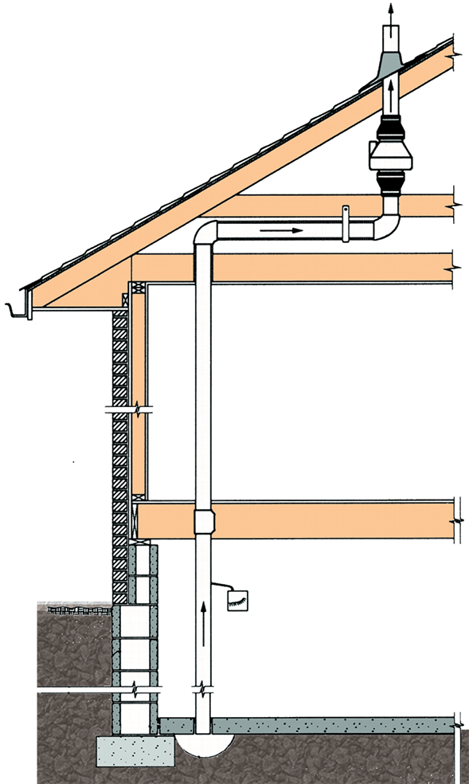
Fan
Exhaust
Fan
Monitor
Piping
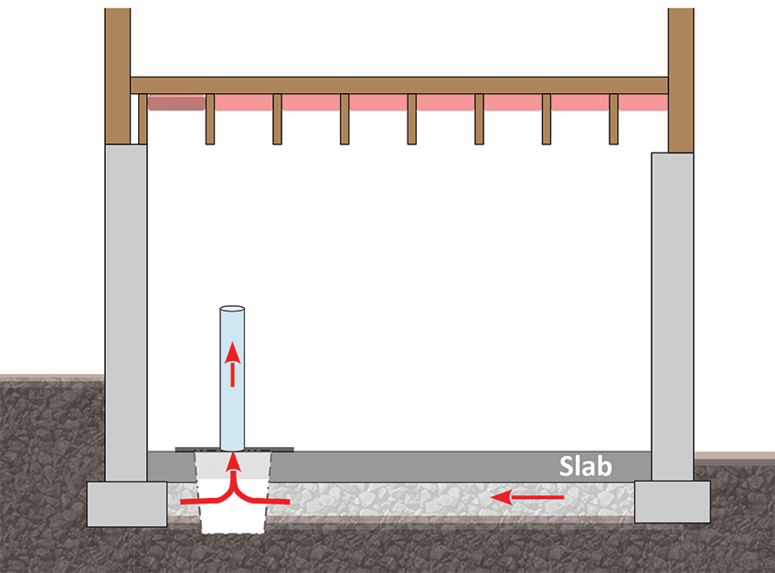
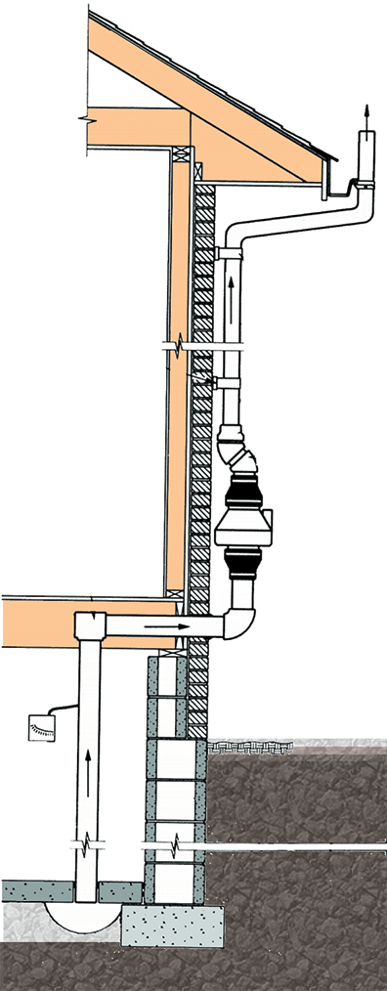
Sumps

Sump

Fan
Exhaust
Fan
Monitor
Piping

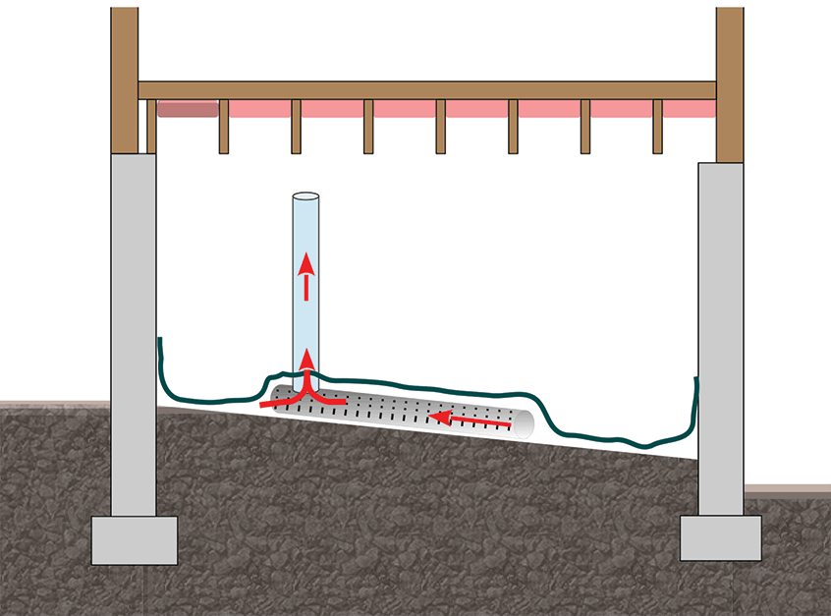
Soil gas retarder membrane

Membrane over soil

Interior Design Exterior Design

Fan Monitors (Pressure Gauge)
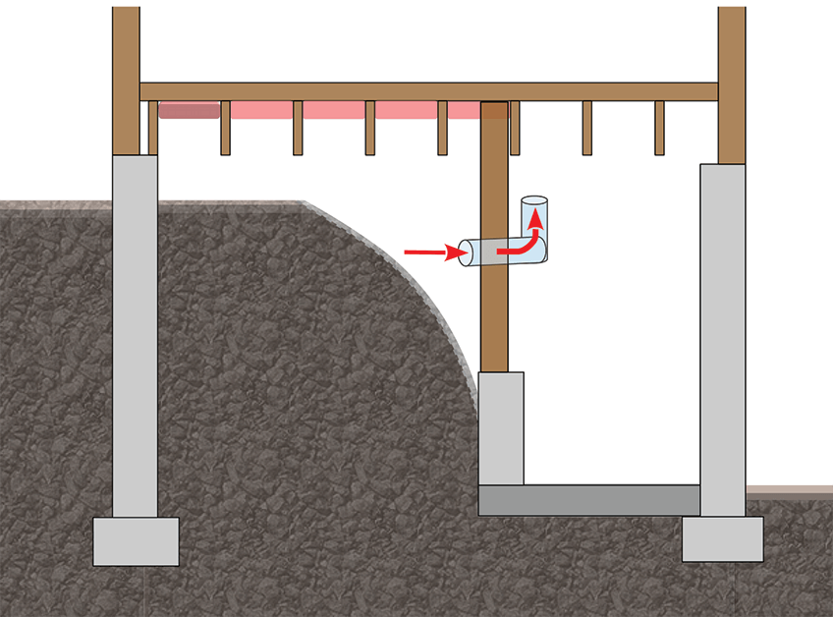
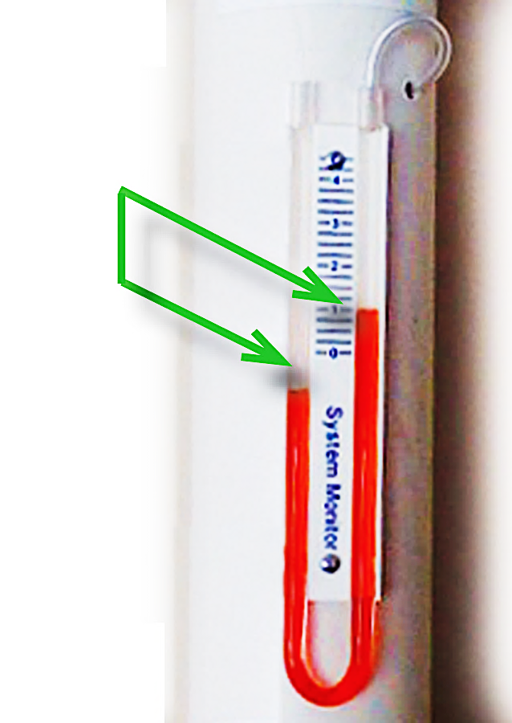
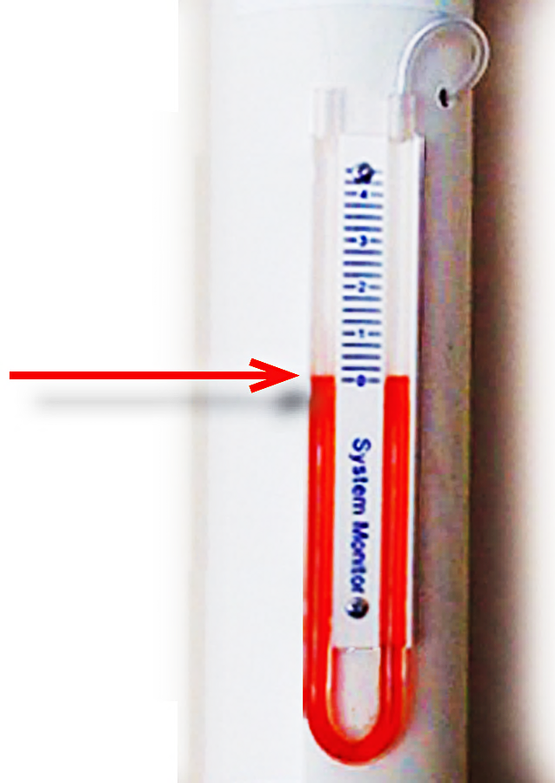
Non-habitable air spaces
Pipe
to Fan

Different?

GOOD
Fan is on

Equal?

BAD
Fan is off

GENERAL INSPECTION — EXISTING RADON MITIGATION SYSTEMS
Safety REVIEW
Advisory—This list is intended for use by homeowners and inspection personnel.
It is not intended to verify compliance with local regulations or any published radon standard.
Radon Testing | If No, recommended action
❏ Was the most recent test within the last 2 years? | ❏ Test for radon
❏ Are recent test reports available?
❏ Is there radon system piping and a radon fan? | ❏ Test for radon. If readings are low, test again in the heating season
Fan and Exhaust Location
❏ Is the fan outside of occupiable space and not beneath an occupiable space (e.g., not in a basement, crawl space or attached garage that is under occupiable space)? | ❏ Relocate the fan to meet compliance with current standards
❏ Does fan electrical wiring appear safe? | ❏ Correct unsafe electrical wiring.
❏ Is the system exhaust at least 10 feet above grade? | ❏ Take action to bring the exhaust location into compliance with current standards
❏ Is the system exhaust at least 2 feet above or 10 feet to the side of operable openings in all windows, doors or other ventilation openings between outdoor air and indoor air?
Radon Pipe Routing
❏ Are building exits for fire and safety clear of obstructions? | ❏ Take action to correct hazards
❏ Does pipe routing retain fire protection and safe distances from electrical panels or meters for gas or liquid fuel?
Radon Fan Monitor
❏ Is there a viewable fan monitor? | ❏ Install a viewable fan monitor
❏ Does the radon fan appear to be running? | ❏ Activate or replace the fan
Openings to soil
❏ Do all sump pits have rigid sealed lids? | ❏ Seal or install a durable sump lid
❏ Are sump lid materials durable and safe if stepped on?
❏ Are accessible openings to soil closed or sealed except those that might compromise water drainage? | ❏ As appropriate, seal openings in slabs and crawl space membranes
Non-habitable air spaces
❏ For less common systems that draw air from behind a wall, under a floor or from a crawl space, are openings closed or sealed between the non-habitable air space and both indoor and outdoor air surrounding the non-habitable air space? | ❏ Take action to establish sufficient closure to prevent energy penalties or flue gas spillage from atmospherically vented combustion appliances
❏ If radon testing indicates open foundation or crawl space vents are an important mitigation component, are permanently open vents installed? | ❏ Take action to install non-closable vents or install a system that is effective during all seasons

GENERAL INSPECTION — EXISTING RADON MITIGATION SYSTEMS
Functional Integrity OF Components
Advisory—This list is intended for use by homeowners and inspection personnel.
It is not intended to verify compliance with local regulations or any published radon standard.
Type of Mitigation System(s) Installed
 | ( ) Sub-slab Depressurization | ( ) Sub-membrane Depressurization |  | ( ) Soil Vent Piping Without Fan
 | ( ) Sump Depressurization | ( ) Block Wall Depressurization |  | ( ) Other Method
 | ( ) Drain Tile Depressurization | ( ) Depressurization of Non-habitable Airspace
Radon System Piping |  |  | If No, recommended action
❏ Is piping watertight or free of visible water leaks? |  |  | ❏ Take action to seal pipe joints
❏ Is piping sloped to drain water in the pipe to the soil? |  |  | ❏ Take action to achieve drainage
❏ Is piping secured to the building in durable manner? |  |  | ❏ Take action to correct piping deficiencies
❏ Is the exhaust air discharging freely without obstructions?
❏ Are building materials safe from exhaust vapor damage?
❏ Is the piping durable and in good repair?
Fans
❏ Is there a switch, plug or labeled breaker to turn off the fan? |  |  | ❏ Take action to correct the fan installation
❏ Do flexible couplings connect the fan to piping?
❏ Is the fan rated for safety and constant activation needed for radon systems and capable of draining water?
Sump Lids
❏ Are sump lids fastened and sealed in a manner that allows removal for service where closure is achieved with non-permanent materials such as silicone caulk or gaskets? |  |  | ❏ Add features required in national standards that allow reasonable access to conditions inside the pit
❏ For suction piping found attached to a sump lid, does the pipe have a flexible coupling disconnect to ease access to the pit?
Sub-membrane Depressurization
❏ Are air intakes under the membrane free of obstructions? |  |  | ❏ Take action to correct the deficiency
❏ Is the top of the membrane free of standing water?
❏ Are all sizable membrane openings to soil closed?
❏ Are the edges of the soil gas retarder closed or sealed? |  |  | ❏ Improvements may be warranted to enhance system effectiveness and long-term integrity of the membrane
❏ Is durability of the membrane material adequate?
❏ Is the soil gas retarder is not secured to walls in crawl space areas that are accessible for routine storage or other activity?
Less Common Radon Mitigation Methods
❏ Does the mitigation method solely consist of system piping, radon fan(s) and closure between soil gas and indoor air? |  |  | ❏ Consult with a radon professional for evaluating Non-ASD systems

Exhibit F. Chain of Custody Form
<If this is not the form you plan on using, replace with a copy of the form you plan on using. Customize as necessary>
<Organization Name>

Device Type (circle): AC CLS EIC ATD CRM

Device Serial Number: __________________________________________________________________________

Date Received: ______________

QA Officer Name: _________________________________________ QA Officer Initials: _____________________

Date Disbursed: _________________

Test Technician Receiving Name: ______________________________ QA Officer Initials: ___________________

Test Address: __________________________________________________________________________________

Date Returned: _________________

Test Technician Returning Name: _______________________________ QA Officer Initials: _________________

If Passive Device, Date Sent to Analytical Lab: _________________ Tracking Number: ______________________

If Passive Device, Date Lab Received: _________________ Serial Number Verified: _________________________

Date Test Results Sent to Client: _________________ QA Officer Initials: ______________________

Exhibit G. Test Report Form
<If this is not the form you plan on using, replace with a copy of the form you plan on using >
<Organization Name>

Radon Test Results Report

Client: ___________________________________________
Test address: ______________________________________
City: _____________________________________________ State: _____ Zip: _________
Average radon level during test was: ____ pCi/L. At this concentration, according to US EPA, the building <should/should not> be mitigated.
Email address: ______________________ Phone: _________________ Alt. Phone: ____________
Test location: <floor level, specific room, specific location in room> Test Unit Serial # __________
Start time: ___________ Date: __________ Stop time: __________ Date: _____________
Required test conditions observed at deployment and retrieval (circle one): Yes No
If no, explain: ____________________________________________________________________
PURPOSE OF THIS INSPECTION REPORT
To provide a professional opinion of a structure’s radon levels at the time of and for the test period as limited to the conditions identified in this report.
EPA EXPLANATION OF TEST RESULTS
Radon is the second leading cause of lung cancer, after smoking. The U.S. Environmental Protection Agency (EPA) and the Surgeon General strongly recommend taking further action when the home’s radon test results are 4.0 pCi/l (picocuries per liter of air) or greater. Radon levels less than 4.0 pCi/l still pose some risk and in many cases may be reduced. The annual national average indoor radon level is about 1.3 pCi/l while annual outdoor radon levels average 0.4 pCi/l. The higher a home’s radon level, the greater the health risk to you and your family. Smokers, former smokers, and individuals with a family history of lung cancer are at especially high risk. An Iowa credentialed mitigation specialist should be used to fix radon problems. Contact the Iowa Department of Public Health Radom Program at (515) 281-4928 or at www.idph.iowa.gov/radon/fix to obtain information, including a list of State-credentialed radon mitigation specialists who can fix or can help you develop a plan for fixing the radon problem.

There can be uncertainty with any radon measurement due to statistical variations and other factors such as daily and seasonal variations in radon concentrations due to changes in the weather and operation of the dwelling as well as possible interference with the necessary test conditions that may or may not influence the results.

Page 1 of 2
TEST LIMITATIONS
This tested house, townhouse, condominium, or apartment should be retested in the following cases:
- If the home was unoccupied during the test, the home should be retested after occupancy;
- If the home is located in an area of karst or glacial moraine geology, it should be retested over a 12-month period;
- If occupied by a new owner;
- If the initial test was less than 4 pCi/L, retest every very five years after initial testing;
- If a new addition is added;
- If an alteration is made that could change the home’s ventilation patterns;
- If major cracks or penetrations occur in the home’s foundation walls or slab;
- If significant nearby construction blasting or earthquakes occur;
- If changes are made or happen to an installed mitigation system; or
- If a ground-contacted area is occupied that was not previously tested.

LIMITATIONS OF LIABILITY
<Organization Name> cannot guarantee the necessary conditions were maintained during the test period. There can be uncertainty with any radon measurement due to statistical variations and other factors such as changes in the weather and operation of the dwelling. While our radon measurement technicians and we make every effort to maintain the highest possible quality control and include checks and verification steps in our procedures, we make NO WARRANTY OF ANY KIND, EXPRESSED OR IMPLIED, for the consequences of erroneous test results. <Company’s or organization’s name> nor its employees or agents shall not be liable under any claim, charge or demand, whether in contract, tort, or otherwise, for any and all loss, cost, charge, claim, demand, fee, or expense of any nature or kind arising out of, connected with, resulting from, or sustained as a result of any radon test.

RADON TEST DATA
Attached to this report is a copy of the actual test data either taken from the testing device or provided from the analytical laboratory. This test was done with a <name of testing device> an EPA approved testing device. The test was performed in accordance with the current standards and guidelines accepted for radon testing.

________________________________________ ______________________________
Measurement Specialist IDPH Certification Number

Page 2 of 2

Exhibit H. Example of Onsite Notice – Test in Progress

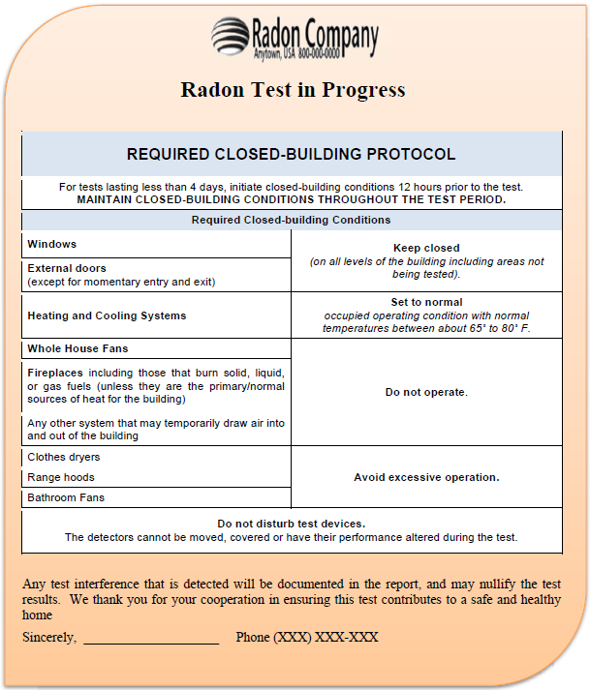

Exhibit I. Example of Onsite Notice – Door Hangar

RADON TEST
IN PROGRESS
Required closed-building conditions
(12 hours prior to the test and during the test)
Keep closed | Windows & Exterior doors  (except for momentary use)
Set to normal | Heating & Cooling systems  keep between about 65˚ 80˚ F)
Set to lowest outdoor ventilation | Systems that temporarily ventilate with outdoor air for seasonal comfort or energy savings
Avoid excessive operation | Clothes dryers, range hoods and bathroom fans
Do not operate | Whole-house and  window fans
Fireplaces that burn
solid, liquid or gas fuels,
unless they are the primary sources of heat for the building

Do not disturb test devices.

Exhibit J. Confidentiality Waiver Form

<COMPANY LOGO OR LETTERHEAD>
<ADDRESS>
<PHONE #>

WAIVER OF RIGHT OF CONFIDENTIALITY FOR RADON MEASURMENT RESULTS*

I, _____________________________________, the owner of the structure located at
[Print Name]
________________________________ in ____________________________, Iowa,
[street address] [City]
do hereby waive the confidentiality rights delineated in Iowa Code 136B.2* and authorize the results of the radon test performed by _____________ , with <COMPNAY NAME>
on to be disclosed to _____________________________________.
[Date] [name of individual]

Owner Signature: _________________________________ Date: ____________

* Iowa Code Chapter 136B.2 Radon testing information — disclosure.
Section 1. b. A person shall not disclose to any other person, except to the department, the results of a test or the address or the name of the owner of a nonpublic building that the person tested for the presence of radon gas and radon progeny, unless the owner of the building waives, in writing, this right of confidentiality. However, a person certified or credentialed pursuant to section 136B.1 may disclose the results of a test performed by the person for the presence of radon and radon progeny to a potential buyer of a nonpublic building when an offer to purchase has been presented by the buyer and if the potential buyer paid for the testing. Any test results disclosed shall be results of a test performed within the five years prior to the date of the disclosure.

<If using the Minnesota Department of Health Excel file, the file contains the following four appendices. While you could place the worksheet and chart here, in your QA Plan, it is better to maintain them in the separate file. Doing so, will reduce the need to update your QA Plan. The MDH example that can be used can be found at https://www.health.state.mn.us/communities/environment/air/docs/radon/qachart.xlsx
Make sure any references to MDH are removed>

<You must include a copy of the template you are using. It can be submitted either as an Excel spreadsheet or a printout of the template you are using. You may submit it as part of this document or upload it as a separate document.

Appendix A. Relative Percent Difference Log and Chart for Comparison Checks and Duplicates for All Devices
In a separate workbook, there are three worksheets for calculating Relative Percent Difference (RPD):
- A1. for recording comparison checks or duplicates) averaging less than 2 pCi/L;
- A2. for recording and charting comparison checks or duplicates averaging between 2 and 4 pCi/L; and
- A3. for recording and charting comparison checks or duplicates averaging 4 pCi/L or greater.
These worksheets reflect monitoring of measurement precision.

Instructions for AARST Duplicate Template
This template is intended for those who are somewhat familiar with using Microsoft Excel. The Duplicate Spreadsheet contains columns with the headers highlighted in Green and some highlighted in Red (Pink). For each set of duplicates, the Date and the Number of the Duplicate are entered for informational purposes only. The measured values or values reported from a laboratory for the two samples are entered in the columns headed “A” and “B.” The larger of the two measurements may be entered into either column. The first few rows have been filled with example data. Merely replace those data with your data. (If the formula were altered to use the absolute value of A – B, then entering the higher number first is moot.)

DO NOT enter data in the columns labeled “Avg” and “RPD” and highlighted in red. The cells in the first four rows of these columns contain the formulae for calculating the average of the two measurements and the "Relative Percent Difference." If you enter data into one of these cells, the formula contained in that cell will be lost. To copy the formula into further cells in these columns, merely move the cursor to one of the cells containing the formula and hit CTRL C (or alternatively use Edit/Copy), then move the cursor to where you want the formula and hit CTRL V (or alternatively use Edit/Paste).

Note that there are three tables in the spreadsheet, depending upon the average of the two duplicates. There are two different sets of criteria that can be applied to the data depending upon the average of the duplicate measurements. One set of criteria is applied when the average of the two measurements is 4.0 pCi/L or larger, and another set is applied when the average is less in the range of 2.0 – 3.9 pCi/L. Further, when the average of the two duplicate measurements is less than 2.0 pCi/L, there may be no benefit to putting these data on a control chart. Therefore included in the spreadsheet is a third table where these data may be tabulated, but they are not placed in a control chart. This is because the RPD becomes very large as the concentration becomes small, and two measurements that are in good agreement.

[There should be a table for entering data where the higher measurement is greater than or equal to 4.0 pCi/L and the lower measurement is less than 4.0 pCi/L. If the higher is less than twice the lower measurement, then the data is cannot be used to make a mitigation decision. This does not have a graph, but exists in table form and is considered when considering corrective action.]

To update the number of duplicates that are shown on a chart, somewhere on the chart "RIGHT CLICK" to get a menu, then select "Source Data." Click on the TAB labeled "Series." In the text box on the lower right, you see text that looks like:

='Duplicate Spreadsheet'!$F$16:$F$19

Change the last number on this line to the number of the row on the spreadsheet that contains your last data entry. For example, if I added three sets of duplicates to the spreadsheet, I would advance this number by 3 and so would change the "19" at the end of the line to "22." Click "OK" at the bottom of this window.

Initially, the chart shows a number on the X-axis for every set of duplicates. As more duplicates are added, this will cause the chart to look very busy. To change this, DOUBLE-CLICK on one of the number on the X-axis, then click on the tab labeled "Scale." Experiment entering different numbers into the two text boxes labeled "Number of categories between tick-mark labels" and "Number of categories between tick marks" until you get a chart that looks as you desire.

The title for the chart may be changed as you desired. Also, the first three rows of the spreadsheet may be changed as you desire.

Be sure to save your changes each time you update the spreadsheet and chart

Example of Worksheet:

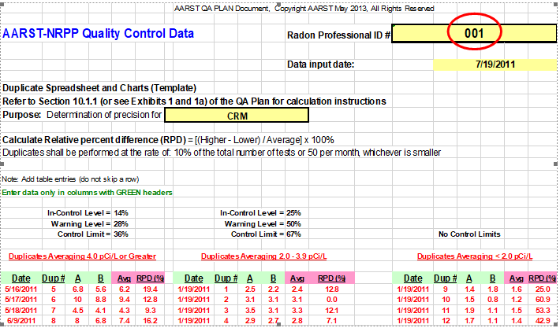

Appendix B. Blank Control Log and Chart
In another worksheet, one can make calculations that allow determination if blanks indicate problems with background.

Instructions for Using Template for Tracking Blank Measurements
This template for blank measurements is intended for use with long-term passive devices, such as alpha-track detectors and long-term electret ion chambers. This version of the template requires the user to perform a number of tasks manually and therefore the user must be familiar with Microsoft Excel. Blank measurements for passive devices are required at the rate of 5%; i.e., for every 100 devices used in the field, five devices should be sent unexposed to the laboratory for analysis.

The laboratory should be able to provide the user with a value of Lower Limit of Detection. A value of 1.1 (pCi/L) was placed in the template in cell I7 merely as an example. The user should put the proper value in cell I7, and then move the end points of the red line on the chart to that value on the Y-axis. The label for the red line should also be moved.

Data were placed in the spreadsheet merely as examples. These data should be replaced with the user’s data. Column A contains the date for the blank device. This may be the date that the device was sent to the laboratory, or the date that the device was analyzed, as appropriate. Column B contains some identification of the device, such as a serial number of an alpha-track detector or an electret. Column C contains the number of the blank; this is used as the value of the X-axis. The user may choose instead to use the date as the value for the X-axis (the user would have to manually change the manner in which the data are charted). Column D contains the value reported by the laboratory for the blank measurement.

The laboratory should report the actual measured value, even if it is below the LLD or even if it is a negative value. However, some laboratories may report the value as <LLD or some other non-numerical value. If the user cannot get an actual value from the laboratory, then the chart may be of little use for those values. In this situation, the user could enter a value of zero for the measurement, realizing that a zero value means that no numerical value was received from the laboratory. The user may choose to use some other means of identifying such measurements.

The chart is set up for a maximum of twenty measurements. The user may wish to increase this maximum when more than twenty measurements are available. This is done using the “Source Data” function within the chart.

By definition, a measured value greater than the LLD means that it is statistically significantly above a laboratory blank value, indicating that the device was exposed to radon. If the user finds that a significant percentage of blank measurements are above the laboratory’s LLD value, this could be an indication of a problem with storing or handling the devices or it could indicate a problem with the analysis itself. The user should investigate the cause of this and correct it, if possible.

Example of log spreadsheet:

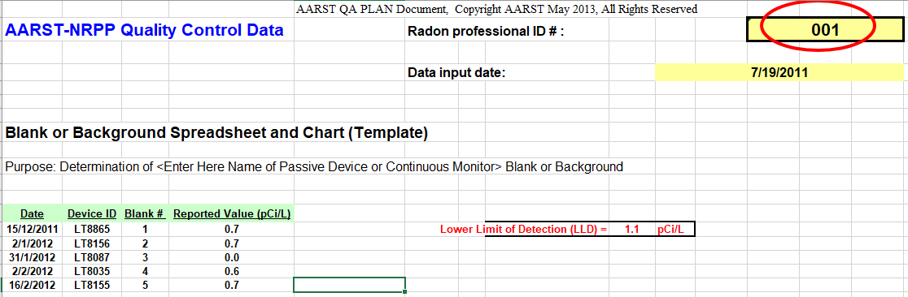

Example of blank control chart:

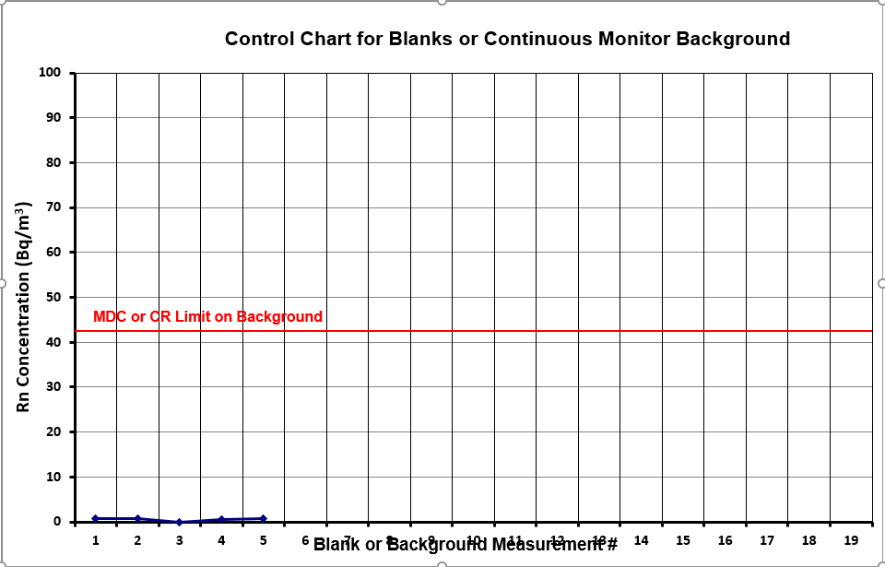

Appendix C. Spike Control Log and Chart for Passive Measurement Devices
In a third worksheet, Relative Percent Error may be calculated that allow determination if there are problems with precision.

Instructions for AARST Spike Template
This template is intended for those who are somewhat familiar with using Microsoft Excel. The Spike Spreadsheet contains five columns with the headers highlighted in Green. For each spike sample, the Date, the Device ID and the Number of the Spike are entered for informational purposes only. The measured value or value reported from a laboratory for the sample is entered in the column headed "(pCi/L)." The value reported by the radon chamber facility that exposed the sample to a known radon concentration is entered in the column labeled "Target Value (pCi/L)." The first five rows have been filled with example data. Merely replace those data with your data.

DO NOT enter data in the column labeled "IRPE (%)" and highlighted in red. The five cells in this column (F7 through F11) contain the formula for calculating the "Individual Relative Percent Error." If you enter data into one of these cells, the formula contained in that cell will be lost. To copy the formula into further cells in column F, merely move the cursor to one of the cells containing the formula (F11 for example) by moving and hit CTRL C (or alternatively use Edit/Copy), then move the cursor to the cell in column F where you want the formula and hit CTRL V (or alternatively use Edit/Paste).

To update the number of spikes that are shown on the chart, somewhere on the chart "RIGHT CLICK" to get a menu, then select "Source Data." Click on the TAB labeled "Series." In the text box on the lower right, you see text that looks like:

='Spike Spreadsheet'!$F$7:$F$11

Change the last number on this line to the number of the row on the spreadsheet that contains your last data entry. For example, if I added five spikes to the spreadsheet, I would advance this number by 5 and so would change the "11" at the end of the line to "16." Click "OK" at the bottom of this window.

Initially, the chart shows a number on the X-axis for every spike. As more spikes are added, this will cause the chart to look very busy. To change this, DOUBLE-CLICK on one of the number on the X-axis, then click on the tab labeled "Scale." Experiment entering different numbers into the two text boxes labeled "Number of categories between tick-mark labels" and "Number of categories between tick marks" until you get a chart that looks as you desire.

The title for the chart may be changed as you desired. Also, the first four rows of the spreadsheet may be changed as you desire.

Be sure to save your changes each time you update the spreadsheet and chart.

Example of log spreadsheet:

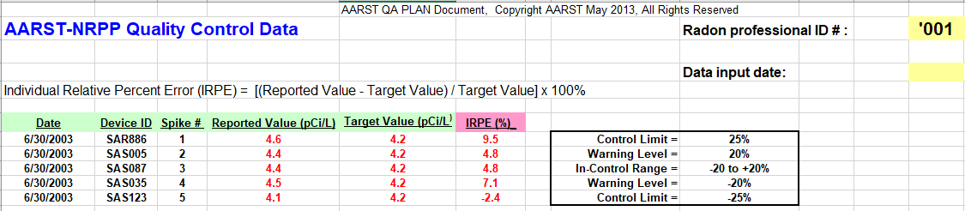

Example of spike chart:

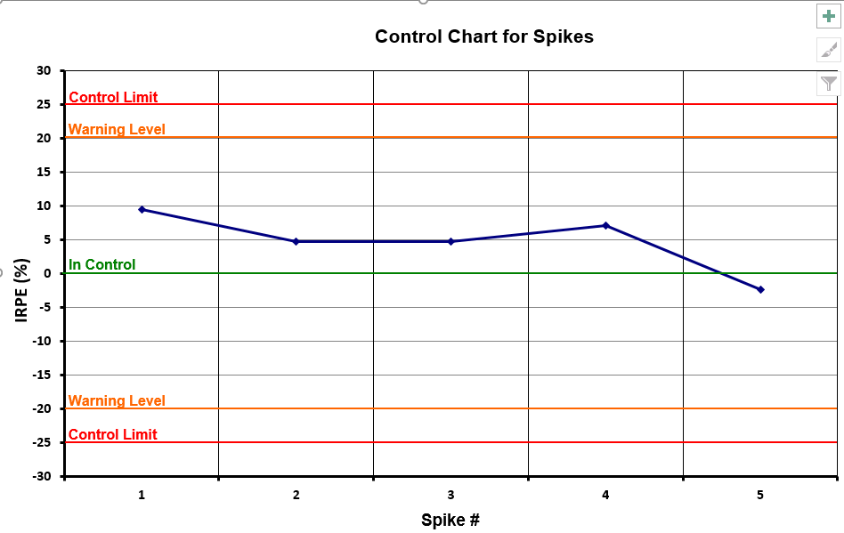

Appendix D. Internal Audit Checklist
Audit Performed by: _____________________________________________ Date: __________________
Audit Approved by: ______________________________________________ Date: _________________
Item (QAP Section, Exhibit [E] or Appendix [A]) | Observed Concerns | Comments | Correction Actions | Done
Staff Distribution List Current (1)
Device List Current (2)

Measurement Procedures Current (4)
Pre-Test Notification Procedure Reviewed (4; E.A)
Testing in Progress Procedure Reviewed (4; E.B)
Test Placement/Retrieval Procedure Reviewed (4; E.C)
Voluntary Compliance Procedure Reviewed (4; E.D)
Detector Chain of Custody Procedure Reviewed (5; E.E)
Analytic Procedures Current (6)
Data Collection Current (7)

Data Validation Current (7)

Reporting Form & Procedure Reviewed (7; E.F)
Comparison Check/ Duplicates Current (8; A.A)
Routine Instrument Checks Current (8)
Blanks Current (8; A.B)

Spikes Current (8; A.C)

Crosschecks Current (8; A.D)

Standard Operating Procedures Current (8; A.E)
Calibration Current (8; A.G)

Instrument Checks Current (8)
Crosschecks Current (8)

Source Checks Current (8)

QA Objectives, Audits & Reports Current (9 & 10)
Corrective Actions Current (11)
QA Training Current (12)

Appendix E. Employee Training Log
<insert example of employee training log>

Next Cal. Date
Next Cal. Date
Next Cal. Date
Next Cal. Date
Calibration Date
Purchase Date
S/N
Model No.
Man./Model Name

